Practice Lab on DNS,ARP,HTTP,SMTP,TCP

- What is the target MAC address of an ARP Query packet?

- Suppose a host gets an ARP query for an IP address, which is not its own IP. What will it do with that packet?

- Refer to the exhibit, you typed www.facebook.com in browser of PC0. PC0 doesn’t know the MAC Addresses of DNS Server and Facebook server.
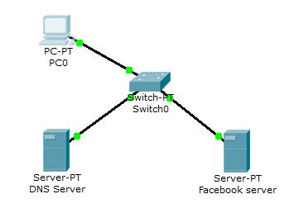

Now rearrange following statements as they occur while PC0 browses facebook.

- Facebook server replies HTTP packet.

- PC0 sends DNS query of www.facebook.com to DNS server

- PC0 sends TCP handshake packet for establishing TCP communication.

- PC0 sends ARP to know MAC of DNS Server.

- PC0 sends TCP packet to facebook server for closing communication.

- PC0 sends ARP query to know the MAC of Facebook server

- Facebook server sends TCP packet to PC0 confirming that it has closed the TCP communication.

- Facebook server replies ARP query of PC0 with its MAC

- DNS server replies ARP query of PC0

- Facebook webpage appears in the web browser of PC0

- PC0 sends HTTP packet.

- DNS server replies DNS query with IP of www.facebook.com
- Refer to the exhibit if PC0 sends a packet to facebook server, what devices’ IP and MAC it will use as destination IP and MAC
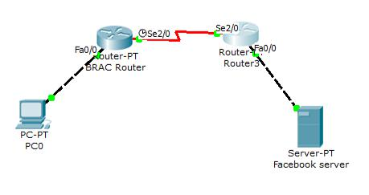

- Suppose you have a e-mail client (say outlook) in your home computer where you have configured your E-mail account in gmail (say something@gmail.com). Suppose gmail supports smtp and pop3 protocol. You can receive e-mails all the time, but you cannot send e-mails. Which of the following are true?

  - SMTP is working fine.

  - There may be some problems with SMTP.

  - POP3 is working fine.

  - Password for POP3 authentication is given wrong.

  - Physical link between your PC and gmail server has been lost. That’s why you cannot send e-mails.

