Machine learning on network analysis

“Software written today differs from that written in the past in two main ways: it is more complex and handles more data than ever before. When Windows 95 was released it contained 11 million lines of code, in contrast six years later Windows XP had 40 million lines [1]. This gives rise to a greater need for systematic testing

Abstract

This paper attempts to incorporate machine learning techniques to improve network security. Is this really true? I thought my aim was to test IDS.

Introduction (this does not fit abstract, write that at the end)

“There are **4.39 billion** internet users in 2019, an increase of 366 million (9 percent) versus January 2018.” [1] <https://wearesocial.com/blog/2019/01/digital-2019-global-internet-use-accelerates>

Stats $6 trilion. 600% increase on Iot 69% anit virus

[2] <https://www.varonis.com/blog/cybersecurity-statistics/>

Smart water bottle

[3] <https://gizmodo.com/15-idiotic-internet-of-things-devices-nobody-asked-for-1794330999>

[4] <https://ieeexplore.ieee.org/abstract/document/6978614> internet of things issue

[5] <http://www3.weforum.org/docs/WEF_GRR18_Report.pdf> offensive cyber capabilities….

[6] <https://www.calyptix.com/top-threats/top-8-network-attacks-type-2017/> network attack types

With the rapid expansion of the Internet, it has become an essential part of our lives with over half the population connected [1]. However, this results in an increasingly complex and fragile network. Many systems are left vulnerable, waiting to be exploited. By 2021, it is predicted that cost of cyber-attacks will reach $6 trillion [2]. The importance of a good and secure security system is far too crucial.

“Offensive cyber capabilities are developing more rapidly than our ability to deal with hostile incidents” [5]. Attacks are becoming smarter, polymorphic viruses and obscured malwares are passing through current systems. Over a third of organizations believe that the threats they are facing cannot be blocked by their anti-virus [2].

Due to our rapid growth, we have left many openings for an attack, one of them is through the network. Our need for constantly being connected is causing a major gap in security. In 2017, 8 different network attacks dominated the market. [6]

1. Browser attacks - malicious users target vulnerable websites to infect, infecting new genuine users.
2. Brute force attack - attempting to guess your way through to the system.
3. Denial of service (DoS) or Distributed Denial of Service (DDoS) – flooding a service by creating many requests in order to slow or crash the system.
4. Worm attacks – self propagating program that spreads through local system through exploitable vulnerabilities.
5. Malware attacks – programs that can take many forms, however their purpose is always malicious.
6. Web attacks – exploiting vulnerabilities found in the website such as SQL injection.
7. Scan attacks – indirect attack to gain knowledge of any vulnerabilities that exist such as an open port.
8. Other attacks – attacks that were out of scope, such as physically attempting to steal device.

Fortunately, methods such as Intrusion detection system (IDS) exist to deter most of these attacks. IDS constantly scan the network for any anomalous activity in the network. Some are even capable of stopping the attack completely rather than just alerting the user.

However, IDS face many issues such as explaining what an anomaly is in the first place. Robustness and accuracy also come into question. How often does an IDS system report false negatives or how many different types of malwares can they detect?

By using machine learning it is possible to overcome these problems because of its ability to learn patterns and understand different classifications. As malware evolve, the system can also be retrained to learn new patterns of attack. Because of this, I aim to create a system that can detect malwares on a network using machine learning and test its robustness and accuracy rates.

Intrusion detection systems (IDS) is one of many methods of securing against cyber-attacks. IDS constantly scan for any anomalous activity, with some even performing actions to deter such activity.

However, defining what is an anomaly is difficult. Machine learning as a whole, excels at such problems. Capable of learning patterns and understanding different classifications can help solve this problem.

Networks, which are simply a connection of two or more nodes capable of sharing resources, are incredibly varied yet engrained in our everyday lives. Along with the boom of Internet of Things, devices capable of communication and storing valuable information, networks are left more vulnerable [4].

A network is a connection of two or more nodes which can share resources. The Internet happens to be the largest network out there. There are constant attacks targeting networks with new attack vectors being discovered.

Especially with the boom of Internet of Things. Smart phones, smart watches and even smart bottles [3] are increasing in popularity. In 2017, attacks on these IoT devices increased by 600% [2].

Intrusion detection systems (IDS) are one method of creating a secure network environment. IDS constantly scan for any anomalous activity, with some even performing actions to deter such activity. However, defining what is anomalous is difficult.

Machine learning has exploded in many areas

There are many vulnerabilities in a network such as … machine learning is good at learning patterns of these attacks …

The increase in Internet of Things (IoT) such as smart phones, smart watches and even smart bottle [3] has caught the attention of attackers. In 2017, attacks on IoT have increased by 600% [2]. IoT devices have the ability to connect to the Internet, creating a passage

They create a vulnerable passage on

Everything nowadays is “smart”. Smart phones, smart watches, smart lightbulbs and even smart water bottle [3]. The increase of these devices known as Internet of Things (IoT) have created a huge network, containing valuable information however are left with massive security flaws [4]. In 2017, the attacks on these IoT devices have increased by 600% [2]. Malicious users are able to constantly find new attack vulnerable vectors.

Intrusion detection systems (IDS) are on the forefront of tackling against network attacks. IDS are constantly scanning

A network is a connection of two or more nodes which can share resources. The Internet happens to be the largest network out there. There are constant attacks targeting networks with new attack vectors being discovered.

<https://www.calyptix.com/top-threats/top-8-network-attacks-type-2017/>

Types of network attacks

1. DoS – flood traffic to services in order to overwhelm them, causes slower service response or shut it down completely.
2. Malware – types of malware constantly change with constant new zero-days. Malware can take many forms but its purpose is always malicious.
3. Web attacks – almost everything has a public web-based interface which requires a database. There are several attack vectors such as SQL injection or cross-site scripting.

“Offensive cyber capabilities are developing more rapidly than our ability to deal with hostile incidents” <http://www3.weforum.org/docs/WEF_GRR18_Report.pdf>

One such method is Intrusion detection systems (IDS). IDS constantly monitors network traffic scanning for any suspicious activity.

Machine learning comes hand in hand with this as it is able to learn patterns well.

Intrusion detection systems (IDS) stands at a forefront as a defense against attackers.

<https://ieeexplore.ieee.org/document/6560100>

IOT increasing attacks

<https://us.norton.com/internetsecurity-emerging-threats-10-facts-about-todays-cybersecurity-landscape-that-you-should-know.html>

<https://assets.publishing.service.gov.uk/government/uploads/system/uploads/attachment_data/file/813599/Cyber_Security_Breaches_Survey_2019_-_Main_Report.pdf>

Explain network and types of attack

Explain why machine learning

Testing robustness

to detect/learn different types of network malwares

synthesized attacks will get flagged – bank, non-malicious anomaly

One area known as Intrusion Detection System (IDS) is on the rise to detect anomalous activity real time. However, it faces many challenges. Defining abnormal activity from the norm is problematic.

Aim

Classify different malwares in dataset – to detect/learn malwares

Synthesize network packets using classifier network // Attempt to generate my own attacks and check with classifier

Test available IDS with synthesized malware packets – bank example analogy where person comes in with mask with water gun not really stealing but gets flagged as suspicious.

[1] <https://ieeexplore.ieee.org/document/6169141>

Aims

The project aims to create a system that can detect malware on a network by incorporating machine learning. The system should be able to classify a wide range of malwares accurately whilst having a low false positive rate

There are several different ways accomplish this. Below is list of steps I will take to approach this problem with several extensions that I would like to do, given time constraints and my own ability.

There are multiple steps that are required with possible extension.

Data drives machine learning. Immense amounts of data have been collected, ready to be analysed however it is lacking for cyber security, especially for network analysis. Creating a network dataset that is unbiased and realistic proves to be a difficult challenge [1]. Unfortunately, the initial step would be finding a suitable dataset. Despite the issues with collecting network data, there are still many public resources available.

A note to consider is that I have already chosen a dataset which I will expand more under initial work. This is because the entire project depends on the dataset therefore, I had to choose a dataset before the project started.

There are several objectives that I would like to fulfill with this project.

1. Develop a system capable of classifying different malwares

This would be the foundation for all solutions to other problems. It would attempt to create an IDS system using machine learning techniques to detect anomalies, in this case malwares. Also, it aids to not only understand the dataset but the behaviour of malwares as well.

1. Create synthetic malware attack patterns.

This depends heavily on the results of step 1. If the system can detect malwares, then it can also learn the pattern of what makes a malware. This would allow creation of synthetic malware attack patterns. It is also possible to retrain the classifier in step 1 to be “smarter” against fake synthetic attacks which hopefully reduces the chances of a false positive, creating a smarter IDS system.

What kind of an attacker attacks using fake synthetic malware packets? – false alarms

* 1. Replicate environment and create my own attacks

Another possibility I would like to do would be to create actual malware attacks, not just synthetic. Replicating the environment, the dataset was collected in, the classifier could be tested on a live network rather than just on a pre-collected dataset.

1. Test robustness of available IDS with synthetic data.

The final step would be to test how well IDS systems work. If synthetic malware data is realistic enough, it would be able to fool IDS systems into thinking an attack has happened. It is then easy to test an IDS system’s reaction to such attacks.

What is the point of this?

* 1. Create genetic adversarial neural networks (GANNs) to create even more realistic synthetic malware data.

With the usage of GANNs, more realistic synthetic malware data can be generated which in turn tests IDS systems. An almost infinite training loop could be created to train IDS systems to learn the correct patterns of malware which should make the system more robust. Again, what is the point of this?

The main aim of this paper is to implement machine learning with network security in order to improve it. Specifically, to detect network malwares. Depending on the possible Multiple steps are required to achieve this with extensions.

The aim of this paper is to test the robustness of network detection systems by feeding synthesized fake network packets.

In order to do so, a neural network will be trained on amazon’s dataset to create a classifier that can detect certain malwares. Once pattern is learnt, it will attempt to synthesize such patterns which will then be fed into a network detection service. The result should be that the network packets are fake.

Related work

I don’t fully understand whats supposed to be under related work?

The hunt for a high true positive with low false positive IDS system has been sought for a while. Variety of different algorithms have been implemented in order to find one true solution.

Most attacks have a certain pattern that they follow resulting in two main approaches [1]. Anomaly detection and signature-based detection. Given a normal day-to-day activity, if a deviation occurs then that is recorded as an anomaly. That is the rule that anomaly detectors follow. Whereas for signature-based detection, it’s based on the fact that an attack has a known pattern. If a known pattern is detected, there must have been an attack.

However, they both fall short. If a day-to-day activity is malicious, anomaly detectors will fail to flag it. Whereas for misuse detectors, the rise of polymorphic and obfuscated malwares is rendering it useless [1].

Nevertheless, many academics have implemented a range of different algorithms that attempts to detect malware.

One paper introduces a novel method for signature-based intrusion detection [2]. Creating an updating database that stores most frequent signatures to detect. The results show that the rate of false positives lowered, and malware detection speed increased. However, the database requires the administrator to choose whether signature is dangerous or not. Furthermore, other paper criticizes signature-based detection for its lack of ability to detect innovative malwares [3].

By utilizing data mining techniques such as Bayesian networks, to select features of importance, they were able to detect various attacks such as DOS with 100% accuracy. Their accuracy did falter for other attacks such as User2Root at 84%. [1].

Further research has been done on applying algorithms that are capable of learning and understanding features on a massive scope. Genetic algorithms mixed with traditional algorithms resulted in lower false positives and false negatives [3].

Unfortunately, even with many different implements, current IDS systems present different results for the same situation [4]. Judging the results can also be difficult. IDS systems that have high true positive and low false positive rate could lead to a false sense of security, especially if the attacks are over a large portion of traffic [4].

This shows that there’s progress still to make when implementing an IDS system that has high positive rate with low false positives. One that is also able to handle the constant face-paced changes of evolving malwares.

How are current IDS systems implemented?

Lots of different methods used to implement current IDS

[1] <https://www.sciencedirect.com/science/article/pii/S016740480400238X>

* Feature selection algorithms
* Classification and regression trees

[2] <https://ieeexplore.ieee.org/document/8253208>

* Signature based, database updates “The administrator must decide whether a signature is dangerous and add it to the small database”

[https://ieeexplore.ieee.org/document/6954236/](https://ieeexplore.ieee.org/document/6954236/references#references)

* Semi supervised learning

[x] <https://ieeexplore.ieee.org/document/7436188>

* Genetic algorithms - is a random search method that is used for optimization issues

[z][3] <https://ieeexplore.ieee.org/document/7783243>

* Supervised techniques – For each class, each algorithm has different result and no single algorithm has high TPR for all 5 different classes. But the overall accuracy of J.48 decision tree is high among all other algorithms and low misclassification rate. On KDD99

What are the benefits/downfall of current IDS?

Even with a huge

[4] <https://ieeexplore.ieee.org/document/5305047>

* current IDS that have high false positive rate (FPR) shows that it is highly likely the system does not detect intrusions due to its low sensibility.
* High TPR and low FPR result could cause false marks of intrusion attacks over large portion of traffic.
* Many current IDS out there present different results

[x] <https://ieeexplore.ieee.org/document/7436188>

* “Traditional intrusion detection methods have some problems such as high false alarm rate, low detection compatibility against the new attacks, and insufficient capacity of the analysis.

[z][3] <https://ieeexplore.ieee.org/document/7783243>

* Although, signature based has high detection rate but it cannot detect novel attacks. Asymmetrically, anomaly based detection method can detect novel attacks but it has high false positive rate

[1] <https://ieeexplore.ieee.org/document/6169141>

Background research / initial work

Data drives machine learning. Immense amounts of data have been collected, ready to be analysed however it is lacking for cyber security, especially for network analysis. Creating a network dataset that is unbiased and realistic proves to be a difficult challenge [1]. Unfortunately, the initial step would be finding a suitable dataset. Despite the issues with collecting network data, there are still many public resources available.

~~A note to consider is that I have already chosen a dataset which I will expand more under initial work. This is because the entire project depends on the dataset therefore, I had to choose a dataset before the project started.~~

Four datasets were chosen as candidates however there were many others available at insert link here.

1. GT Malware netflow https://www.impactcybertrust.org/dataset_view?idDataset=1143

This is an ongoing project by Georgia Tech (GT) where they are collecting a daily network feed in an isolated environment. Specific programs are executed for short period of time and recorded.

The issue with this dataset is that

[1]

@inproceedings{Henry:1993:QAS:170791.170868,

author = {Henry, Joel and Henry, Sallie},

title = {Quantitative Assessment of the Software Maintenance Process and Requirements Volatility},

booktitle = {Proceedings of the 1993 ACM Conference on Computer Science},

series = {CSC '93},

year = {1993},

isbn = {0-89791-558-5},

location = {Indianapolis, Indiana, USA},

pages = {346--351},

numpages = {6},

url = {http://doi.acm.org/10.1145/170791.170868},

doi = {10.1145/170791.170868},

acmid = {170868},

publisher = {ACM},

address = {New York, NY, USA},

}

[2] @book{Schwaber:2004:APM:984028,

author = {Schwaber, Ken},

title = {Agile Project Management With Scrum},

year = {2004},

isbn = {073561993X},

publisher = {Microsoft Press},

address = {Redmond, WA, USA},

}

[3] <https://help.github.com/en/articles/about-project-boards>

[4] [https://miro.medium.com/max/2346/1*H-J92JWTuUvoZ8yEEJEDEA.png](https://miro.medium.com/max/2346/1*H-J92JWTuUvoZ8yEEJEDEA.png)

[4] https://medium.com/qash/how-and-why-to-use-agile-for-machine-learning-384b030e67b6

[5] <https://ieeexplore.ieee.org/document/6954236/>

* Not generalisable

Project management

Methodology

For this project, I have chosen to use Scrum agile methodology because of its iterative nature. Scrum framework follows one simple rule, that requirements can change, or otherwise known as requirements volatility [1]. Due to its flexibility, Scrum is ideally designed for a team of ten or fewer [2] and since I will be working alone, some of its fundamentals will be altered.

Usually a daily Scrum takes place at the start of the day where the development team discuss the events of yesterday, however since I will be working alone, no daily Scrum will take place. Instead, a meeting with all other undergraduates under the same supervisor will take place every fortnight. This way everyone can discuss the progress of their respective projects.

Whereas for sprints, I will create a meeting with my supervisor every fortnight, which will be the length of one sprint. Instead of having a different meeting for planning, review and retrospective, it will all be merged into one. By doing this, I will still be able to receive some feedback and talk about issues that are/may cause problems.

Since I am the sole person working on this project, I will be responsible for creating a product and sprint backlog. Tasks will be broken down into separate categories, such as “todo” or “in-progress”. Each task will also be assigned a priority ranging from “must haves” to “would be nice”. I will be using GitHub project board [3] or some alternative that is similar in order to create the task board. Having an online task board allows easy access wherever I am.

This methodology also ties in well with the structure for machine learning projects. The brunt of the work for machine learning projects is always at the start which is data processing. In this step, data must be prepared and cleaned such that it can be fed into a model. This is then followed by model training and finally model testing and evaluation [4]. Depending on how the data is processed, this results in different results for the model. The algorithms used for the model also highly influences the outcome. This ends up being an iterative process since at each sprint, the goal would be to create the best model possible.

Risk analysis

1. Time management

Due to my lack of productivity, unpredicted events or underestimation of the workload, the project may not be completed in time. However, because of my chosen software life cycle, I will be able to create a plan of tasks with their priority and effort levels recorded at the start of every sprint which should help guide the workflow. Also, the roadmap laid out by the Gantt chart contains a timeline which I will follow.

1. Hardware access

This project deals with big data which requires extensive hardware. Lack of hardware can hinder progress as methods will have to be optimized which will require more time. For example, trying to just load the data will have to be split into various batches as there won’t be enough RAM. Training models can also take significantly longer as a lot of processing power will be needed. Hopefully, this should not be an issue as the university has many different devices suited for this project.

High, medium should not affect too much as I will still be able to use any machine, just takes longer.

1. Lack of ability

This project deals with two separate issues, machine learning and security. For this project to succeed, it requires high domain knowledge in both fields which I may not have. However, by planning properly, tasks can be broken down into simpler components. Also, guidance is available from experts in the field.

High, high

* 1. Dataset

Every machine learning project requires a dataset and since it is far too time consuming to produce my own [5], I will have to select an existing one. I may end up choosing a wrong dataset that is not fit for this project. Before I make a concrete decision on which dataset to choose from, I will ask for feedback from experts in the field.

Low, high

* 1. Generalizable

A lot of IDS systems that have been implemented using machine learning techniques seem to not be generalizable to other networks or system [5]. To avoid this, the model should not overfit the dataset, however if the model ends up underfitting, then the accuracy level will be poor. A balance between the two will be required.

Creating my own hack and applying it to the model could also help learn patterns of malwares instead of learning what is the norm and any deviation from the norm is a malware. This could make it more generalizable.

High, low

* 1. Malware – features of importance

There are many algorithms that can understand what features are important and can find correlation between x and y easily. However, even if I created a list of features of importance, my lack of domain knowledge could make it harder to understand what the algorithm is trying to tell me. The results of the algorithm could be nonsense as well. There are many guides on known malwares, I will have to read up on them. If necessary, ask for expert advice as well.

Med, med

* 1. Machine learning – applying right methods

Machine learning has a wide variety of different algorithms that could be implemented in this project. However, I may end up choosing the wrong ones. For example, when attempting to refine the model, I could end up implementing a strategy that does not make any sense. It could even lead my model to learn incorrect information.

Also, the first crucial step is to preprocess the data. Again, preprocessing it incorrectly could lead the model learning biased or incorrect information. For example, when the data contains a lot of NaNs, the model will not be able to handle this value. There are many ways of dealing with NaNs such as replacing it with a special value, using mean values or outright removing them. Whatever the method, it will affect the dataset which in turn will change the outcome of the model. A lot of background reading will be required and visualization of the dataset.

Med, med

[1] https://hackernoon.com/top-8-python-libraries-for-machine-learning-and-artificial-intelligence-y08id3031

[2] <https://www.nopsec.com/5-python-libraries-every-pentester-should-be-using/>

[3] <https://ieeexplore.ieee.org/document/6169141>

[4] <https://www.impactcybertrust.org/dataset_view?idDataset=1143>

[5] <https://www.kaggle.com/crawford/computer-network-traffic>

[6] <https://www.kaggle.com/xwolf12/malicious-and-benign-websites>

[7] <https://registry.opendata.aws/cse-cic-ids2018/>

[8] http://kdd.ics.uci.edu/databases/kddcup99/kddcup99.html

Understanding the project

The entire purpose of this project is to create a system that can reliably detect malwares on a network. and generate synthetic malware patterns? To do this, I will be using Python 3 as it provides many native packages and resources that I can use.

For machine learning, there is a variety of packages that has all the core functionalities already covered.

1. Tensorflow

Tensorflow is a package that can perform high-end numerical computations [1] and can create neural networks. Manually implementing a neural network is another project on its own therefore I will use Tensorflow as it abstracts away all that work.

1. Keras

Keras is another machine learning framework that adds another layer of abstraction on top of Tensorflow. It also supports other machine learning packages such as Theano however for this project, I will be using it for Tensorflow.

Keras makes it easier to implement models for neural network rather than using Tensorflow directly. Also, implementing custom functions such as loss, is easy to do with Keras.

1. Scikit-learn

Another machine learning package that contains a multitude of functions such as clustering, regression and classification algorithms [1]. Instead of just neural networks, there are many other algorithms such as random forest, which Scikit supports.

1. NumPy

This provides a data structure known as NumPy that handles multidimensional array objects. It includes a vast range of methods on arrays that have quick execution time. This makes it easier to handle big data.

1. Pandas

Pandas is another package for handling big data. Data can be loaded directly into Python from various formats such as CSV easily with Pandas. It also contains various functions to handle complex data operations [1].

1. Matplotlib

Every machine learning project starts out with visualizing the dataset. Matplotlib is a great tool that allows you to plot various charts easily. However, there are other visualization packages such as Seaborn which provides more functionalities. Although, they are all built on top of Matplotlib. When necessary I will use other visualization packages however Matplotlib provides the core functionalities.

Whereas if I were to implement my own exploit, Python again provides a lot of packages that are suitable for network communication.

1. Scapy

Scapy is a package that allows manipulation of network packets. It provides the utility capable from tools such as Wireshark [2] and more. Aside from the norm such as scanning packets, Scapy also allows the ability to create attacks such as ARP poisoning. It is a powerful tool with a simple user interface.

1. Socket

This is a low-level networking interface provided by Python. Socket provides the full functionality for network communication however there are many other packages such as Scapy that is easier to use. But most of these packages, including Scapy have Socket as their underlying tool.

1. Virtualenv

This is a native Python package where the user can create secluded Python environments. Any experiments I perform will only exist in that virtual environment, ensuring no clashes of packages. Furthermore, there are many Python versions and many packages, if a package that is necessary is not supported by my version of Python, virtualenv makes it easy to switch.

There are also various integrated development environments (IDE) that work with Python. But for this project I will be mostly using PyCharm by JetBrains. PyCharm comes with an integrated visual debugger, a built-in terminal and version control support for Git. It also has a scientific version which is made for projects that use scientific packages such as NumPy.

Whilst I will do most of my development in PyCharm, I will also use Jupyter notebook. This is a web application that allows you to code in your browser. It is create for creating a presentation or writing small snippets of useful code down.

Choosing a dataset

Data drives machine learning. Immense amounts of data have been collected, ready to be analysed however it is lacking for cyber security, especially for network analysis. Creating a network dataset that is unbiased and realistic proves to be a difficult challenge [3]. Unfortunately, the initial step would be finding a suitable dataset. Despite the issues with collecting network data, there are still many public resources available.

I have identified four different datasets that could be suitable for this task. Since they are all large, its impossible to understand what information they have without visualizing the data. I chose a subset of the data for each dataset and only few attributes to visualize. There are techniques available to learn what features are important however since this was just preliminary work, I did not delve deep. Also, since I was using only a subset, the analysis could have been misleading and/or important data were missing.

[4] <https://www.impactcybertrust.org/dataset_view?idDataset=1143>

[5] <https://www.kaggle.com/crawford/computer-network-traffic>

[6] <https://www.kaggle.com/xwolf12/malicious-and-benign-websites>

[7] <https://registry.opendata.aws/cse-cic-ids2018/>

1. GT Malware netflow [4]

This is an ongoing project by Georgia Tech (GT) where they are collecting a daily network feed in an isolated environment. Specific programs are executed for short period of time and recorded. However, the programs executed are not specified, only the network activity is just logged using nfcapd.

Before I could visualize this dataset, all files had to be converted from nfcapd to CSV. By using the same tool that produces nfcapd files, NFDump, I generated the CSV files. However strangely, the CSV produced had extra attributes which did not exist in the original nfcapd file. All values for the extra attributes were set to zero, which I am therefore assuming were just default attributes that were not recorded by GT.

For this dataset, I decided to visualize the number of incoming bytes against a certain time period which resulted in fig 1. It shows clearly that at 17H30M20S there was a spike of incoming data. There are also many periods where there is very little network activity happening. However, since the chart is so biased against the maximum incoming bytes, if the incoming bytes were very frequent but small, it would not show as clearly. Also, there could have been duplicate time entries but only the maximum value would have been displayed. Therefore, I also created a histogram of incoming bytes with bins of 5-minutes time entries.

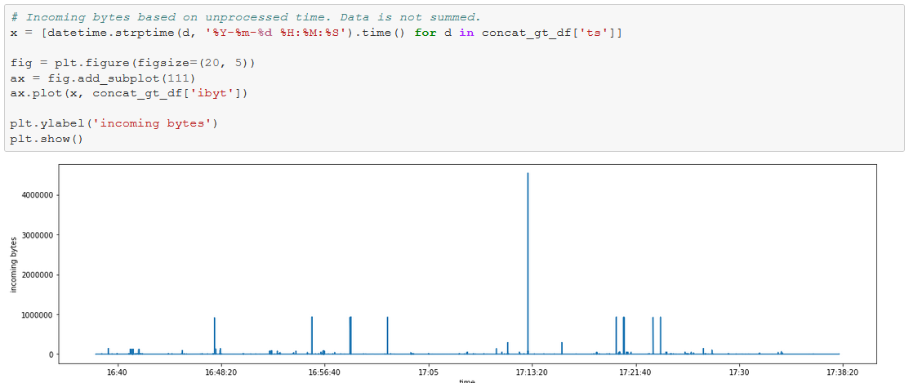

Fig 1

The histogram showed that there were a lot of activity happening in time period before and after the spike which were just hidden.

Finally, I drew a pie chart to show what type of protocol were being used the most. This was to see what kind of network data was being passed around. Some protocols are also more vulnerable than others.

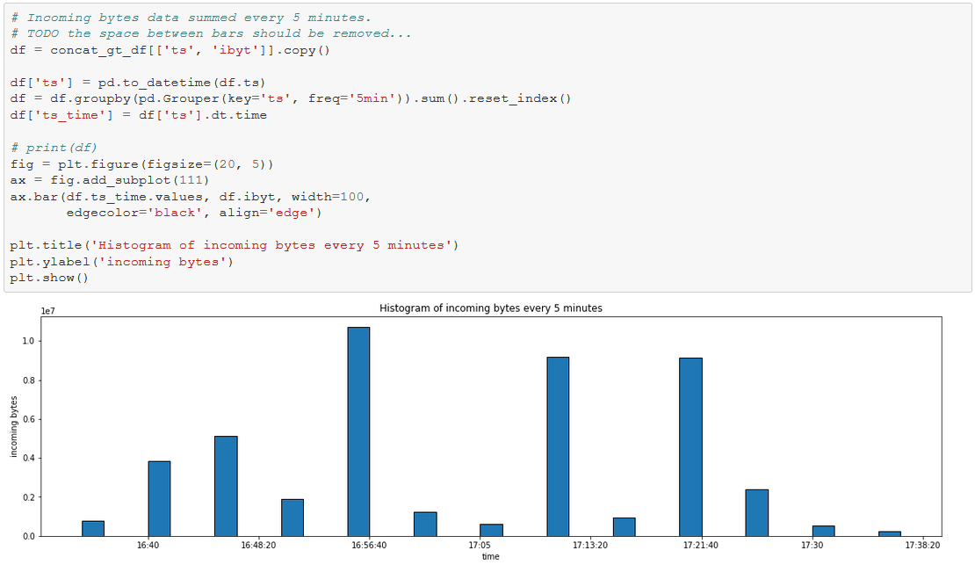

Fig 2

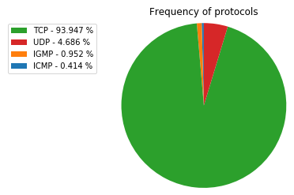

Fig 3

1. Computer network traffic [5]

This dataset is relatively small compared to others consisting of only ~500k lines and 4 features. In this dataset, 10 local workstations were monitored over 3 months period and half of these became compromised and were part of a botnet.

Since there weren’t many attributes to visualize, I went with the easiest one – “flow” which is the number of connections for that given day.

The graph clearly shows one machine number 4 had been compromised in September. However, that was for only one machine, there are still others to find. The Y axis again was very biased towards the max value, I decided to set a limit to the Y axis to make it easier to see the traffic for other machines.

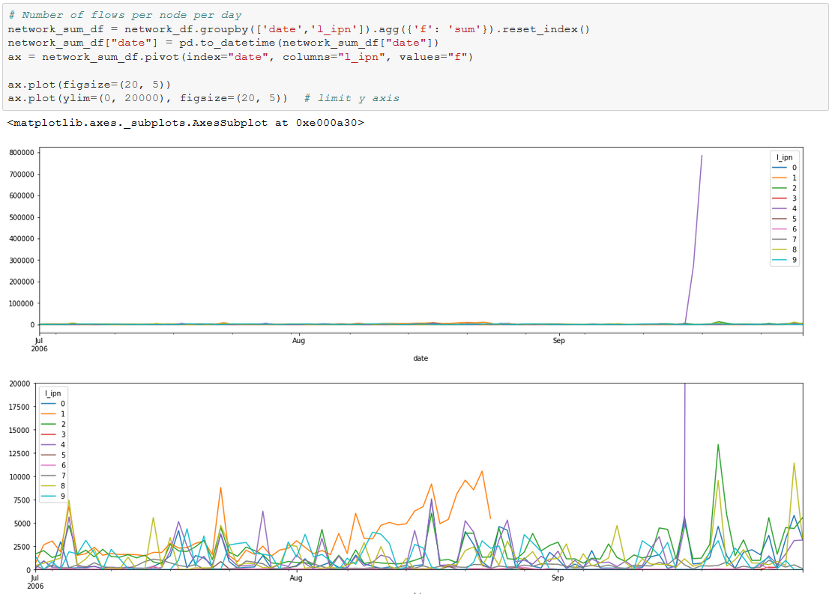

1. Malicious and benign websites [6]

This dataset is different to the rest since it does not deal with network traffic. I was mostly just curious as what this dataset contained.

This dataset contains a list of attributes about a website along with a label that says whether it is malicious or not.

Since the dataset is labelled, there are different techniques to visualize the dataset. I drew a normalized boxplot to start off with to see if there were any outliers. Since the dataset contained both categorical and numerical data, I just plotted the numerical information. There are methods to convert categorical to numerical such as one hot encoding however I did not do it for this dataset. This graph clearly shows that there are various outliers that do not fit the rest, some are very prominent compared to others.

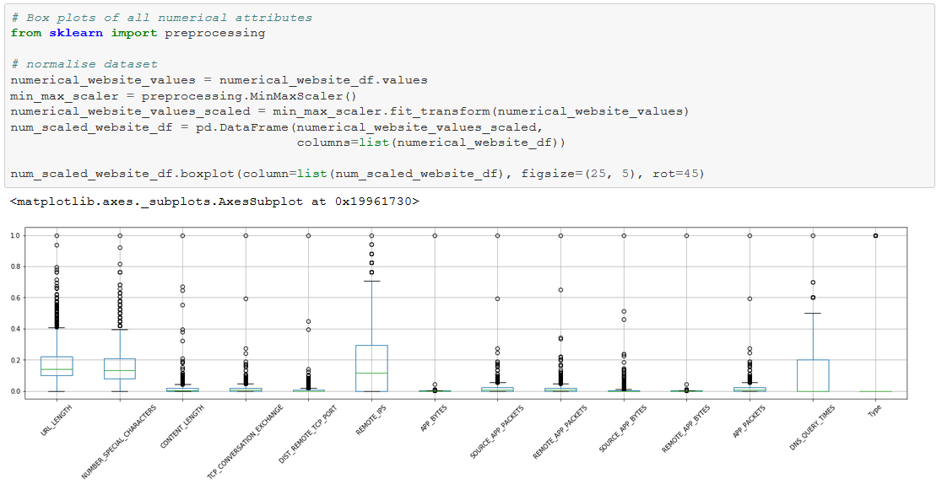

I also drew a correlation graph since it can easily show what attributes are responsible for indicating that a website is malicious or not. However, its normally a set of features that indicate whether a website is malicious or not, not just one. This graph will not show that.

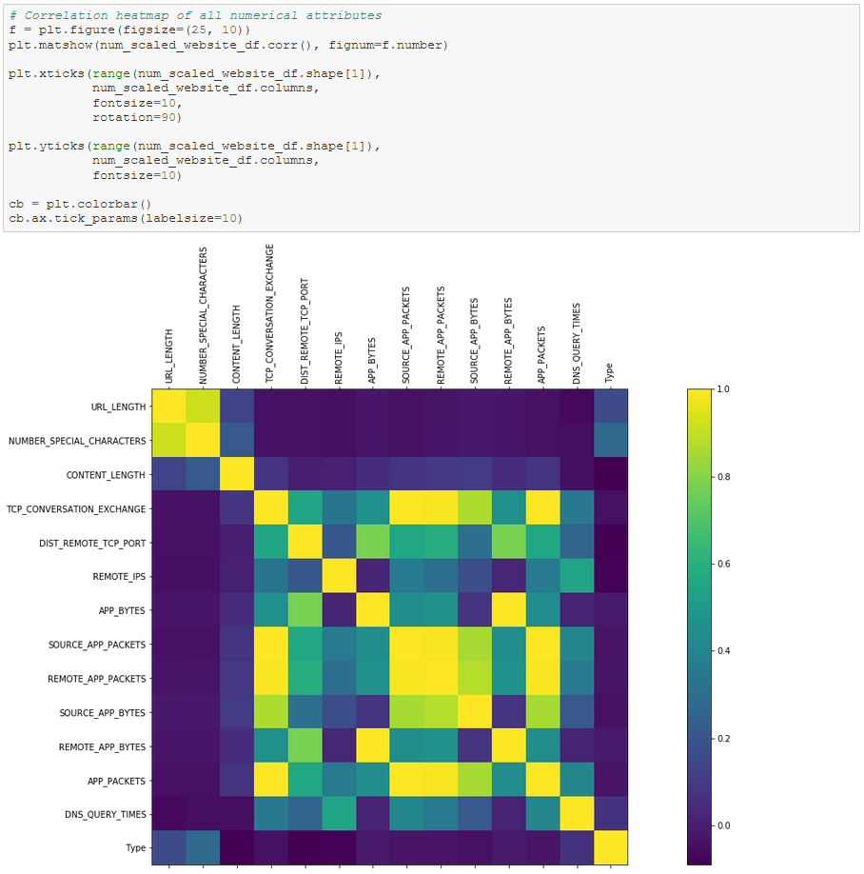

1. AWS Cyber defense [7]

For my final dataset I choose AWS Cyber defense. This dataset contains network traffic of 420 PCs and 30 servers which were victims to 7 different attacks such as DDoS. All network traffic is labelled with its respective attack. This is also the biggest dataset; its raw size comes up to 220gb or 7gb of CSV.

Similarly, to benign and malicious websites I drew a boxplot followed by a correlation to visualize it quickly instead of choosing certain features. However, this time the label was categorical therefore I had to convert it to numerical value by encoding it. Also, instead of plotting just raw data, I drew the boxplot using the correlation data.

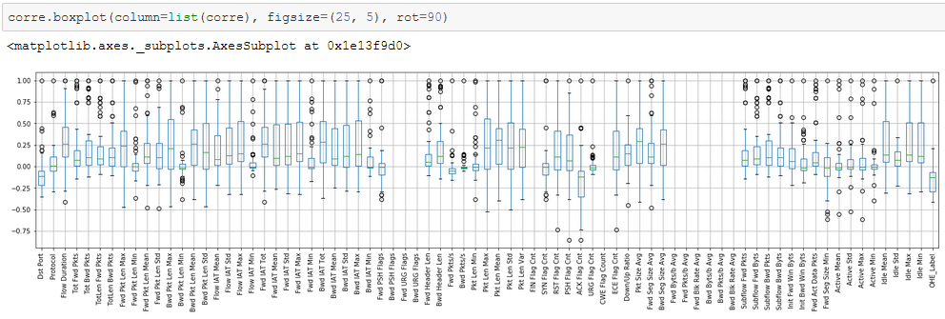

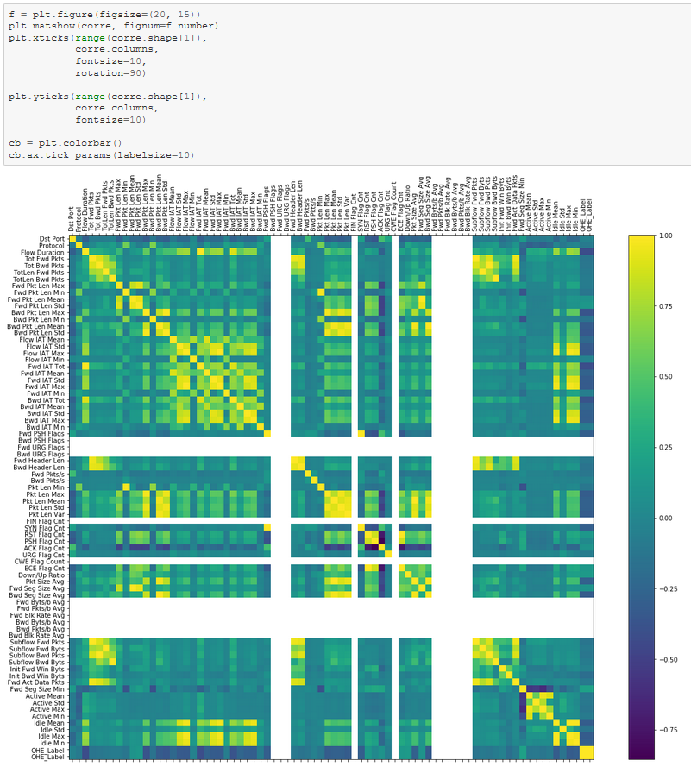

There were many other datasets to choose from, a notable one is KDDCUP99 [8] which was the first “good” network dataset. However, the dataset is quite old therefore I decided not to use it.

After discussing with experts in the field, I decided to use AWS cyber defense dataset. This is because of many factors, the first being that it is labelled. Instead of attempting to cluster data to find anomalies, the data is already clustered to say whether an attack happened or not. Furthermore, there are various attacks in this dataset, not just one, which will help me create a more robust system.

However, this dataset is quite tricky in the sense that it is bigger than rest. There will have to be management of big data. Also, more classifications can make it harder. The model may perform well in one classification but fail for the rest, fine tuning parameters without affecting the good results will be difficult.

Data processing

There is currently a lot of hype around deep learning however there are still basic classifiers that can be trained as initial findings to understand the structure of the data. They have many advantages over deep learning such as being easy to implement and reduced training time.

But before training any classifiers, the data will have to be visualised and cleaned. Since I am working with a huge dataset containing multiple CSVs, I will start by visualising only one CSV. If I were to visualise all of them at once, important features that are only applicable to one CSV may be lost and the processing time will be longer.

I chose a random CSV of ~300mb containing all information of an attack where the victim devices became part of a botnet. The data is all labelled, containing ~1million rows and 80 features.

The first step would be to load the data into my script however since it is quite large, normal methods do not work. Reading the CSV in requires it to be “chunked” where N number of rows will be read in at a time. This also requires an extensive amount of memory. This step is quite trivial however still important when processing large datasets.

Next the data needs to be visualised to see if it contains any abnormalities and there were quite a few. The first being that in random parts of the CSV, the header would repeat instead of the actual data. This caused a lot of issues as all features were no longer their correct datatype and everything became string. Fixing it was easy as when the data was being read in, filter out rows that contained header values again.

One of the biggest issues when handling big data would be occurrences of missing data. Many classifiers cannot work with such information missing as well, therefore I visualised all NaNs that existed in the data. It resulted that there was only one feature that contained NaNs.

Picture here.

However, there were also feature values where it was set to “Infinity” (in string) rather than an actual value. Again, classifiers will find this difficult to handle.

There are various techniques when it comes to handling missing data, such as replacing NaNs and incorrect values with the mean or median and so on. However, each time this is done, the impact also needs to be considered. Changing the value to e.g. the mean will make it lose its original value and it might have been of importance. The easiest solution to handling missing data would be to just remove it. Due to lack of time, I only trained classifiers where all missing data were removed however it does need to be visualised to understand why there were in the first place.

CSV snap shot here

Upon inspecting the feature values, it seems that when there was a NaN most of the values were set to zero where only few features are changing such as destination port. This suggests to me that they simply collected invalid data for a brief time. Also, all NaNs contained the label “Benign” as shown in pie chart picture here. This further supports my idea, however if such an activity did occur there is a chance that the classifier I train with this data removed could label it as “Bot” since it is irregular. Although these occurrences were very rare, ~2k rows contained NaNs out of a million or 0.2% of the data.

With missing data handled, it is then trivial to train classifiers.

A random forest classifier is a learning method where it contains many regression trees \cite{initial-analysis-rf}. Each tree is based on a random subset of inputs which reduces the correlation between the trees therefore improving the performance of the random forest.

Create classifier

Conclusion

From my research, it shows that there is still a need for a good intrusion detection system that has a high true positive rate and a low false positive rate and with the capabilities to adapt to new evolving malwares.

To create this intrusion detection system, I have chosen a dataset containing multiple different attacks on a network. Using this dataset, I will create a classifier that is can detect these attacks with high accuracy. My preliminary work using random forest and linear support vector machine to create a classifier that can detect if a device is part of a botnet shows promising results.

There are still many different algorithms to implement to produce the best results including deep learning. This will require strenuous processing and visualization of the data.

Finally, if the model can understand different classifications well, then I will produce synthetic data and retrain the model such that it will be able to understand the difference between a real and fake attack. This should then reduce the number of false positives.