**HOW TO CREATE A GITHUB ACCOUNT?**

**Step 1**: Go to the internet browser and search for GITHUB login.

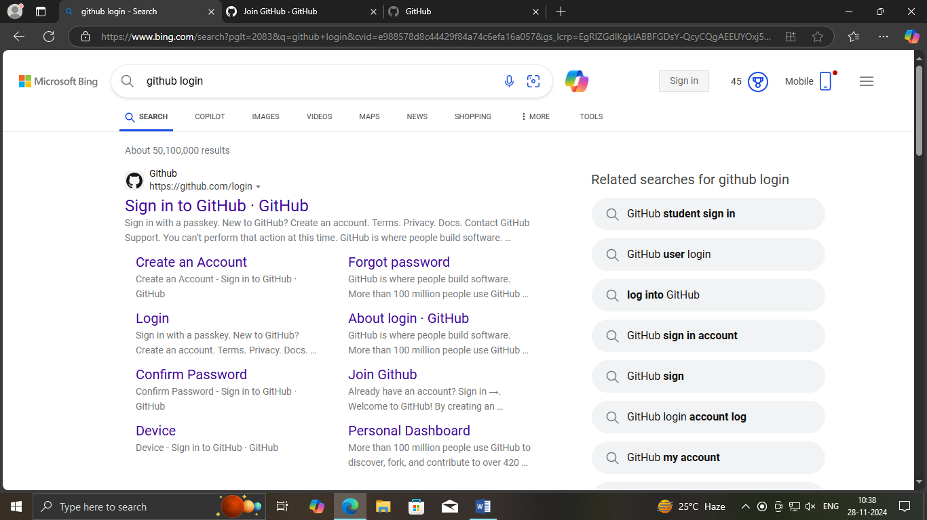

**Step 2**: By clicking on “create an account”, the page opens to enter your email.

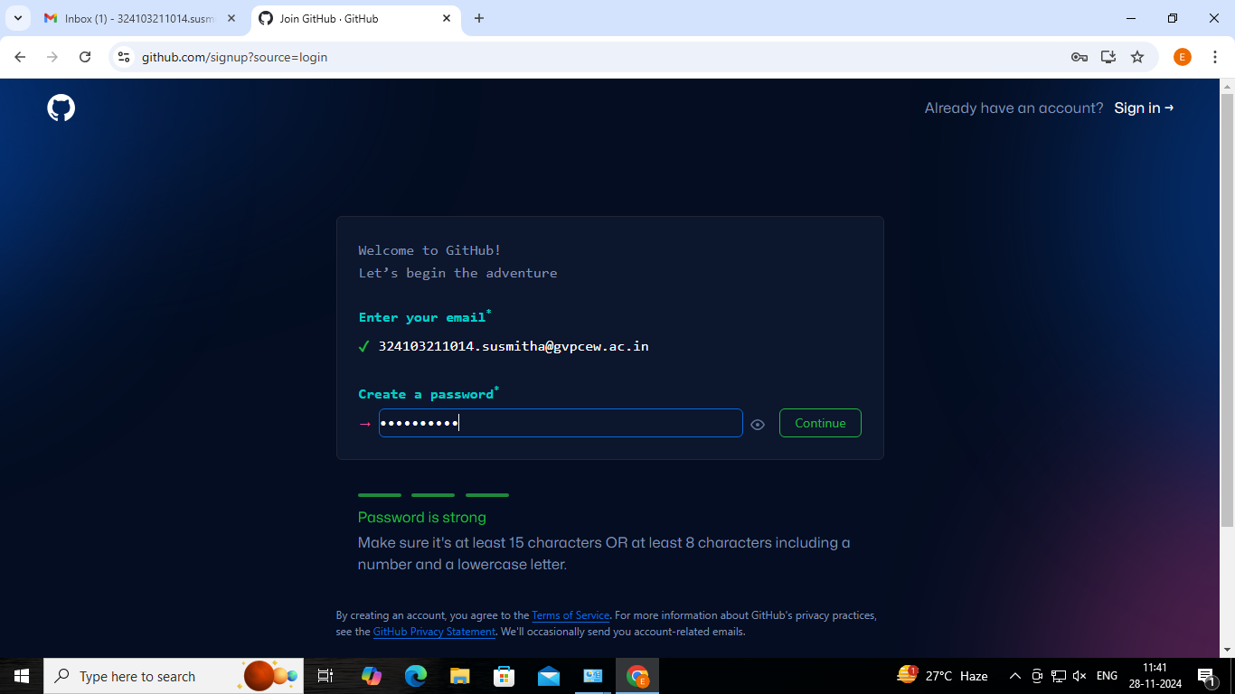

**Step 3**: create a password and enter username with the requirements specified.

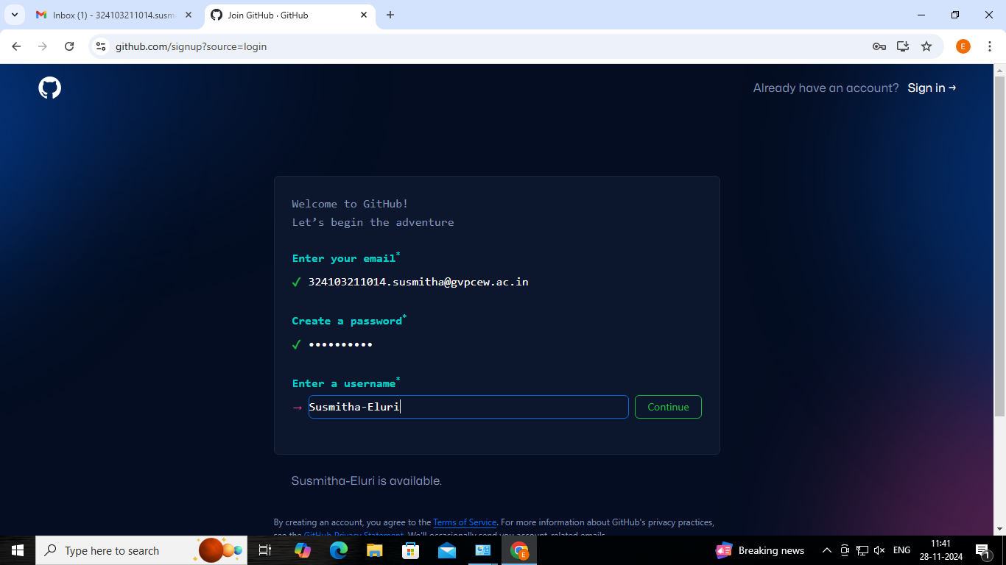

**Step 4**: after finishing up with the creating account process sign up to continue

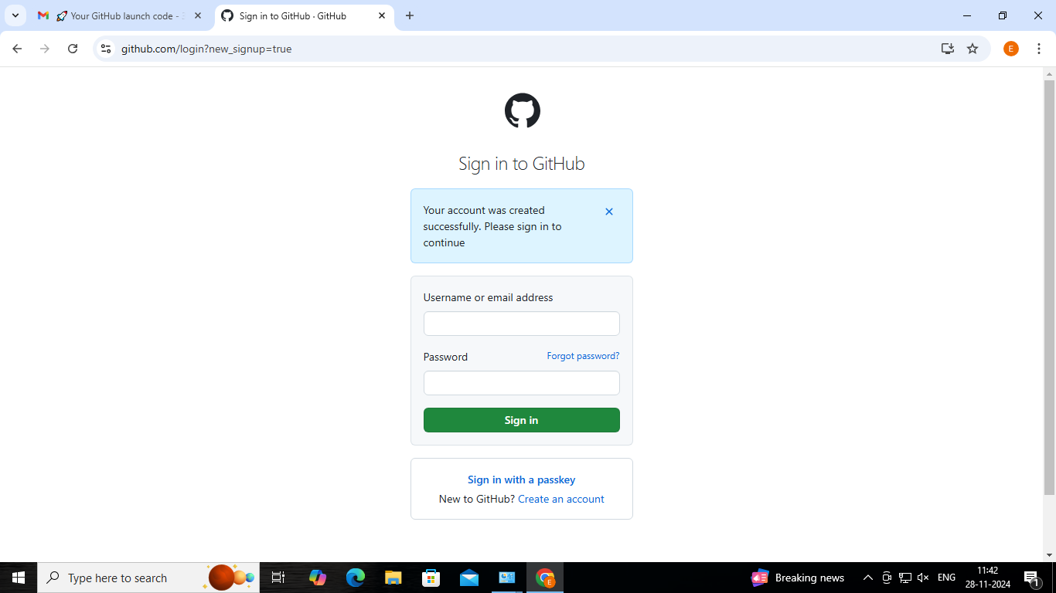

**Step 5**: choose the options as per your requirements

