

**RESUME**



**S.SUSMITHA**



Cell :

9342622424

ADDRESS:

Email id

:

susmithamadhu503@gmail.com

124

Uchimedu,

Devarkandanallur

,

Kodavasal(tk)

,

Tiruvarur(Dt)

.

CAREER OBJECTIVES:

*To achieve excellence by applying my knowledge &skills in profession and*

*continuously improving my knowledge base by learning through work*

*experience and to make significant contribution in the growth of*

*organization.*

EDUATION:

*CLASS X:*

*GHSS:*

*Kulikkarai*

*Medium:*

*Tamil*

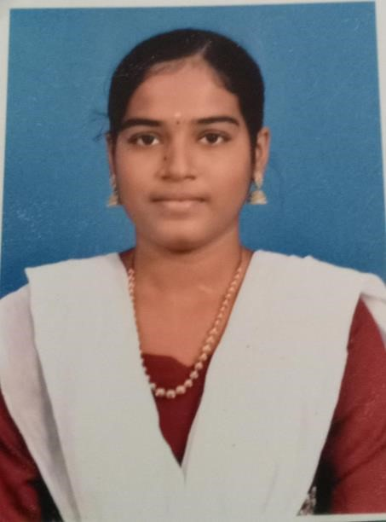

|  |
| --- |
| *Year of passing:2019 Grade:300*  *CLASS XII:*  *GHSS: Kulikkarai*  *Medium: Tamil*  *Year of passing:2021 Grade:450*  *COLLEGE:*  *III-B.sc (Computer science) final year student*  *Thiru.Vi.Ka.Govt arts &S*cience, *college thiruvarur*  *Bharadhidasan university*    AMBHITION:     * *I Try to well salary for government job* * *I Will be create App developer*     HOBBIES:  *Listening music, Play settle cork,reading books.*        DECLARATION:  *I hereby declare that all above mentioned information is true to the best of my knowledge and belief.*    YOUR’S FAITHFULLY:-  S.SUSMITHA |