Task 19: Git Repository
Aim:-
To create a local Git repository for a sample project, perform basic Git operations such as initializing, staging, committing, and tracking version history, and push the repository to GitHub using a remote repository.
Algorithm:-
- Create Project
  - Create project folder (task-19)
  - Add files: index.html, style.css, script.js, server.js, db.js
- Initialize Git
  - Open terminal in project folder
  - Run git init to initialize repository
- Stage Files
  - Use git add . to add all files to staging area
- Commit Files
  - Run git commit -m "Initial commit" to save project snapshot
- Check Version History
  - Use git log to view commit history
- Create Remote Repository
  - Create a new repository on GitHub (e.g., student-app)
- Connect Local to Remote
  - Run git remote add origin <repository-URL>
- Push to GitHub
  - Use:
git branch -M main
git push -u origin main
- Modify and Update Project
  - Make changes in files
  - Run:
git add .
git commit -m "Updated project"
git push
10.Track Changes
- Use git log --oneline to view version history

Code:-
Index.html:-
<!DOCTYPE html>
<html>
<head>
<title>Student App</title>
<link rel="stylesheet" href="style.css">
</head>
<body>

<h1>Student Management</h1>

<input type="text" id="name" placeholder="Enter Name">
<input type="number" id="age" placeholder="Enter Age">
<button onclick="addStudent()">Add Student</button>

<h2>Students List</h2>
<ul id="list"></ul>

<script src="script.js"></script>
</body>
</html>
Style.css:-
body {
font-family: Arial;
text-align: center;
}

input {
padding: 10px;
margin: 5px;
}

button {
padding: 10px;
background: blue;
color: white;
border: none;
}

li {
margin: 5px;
}
Script.js:-
const API = "http://localhost:3000/students";

async function addStudent() {
const name = document.getElementById("name").value;
const age = document.getElementById("age").value;

await fetch(API, {
method: "POST",
headers: { "Content-Type": "application/json" },
body: JSON.stringify({ name, age })
});

loadStudents();
}

async function loadStudents() {
const res = await fetch(API);
const data = await res.json();

const list = document.getElementById("list");
list.innerHTML = "";

data.forEach(s => {
const li = document.createElement("li");
li.innerText = `${s.name} - ${s.age}`;
list.appendChild(li);
});
}
loadStudents();
Server.js:-
const express = require("express");
const cors = require("cors");
const db = require("./db");

const app = express();
app.use(cors());
app.use(express.json());
app.use(express.static("public"));

app.get("/students", (req, res) => {
db.query("SELECT * FROM students", (err, result) => {
if (err) throw err;
res.json(result);
});
});

app.post("/students", (req, res) => {
const { name, age } = req.body;
db.query(
"INSERT INTO students (name, age) VALUES (?, ?)",
[name, age],
(err) => {
if (err) throw err;
res.send("Student Added");
}
);
});

app.listen(3000, () => {
console.log("Server running on http://localhost:3000");
});
Db.js:-
const mysql = require("mysql2");

const connection = mysql.createConnection({
host: "localhost",
user: "root",
password: "harsha2006",
database: "tasks19"
});

connection.connect((err) => {
if (err) throw err;
console.log("MySQL Connected");
});

module.exports = connection;
Outputs:-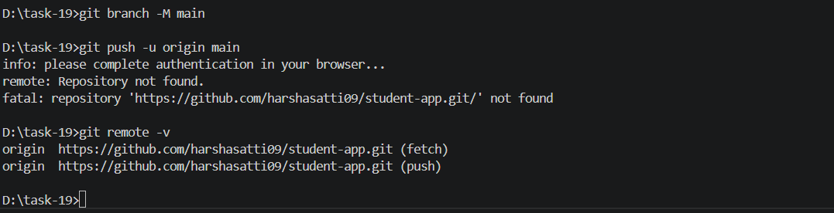
Result:- A sample project repository is successfully created and managed using Git. All files are tracked, version history is maintained through commits, and the project is pushed to GitHub using a remote repository, enabling efficient version control and collaboration.

