Task 19: Implement branching strategies in Git
Aim:-
To implement Git branching strategies by creating feature branches, performing merging and rebasing operations, and intentionally creating merge conflicts to understand and resolve them effectively.
Algorithm:-
- Initialize repository using git init
- Add files using git add .
- Commit files using git commit
- Create feature branch using git checkout -b
- Modify files and commit changes
- Switch to main branch
- Create another feature branch
- Modify same file and commit changes
- Merge first branch into main
- Merge second branch (conflict occurs)
- Resolve conflict manually
- Add and commit resolved file
- Perform rebase using git rebase
- Continue rebase if conflicts occur
- Push project to GitHub
Code:-
Index.html:-
<!DOCTYPE html>
<html>
<head>
<title>Student App</title>
<link rel="stylesheet" href="style.css">
</head>
<body>

<h2>Student Manager</h2>

<input type="text" id="name" placeholder="Enter Name">
<button onclick="addStudent()">Add</button>

<ul id="list"></ul>

<script src="script.js"></script>
</body>
</html>
Style.css:-
body {
font-family: Arial;
text-align: center;
}

input {
padding: 8px;
}

button {
padding: 8px;
background: green;
color: white;
border: none;
}
Script.js:-
const API = "http://localhost:3000/students";

function fetchStudents() {
fetch(API)
.then(res => res.json())
.then(data => {
const list = document.getElementById("list");
list.innerHTML = "";

data.forEach(s => {
list.innerHTML += `<li>${s.name}</li>`;
});
});
}

function addStudent() {
const name = document.getElementById("name").value;

fetch(API, {
method: "POST",
headers: { "Content-Type": "application/json" },
body: JSON.stringify({ name })
}).then(() => {
fetchStudents();
});
}

fetchStudents();
Server.js:-
const mysql = require("mysql2");

const db = mysql.createConnection({
host: "localhost",
user: "root",
password: "harsha2006",
database: "studentss"
});

db.connect(err => {
if (err) throw err;
console.log("MySQL Connected");
});

module.exports = db;
Db.js:-
const express = require("express");
const cors = require("cors");
const db = require("./db");

const app = express();
app.use(cors());
app.use(express.json());
app.use(express.static("public"));

// GET
app.get("/students", (req, res) => {
db.query("SELECT * FROM students", (err, result) => {
if (err) throw err;
res.json(result);
});
});

// POST
app.post("/students", (req, res) => {
const { name } = req.body;
db.query("INSERT INTO students (name) VALUES (?)", [name], (err) => {
if (err) throw err;
res.send("Added");
});
});

app.listen(3000, () => console.log("Server running on 3000"));

Outputs:-
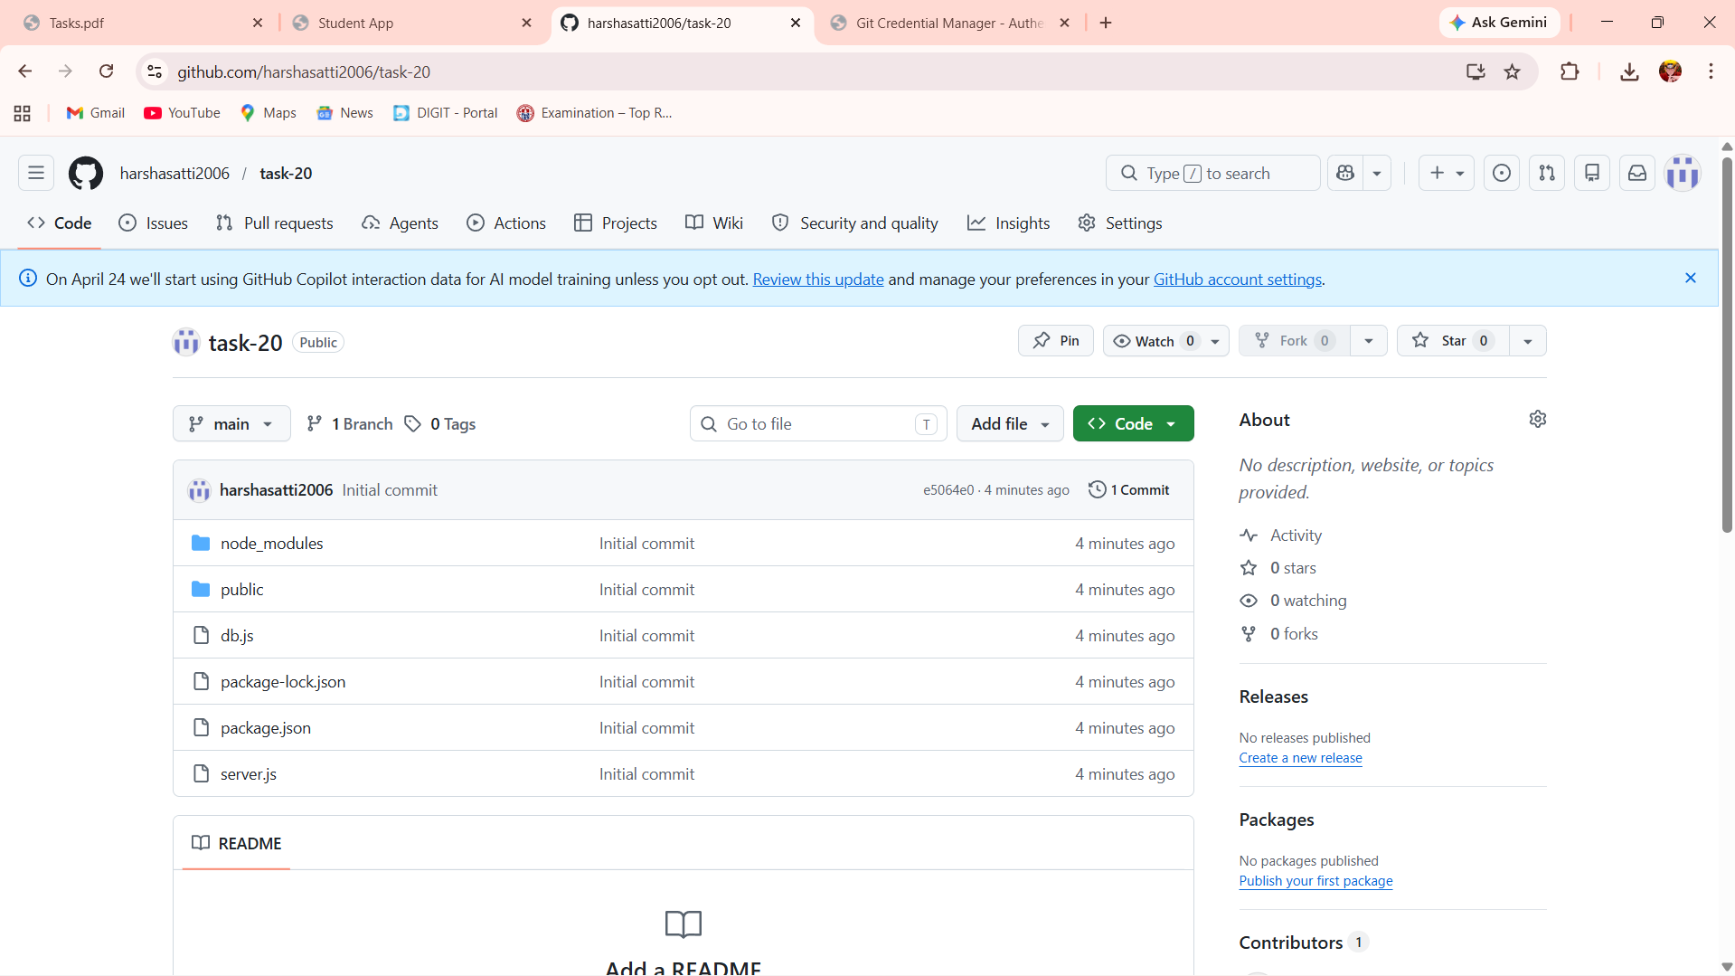
Result:- Successfully implemented Git branching strategy with feature branches, merging, rebasing, and resolving merge conflicts.

