Temasek Polytechnic
School of Informatics and IT

Diploma in Information Technology (IT)

Software Design Specifications (DS)

Project Particulars

Tutor | Mr Goh Mya Hu, Mel
Class | P01
Project Title | Delonix Regia Hotel Management System

Project Team’s Particulars

Matric Number | Student Name
1505544E | Susmitha D/O Appalanaidu
1400777G | Lee Yi De Jasper
1505449G | Claudia Yeo Jun Bing

Table of Contents

1. DISTRIBUTION OF WORKLOAD 3
2. ARCHITECTURE DESIGN 3
3. USER INTERFACE (UI) DESIGN 4
4. PROGRAM DESIGN 8
5. DATABASE DESIGN 15

DISTRIBUTION OF WORKLOAD

Design | Members
Architecture Design | Susmitha D/O Appalanaidu
User Interface Design | Susmitha D/O Appalanaidu (Home page, Reservation management page)  Lee Yi De Jasper (Check in page, customer records page)  Claudia Yeo Jun Bing (Reporting module management page, login page)
Program Design | Claudia Yeo Jun Bing
Database Design | Susmitha D/O Appalanaidu (Database Dictionary)  Lee Yi De Jasper  (ERD)

ARCHITECTURE DESIGN

We are proposing a 2-tier system architecture design which comprises of client-data for Mr Wang’s hotel system. The diagram below illustrates the different tiers in the architecture. 1 tier architecture involves putting all of the required components of a software application on a single server or platform. Two tier architecture is based on client server architecture. And a three-tier architecture consists of three layers: client layer, business layer and data layer.
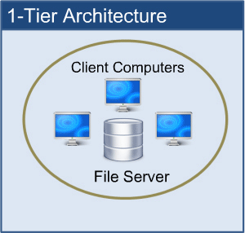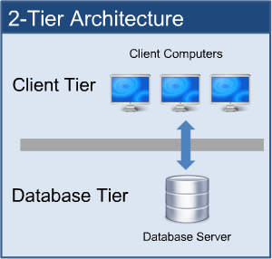
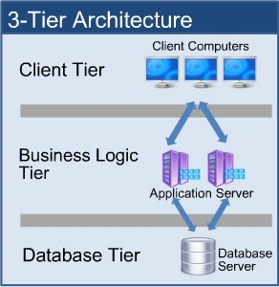

Two tier architecture is based on client server architecture. A two-tier architecture is a software architecture in which a presentation layer or interface runs on a client, and a data structure gets stored on a server. The two-tier architecture is divided into two parts:

- Client application (Client tier)
- Database (Data tier)

On client application side, the code is written for saving the data in the SQL server database. The client sends the request to server and it processes the request and sends back with data.

The advantages of a two-tier architecture are applications can be easily developed due to simplicity and database server and business logic is physically close and this offers higher performance. However, developing a three-tier architecture will take more time as it is more complex. Communication is also not easy. A three-tier architecture would also cost more to develop as compared to a two-tier architecture.

We propose the two-tier architecture to Mr Wang as there is limited budget and limited development time for the project team to develop this system therefore, the two-tier architecture would be a better and a more efficient solution.

USER INTERFACE (UI) DESIGN

Susmitha (Home page, Reservation management page)

Home page
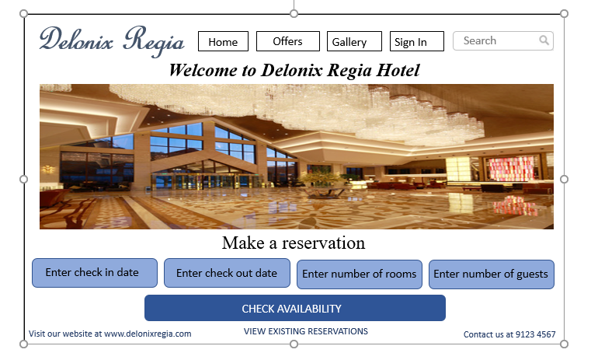

Reservation management page:

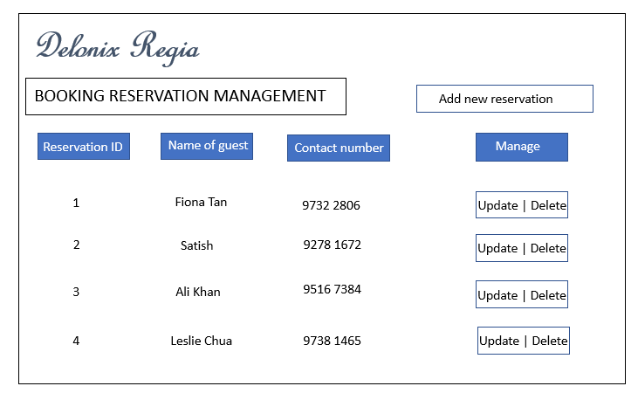

Jasper (Online check in page, Customer Records)

Online Check In Page:
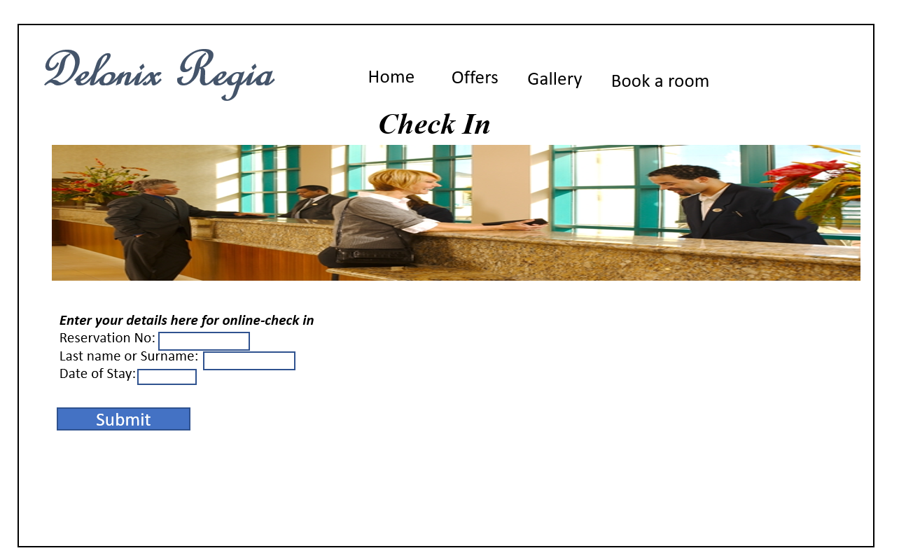
Customer Records:
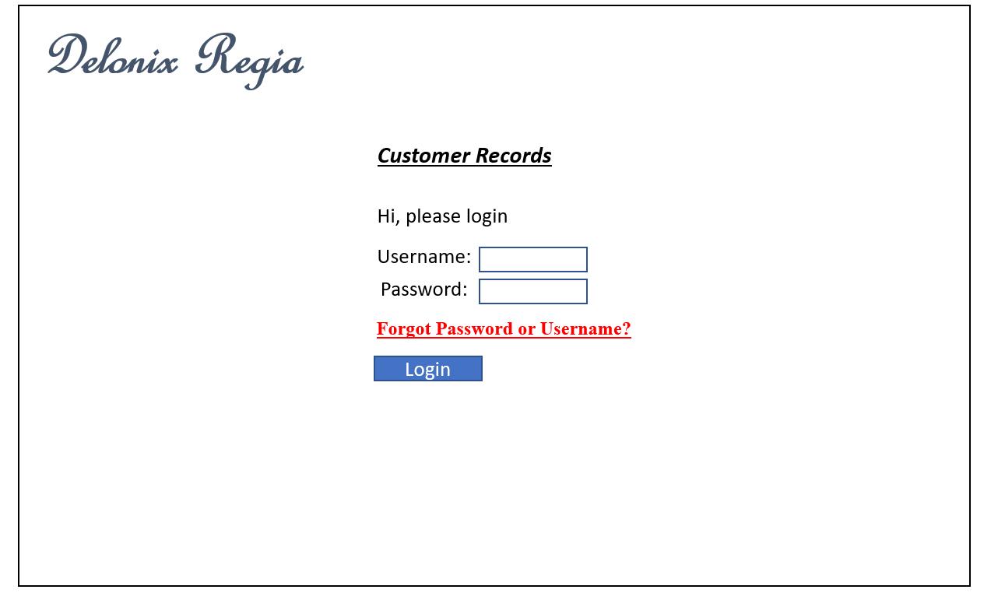
Claudia (Login Page, Reports Module)

Login Page UI:
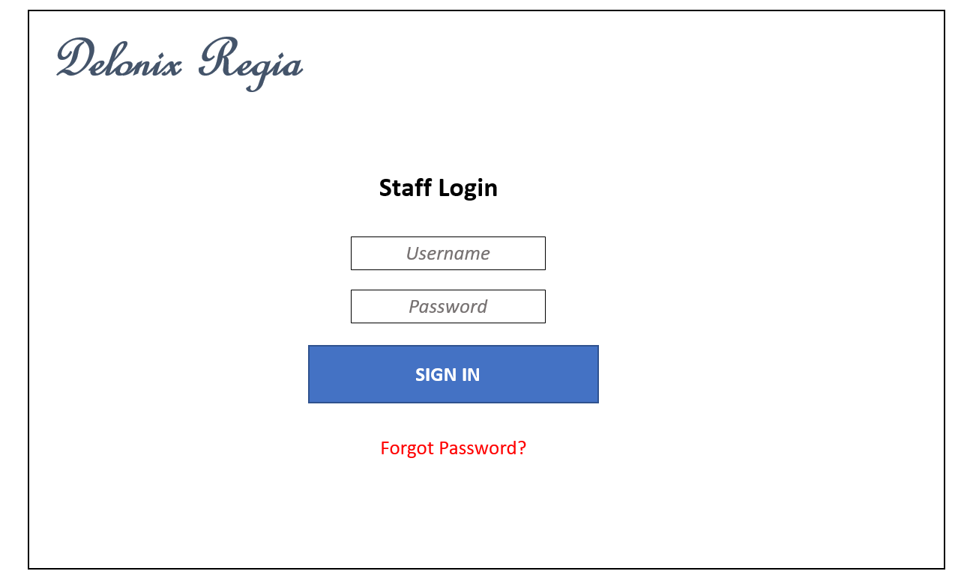

Report module UI:
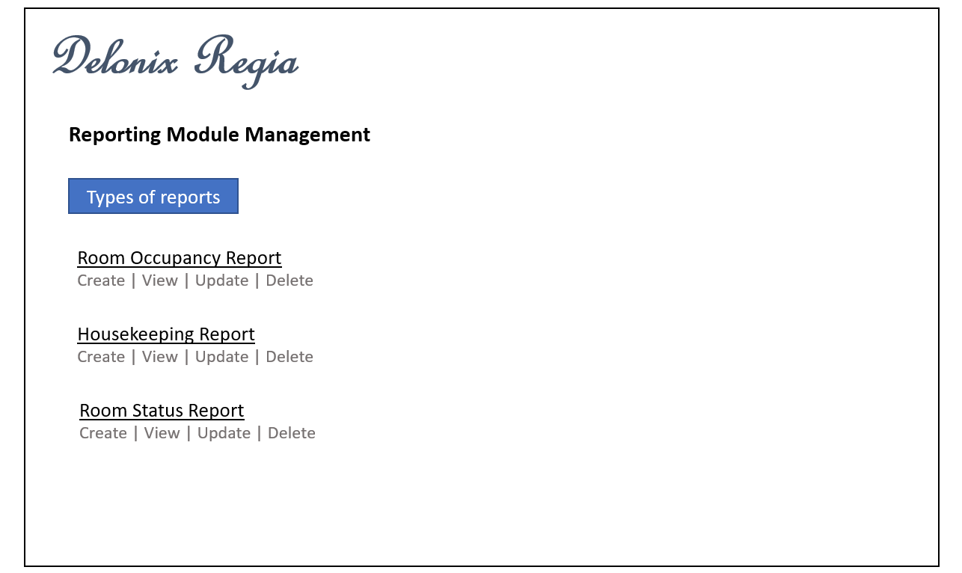

PROGRAM DESIGN

Use Case Diagram:

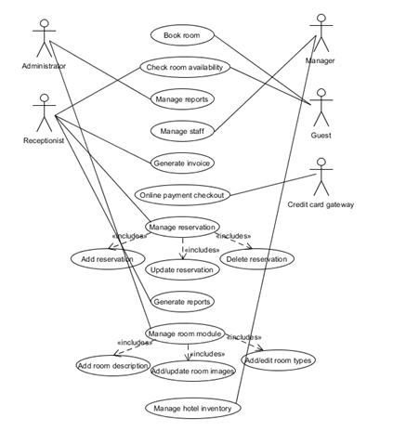

Sequence Diagram (Room availability and booking module)

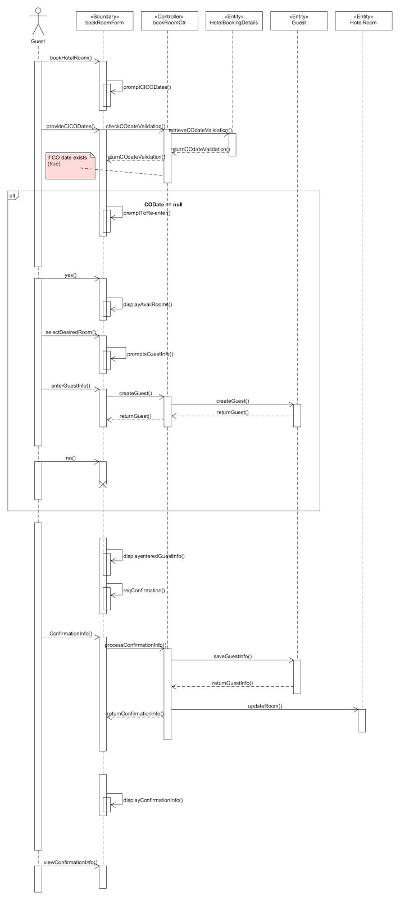

VOPC (Room availability and booking module)

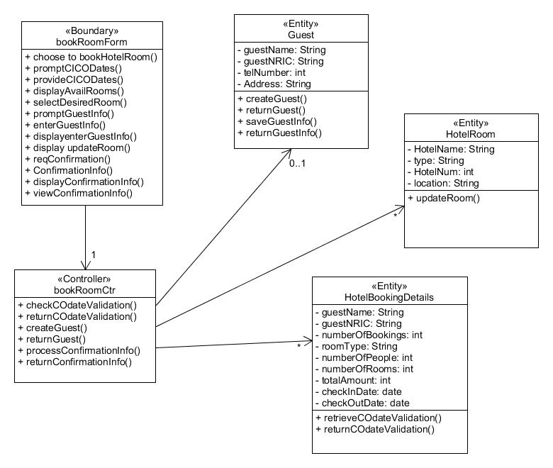

Sequence Diagram (Housekeeping and staff management module)

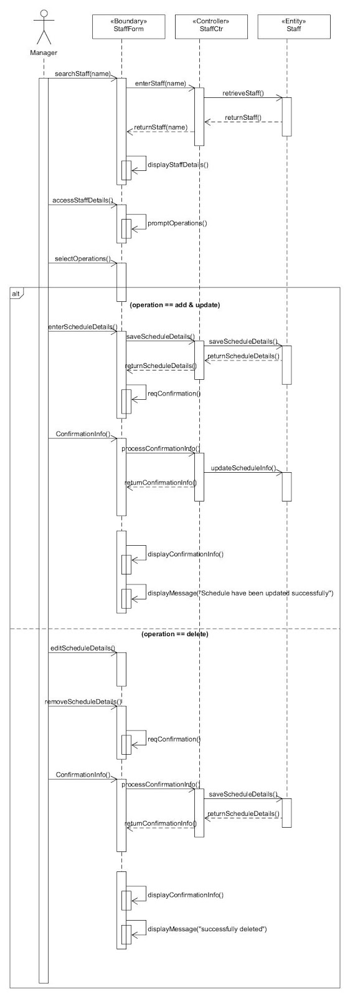

VOPC (Housekeeping and staff management module)

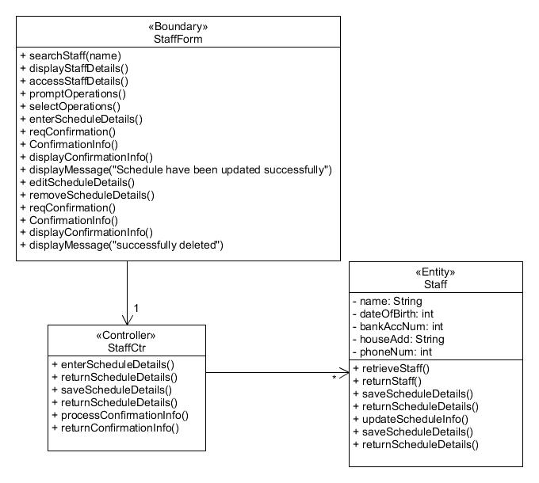

Sequence Diagram (Reporting module)

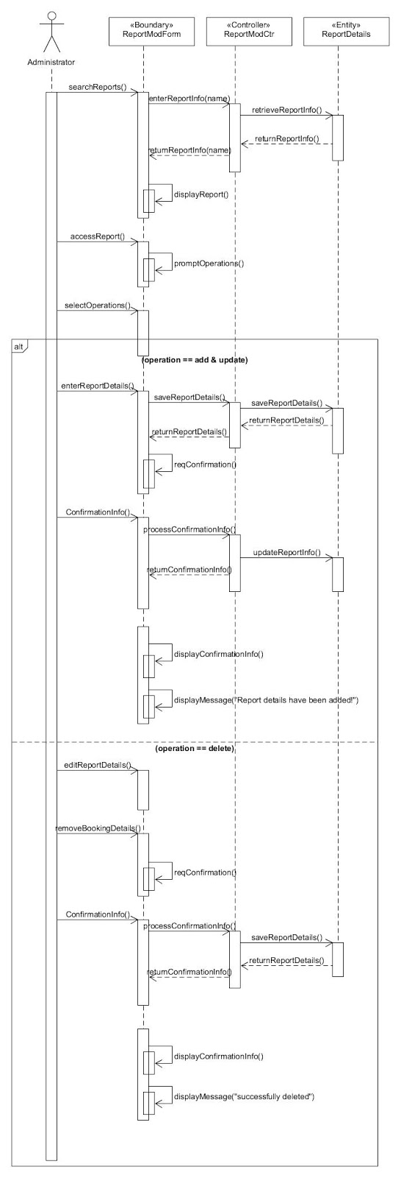

VOPC (Reporting module)

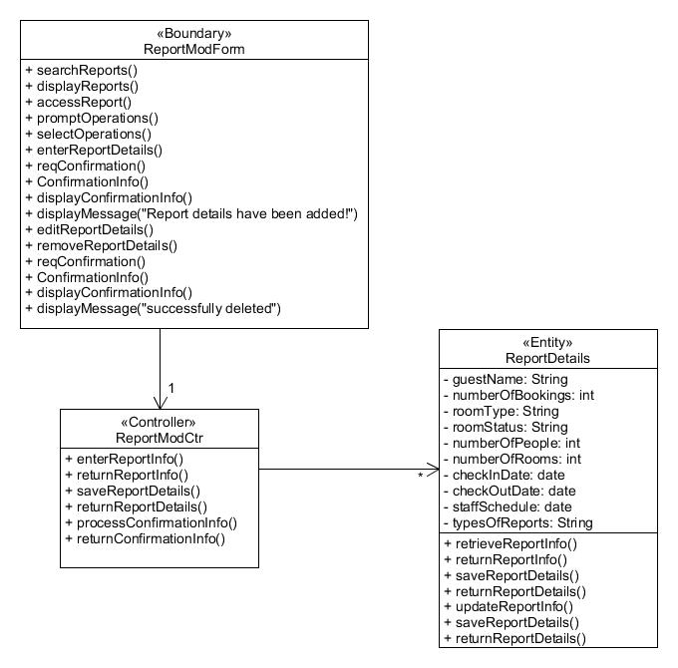

DATABASE DESIGN

DATABASE DICTIONARY

Table name: Guest_Details

Table column name | Table column datatype | Table column null option | Table column comment | Table column is primary key | Table column is foreign key
Guest_Id | INT (5) | NOT NULL |  | Yes | No
Guest_First_Name | VARCHAR (25) | NOT NULL |  | No | No
Guest_Last_Name | VARCHAR (25) | NOT NULL |  | No | No
Guest_Date_Of_Birth | DATE | NOT NULL |  | No | No
Guest_Contact_Number | INT (10) | NOT NULL |  | Yes | No
Guest_Address | VARCHAR (50) | NOT NULL |  | No | No
Guest_Email_Address | VARCHAR (50) | NULL |  | No | No
Guest_Credit_Card_Number | INT (15) | NOT NULL |  | Yes | No

Table name: Staff_Details

Table column name | Table column datatype | Table column null option | Table column comment | Table column is primary key | Table column is foreign key
Staff_Id | INT (5) | NOT NULL |  | Yes | No
Staff_First_Name | INT (25) | NOT NULL |  | No | No
Staff_Last_Name | INT (25) | NOT NULL |  | No | No
Staff_Date_Of_Birth | DATE | NOT NULL |  | No | No
Staff_Bank_Account_Number | INT (15) | NOT NULL |  | Yes | No
Staff_Address | VARCHAR (50) | NOT NULL |  | No | No
Staff_Contact_Number | INT (10) | NOT NULL |  | No | No
Type_Of_Duty | VARCHAR (25) | NULL |  | No | Yes

Table Name: Type_Of_Duty_Table

Table column name | Table column datatype | Table column null option | Table column comment | Table column is primary key | Table column is foreign key
Type_Of_Duty | VARCHAR (25) | NULL | Indicate ‘General maintenance/room maintenance/estate maintenance/ security maintenance’ | No | No

Table Name: Room_Details

Table column name | Table column datatype | Table column null option | Table column comment | Table column is primary key | Table column is foreign key
Room_Number | INT (5) | NOT NULL |  | Yes | No
Room_Availability | VARCHAR (25) | NOT NULL | Indicate ‘Available’ or ‘Not Available’ | No | No
Number_Of_Beds | Int (2) | NOT NULL |  | No | No

Table Name: Room_Status_Report

Table column name | Table column datatype | Table column null option | Table column comment | Table column is primary key | Table column is foreign key
Room_Number | INT (5) | NOT NULL |  | Yes | Yes
Room_availability | VARCHAR (25) | NOT NULL | Indicate ‘Available’ or ‘Not Available’ | No | Yes
Room_Occupancy | VARCHAR (25) | NOT NULL | Indicate ‘Occupied’ or ‘Not Occupied’ | No
Cleaning_Schedule | VARCHAR (5) | NULL | If room is vacant, must fill up this data. Indicate ‘Yes’ or ‘No’ | No

Table name: Guest_In_Room_Report

Table column name | Table column datatype | Table column null option | Table column comment | Table column is primary key | Table column is foreign key
Guest_Id | INT (5) | NOT NULL |  | Yes | Yes
Guest_Name | VARCHAR (50) | NOT NULL |  | No | Yes
Room_Number | INT (5) | NOT NULL |  | Yes | Yes
Number_Of_Adults | INT (2) | NULL |  | No | No
Number_Of_Children | INT (2) | NULL |  | No | No

Table name: Guest_Given_Point_Of_Time_Report

Table column name | Table column datatype | Table column null option | Table column comment | Table column is primary key | Table column is foreign key
Guest_Id | INT (5) | NOT NULL |  | Yes | Yes
Guest_Name | VARCHAR (50) | NOT NULL |  | No | Yes
Room_Number | INT (5) | NOT NULL |  | Yes | Yes
Number_Of_Adults | INT (2) | NULL |  | No | No
Number_Of_Children | INT (2) | NULL |  | No | No
Date_Time | DATETIME | NOT NULL |  | No | No

Table name: Room_Occupancy_Report (CHECK)

Table column name | Table column datatype | Table column null option | Table column comment | Table column is primary key | Table column is foreign key
Room_Number | INT (5) | NOT NULL |  | Yes | Yes

Table name: Housekeeping_Report

Table column name | Table column datatype | Table column null option | Table column comment | Table column is primary key | Table column is foreign key
Staff_Id | INT (5) | NOT NULL |  | Yes | Yes
Staff_First_Name | INT (25) | NOT NULL |  | No | Yes
Staff_Last_Name | INT (25) | NOT NULL |  | No | Yes
Type_Of_Duty | VARCHAR (25) | NULL |  | No | Yes

ERD

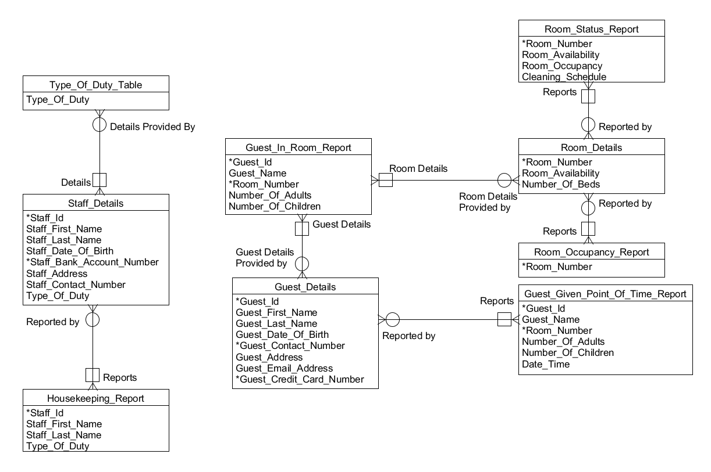

REFERENCES

http://www.simcrest.com/img/1tier.png
http://www.simcrest.com/img/2tier.png
https://qph.ec.quoracdn.net/main-qimg-3cb11001da63c62d9d61c9da2984d990-c
http://clientserverarch.blogspot.sg/2013/03/advantages-and-disadvantages-of.html

