# BUS RESERVATION SYSTEM

A MINI PROJECT REPORT SUBMITTED IN PARTIAL FULFILLMENT OF THE

REQUIREMENTS FOR THE AWARD OF DEGREE OF

BACHELOR OF ENGINEERING

IN

INFORMATION TECHNOLOGY

BY

Ms. Mounika Thati (1602-15-737-081)

Ms. Rajeshwari Macharla (1602-15-737-313)



# Department of Information Technology

VASAVI COLLEGE OF ENGINEERING

IBRAHIMBAGH, HYDERABAD – 500 031.

2016

## Department of Information Technology

VASAVI COLLEGE OF ENGINEERING

IBRAHIMBAGH, HYDERABD – 500 031

# CERTIFICATE

This is to certify that the Mini Project Work **BUS RESERVATION SYSTEM** was carried out by **T.MOUNIKA and M.RAJESHWARI** in partial fulfillment of the requirement for the award of Bachelor of Engineering (B.E) in Information Technology by Osmania University during the period **2016-2017 2 nd SEMESTER** under our guidance.

The results embodied in this project have not been submitted to any other University of Institution for the award of any degree or diploma.

|  |  |
| --- | --- |
| Internal Guide | Head of the department of IT |

ACKNOWLEDGEMENT

We are greatly indebted to our college , ***vasavi college of Engineering*** which has provided us the healthy environment to drive us to achieve our ambitions and goals.

We express deep gratitude towards our principal **Dr.K.Jayasankar** and the Head of

Department (HOD) of Information Technology, **Dr.Ram Mohan Rao** for their valuable suggestions and encouragement during the course of the work.

We would like to thank our internal guide **Shruti** and **Mr.G.Rajashekar** for their encouragement and valuable feedback through out the semester , which has benefited us profusely.

We owe our hearty regards to our professors and staff for their encouragement

at each step and their assistance without which we would not have completed the project. Last but not the least we would like to thank our friends for their co-operation and consistent support.

**INDEX**

1.INTRODUCTION

(project background, objectives and need , advantages , limitations )

2.SYSTEM ANALYSIS AND DESIGN

(algorithm ,flowcharts with explanations , system requirements , hardware and software requirements pertaining to the project )

3.IMPLEMENTATION AND CODING

4.TEST RESULTS

(output screens with description)

5.CONCLUSION

# Abstract

Traveling is a large growing business across all countries. Bus reservation system deals with maintenance of records of details of each passenger. It also includes maintenance of information like schedule and details of each bus.

We observed the working of the Bus reservation system and after going through it, we get to know that there are many operations, which they have to do manually. It takes a lot of time and causing many errors while data entry. Due to this, sometimes a lot of problems occur and they were facing many disputes with customers. To solve the above problem, and further maintaining records of passenger details, seat availability, price per seat, bill generation and other things, we are offering this proposal of computerized reservation system.

By using this software, we can reserve tickets from any part of the world, through telephone lines, via internet. Customer can check availability of bus and reserve selective seats. The project provides and checks all sorts of constraints so that user does give only useful data and thus validation is done in an effective way.

# Introduction

The focus of the project is to computerize traveling company to manage data, so that all the transactions become fast and there should not be any error in transaction like calculation mistake, bill generation and other things. It replaces all the paper work. It keeps records of all bills also, giving to ensure 100% successful implementation of the computerized Bus reservation system.

This reservation system has three modules. First module helps the customer to enquire about the details of bus. Second module helps him to reserve a ticket and payment.

# PROBLEM SPECIFICATION

Bus Reservation Systems that were suggested till now, are not up to the desired level. There is no single system which automates all the process.

In order to build the system, all the processes in the business should be studied, System study helps us under the problem and needs of the application. System study aims at establishing requests for the system to be acquired, development and installed. It involves studying and analyzing the ways of an organization currently processing the data to produce information. Analyzing the problem thoroughly forms the vital part of the system study. In system analysis, prevailing situation of problem is carefully examined by breaking them into sub problems. Problematic areas are identified and information is collected. Data gathering is essential to any analysis of requests. It is necessary that this analysis familiarizes the designer with objectives, activities and the function of the organization in which the system is to be implemented.

#### Existing system

✓Existing system is totally on book and thus a great amount of manual work has to be done. The amount of manual work increases exponentially with increase in services.

✓Needs a lot of working staff and extra attention on all the records.

✓In existing system, there are various problems like keeping records of items, seats available, prices of per/seat and fixing bill generation on each bill.

✓Finding out details regarding any information is very difficult, as the user has to go through all the books manually.

✓Major problem was lack of security.

#### Proposed system

The system is very simple in design and to implement. The system requires very low system resources and the system will work in almost all configurations. It has got following features:

✓Needs a lot of working staff and extra attention on all the records.

✓Ensure data accuracy.

✓Any person across the world, having internet can access this service.

✓Availability of seats can be enquired very easily.

✓Passengers can also cancel their tickets easily.

✓Minimum time needed for the various processing

✓Better Service

✓Minimum time required

✓This would help the corporation prepare and organize its schedules more efficiently on the basis of traffic demand

**Advantages:**

* Instant payment order on the web-site.
* The customer immediately receives a guarantee of obtaining services. Often online booking system uses a loyalty program, providing discounts and bonuses, thereby attracting more clients.
* The client chooses the desired services of a set of additional services, the exact time and date of booking.
* Business does not need to communicate with the client, as the book takes place automatically without administrator intervention.
* The system operates autonomously 24/7
* It is possible to send SMS and push notifications
* It is possible to receive payments via paypal and other payment systems.
* No need to install software on your server or device
* Time economy

**Disadvantages:**

* Need constant access to the Internet

SYSTEM ANALYSIS AND DESIGN

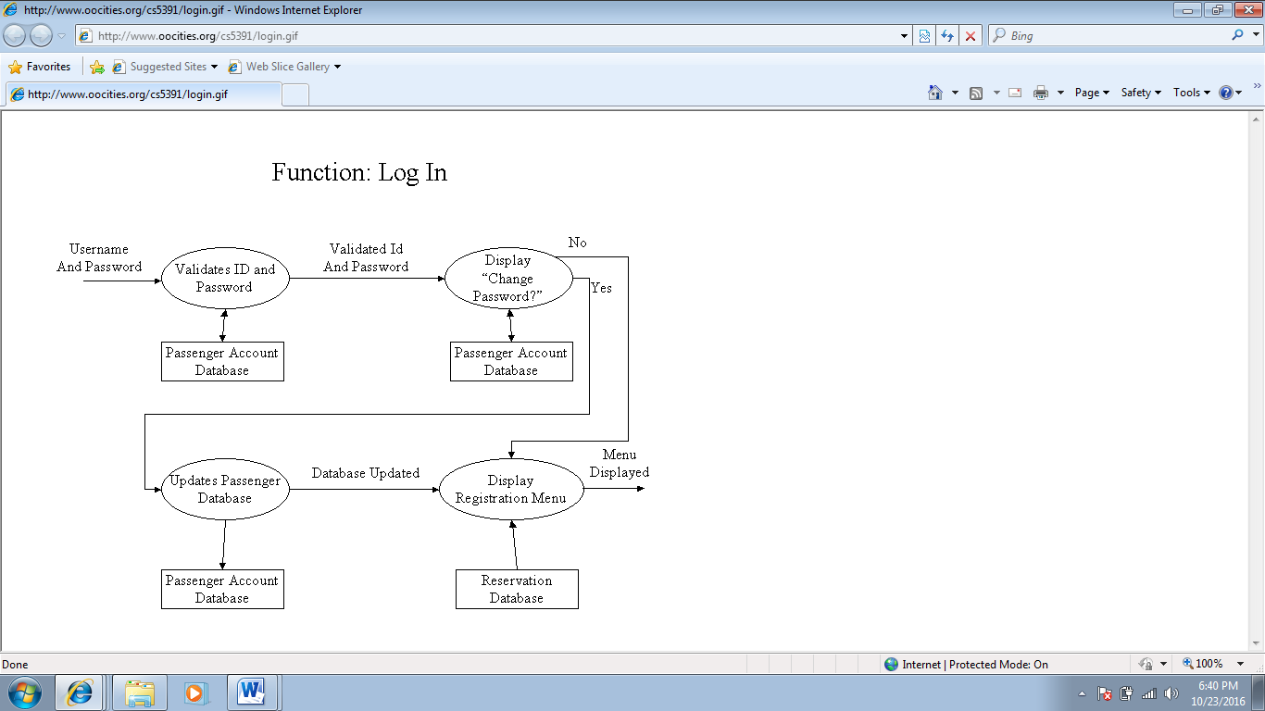0

ALGORITHM:

1.Start

2.enter the passengers user id and password.

3.In the display function ,by the information like from and to the details of the bus are shown.

4.Next it asks whether we want ac or non ac and according to it id displays the bus details like bus no. ,arrival and departure time,driver no.,etc.,

5.In the booking function we can select the bus by its bus no.,so that it shows the number of seats already reserved.After selevting the seats it takes the required information about the passenger required for online payment.

6.stop.

BLOCK DIAGRAM OF SYSTEM:

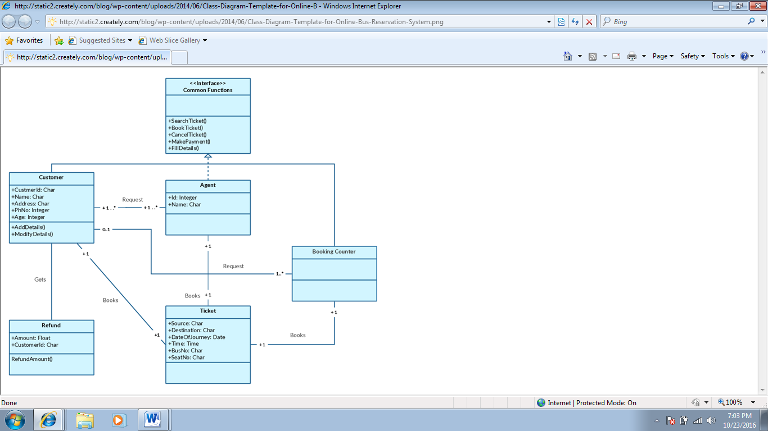

# SOFTWARE AND HARDWARE REQUIREMENTS

#### Hardware Requirements:

* + PC with Pentium IV processor.
  + 512 MB RAM or above.
  + 40 GB Hard Disk or above.

#### Software Requirements:

* + Operating system : Windows XP (or latest).
  + Front end : TURBO

IMPLEMENTATION AND CODING

**#include<stdio.h>**

**#include<conio.h>**

**#include<stdlib.h>**

**#include<iostream.h>**

**#include<string.h>**

**class a**

**{ char from[10],to[10],seat[4][10];**

**int n,s,b[];**

**public:**

**void display();**

**void booking();**

**void empty();**

**void payment();**

**}**

**bus[10];**

**void a::display()**

**{**

**cout<<"\nfrom:\t\t\t";**

**cin>>from;**

**cout<<"\n to\t\t";**

**cin>>to;**

**/*bus[p].empty();*/**

**cout<<"1.ac \n 2.nonac";**

**cin>>n;**

**if((strcmp(from,"hyderabad")==0)&&(strcmp(to,"mumbai")==0))**

**{**

**if(n==1)**

**{**

**cout<<"\n1.garuda \t arrival time:3:00 am \t departure time:4:00 pm\t cost:800\tbusno:123\t bus driver no:9545423342 \t driver name:shekar";**

**cout<<"\n2.indra \t arrival time:1:30 pm \t departure time:2:30 am\t cost:800\t bus no:124\t bus driver no:9346745321\t driver name:chandra ";**

**}**

**if(n==2)**

**{**

**cout<<"\n1.superdelux \t arrival time:3:00 pm\t departure time:4:00 am\t cost:500\t bus no:125\tbus driver no:8456729103\t driver name:shiva ";**

**cout<<"\n2.indra \t arrival time:12:30 pm\t departure time:2:00 am \t cost:500\t bus no:126\tbus driver no:7456387569\tdriver name:kumar";**

**}**

**}**

**else if((strcmp(from,"hyderabad")==0)&&(strcmp(to,"banglore")==0))**

**{**

**if (n==1)**

**{**

**cout<<"\n1.garuda \t arrival time :11:00 pm \t departure time :9:00 am cost: 800 bus no: 234 bus driver no: 7689421891 \t driver name:sandeep ";**

**cout<<"\n2.indra \t arrival time: 1:00 am \t departure time: 11:00 am cost: 800 bus no:235 bus driver no:9634275486 \tdriver name:kishan ";**

**}**

**if(n==2)**

**{**

**cout<<"\n1.superdelux \t arrival time: 2:00 pm \t departure time:11:00 pm cost: 500 bus no:236 bus driver no: 9864352764 \tdriver name: murali ";**

**cout<<"\n2.delux \t arrival time:3:00 pm \t destination time : 12:30 am cost: 500 bus no:237 bus driver no: 8547894451\t driver name:srinivas ";**

**}**

**}**

**else if((strcmp(from,"hyderabad")==0)&&(strcmp(to,"chennai")==0))**

**{**

**if(n==1)**

**{**

**cout<<"\n1.garuda \t arrival time:-12:00 pm \t destination time:- 1:00am cost:800 bus no: 323 bus driver no: 7654893341 \tdriver name:manohar ";**

**cout<<"\2.indra \t arrival time:-1:00 am \t destination time:- 2:30 pm cost:800 bus no: 324 bus driver no: 8876568897 \t driver name:sandeep ";**

**}**

**if(n==2)**

**{**

**cout<<"\n1.super delux \t arrival time:- 1:00pm \t destination time:- 2:00am cost: 500 bus no: 325 bus driver no: 9967547762 \t driver name:aditya ";**

**cout<<"\n2.delux \t arrival time: 3:00pm \t destination time:-4:00 am cost:500 bus no:326 bus driver no:9856325647 \tdriver name:surya ";**

**}**

**}**

**}**

**void a::empty()**

**{**

**char r;**

**for(int i=0;i<8;i++)**

**{**

**for(int j=0;j<4;j++)**

**{**

**if(i==3&&j==2)**

**seat[3][2]='r';**

**else if(i==3&&j==3)**

**seat[3][3]='r';**

**else if(i==4&&j==0)**

**seat[4][0]='r';**

**else seat[i][j]='e';**

**}**

**}**

**}**

**void a::booking()**

**{**

**int no,b[40];**

**cout<<"enter bus number";**

**cin>>no;**

**if(no==123 )**

**cout<<"\n1.garuda \t arrival time:3:00 am \t departure time:4:00 pm\t cost:800\tbusno:123\t bus driver no:9545423342 \t driver name:shekar";**

**if(no==124)**

**cout<<"\n2.indra \t arrival time:1:30 pm \t departure time:2:30 am\t cost:800\t bus no:124\t bus driver no:9346745321\t driver name:chandra ";**

**if(no==125)**

**cout<<"\n1.superdelux \t arrival time:3:00 pm\t departure time:4:00 am\t cost:500\t bus no:125\tbus driver no:8456729103\t driver name:shiva ";**

**if(no==126)**

**cout<<"\n2.indra \t arrival time:12:30 pm\t departure time:2:00 am \t cost:500\t bus no:126\tbus driver no:7456387569\tdriver name:kumar";**

**if(no==234)**

**cout<<"\n1.garuda \t arrival time :11:00 pm \t departure time :9:00 am cost: 800 bus no: 234 bus driver no: 7689421891 \t driver name:sandeep ";**

**if(no==235)**

**cout<<"\n2.indra \t arrival time: 1:00 am \t departure time: 11:00 am cost: 800 bus no:235 bus driver no:9634275486 \tdriver name:kishan ";**

**if(no==236)**

**cout<<"\n1.superdelux \t arrival time: 2:00 pm \t departure time:11:00 pm cost: 500 bus no:236 bus driver no: 9864352764 \tdriver name: murali ";**

**if(no==237)**

**cout<<"\n2.delux \t arrival time:3:00 pm \t destination time : 12:30 am cost: 500 bus no:237 bus driver no: 8547894451\t driver name:srinivas ";**

**if(no==323)**

**cout<<"\n1.garuda \t arrival time:-12:00 pm \t destination time:- 1:00am cost:800 bus no: 323 bus driver no: 7654893341 \tdriver name:manohar ";**

**if(no==324)**

**cout<<"\2.indra \t arrival time:-1:00 am \t destination time:- 2:30 pm cost:800 bus no: 324 bus driver no: 8876568897 \t driver name:sandeep ";**

**if(no==325)**

**cout<<"\n1.super delux \t arrival time:- 1:00pm \t destination time:- 2:00am cost: 500 bus no: 325 bus driver no: 9967547762 \t driver name:aditya ";**

**if(no==326)**

**cout<<"\n2.delux \t arrival time: 3:00pm \t destination time:-4:00 am cost:500 bus no:326 bus driver no:9856325647 \tdriver name:surya ";**

**cout<<"\nenter number of seats you want to book";**

**cin>>s;**

**cout<<"\nhere the list of reserved seats:";**

**for(int i=0;i<8;i++)**

**{**

**for(int j=0;j<4;j++)**

**{**

**if(seat[i][j]=='r')**

**{**

**cout<<"seat no "<<(i*4)+j+1<<"is reserved";**

**}**

**}**

**}**

**cout<<"kindly select remaining seats";**

**cout<<"\n enter the seat numbers";**

**i=0;**

**while(i<s)**

**{**

**cin>>b[i];**

**i++;**

**}**

**}**

**void a::payment()**

**{**

**int c;**

**char name[15],cardno[16],name1[15],mobile[10],month[15],year[5];**

**if(n==1)**

**{**

**cout<<"\ntotal cost is" <<s*800;**

**}**

**if(n==2)**

**{**

**cout<<"\ntotal cost is"<<s*500;**

**}**

**cout<<"\nenter your name";**

**cin>>name1;**

**cout<<"\nenter mobile number";**

**cin>>mobile;**

**cout<<"\nselect payment method";**

**cout<<"\n 1.credit card 2.debit card";**

**cin>>c;**

**if(c==1||c==2)**

**{**

**cout<<"\nenter name on the card";**

**cin>>name;**

**cout<<"\nenter card number";**

**cin>>cardno;**

**cout<<"\nenter expiry month";**

**cin>>month;**

**cout<<"\nexpiry year";**

**cin>>year;**

**cout<<"\nsuccessfully verified";**

**}**

**cout<<"\npayment summary";**

**for(int i=0;i<s;i++)**

**cout<<b[i];**

**cout<<"seats are reserved by"<<name1;**

**}**

**int main()**

**{**

**clrscr();**

**a x;**

**x.empty();**

**int q;**

**while(q!=4)**

**{**

**cout<<"\n 1.display \n 2.booking\n 3.exit";**

**cin>>q;**

**switch(q)**

**{**

**case 1:x.display();**

**break;**

**case 2:x.booking();**

**x.payment();**

**break;**

**case 3:exit(0);**

**}**

**}**

**return 0;**

**}**

TESTING AND TEST RESULTS

OUTPUT SCREENSHOT1:

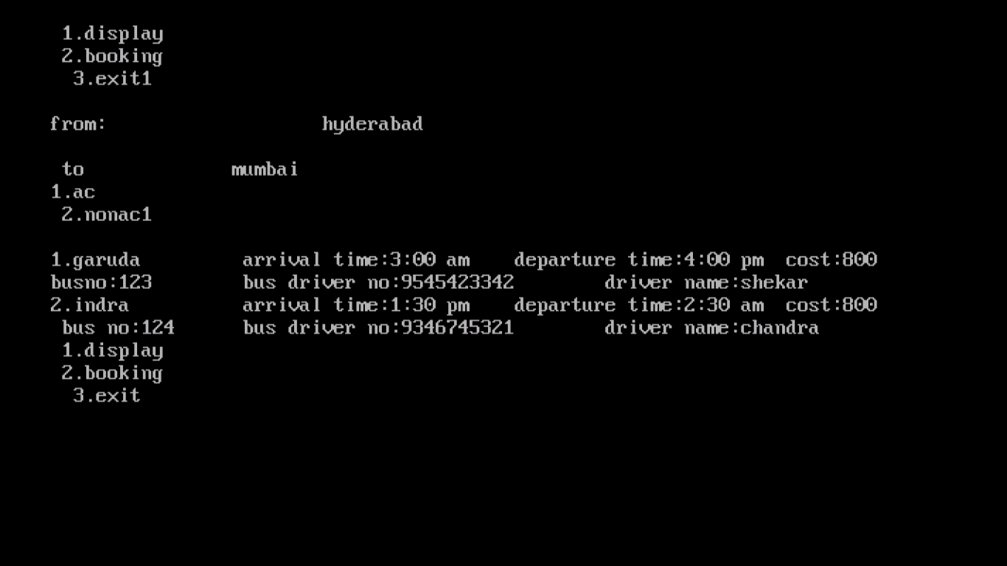

OUTPUT SCREENSHOT 2:

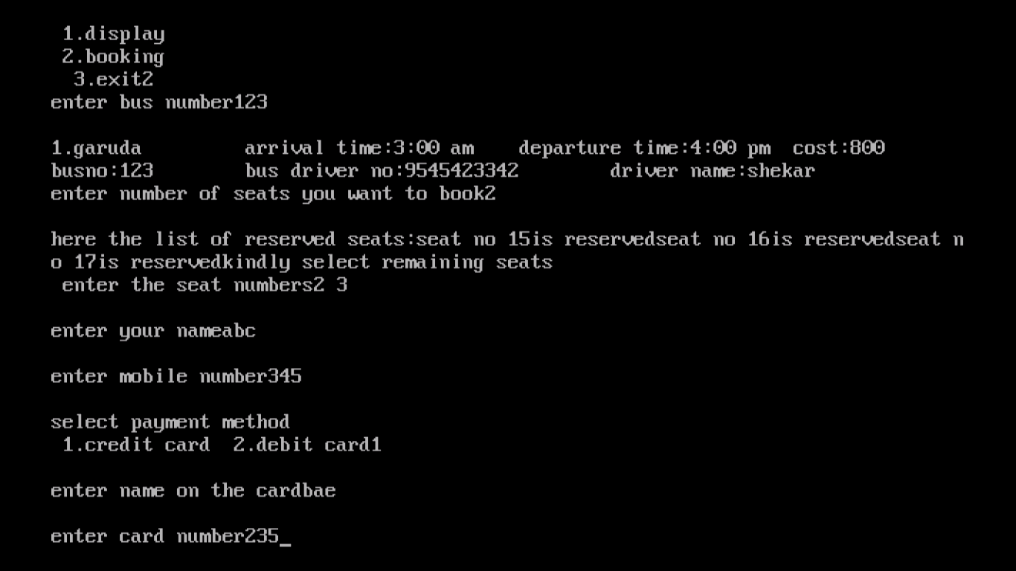

**4.CONCLUSION**

thus the program “Bus reservation system” is created and executed successfully.

There is more scope for this program as it is constructive and can be developed in various different languages like python , dbms etc. all of which are beyond the scope of this project .

REFERNCES

<http://shivajivarma.com/project/bus-reservation-system/>

<http://www.codewithc.com/bus-reservation-system-project-in-c/>