HTML CSS DAY19  
TASK 1

1.Fix the bugs in the below snippet

Given Snippet-

<html lang="en">

<head>

<title>Document

<body>

guvi

</title>

</head>

<div>

Lorem ipsum dolor sit amet consectetur adipisicing elit.

<div>

<div>

Guvi Geek Network

</div>

</body>

</html>

Corrected snippet -

<html lang="en">

<head>

<title>Document</title>

</head>

<body>

guvi

<div>Lorem ipsum dolor sit amet consectetur adipisicing elit.</div>

<div>Guvi Geek Network</div>

</body>

</html>

2.  
  
Given Snippet -

<html lang="en">

<head>

<title>Document

<body>

guvi

</head>

<div>

Lorem ipsum dolor sit amet consectetur adipisicing elit.

<div>

<div>

Guvi Geek Network

</div>

</body>

</html>

Corrected Snippet -

<html lang="en">

<head>

<title>Document</title>

</head>

<body>

guvi

<div>Lorem ipsum dolor sit amet consectetur adipisicing elit.</div>

<div>Guvi Geek Network</div>

</body>

</html>

ppet

3.Design a contact us form with all fields as required.

Code -

<!DOCTYPE html>

<html lang="en">

<head>

<meta charset="UTF-8">

<meta name="viewport" content="width=device-width, initial-scale=1.0">

<title>Document</title>

</head>

<body>

<h1 style="text-align: center;color: blueviolet;">Contact US</h1>

<form action="#"method="post">

<label for="fname">First Name: </label>

<input type ="text" name="fname" id ="fname" placeholder ="Enter the first name" required ><br><br>

<label for="lname">Last Name: </label>

<input type ="text" name="lname" id ="lname" placeholder="Enter the Last Name:"required><br><br>

<label for="mail">Email: </label>

<input type ="email" name="mail" id ="mail"><br><br>

<label for="Phone No.">Phone Number: </label>

<input type ="number" name="Phone No." id ="Phone No."><br><br>

<label for="psw">Password: </label>

<input type ="password" name="psw" id ="psw"><br><br>

<label for="subject">Subject: </label><br>

<input type="text" id="subject" name="subject" required><br><br>

<label for="message">Message: </label><br>

<textarea id="message" name="message" rows="5" required></textarea><br><br>

<input type="submit" value = "Submit">

<input type = "reset" value ="reset">

</form>

</body>

</html>

Output -

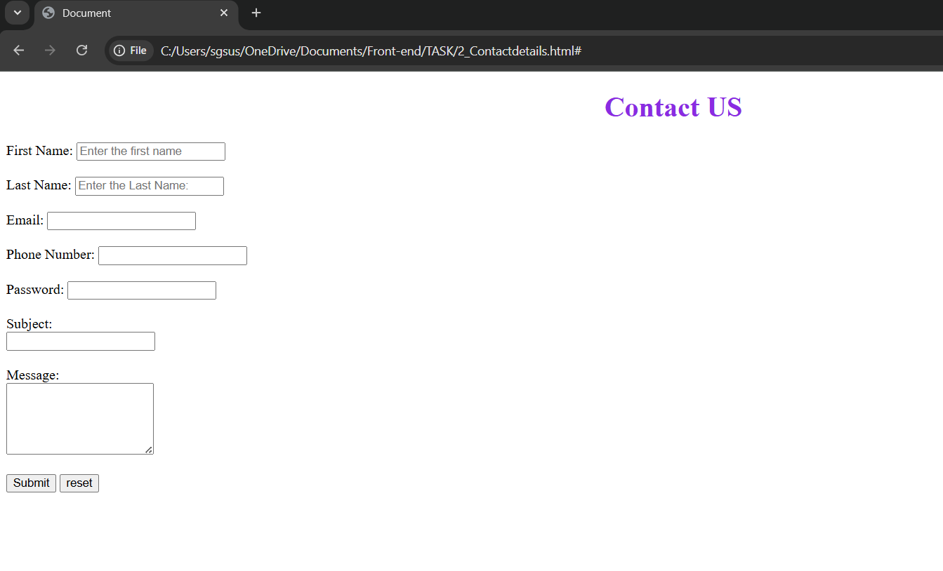

4.Use certain HTML elements to display the following in a HTML page.

Programming Language

* + JavaScript
    1. Angular
    2. React
    3. Vue.js
  + Python
    1. Django Framework
    2. Flask Framework
  + Java
    1. Spring
    2. Maven
    3. Hibernate

Database

* + MySQL
  + MongoDB
  + Cansandra

Code -

<!DOCTYPE html>

<html lang="en">

<head>

<meta charset="UTF-8">

<meta name="viewport" content="width=device-width, initial-scale=1.0">

<title>List</title>

</head>

<body>

<P> Programming Language </P>

<ul style="list-style-type: circle;">

<li>JavaScript</li>

<ol style="list-style-type: lower-alpha;">

<li>Angular</li>

<Li>React</Li>

<li>Vue.js</li>

</ol>

<li>Python</li>

<ol style="list-style-type: lower-alpha;">

<li>Django Framework</li>

<Li>Flask Framework</Li>

</ol>

<li>Java</li>

<ol style="list-style-type: lower-alpha;">

<li>Spring</li>

<Li>Maven</Li>

<li>Hibernate</li>

</ol>

</ul>

<p>Database</p>

<ul style="list-style-type: circle;">

<li>MySQL</li>

<li>Mongo DB</li>

<li>Candandra</li>

</ul>

</body>

</html>

5.Create an element that helps you to open the [https://google.com](https://google.com/) in separate new tab.

Code -   
<!DOCTYPE html>

<html lang="en">

<head>

<meta charset="UTF-8">

<meta name="viewport" content="width=device-width, initial-scale=1.0">

<title>Google</title>

</head>

<body>

<a href="https://google.com" target="_blank">Open Google on New tab</a>

</body>

</html>

Output -

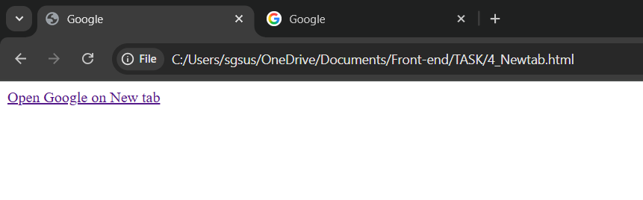

6.In the form, add two radio buttons with grouping them for employee type(Salaried and own business)\

Code -  
<!DOCTYPE html>

<html lang="en">

<head>

<meta charset="UTF-8">

<title>Employee Contact Form</title>

</head>

<body>

<h2>Employee Contact Form</h2>

<form action="#" method="post">

<label for="fullname">Full Name:</label><br>

<input type="text" id="fullname" name="fullname" required><br><br>

<label for="email">Email Address:</label><br>

<input type="email" id="email" name="email" required><br><br>

<label for="phone no.">Phone Number:</label><br>

<p>Employee Type:</p>

<input type="radio" id="salaried" name="employee_type" value="Salaried" required>

<label for="salaried">Salaried</label><br>

<input type="radio" id="own_business" name="employee_type" value="Own Business">

<label for="own_business">Own Business</label><br><br>

<button type="submit">Submit</button>

</form>

</body>

</html>

Output -

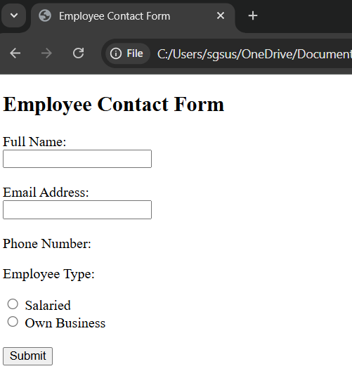

7.Design form shown in the link (<http://evc-cit.info/cit040/formguide/card_0.png>)

8.Use the table tag to design given image [Click here](https://www.bapugraphics.com/assets/img/port_upload_dir/table-4.jpg).

9.Write HTML input tags snippet to show default values for all Form elements.

Code -   
  
<!DOCTYPE html>

<html lang="en">

<head>

<meta charset="UTF-8">

<meta name="viewport" content="width=device-width, initial-scale=1.0">

<title>Form Snippet</title>

</head>

<body>

<form action="#" method="get">

<h1>FORM SNIPPET</h1>

<!-- TEXTBOX -->

<label for="fname" autofocus="fname">First Name:</label>

<input id="fname" name="fname" type="text" placeholder ="Enter Your First Name Here" required> <br><br>

<label for="lname">Last Name:</label>

<input id="lname" name="lname" type="text" placeholder="Enter Your Last Name Here" required> <br><br>

<!-- CHECKBOX -->

<label for ="Phone">Choose the Model</label><br><br>

<input type="checkbox" name="Phone1" id="Phone1" value="Iphone">

<label for = Phone1>Iphone</label><br>

<input type="checkbox" name="Phone2" id="Phone2" value="Samsung">

<label for = Phone2>Samsung</label><br>

<label for = Phone3><input type="checkbox" name="Phone3" id="Phone3" value="Oneplus">Oneplus</label><br><br>

<!-- RADIO BUTTONS -->

<label for ="Phone">Choose the Car Model</label><br><br>

<input name="radio" type="radio" value="Nissan">

<label for="radio">Nissan</label><br>

<input name="radio" type="radio" value="Audi">

<label for="radio">Audi</label><br><br>

<!-- PASSWORD -->

<label for="password">Password:</label>

<input id="password" name="password" type="password" required> <br><br>

<!-- DROP DOWN-->

<label for="cars">Choose a Car:</label>

<select name="cars" id="cars">

<option value="volvo">Volvo</option>

<option value="fiat">Fiat</option>

<option value="tata">Tata</option>

</select><br><br>

<!-- TEXT AREA -->

<textarea name="message" id="message" rows="4" cols="20"> About Yourself </textarea> <br><br>

<!-- EMAIL -->

<label for="email">Email:</label>

<input id="email" name="email" type="email" disabled> <br><br>

<!-- DATE -->

<label for="dob">DOB:</label>

<input id="dob" name="dob" type="date"> <br><br>

<label for="time">Time: </label>

<input id="time" name="time" type="time"> <br><br>

<!-- PHONE NUMBER -->

<label for="phone">Phone:</label>

<input id="phone" name="phone" type="tel" pattern="[0-9]{2}-[0-9]{10}" readonly> <br><br>

<!-- BUTTON -->

<input type="submit" value="Submit">

<input type ="reset" value="Reset">

</form>

</body>

</html>

Output -  
  
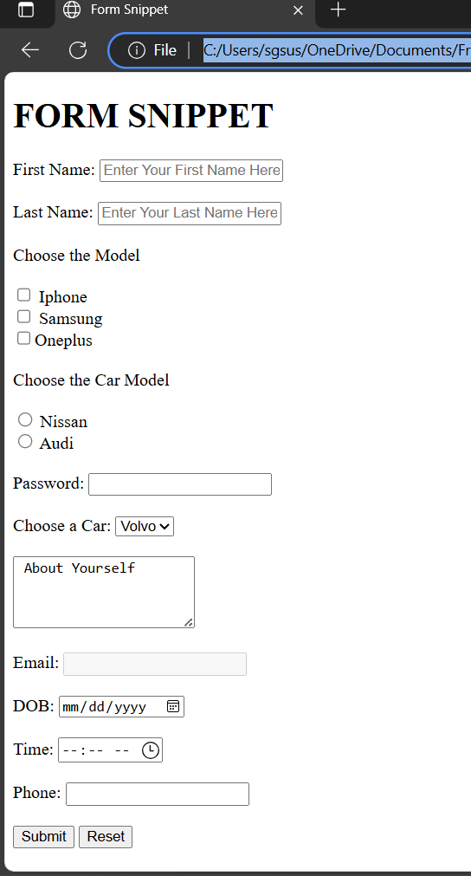

10.In your, HTML page add the below line and Highlight it without using any CSS.

* “HTML &CSS is awesome”

Code -  
  
<!DOCTYPE html>

<html lang="en">

<head>

<meta charset="UTF-8">

<meta name="viewport" content="width=device-width, initial-scale=1.0">

<title>Text Highloght</title>

</head>

<body>

<mark> HTML &CSS is awesome</mark>

</body>

</html>

Output -  
  
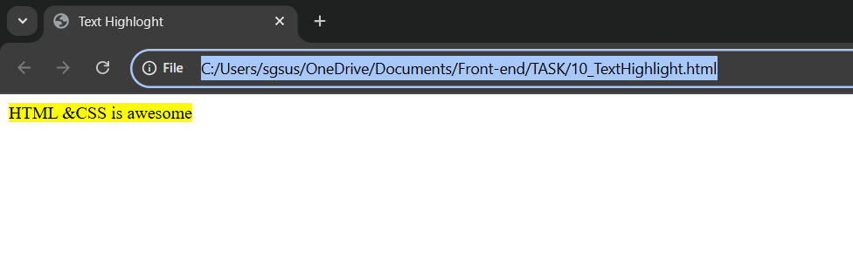

11.Create an HTML page, which should contain all types of input elements.

Code -

<!DOCTYPE html>

<html lang="en">

<head>

<meta charset="UTF-8">

<meta name="viewport" content="width=device-width, initial-scale=1.0">

<title>Input Statement Document</title>

</head>

<body>

<form action="#" method="get">

<h3>Input Statement</h3>

<!-- TEXTBOX -->

<label for="fname" autofocus="fname">First Name:</label>

<input id="fname" name="fname" type="text" placeholder ="Enter Your First Name Here" required> <br>

<label for="lname">Last Name:</label>

<input id="lname" name="lname" type="text" placeholder="Enter Your Last Name Here" required> <br>

<!-- CHECKBOX -->

<label for ="Phone">Choose the Model</label><br>

<input type="checkbox" name="Phone1" id="Phone1" value="Iphone">

<label for = Phone1>Iphone</label>

<input type="checkbox" name="Phone2" id="Phone2" value="Samsung">

<label for = Phone2>Samsung</label>

<label for = Phone3><input type="checkbox" name="Phone3" id="Phone3" value="Oneplus">Oneplus</label><br><br>

<!-- RADIO BUTTONS -->

<label for ="Phone">Choose the Car Model</label><br>

<input name="radio" type="radio" value ="Nissan">

<label for="radio">Nissan</label>

<input name="radio" type="radio" value="Audi">

<label for="radio">Audi</label><br><br>

<!-- PASSWORD -->

<label for="password">Password:</label>

<input id="password" name="password" type="password" required> <br><br>

<!-- DROP DOWN-->

<label for="cars">Choose a Car:</label>

<select name="cars" id="cars">

<option value="volvo">Volvo</option>

<option value="fiat">Fiat</option>

<option value="tata">Tata</option>

</select><br><br>

<!-- TEXT AREA -->

<textarea name="message" id="message" rows="4" cols="20"> About Yourself </textarea> <br><br>

<!-- EMAIL -->

<label for="email">Email:</label>

<input id="email" name="email" type="email" disabled> <br><br>

<!-- DATE -->

<label for="dob">DOB:</label>

<input id="dob" name="dob" type="date"> <br><br>

<label for="time">Time: </label>

<input id="time" name="time" type="time"> <br><br>

<!-- PHONE NUMBER -->

<label for="phone">Phone:</label>

<input id="phone" name="phone" type="tel" pattern="[0-9]{2}-[0-9]{10}" readonly> <br><br>

<!-- URL -->

<label for="url">Website:</label>

<input type="url" id="url" name="url" placeholder="https://example.com"><br><br>

<!-- DATE & TIME -->

<label for="datetime">Date & Time:</label>

<input type="datetime-local" id="datetime" name="datetime"><br><br>

<!-- MONTH -->

<label for="month">Month:</label>

<input type="month" id="month" name="month"><br><br>

<!-- WEEK -->

<label for="week">Week:</label>

<input type="week" id="week" name="week"><br><br>

<!-- FILE UPLOAD -->

<label for="file">Upload File: </label>

<input type="file" id="file" name="file" multiple><br>

<!-- BUTTON -->

<input type="submit" value="Submit">

<input type ="reset" value="Reset">

</form>

</body>

</html>

Output -

