JAVA DAY4 - TASK 1  
  
  
1.Write a program to print 10 - 50 using for loop or while loop  
  
Using For Loop:  
  
package task.one;

public class PrintNumbers {

public static void main(String [] args){

for(int i=10;i<=50;i++){

System.*out*.println(i);

}

}

}

Using While Loop:  
  
package task.one;

public class PrintNumbers {

// public static void main(String [] args){

// for(int i=10;i<=50;i++){

// System.out.print(i);

// }

// }

public static void main(String[]args){

int i=10;

while(i<=50){

System.*out*.println(i);

i++;

}

}

}

Output:

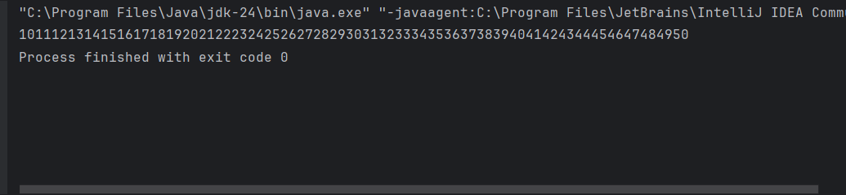

2. Write a program to find the given number is Positive or Negative.

Input = 123  
Output = Positive

package task.one;

public class PositiveNumber {

public static void main(String[]args) {

int Number = 123;

if (Number > 0) {

System.*out*.println("Positive");

}

else if (Number < 0) {

System.*out*.println("Negative");

}

else{

System.*out*.println("Zero");

}

}

}

Output:  
  
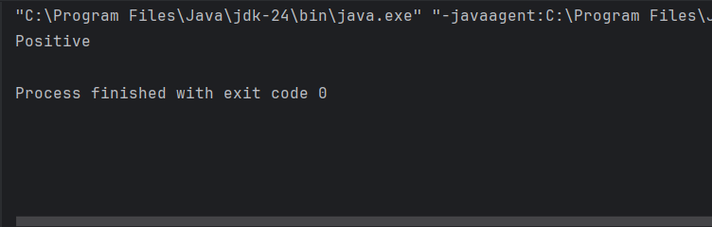

3.Write down a program to reverse the given number using For Loop

Input = 876

package task.one;

//public class ReverseNumber {

// public static void main(String[] args){

// String Number = "876";

// for (int i=2;i>=0;i--){

// System.out.print(Number.charAt(i));

// }

// }

//}

public class ReverseNumber {

public static void main(String[] args) {

int number = 876;

int reversed = 0;

for (int temp = number; temp != 0; temp /= 10) {

int digit = temp % 10;

reversed = reversed \* 10 + digit;

}

System.*out*.println(reversed);

}

}

Output:  
  
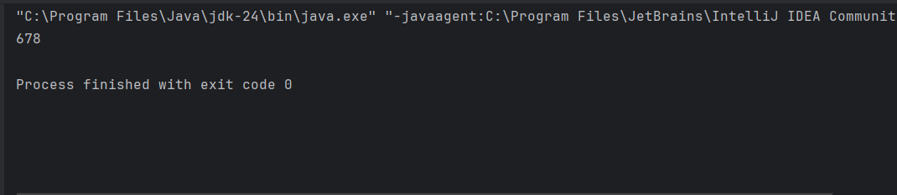

4. Write a Java Program to find the smallest among three numbers

package task.one;

import java.util.Scanner;

public class SmallestAmongThree {

public static void main(String[] args) {

Scanner scanner = new Scanner(System.*in*);

System.*out*.print("Enter first number: ");

int Num1 = scanner.nextInt();

System.*out*.print("Enter second number: ");

int Num2 = scanner.nextInt();

System.*out*.print("Enter third number: ");

int Num3 = scanner.nextInt();

int smallest;

if (Num1 <= Num2 && Num1 <= Num3) {

smallest = Num1;

} else if (Num2 <= Num1 && Num2 <= Num3) {

smallest = Num2;

} else {

smallest = Num3;

}

System.*out*.println("The smallest number is: " + smallest);

}

}

Output:

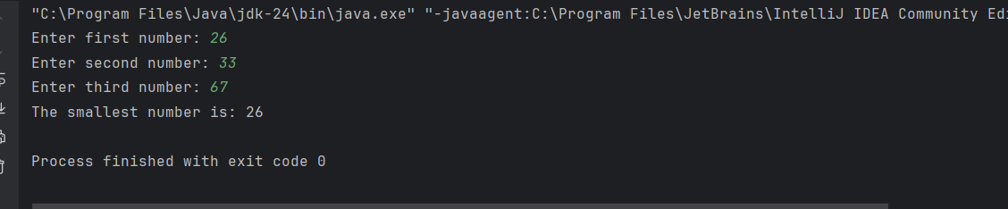

5. Write a Java program that takes the purchase amount as input and calculates the final payable amount after applying the discount.

1. If the purchase amount is less than 500, no discount is applied.

2. If the purchase amount is between 500 and 1000, a 10% discount is applied.

3. If the purchase amount is greater than 1000 a 20% discount is applied.

package task.one;

import java.util.Scanner;

public class Discount {

public static void main(String[] args) {

Scanner scanner = new Scanner(System.*in*);

System.*out*.print("Enter the purchase amount: ");

double amount = scanner.nextDouble();

double discount = 0.0;

if (amount < 500) {

discount = 0.0;

}

else if (amount <= 1000) {

discount = amount \* 0.10;

}

else {

discount = amount \* 0.20;

}

double totalAmount = amount - discount;

System.*out*.println("Discount Amount:" + discount);

System.*out*.println("Total Payable Amount:" + totalAmount);

}

}

Output:

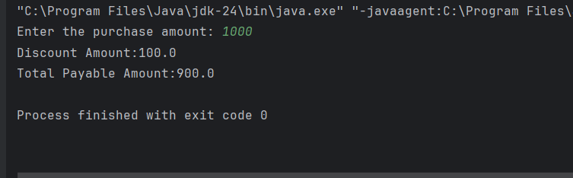

6. Write a java program to print bellowed pattern - >i and j and k=>5

55555

54444

54333

54322

54321

package task.one;

public class NumberPattern {

public static void main(String[] args) {

int n = 5;

for (int i = 0; i < n; i++) {

for (int j = 5; j > 5 - i; j--) {

System.*out*.print(j);

}

for (int k = 0; k < n - i; k++) {

System.*out*.print(5 - i);

}

System.*out*.println();

}

}

}

Output  
  
