Assignment (BCAC391)

(Basic class, this keyword, getter & setter method, return type, package concept)

1. A class called **Student**, with student name, course, rollno, section, semester, is designed as shown in the following class diagram. Write the **Student** class.

Create **Student** class within **com.student.domain** package and create **main** class within **com.testStudent.domain** package.

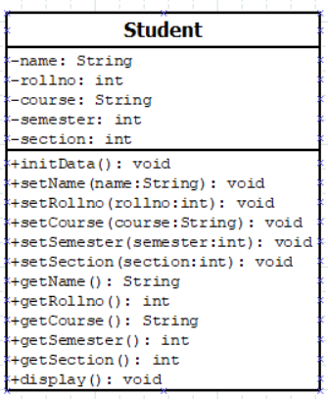

**[Note: using initData() to initialize the default value. ]**

**Below is the TestDriver code:**

public class **testDriver** {

public static void main(String[] args) {

Student student1=new Student();

student1.initData();

//using setter method

student1.setName("Anup Saha");

student1.setCourse("BCA");

student1.setRollno(123456789);

student1.setSemester(2);

student1.setSection('C');

student1.display();

//using getter and setter method

student1.setName("Subhajit Das");

student1.setCourse("MCA");

student1.setRollno(223456789);

student1.setSemester(3);

student1.setSection('A');

System.out.println("\nName->\t\t"+student1.getName());

System.out.println("Roll No->\t"+student1.getRollno());

System.out.println("Course->\t"+student1.getCourse());

System.out.println("Semester->\t"+student1.getSemester());

System.out.println("Section->\t"+student1.getSection());

}

}

**The expected output:**

.............Student Details...............

Name-> Anup Saha

Roll No-> 123456789

Course-> BCA

Semester-> 2

Section-> C

Name-> Subhajit Das

Roll No-> 223456789

Course-> MCA

Semester-> 3

Section-> A

1. Write a program to check a number is prime or not. Create a class **PrimeChecker** and take a variable **int number** , and create **isPrime() : Boolean** method to check a number is prime or not ,if number is prime the return **true**, create another method **takeNumber(int number)** to initialize the value of **number:int** variable. In the **main** class create an object of **PrimeChecker** class and using class members to check a number is prime or not.

Create **PrimeChecker** class within **com.prime.domain** package and create main class within **com.testPrime.domain** package.

**Below is the main class code:**

public class **TestDriver**{

public static void main(String args[]){

PrimeChecker pc=new PrimeChecker();

pc.takeInput(7);

if(pc.isPrime())

{

System.out.println(pc.number+”is a prime number”);

}

else

{

System.out.println(pc.number+”is not a prime number”);

}

}

}

**The expected output is:**

7 is a prime number.

1. Create a Class **TaxCalculation** to calculate the tax, in the class write a method **takeIncome(double income)** to take the value of annual income, write another method **calculate()** to calculate the tax based of annual income which is given by user as per the following table.

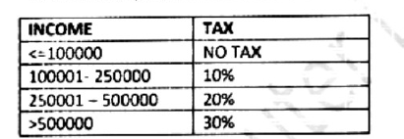

1. Create a class **EmployeeSalary** to calculate the salary of an employee. In the class create a method **take_input()** to take **basic_salary** value and create a another method **calculate()** to calculate the Gross and Net pay of an employee based of following criteria.

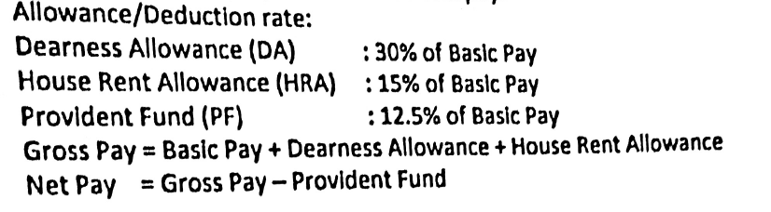

Finally create a another method **display_salary()** to display the Gross pay and Net Pay of an employee.

1. A manufacturing company has made an increase in the cost of its vehicles as per type of engine as given below:

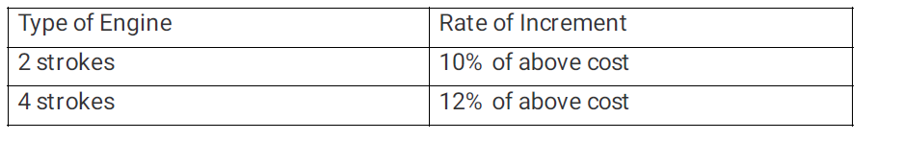

Write a program to find out the new cost as per the given specification:

**Class Name:** **Vehicle**

**Data Members**: **int type** – to accept two type of engine, 2/4 stroke

**int cost** – to accept previous cost

**Member Methods**: **void getType()** – to accept the type of engine and previous cost.

**void find()** – to find the new cost as per the criteria given above.

**void printcost()**– to print the type and new cost of the vehicle.

1. Design a class **RailwayTicket** with the following description:

Instance variables/data members

**String name** – To Store name of the customer.

**String coach** – To store the type of coach customer wants to travel.

**long mobno** – To store customer’s mobile number.

**int amt** – To store the basic amount of ticket.

**int total_amt** – To store the amount to be paid after updating the original amount.

Member methods

**void accept()** – To take input for name ,coach, mobile number and amount.

**void update()** – To update the amount as per the coach selected

(Extra amount to be added in the amount as follows)

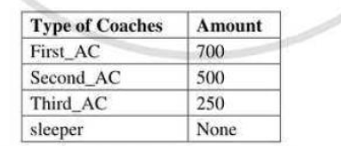

**void display()** – To display all details of a customer such as name, coach, total amount and mobile number.

Write a main method to create an object of the class and call the above member methods.