Assignment (BCAC391)

(Basic class, constructors, package concept)

1. Design a class name ShowRoom with the following description :

Instance variable/ Data members:

String name – to store the name of the customer

long mobno – to store the mobile number of the customer

double cost – to store the cost of items purchased

double dis – to store the discount amount

double amount – to store amount to be paid after discount

Member method :

ShowRoom() – default constructor to initialize data members

void input() – to input customer name, mobile number, cost

void calculate() – to calculate discount on the cost of purchased items based on the

following criteria

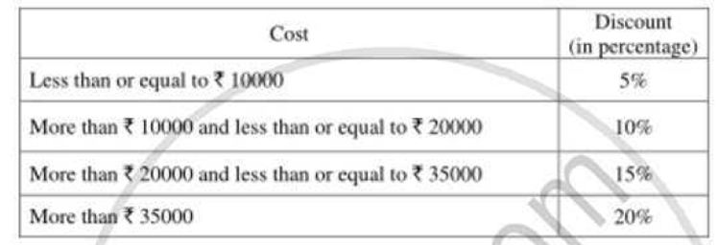

void display() – to display customer name, mobile number, amount to be paid after discount.

Write a main method to create an object of the class the above member’s methods.

Sample Output:

1. A class called **circle** is designed as shown in the following class diagram.

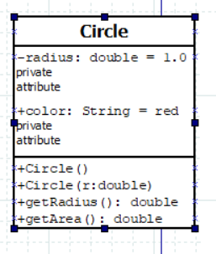

This Circle class does not have a main() method. Hence, it cannot be run directly. This Circle class is a “building block” and is meant to be used in another program.

Let us write a test program called TestCircle (in another source file called TestCircle.java) which uses the Circle class, as follows:

/**

* A Test Driver for the Circle class

*/

public class **TestCircle** { // Save as "TestCircle.java"

public static void main(String[] args) {

Circle c1 = new Circle();

System.out.println("The circle has radius of "

+ c1.getRadius() + " and area of " + c1.getArea());

Circle c2 = new Circle(2.0);

System.out.println("The circle has radius of "

+ c2.getRadius() + " and area of " + c2.getArea());

//The circle has radius of 2.0 and area of 12.566370614359172

}

}

Now, run the TestCircle

Sample Output:

1. A class called Rectangle, which models a rectangle with a length and a width (in float), is designed as shown in the following class diagram. Write the Rectangle class.

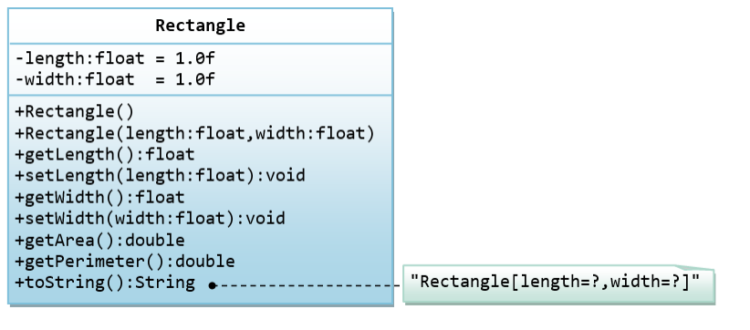

Below is a test driver to test the Rectangle class:

public class TestMain {

public static void main(String[] args) {

// Test constructors and toString()

// You need to append a 'f' or 'F' to a float literal

Rectangle r1 = new Rectangle(1.2f, 3.4f);

System.out.println(r1); // toString()

Rectangle r2 = new Rectangle(); // default constructor

System.out.println(r2);

// Test setters and getters

r1.setLength(5.6f);

r1.setWidth(7.8f);

System.out.println(r1); // toString()

System.out.println("length is: " + r1.getLength());

System.out.println("width is: " + r1.getWidth());

// Test getArea() and getPerimeter()

System.out.printf("area is: %.2f%n", r1.getArea());

System.out.printf("perimeter is: %.2f%n", r1.getPerimeter());

}

}

The expected output is:

Rectangle[length=1.2,width=3.4]

Rectangle[length=1.0,width=1.0]

Rectangle[length=5.6,width=7.8]

length is: 5.6

width is: 7.8

area is: 43.68

perimeter is: 26.80

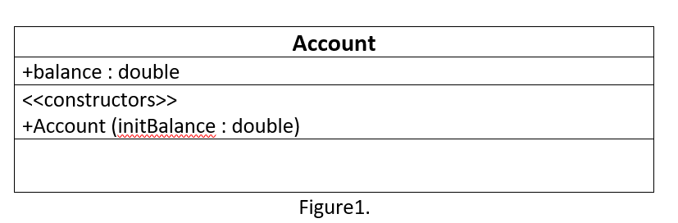

1. Figure1 shows the UML class diagram of the Account class that you are going to create. It will have one public data member (or instance variable) called balance that maintains the monitory value of the customer’s bank account. Initialize the balance instance variable with the parameter of the constructor. Create another class TestAccount which acts as a programmed to create an Account object with an initial balance of hundred. The test programmed will then add 47 and then subtract 150.Finally the test programmed must print the balance of the object to the standard output string.

**[The output should be similar to the following:**

**Final account balance is -3.0]**

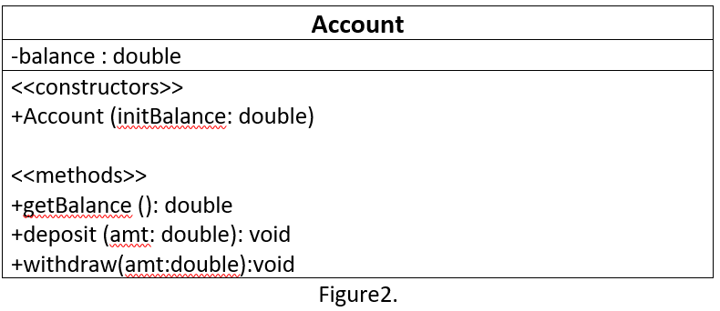

Modify the Account class source file according to the Figure2 UML class diagram. The deposit method adds money to the account, the withdraw method removes money from the account and the getBalance method returns the current value of the current instance variable. The withdraw method should be implemented in such a way that the balance of the bank account should never go below zero.

Modify the TestAccount class by changing the amount in the call to the deposit method to 47 and the amount in the call to the withdraw method to 150.

**[The output should be similar to the following:**

**Final account balance is 147.0]**