Assignment (BCAC391)

**(Inheritance, super, abstract class, abstract method, downcast, upcast, array)**



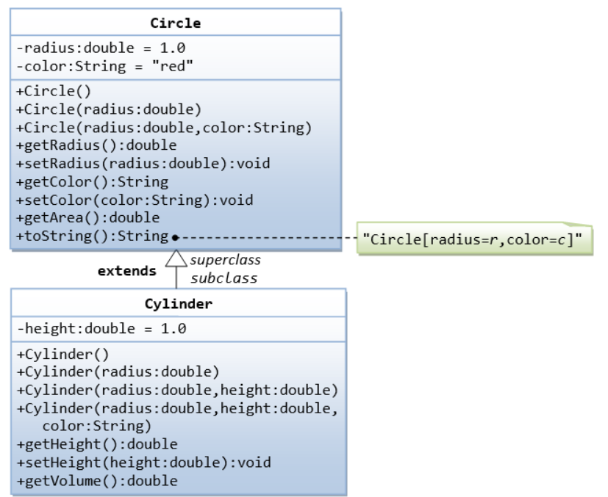

Write a test program (says TestCylinder) to test the **Cylinder** class created, as follow:

public class **TestCylinder** { // save as "TestCylinder.java"

public static void main (String[] args) {

// Declare and allocate a new instance of cylinder

// with default color, radius, and height

Cylinder c1 = new Cylinder();

System.out.println("Cylinder:"

+ " radius=" + c1.getRadius()

+ " height=" + c1.getHeight()

+ " base area=" + c1.getArea()

+ " volume=" + c1.getVolume());

// Declare and allocate a new instance of cylinder

// specifying height, with default color and radius

Cylinder c2 = new Cylinder(10.0);

System.out.println("Cylinder:"

+ " radius=" + c2.getRadius()

+ " height=" + c2.getHeight()

+ " base area=" + c2.getArea()

+ " volume=" + c2.getVolume());

// Declare and allocate a new instance of cylinder

// specifying radius and height, with default color

Cylinder c3 = new Cylinder(2.0, 10.0);

System.out.println("Cylinder:"

+ " radius=" + c3.getRadius()

+ " height=" + c3.getHeight()

+ " base area=" + c3.getArea()

+ " volume=" + c3.getVolume());

}

}

**Expected Output:**

Cylinder: radius=1.0 height=1.0 base area=3.141592653589793 volume=3.141592653589793

Cylinder: radius=10.0 height=1.0 base area=314.1592653589793 volume=314.1592653589793

Cylinder: radius=2.0 height=5.0 base area=12.566370614359172 volume=62.83185307179586

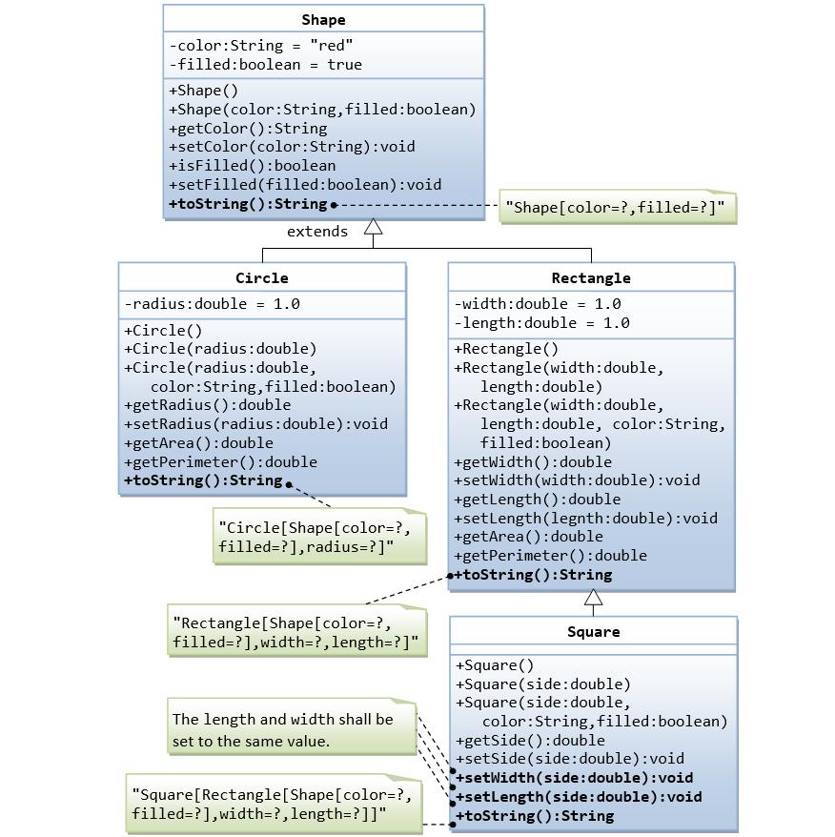

Write a test program (says **TestDriver**) to test the above class created, as follow:

public class testDriver {

public static void main(String[] args) {

Shape s1=new Shape();

System.out.println(s1);

s1.setColor("black");

s1.setFilled(false);

System.out.println("Color:"+s1.getColor());

System.out.println("Color:"+s1.isFilled());

Circle c1=new Circle();

System.out.println(c1);

Circle c2=new Circle(10);

System.out.println(c2);

Circle c3=new Circle(11.0,"Red",false);

System.out.println("Radius:"+c3.getRadius());

c3.setRadius(12.0);

System.out.println("Radius:"+c3.getRadius());

System.out.println(c3);

Rectangle r1=new Rectangle(10.0,15.0,"White",true);

System.out.println(r1);

r1.setColor("Blue");

r1.setLength(20.0);

System.out.println("Color:"+r1.getColor());

System.out.println("Length:"+r1.getLength());

Square sq1=new Square(10,"Black",true);

System.out.println("Sides:"+sq1.getSide());

sq1.setWidth(5);

sq1.setLength(10);

System.out.println(sq1);

}

}

**Expected Output:**

Shape[color=red, filled=true]

Color:black

Color:false

Circle[Shape[color=red, filled=true], radius=1.0]

Circle[Shape[color=red, filled=true], radius=10.0]

Radius:11.0

Radius:12.0

Circle[Shape[color=Red, filled=false], radius=12.0]

Rectangle[Shape[color=White, filled=true],width=10.0,length=15.0]

Color:Blue

Length:20.0

Sides:10.0

Square[Rectangle[Shape[color=Black, filled=true],width=10.0,length=10.0]]

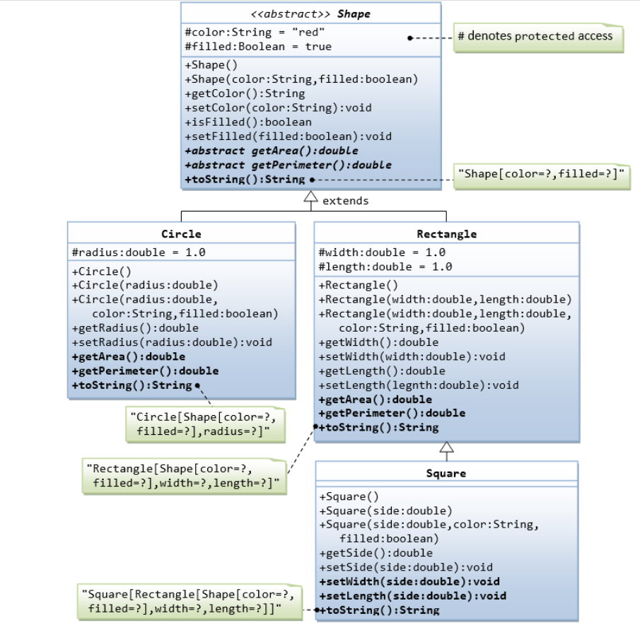

Write a test class to test these statements involving polymorphism and explain the outputs. Some statements may trigger compilation errors. Explain the errors, if any.

public class testDriver {

public static void main(String[] args) {

Shape s1 = new Circle(5.5, "red", false); // Upcast Circle to Shape

System.out.println(s1); // which version?

System.out.println(s1.getArea()); // which version?

System.out.println(s1.getPerimeter()); // which version?

System.out.println(s1.getColor());

System.out.println(s1.isFilled());

//System.out.println(s1.getRadius());// we can't access this child class method

Circle c1 = (Circle)s1; // Downcast back to Circle

System.out.println(c1);

System.out.println(c1.getArea());

System.out.println(c1.getPerimeter());

System.out.println(c1.getColor());

System.out.println(c1.isFilled());

System.out.println(c1.getRadius());

//Shape s2 = new Shape();

Shape s3 = new Rectangle(1.0, 2.0, "red", false); // Upcast

System.out.println(s3);

System.out.println(s3.getArea());

System.out.println(s3.getPerimeter());

System.out.println(s3.getColor());

//System.out.println(s3.getLength());// we can't access this child class method

Rectangle r1 = (Rectangle)s3; // downcast

System.out.println(r1);

System.out.println(r1.getArea());

System.out.println(r1.getColor());

System.out.println(r1.getLength());

Shape s4 = new Square(6.6); // Upcast

System.out.println(s4);

System.out.println(s4.getArea());

System.out.println(s4.getColor());

//System.out.println(s4.getSide());// we can't access this child class method

// Take note that we downcast Shape s4 to Rectangle,

// which is a superclass of Square, instead of Square

Rectangle r2 = (Rectangle)s4;

System.out.println(r2);

System.out.println(r2.getArea());

System.out.println(r2.getColor());

//System.out.println(r2.getSide());

System.out.println(r2.getLength());

// Downcast Rectangle r2 to Square

Square sq1 = (Square)r2;

System.out.println(sq1);

System.out.println(sq1.getArea());

System.out.println(sq1.getColor());

System.out.println(sq1.getSide());

System.out.println(sq1.getLength());

}

}

**Expected Output:**

Circle[Shape[color=red,filled=false]],radius=5.5]

95.03317777109125

34.55751918948772

red

false

Circle[Shape[color=red,filled=false]],radius=5.5]

95.03317777109125

34.55751918948772

red

false

5.5

Rectangle[Shape[color=red,filled=false],width=1.0,length=2.0]

2.0

6.0

red

Rectangle[Shape[color=red,filled=false],width=1.0,length=2.0]

2.0

red

2.0

Square[Rectangle[Shape[color=red,filled=true],width=6.6,length=6.6]]

43.559999999999995

red

Square[Rectangle[Shape[color=red,filled=true],width=6.6,length=6.6]]

43.559999999999995

red

6.6

Square[Rectangle[Shape[color=red,filled=true],width=6.6,length=6.6]]

43.559999999999995

red

6.6

6.6

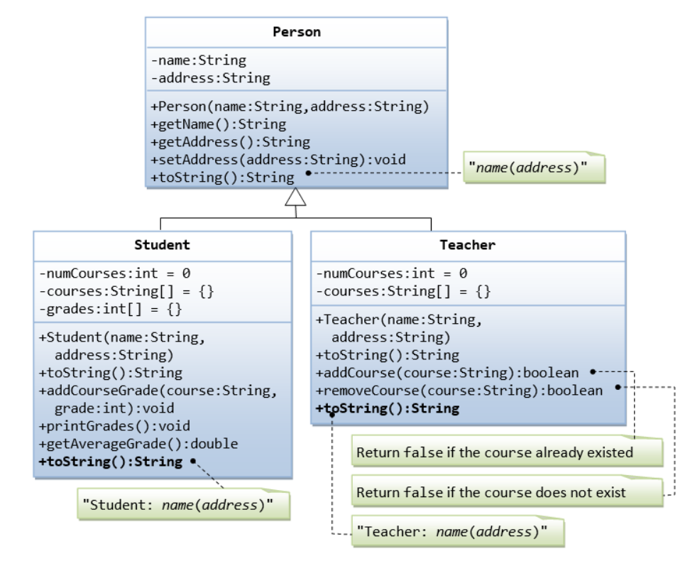

Suppose that we are required to model **students** and **teachers** in our application. We can define a superclass called **Person** to store common properties such as **name** and **address**, and subclasses **Student** and **Teacher** for their specific properties. For students, we need to maintain the courses taken and their respective grades; add a course with grade, print all courses taken and the average grade. Assume that a student takes no more than 30 courses for the entire program. For teachers, we need to maintain the courses taught currently, and able to add or remove a course taught. Assume that a teacher teaches not more than 5 courses concurrently.

Write the Test Driver(**testDriver.java**) code to check the above implementation:

public class TestPerson {

public static void main(String[] args) {

Student s1 = new Student("Subhajit", "Kolkata");

s1.addCourseGrade("B.tech(CSE)", 97);

s1.addCourseGrade("M.tech(CSE)", 68);

s1.printGrades();

System.out.println("Average is " + s1.getAverageGrade());

Teacher t1 = new Teacher("Susovan Kumar Pan", "Kolkata");

System.out.println("\n"+t1);

//Teacher: Paul Tan(8 sunset way)

String[] courses = {"B.tech(CSE)", "B.tech(IT)", "B.tech(CSE)"};

for (String course: courses) {

if (t1.addCourse(course)) {

System.out.println(course + " added");

} else {

System.out.println(course + "already in list,cannot be added");

}

}

for (String course: courses) {

if (t1.removeCourse(course)) {

System.out.println(course + " removed");

} else {

System.out.println(course + "Not in list,cannot be removed");

}

}

}

}

**Expected Output:**

Student: Subhajit(Kolkata)

B.tech(CSE):97

M.tech(CSE):68

Average is 82.5

Teacher: Susovan Kumar Pan(Kolkata)

B.tech(CSE) added

B.tech(IT) added

B.tech(CSE)already in list,cannot be added

B.tech(CSE) removed

B.tech(IT) removed

B.tech(CSE)Not in list,cannot be removed

1. Write the codes for all the classes shown in the class diagram. Mark all the overridden methods with annotation @Override.

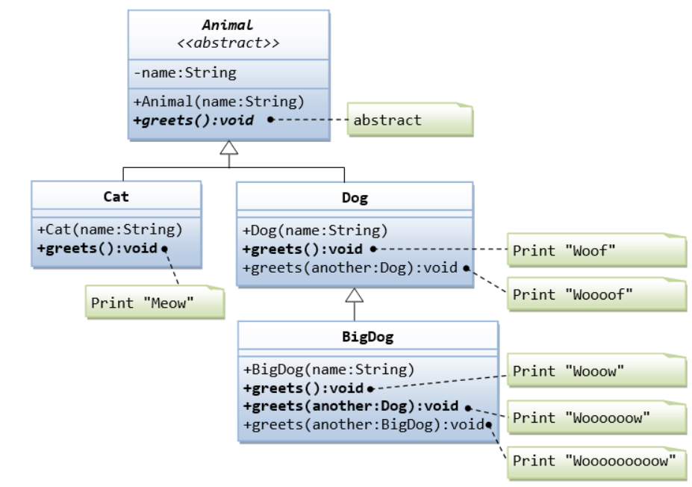

Write the TestAnimal(**TestAnimal.java**) code to check the above implementation:

public class TestAnimal {

public static void main(String[] args) {

// TODO code application logic here

Cat cat1=new Cat("Tom");

cat1.greets();

Dog dog1=new Dog("Pug");

dog1.greets();

dog1.greets(dog1);

BigDog bigDog1=new BigDog("Big Pug");

bigDog1.greets();

bigDog1.greets(bigDog1);

}

}

**Expected Output**:

Meow

Woof

Woooof

Wooow

Woooooooooooooow