**Day 10: Coding Challenge: React & ASP.NET Core API Integration**

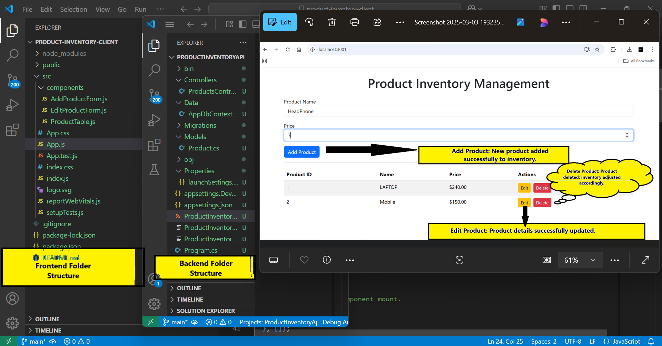***Folder Structure:***

**Image 1:**