**Coding Challenge: E-Commerce Product Management using Redux & .NET Core API**

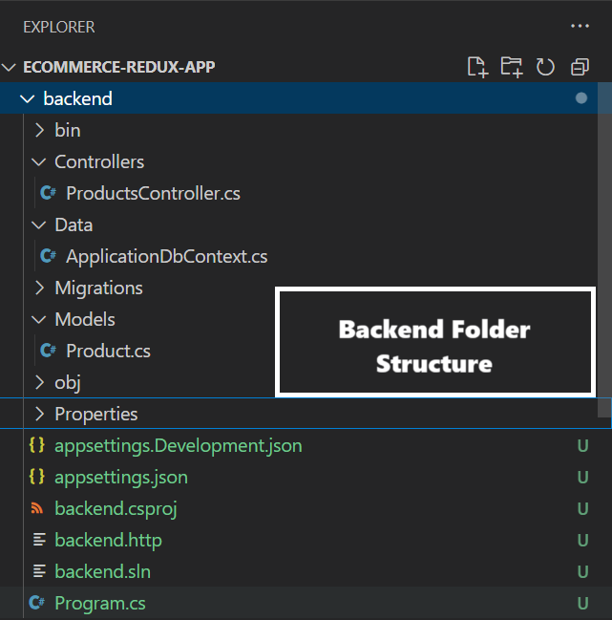**Folder Structure:**Backend:

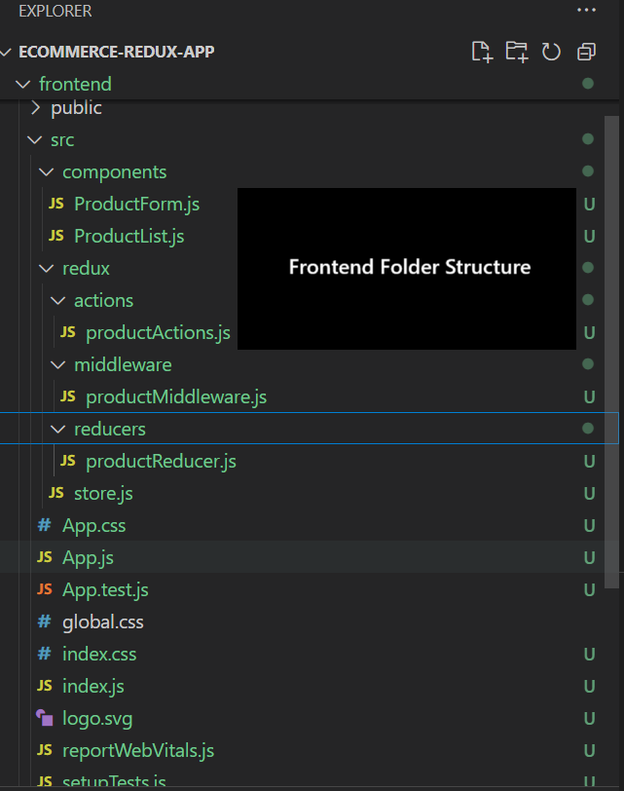Frontend:

Image 1:

Image 2:

