**Day 6 CC5: React Coding Challenge: State Management & Progressive Web Apps**

**Image 1:**

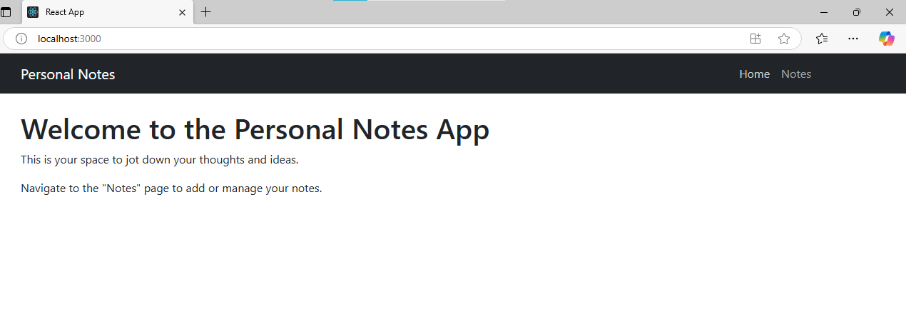

**Image 2:**

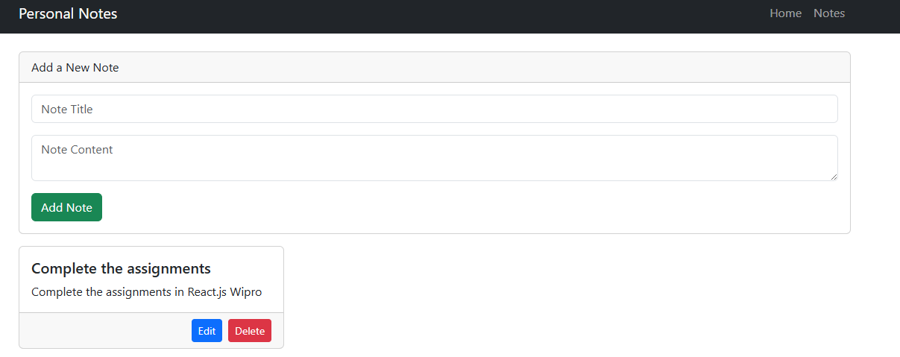

**Image 3:**