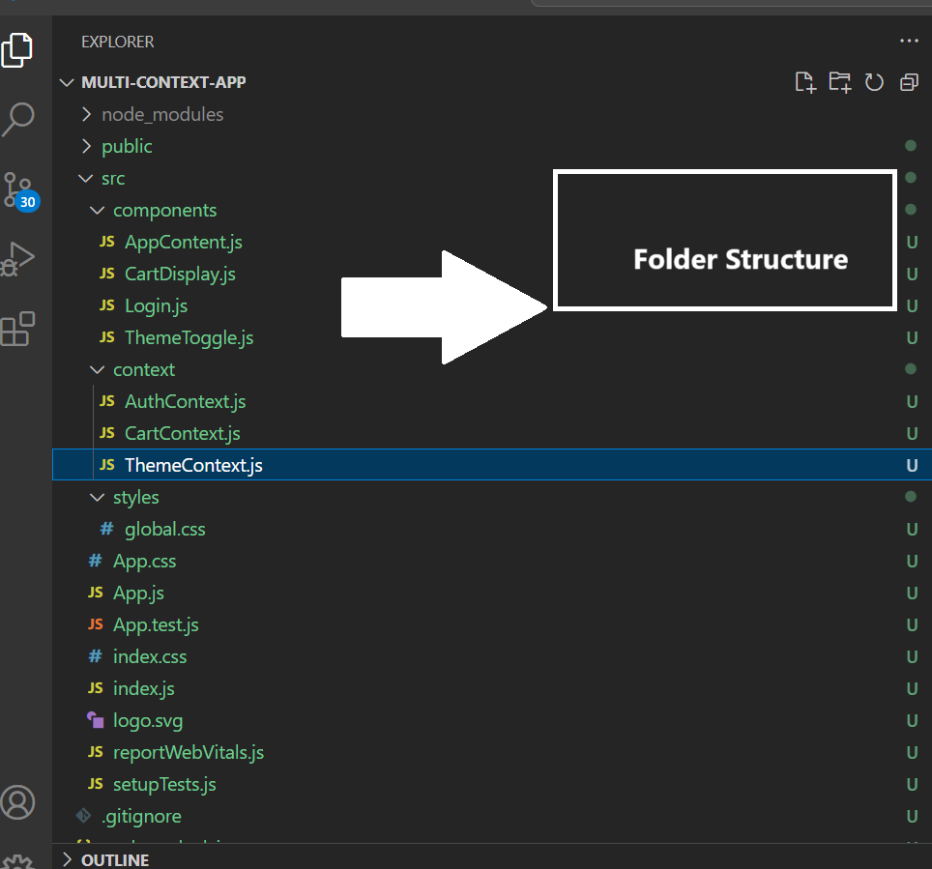**Day 8: Coding Challenge: Multi-Context Integration & useReducer in Context API  
  
Folder Structure:**

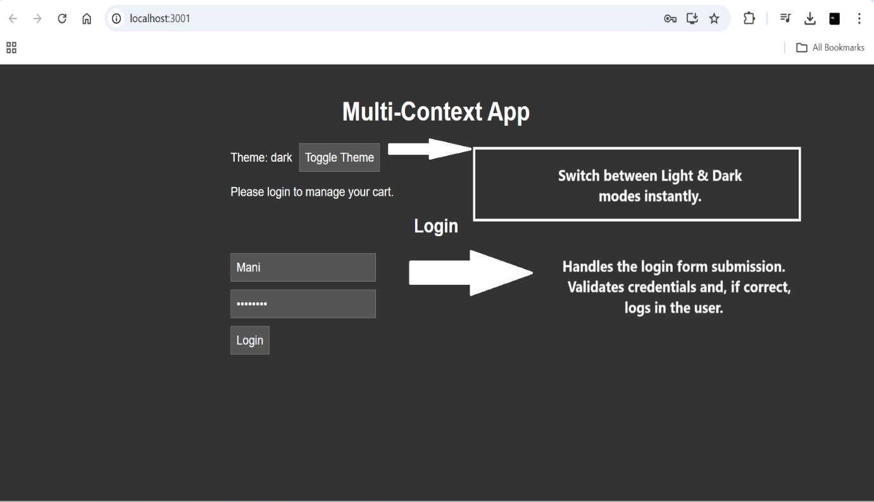**Image 1:**

**Image 2:**