**INSTALL CHEFSERVER (UBUNTU 16.04)**

Instances: One Ubuntu 16.04 (T2.MEDIUM) and 1 Windows 2012R2Base(T2.MEDIUM)

1. sudo vi /etc/hosts

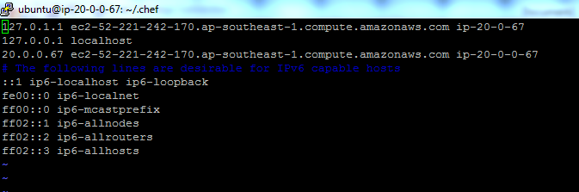

2 Now install chef server from

[https://downloads.chef.io/chef-server](https://downloads.chef.io/chef-server 3)

[3](https://downloads.chef.io/chef-server 3) wget <https://packages.chef.io/files/stable/chef-server/12.15.7/ubuntu/16.04/chef-server-core_12.15.7-1_amd64.deb>

4. sudo dpkg -i chef-server*.deb

5. sudo chef-server-ctl reconfigure

5 sudo chef-server-ctl status

6 mkdir ~/.chef

If success now start creating organization and users

  sudo chef-server-ctl user-create susritha sai munukutla [susrithasai94@gmail.com](mailto:susrithasai94@gmail.com) admin123 --filename ~/.chef/susritha.pem

  sudo chef-server-ctl org-create virtusa virtusacompany --association_user susritha --filename ~/.chef/virtusa.pem

=========Now start creating Node(chef-client)/WorkStation======

Install chefDk <https://downloads.chef.io/chefdk>

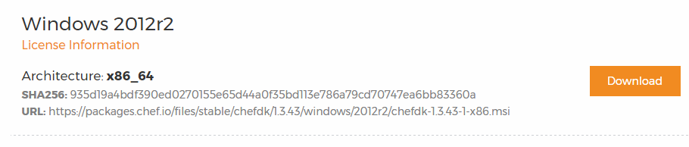

Download this package

<https://packages.chef.io/files/stable/chefdk/1.3.43/windows/2012r2/chefdk-1.3.43-1-x86.msi>

Now check : chef –version

Git –version

* chef generate app chef-repo

This generates default chef-repo with cookbooks

* cd chef-repo
* mkdir .chef
* cd .chef
* Now copy organization and users RSA Private Key Files ie virtusa.pem and susritha.pem to .chef folder
* Now create knife.rb file

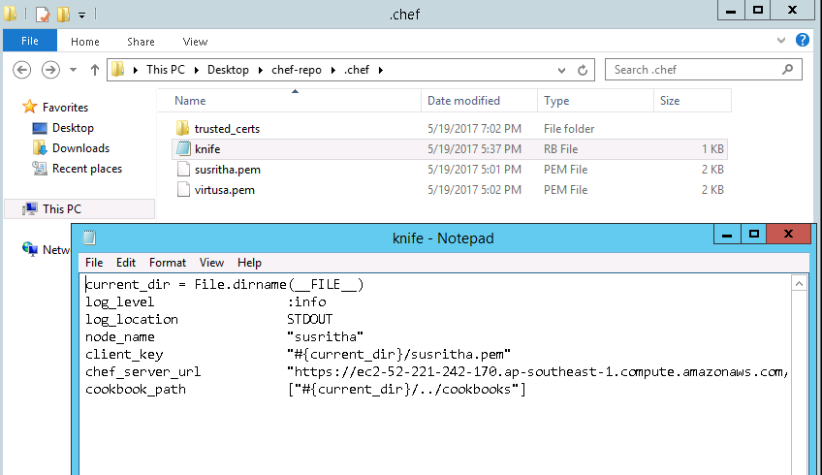

* Ie by following above screenshot

>>knife.rb

current_dir = File.dirname(__FILE__)

log_level :info

log_location STDOUT

node_name "susritha"

client_key "#{current_dir}/susritha.pem"

chef_server_url "https://ec2-52-221-242-170.ap-southeast-1.compute.amazonaws.com/organizations/virtusa"

cookbook_path ["#{current_dir}/../cookbooks"]

* Save those files in current location
* Now : knife ssl fetch

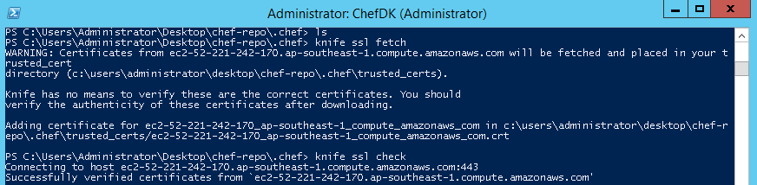

This will create trusted_certs

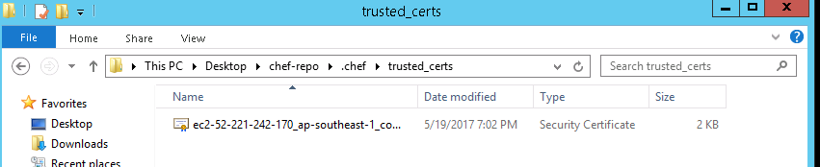

* Then knife ssl check
* Now bootstrap your node with chef-server

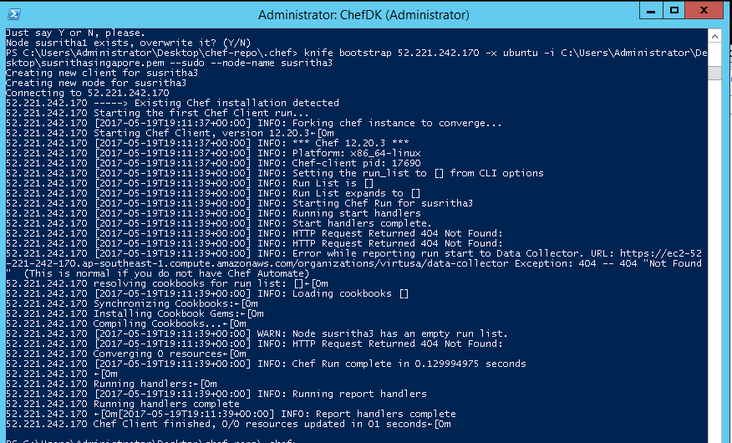

* Bootstrapping a client server will install the chef-client onto the client server .Now go to chef-server and run chef-client
* 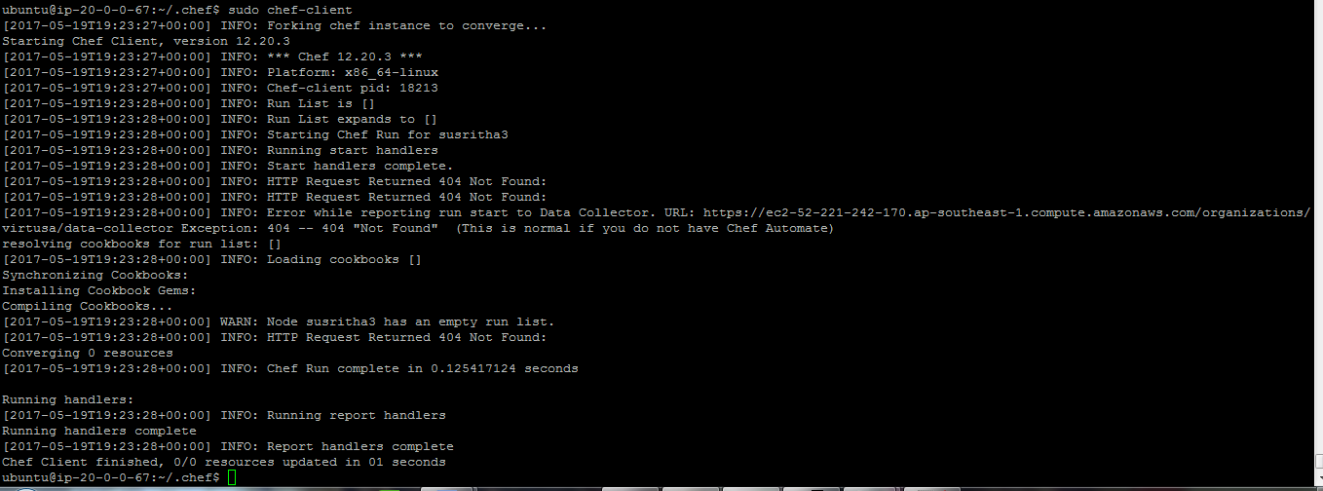

Now start Uploading Cookbooks to your server : Go to Your Node (Workstation)

Cd chef-repo/cookbboks (go into cookbooks path and start uploading)

knife cookbook upload chef-repo

knife cookbook list

knife node list

knife node run_list add susritha3 'recipe[chef-repo::default]'

knife cookbook upload chef-repo

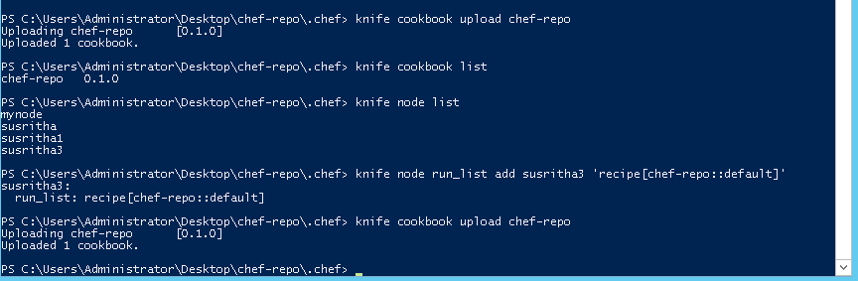

Now run :

Sudo chef-client

