MindfulAI: Real-Time Mental Health Chatbot with Emotion Recognition

Student1: Antara Chakraborty, BCA 2nd Year Student, Computational Sciences, Brainware University, Kalyani, India
Student2:Susruta Chatterjee, BCA 2nd Year Student, Computational Sciences, Brainware University, Ashoknagar, India
Student3:Risabh Ghosh,BTech CSE 2nd Year, BTech-CSE, Brainware University, Ashoknagar, India
Student4:Joyjeet Debnath, Electronics & Communication 2nd Year, Electronic & Communication, Techno Main Salt Lake, Ashoknagar, India
Student5:Atanu Das,Computer Science & Engineering 2nd Year, Computer Science & Engineering, Techno Main Salt Lake, Ashoknagar, India

OVERVIEW OF THE PROJECT
The rising prevalence of emotional distress, academic burnout, and severe anxiety among youth and students has highlighted a critical gap in accessible mental healthcare. While professional therapy is invaluable, the immediate moments of crisis—such as a pre-exam panic attack or sudden depressive episodes—often occur when professional help is unreachable. To address this, we present 'MindfulAI,' a highly responsive, browser-based artificial intelligence companion engineered to provide immediate, empathetic, and evidence-based mental health interventions. MindfulAI operates not just as a chatbot, but as an active emotional sensor that dynamically reshapes its environment to support the user’s current mental state.
At the core of the project is a sophisticated Conversational AI engine powered by a Large Language Model (Llama-3.1 via the Groq API), which is specifically prompt-engineered to emulate a psychologically safe, supportive, and non-judgmental companion named 'Mira.' Unlike standard generative AI, Mira’s pipeline is reinforced with a proprietary, client-side 'Emotion Detection Engine.' This engine performs real-time heuristic sentiment analysis on the user's text to categorize their dominant emotional state into specific vectors, such as Stress, Anxiety, Sadness, Burnout, or Anger.
Furthermore, the system introduces a unique 'Typing Stress Detector' which tracks the user’s Words-Per-Minute (WPM) cadence. If erratic or hyper-accelerated typing is detected—a common physiological symptom of a panic attack—the interface visually intervenes, gently prompting the user to pause and breathe. To provide holistic stabilization, MindfulAI integrates an automated 'Real-Time Music Therapy' module. Upon detecting a shift in the user's emotional state, the system dynamically curates and embeds specific therapeutic audio playlists continuously fetched via YouTube's iframe API. For instance, if severe stress is detected, the system auto-populates 'Focus Lo-Fi' tracks; for sadness, it queues 'Uplifting Acoustics.'
Recognizing the severe toll of academic pressure, a dedicated 'Student Wellness Hub' is integrated directly into the platform. This module features a localized Burnout Self-Assessment questionnaire algorithmically designed to identify early symptoms of academic exhaustion. Furthermore, to aid in cognitive load management, the hub includes a built-in Pomodoro study timer and interactive study-break intervention guides.
Safety and early crisis intervention are the highest priorities of MindfulAI. The platform features an instantly accessible 'Panic Mode' override. At the click of a button, the standard interface is replaced with an emergency grounding overlay. This includes a pulsing visual ring for guided breathing synchronization (specifically the 4-7-8 and Box Breathing techniques) and an interactive 5-4-3-2-1 sensory grounding exercise. Additionally, localized emergency hotline numbers (e.g., AASRA, iCall) are hard-coded into the interface, prioritizing the user's safety above all else.
The architecture of MindfulAI is built strictly on lightweight, vanilla web technologies (HTML5, CSS3, JavaScript) utilizing modern 'Glassmorphism' UI/UX principles to ensure a visually calming and frictionless user experience. Importantly, all behavioral data and chat history are deliberately stored on the client's local machine via localStorage, ensuring zero data harvesting and total privacy for sensitive mental health conversations. Ultimately, MindfulAI stands as a powerful, scalable first-line defense tool, providing compassionate intervention precisely at the moment it is needed most.

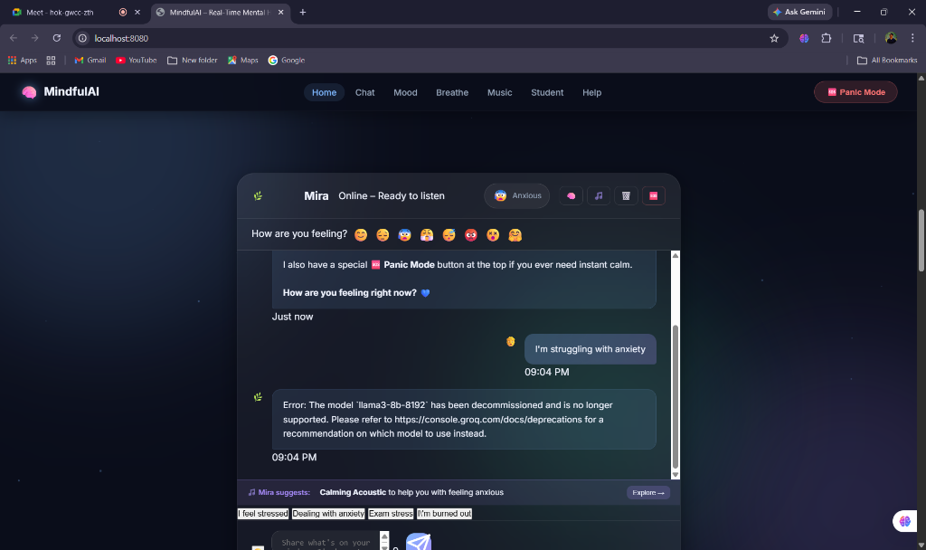 | 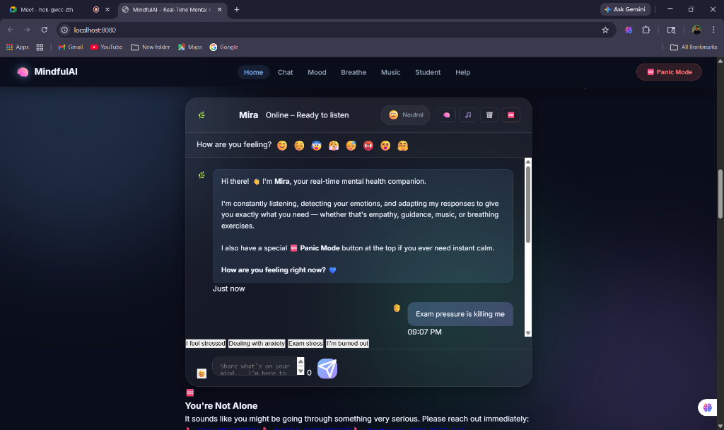
Fig 1. : MinfulAI Chat Interface & Emotion Panel | Fig 2. : Student Wellness Hub UI

