
PROJECT REPORT
ON
PUBLIC PROCUREMENT COLLUSION ANALYTICS WITH BID GRAPHS AND EXPLAINABLE ANOMALY SCORING
IN THE PROGRAMME
BACHELOR OF SCIENCE (DATA SCIENCE)
SUBMITTED BY
MR. NAVNIT SHARMA
TY BSc. DATA SCIENCE
TDDS021B
SEMESTER V
UNDER THE GUIDANCE OF
MR. NITISH KUMAR
ACADEMIC YEAR
2026 – 2027

CERTIFICATE
This is to certify that Mr. NAVNIT SHARMA of THIRD year of Bachelor of Science in Data Science, Div.: B, Roll No. TDDS021B of Semester V (2026 - 2027) has successfully completed the Project on the topic PUBLIC PROCUREMENT COLLUSION ANALYTICS WITH BID GRAPHS AND EXPLAINABLE ANOMALY SCORING as per the guidelines of KES' Shroff College of Arts and Commerce, Kandivali (W), Mumbai- 400067.

Teacher In-charge: | Principal
Mr. Nitish Kumar | Dr. L. Bhushan
PROFORMA FOR THE APPROVAL PROJECT PROPOSAL
PRN No.: …………………… | Roll no: ……………………

1. Name of the Student: -
________________________________________________________________
2. Title of the Project: -
________________________________________________________________
3. Name of the Guide: -
________________________________________________________________

Signature of the Student | Signature of the Guide
Date: …………………… | Date: ……………………

Signature of the Coordinator
Date: ……………………
ABSTRACT
Public procurement is meant to be competitive: several vendors bid for a government tender and the lowest valid bid wins. Bid rigging breaks this. A group of vendors (a cartel) secretly decides who will win, the others submit deliberately high cover bids, take turns winning (bid rotation) or stay out of each other's areas (market allocation), and the public pays more. Reviewing thousands of tenders by hand makes such coordinated behaviour very hard to find.
This project builds an end-to-end collusion analytics system in Python that analyses tender, vendor and bid data, scores every tender for collusion risk, ranks the tenders into an investigation queue and explains in plain language why each case was flagged. The pipeline cleans and validates the data with pandas, links duplicate and shell vendor identities with fuzzy entity resolution (RapidFuzz), engineers pricing, participation and vendor-history features, builds a bipartite tender–vendor graph and a vendor co-bidding network with NetworkX (centrality measures and community detection), compares a rule-based red-flag baseline with a LightGBM risk-ranking model, and explains the model with SHAP. Results are served through a FastAPI REST API and a Streamlit + Plotly investigator dashboard, stored in a relational database through SQLAlchemy, packaged with Docker and tested with pytest.
Because real labelled cartel data is not publicly available, the system is evaluated on a synthetic procurement benchmark with known answers: 400 tenders, 104 vendor records and 1,842 bids across seven Maharashtra departments, with 80 collusive tenders (20%) planted by three cartel rings and four alias vendors. In 5-fold stratified cross-validation the LightGBM ranker reached a ROC-AUC, PR-AUC and Precision@10 of 1.00, and every planted collusive tender appeared in the top 80 of the queue. The transparent red-flag baseline reached a ROC-AUC of 0.987 and Precision@80 of 93.8%. Entity resolution linked all four planted aliases but also merged eight unrelated vendors (precision 33%).
The near-perfect scores show that the pipeline works end to end, but also that the synthetic collusion patterns are much easier to separate than real cartels. The report therefore documents the evaluation honestly, including a feature-family ablation, a time-based split, seed-stability checks, the limits of entity resolution and the parts of the original blueprint (experiment tracking, monitoring, authentication and an investigator feedback loop) that are left as future work. The system never declares that a vendor is guilty: it only prioritises and explains cases for human investigation.
ACKNOWLEDGEMENT
I would like to express my sincere gratitude to everyone who contributed to the completion of this project, Public Procurement Collusion Analytics with Bid Graphs and Explainable Anomaly Scoring. First and foremost, I thank my project guide, Mr. Nitish Kumar, for his guidance, feedback and encouragement throughout the project.
I am grateful to Dr. L. Bhushan, Principal, and to the faculty of the Department of Data Science of KES' Shroff College of Arts and Commerce for providing the opportunity, resources and environment to carry out this work.
I also acknowledge the open-source communities behind pandas, NumPy, RapidFuzz, NetworkX, scikit-learn, LightGBM, SHAP, FastAPI, Streamlit, Plotly, SQLAlchemy, pytest and Docker, and the competition authorities and researchers whose published guidance on detecting bid rigging (the OECD and the Competition Commission of India) shaped the red flags used in this project.
Finally, I am grateful to my family and friends for their constant support and encouragement.

Navnit Sharma
DECLARATION
I hereby declare that the project entitled, “PUBLIC PROCUREMENT COLLUSION ANALYTICS WITH BID GRAPHS AND EXPLAINABLE ANOMALY SCORING” done at KES' Shroff College, has not been in any case duplicated to submit to any other university for the award of any degree. To the best of my knowledge other than me, no one has submitted to any other university.
The project is done in partial fulfilment of the requirements for the award of degree of BACHELOR OF SCIENCE (DATA SCIENCE) to be submitted as the Semester V project as part of our curriculum.

Name and Signature of the Student
TABLE OF CONTENTS
SR. NO. | TOPIC | PAGE NO.
1 | INTRODUCTION | 1-5
1.1 | SIGNIFICANCE | 1
1.2 | OBJECTIVES | 2
1.3 | PURPOSE AND SCOPE | 3
1.3.1 | PURPOSE | 3
1.3.2 | SCOPE | 3
1.4 | APPLICABILITY | 4
1.5 | ACHIEVEMENTS | 4
2 | SYSTEM ANALYSIS | 6-11
2.1 | EXISTING SYSTEM | 6
2.2 | PROPOSED SYSTEM | 6
2.3 | REQUIREMENT ANALYSIS | 7
2.4 | HARDWARE REQUIREMENTS | 8
2.5 | SOFTWARE REQUIREMENTS | 8
2.6 | SURVEY OF TECHNOLOGY | 9
3 | SYSTEM DESIGN | 12-19
3.1 | MODULE DIVISION | 12
3.2 | GANTT CHART | 13
3.3 | E-R DIAGRAM | 14
3.4 | DATA FLOW REPRESENTATION | 14
3.4.1 | DATA FLOW DIAGRAM | 15
3.5 | UML DIAGRAMS | 16
3.5.1 | CLASS DIAGRAM | 16
3.5.2 | SEQUENCE DIAGRAM | 17
3.5.3 | STATE CHART DIAGRAM | 18
3.5.4 | USE-CASE DIAGRAM | 19
4 | IMPLEMENTATION AND TESTING | 20-27
4.1 | CODE | 20
4.2 | TESTING APPROACH | 24
5 | RESULTS AND DISCUSSIONS | 28-36
5.1 | FUNCTIONALITY EVALUATION | 28
5.2 | MODEL PERFORMANCE | 31
5.3 | USER EXPERIENCE ASSESSMENT | 36
6 | CONCLUSION AND FUTURE WORK | 37-38
6.1 | CONCLUSION | 37
6.2 | FUTURE SCOPE | 37
6.3 | LIMITATIONS | 38
7 | REFERENCES | 39-40

CHAPTER 1 INTRODUCTION
Every year government departments, municipal corporations, hospitals and boards buy road works, medical equipment, IT hardware, school furniture and water-pipeline maintenance through public tenders. A tender is published with an estimated value, vendors submit sealed bids, and the lowest valid bid normally wins. The whole system relies on one assumption: that the vendors are really competing. When they are, the price paid by the public is close to a fair market price.
Bid rigging (collusive tendering) breaks that assumption. A group of vendors, called a cartel or ring, agrees in advance who will win a tender. The other members then help the chosen winner by submitting cover bids that are deliberately too high to win, by taking turns to win across a series of tenders (bid rotation), or by staying out of each other's regions or departments (market allocation). Some cartels also register shell companies with slightly different names or the same address to make a ring look like independent competition. From the outside every tender still looks competitive, but the winning price is inflated and the public loses money.
The signals of collusion are spread across many tenders: the same vendors keep appearing together, the winner keeps changing in a fixed order, losing bids sit far above the winner, or a vendor never faces competition in one city. An auditor reviewing one tender at a time cannot see these patterns, and no audit or vigilance team can read thousands of tenders by hand. What is needed is a system that looks at all tenders, vendors and bids together, ranks the cases that most deserve a closer look, and explains why.
This project, Public Procurement Collusion Analytics with Bid Graphs and Explainable Anomaly Scoring (capstone topic BDS-31), builds such a system in Python. It cleans and validates the procurement data, resolves duplicate and alias vendor identities with fuzzy matching, engineers pricing and participation features, models the market as a bid graph (tenders and vendors as nodes, bids as edges) and a vendor co-bidding network, scores every tender with a rule-based baseline and a LightGBM machine-learning ranker, explains each score with SHAP, and presents a prioritised investigation queue through a FastAPI service and a Streamlit dashboard.
Because real tender data with confirmed cartel labels is not publicly available, the project uses a synthetic procurement benchmark: 400 tenders, 104 vendor records and 1,842 bids, in which three cartel rings and four alias vendors were planted on purpose. Since the true answer is known, the system can be measured with the metrics required by the capstone brief: precision at top-k, injected-ring recovery, false-positive rate, ranking stability and entity-resolution accuracy.
An important boundary is kept throughout the project: the system never declares that a vendor is guilty. It identifies and explains unusual patterns and prioritises cases for human investigation.

1.1 SIGNIFICANCE
Public procurement is one of the largest channels of government spending, and competition authorities such as the OECD and the Competition Commission of India (CCI) treat bid rigging as one of the most harmful forms of anti-competitive behaviour. Even a small overcharge on every rigged contract adds up to a large loss of public money, and it also shuts honest firms out of the market.
The significance of this project lies in four points:
- It moves from single tenders to networks. Classic red flags ("only one bidder", "large gap between first and second bid") look at one tender at a time. This project also looks at who bids with whom across all tenders, using a bipartite tender–vendor graph, a co-bidding network, centrality measures and community detection.
- It deals with messy identities. Cartels hide behind name variants and shell companies. A fuzzy entity-resolution step links "Kestrel Titan Pvt Ltd" and "Kestrel Titan Private Limited" to one canonical vendor before any feature is computed.
- It explains every decision. An auditor cannot act on a black-box score. Each case in the queue carries the baseline red flags that fired and a SHAP-based sentence naming the features that pushed its score up.
- It is measured against a known answer. Because the collusion was injected deliberately, the project can report how many planted cases were recovered, how many honest tenders were wrongly flagged, and how well aliases were resolved, rather than only showing a dashboard.
From an academic point of view, the project brings together data engineering (cleaning, validation and relational storage), record linkage, graph analytics, supervised machine learning, model explainability and software engineering (REST API, dashboard, tests and containers) in one working prototype.

1.2 OBJECTIVES
The main objective of this project is to build a system that analyses tender, vendor and bid data, identifies unusual bidding patterns, ranks cases for investigation and explains why each case was flagged. The specific objectives are:
- To design a relational data model for tenders, vendors and bids, and to generate a realistic synthetic dataset with controlled collusion patterns (cover bidding, bid rotation and market allocation) and alias vendors, together with a ground-truth file.
- To clean and validate the raw data: remove duplicates, standardise text, parse dates, reject invalid values and enforce referential integrity between tenders, vendors and bids.
- To resolve vendor identities with fuzzy name and address matching, so that aliases and shell companies are mapped to one canonical vendor ID.
- To engineer features describing pricing (bid ratios, spread, coefficient of variation, gap between the winner and the runner-up), participation and co-bidding, and the historical behaviour of the winning vendor.
- To build a bipartite tender–vendor graph and a vendor co-bidding network, compute centrality measures and detect dense vendor communities that may be rings.
- To build a transparent baseline red-flag score and an advanced LightGBM risk-ranking model, and to compare them.
- To explain each model score with SHAP and produce a ranked investigation queue with a plain-language rationale for every case.
- To expose the results through a FastAPI REST API and an interactive Streamlit investigator dashboard, and to store them in a relational database.
- To verify the system with automated unit and integration tests, package it with Docker, and evaluate it with precision at top-k, injected-ring recovery, false-positive rate, ranking stability and entity-resolution accuracy.

1.3 PURPOSE AND SCOPE

1.3.1 PURPOSE
The purpose of the system is to help an auditor, vigilance officer or procurement reviewer decide which tenders to examine first. Instead of sampling tenders at random or reacting to complaints, the investigator opens a queue in which tenders are ordered by collusion risk. For each tender the investigator can see the submitted bids, the red flags that fired, the features that drove the model's score, the vendor's co-bidding partners and any alias identities linked to the winner.
A second purpose is transparency. Every score can be traced back to measurable facts about the tender (for example "winning bid at 97.6% of the estimate with a 30.9% spread of bids" or "this pair of vendors bid together 33 times"). This makes the output usable as a starting point for an investigation, not as a verdict.
A third purpose is educational: to demonstrate, on data where the true answer is known, how each stage of an analytics pipeline (cleaning, entity resolution, features, graphs, models and explanations) contributes to the final result, and where each stage can fail.

1.3.2 SCOPE
In scope
- Three datasets that follow the project blueprint: Tenders (ID, date, department, category, location, estimated value, deadline), Vendors (ID, name, address, city, registration ID, industry) and Bids (tender, vendor, amount, rank, status, winner).
- A synthetic benchmark of 400 tenders over one year (January 2025 to January 2026), 7 departments, 7 categories and 8 Maharashtra cities, with three cartel rings and four alias vendors.
- Data cleaning, fuzzy entity resolution, feature engineering, bipartite and co-bidding graphs, community detection, a baseline red-flag scorer, a LightGBM ranker, SHAP explanations and a ranked investigation queue.
- A FastAPI service with six endpoints, a five-tab Streamlit dashboard, SQLite/PostgreSQL persistence, Docker packaging and 15 automated tests.
Out of scope
- Declaring any vendor guilty, blacklisting vendors or taking automatic action: the output is a ranked list for human review.
- Live integration with an e-procurement portal: the CSV data contract is ready for real data, but validation on real tenders is future work.
- User authentication, an investigator feedback loop, experiment tracking with MLflow and production monitoring, which are planned in the blueprint but not implemented in this release (Chapter 6).

1.4 APPLICABILITY
The system is applicable wherever many buyers purchase from many suppliers through competitive bidding:
- Audit and vigilance departments of state governments, municipal corporations and public-sector undertakings, to prioritise which tenders to audit.
- Competition authorities such as the CCI, as a screening tool to find markets where coordinated bidding is likely before opening a formal inquiry.
- E-procurement portal operators, to add automated red-flag screening to the tender evaluation workflow.
- Internal audit teams of large companies, whose purchasing departments run supplier tenders and face the same risk of supplier collusion.
- Anti-corruption researchers, journalists and civil-society groups that analyse open contracting data.
- Academic use, as a teaching example of record linkage, graph analytics, ranking metrics and explainable machine learning on one realistic problem.

1.5 ACHIEVEMENTS
The project achieved the following:
- A complete, reproducible pipeline that runs from synthetic data generation to a ranked and explained investigation queue in about 5.5 seconds on a 2-core machine, with a fixed random seed (42) so that every run gives identical results.
- A synthetic benchmark of 400 tenders, 104 vendor records and 1,842 bids, with 80 collusive tenders (28 cover bidding, 25 bid rotation, 27 market allocation) and 4 planted aliases, plus a ground-truth file for evaluation.
- Fuzzy entity resolution that linked all four planted alias vendors to their parent companies (recall 100%).
- A vendor co-bidding network of 92 canonical vendors and 2,250 edges in which community detection placed every member of the cover-bidding ring and of the bid-rotation ring inside a community flagged as a suspicious dense ring.
- A LightGBM ranker with a 5-fold cross-validated ROC-AUC, PR-AUC and Precision@10 of 1.00, ranking all 80 planted collusive tenders in the top 80 positions of the queue, compared with 93.8% Precision@80 for the rule-based baseline.
- SHAP explanations and baseline red-flag descriptions attached to every tender in the queue.
- A FastAPI service (six endpoints, median response time 1 to 22 ms), a five-tab Streamlit + Plotly dashboard, SQLAlchemy persistence for SQLite or PostgreSQL, a Dockerfile and docker-compose setup, and 15 passing pytest tests.
- An honest evaluation that also reports what does not work yet: entity-resolution precision of 33%, a benchmark that is too easy to separate, explanation text attached even to low-risk tenders, and blueprint stages still to be built.

CHAPTER 2 SYSTEM ANALYSIS

2.1 EXISTING SYSTEM
In most public bodies, the detection of bid rigging is still manual and reactive. A typical process looks like this:
- Tender evaluation committees check each tender on its own: whether the bids are complete, whether the lowest bidder is eligible and whether the price is close to the estimate.
- Audits are done on a sample of tenders, usually chosen by value or at random, long after the contract has been awarded.
- Investigations usually start from a complaint by a losing bidder or a whistle-blower, not from analysis of the data.
- Where checklists exist (for example the OECD checklist for detecting bid rigging), they are applied by hand to individual tenders.
Limitations of the existing system
- No view across tenders. Rotation, repeated co-bidding and market allocation only show up when many tenders are analysed together, which a person reading files one by one cannot do.
- Identity problems. The same company can appear as "Pvt Ltd" in one tender and "Private Limited" in another, or behind a shell company at the same address. Manual review rarely links them.
- No prioritisation. Thousands of tenders are treated as equally suspicious, so limited audit time is spent on low-risk cases.
- Inconsistent and undocumented judgement. Two auditors may reach different conclusions, and the reasons are not recorded in a structured way.
- Late detection. Problems are found after the money has been spent.

2.2 PROPOSED SYSTEM
The proposed system replaces sampling and complaints with a data-driven, explainable ranking of all tenders. Its workflow follows the stages of the project blueprint:
Stage | What the system does | Output
2–5 Data | Generates (or loads) tenders, vendors and bids, and injects known collusion patterns for testing | Raw CSV files + ground truth
6 Cleaning | Removes duplicates, standardises text, parses dates, rejects invalid values, enforces referential integrity | Clean datasets
7 Entity resolution | Fuzzy name and address matching; connected components give one canonical ID per real company | Unified vendor IDs + match log
8 Features | Pricing, co-bidding and winning-vendor history features for every tender | Feature table (400 × 22)
10–11 Graphs | Bipartite tender–vendor graph, co-bidding network, centrality, community detection | Graph features + communities
12 Baseline | Five weighted red-flag rules give a 0–100 score and readable flags | Baseline score
13, 15 Ranking | LightGBM classifier with 5-fold cross-validation; tenders sorted by risk | Investigation queue
14 Explainability | SHAP TreeExplainer turns each score into its main drivers | Explanation per case
16–18 Serving | FastAPI endpoints, Streamlit dashboard, SQL database | API, dashboard, database
20–22 Quality | Unit and integration tests, Docker, evaluation metrics | Test evidence, container, metrics

Advantages of the proposed system
- Every tender is screened, and the investigator starts with the highest-risk cases.
- Patterns across tenders (co-bidding, rotation, dominant winners) become measurable features.
- Alias and shell vendors are linked before analysis, so a ring cannot hide behind name variants.
- Each case comes with readable evidence: the red flags that fired and the features that drove the score.
- The whole pipeline is reproducible, tested and containerised, and can be re-run whenever new data arrives.

2.3 REQUIREMENT ANALYSIS

2.3.1 Functional requirements
ID | Requirement
FR-01 | Generate a synthetic dataset of tenders, vendors and bids with configurable size, collusion rate and random seed, plus ground-truth and alias logs.
FR-02 | Clean tenders, vendors and bids; drop duplicates and non-positive values; keep only bids whose tender and vendor exist.
FR-03 | Detect alias vendors by fuzzy matching of names and addresses and assign a canonical vendor ID to every vendor and bid.
FR-04 | Compute tender-level pricing features, co-bidding features and the winning vendor's historical behaviour.
FR-05 | Build a bipartite tender–vendor graph and a weighted co-bidding network; compute degree, betweenness, clustering and PageRank; detect communities and flag dense rings.
FR-06 | Score every tender with a rule-based red-flag baseline (0–100) and list the flags that fired.
FR-07 | Train a LightGBM model, report cross-validated ROC-AUC, PR-AUC and Precision@10, and rank all tenders by predicted risk.
FR-08 | Attach a SHAP-based explanation to every tender and save the ranked investigation queue.
FR-09 | Provide REST endpoints for health, KPIs, filtered case lists, case details, vendor profiles and network graph data.
FR-10 | Provide a dashboard with KPIs, a filterable queue with CSV export, a case inspector, a network visualiser and an alias audit view.
FR-11 | Load processed tables into a relational database (SQLite by default, PostgreSQL through a connection URL) and allow SQL queries.

2.3.2 Non-functional requirements
Category | Requirement
Reproducibility | Fixed random seeds; the full pipeline re-creates every output from code.
Explainability | Every flagged case must carry human-readable reasons; no unexplained score is shown.
Responsible use | The system ranks and explains; it never labels a vendor as guilty.
Performance | Full pipeline in seconds on a laptop; API responses well under one second.
Portability | Runs on Windows or Linux with Python, or in Docker containers.
Maintainability | Modular packages (data generation, preprocessing, features, graph, models), docstrings and automated tests.
Usability | Investigators use a web dashboard without writing code.

2.4 HARDWARE REQUIREMENTS
Component | Minimum | Recommended
Processor | Dual-core 64-bit CPU | Quad-core CPU (Intel i5 / AMD Ryzen 5 or better)
RAM | 4 GB | 8 GB or more
Storage | 2 GB free (Python environment + data) | 5 GB free (including Docker images)
Display | 1366 × 768 | 1920 × 1080 for the dashboard
Network | Only for installing packages | Broadband for Docker image builds

The development machine was a Windows laptop. The complete pipeline (data generation, cleaning, entity resolution, features, graphs, training, explanations and ranking) took about 5.5 seconds on a 2-core test machine, so no GPU is required.

2.5 SOFTWARE REQUIREMENTS
Software | Version | Purpose
Python | 3.14 (local), 3.11 (Docker) | Programming language
pandas / NumPy | 3.0 / 2.5 | Data loading, cleaning and feature computation
RapidFuzz | 3.14 | Fuzzy string matching for entity resolution
NetworkX | 3.7 | Bipartite graph, co-bidding network, centrality, communities
scikit-learn | 1.9 | Stratified K-fold cross-validation and metrics
LightGBM | 4.7 | Gradient-boosted risk-ranking model
SHAP | 0.52 | TreeExplainer feature attributions
FastAPI / Uvicorn | 0.142 / 0.54 | REST API and ASGI server
Streamlit / Plotly | 1.64 / 7.1 | Investigator dashboard and interactive charts
SQLAlchemy / psycopg2 | 2.1 / 2.9 | Relational persistence (SQLite or PostgreSQL)
pytest / httpx | 9.1 / 0.28 | Unit and integration testing
joblib | 1.6 | Saving and loading the trained model
Docker / Docker Compose | 24+ / v2 | Containerised deployment
Git / GitHub | 2.x | Version control
Operating system | Windows 10/11 (development) | Also runs on Linux and macOS

2.6 SURVEY OF TECHNOLOGY

2.6.1 Python and pandas
Python is the most widely used language for data science because of its readable syntax and its large ecosystem of libraries. pandas provides the DataFrame, a table structure with labelled columns that supports filtering, grouping, merging and type conversion. In this project pandas is used in every stage: reading CSV files, cleaning, merging bids with tenders and vendors, computing group-wise statistics and writing the processed outputs. NumPy provides the fast numerical arrays underneath pandas and is used for the random generators of the synthetic data and for ranking.

2.6.2 Fuzzy matching and entity resolution (RapidFuzz)
Entity resolution (record linkage) is the task of deciding whether two records describe the same real-world entity. Exact matching fails on "Pvt Ltd" versus "Private Limited" or on a different word order. Fuzzy matching measures how similar two strings are, usually with the Levenshtein edit distance: the number of single-character insertions, deletions and substitutions needed to turn one string into the other, converted into a score from 0 to 100. RapidFuzz is a fast C++ implementation of these measures. The project uses two of them: token_sort_ratio, which sorts the words of each string before comparing (so word order does not matter), and token_set_ratio, which compares the shared and the remaining words of two addresses. Pairs above a threshold are joined in a graph, and each connected component is treated as one company.

2.6.3 Graph analytics (NetworkX)
A procurement market is naturally a bipartite graph: one set of nodes are tenders, the other set are vendors, and an edge means "this vendor bid on this tender". Projecting it onto the vendors gives a co-bidding network in which two vendors are joined if they bid on the same tender, with the edge weight equal to the number of shared tenders. On this network the project computes:
- Degree centrality: the share of other vendors a vendor has bid against.
- Weighted degree (strength): the total number of co-bids.
- Betweenness centrality: how often a vendor lies on the shortest paths between others (a broker between groups).
- Clustering coefficient: how tightly a vendor's partners are connected to each other (closed groups score high).
- PageRank: importance based on being connected to other well-connected vendors.
- Community detection by greedy modularity maximisation (Clauset–Newman–Moore): groups of vendors that bid together much more than chance, and the density of each group (share of possible pairs that are actually connected).
NetworkX is the standard Python library for building and analysing such graphs.

2.6.4 Red-flag screening
Competition authorities publish red flags that indicate possible bid rigging: unusually few bidders, a large and regular gap between the winning bid and the other bids, the same vendors always bidding together, a winner that wins a suspiciously large share of tenders, and winning bids close to the estimate while losing bids are far above it. A weighted rule score turns these flags into a number. It is fully transparent and needs no training labels, which makes it the natural baseline to compare any machine-learning model against.

2.6.5 Gradient boosting (LightGBM)
Gradient-boosted decision trees build an ensemble of small decision trees one after another; each new tree corrects the errors of the trees before it. LightGBM (Microsoft) is a fast implementation that grows trees leaf-wise and uses histogram binning. It handles features on different scales without normalisation, captures interactions between features and is one of the strongest methods for tabular data. In this project LightGBM is trained as a binary classifier (collusive or not) and its predicted probability is used to rank tenders.

2.6.6 Evaluation of a ranking: Precision@k and PR-AUC
An investigation team can only open a limited number of cases, so the most relevant metric is Precision@k: of the top k tenders in the queue, what share are truly collusive. ROC-AUC measures how well the score separates the two classes overall, and PR-AUC (average precision) summarises precision across all recall levels and is more informative when positive cases are rare. Stratified K-fold cross-validation splits the data into K parts with the same share of collusive tenders, trains on K−1 parts and tests on the remaining part, so every tender is scored by a model that did not see it during training.

2.6.7 Explainable AI (SHAP)
SHAP (SHapley Additive exPlanations) is based on the Shapley value from cooperative game theory. It splits a model's prediction for one case into additive contributions of each feature, relative to the model's average output, so that the contributions plus the base value equal the prediction. TreeExplainer computes exact SHAP values for tree ensembles such as LightGBM in polynomial time. Positive values push a case towards "collusive", negative values away from it. Averaging the absolute values over all cases gives a global feature importance.

2.6.8 FastAPI
FastAPI is a modern Python web framework for building REST APIs. It uses Python type hints to validate request parameters (for example a risk threshold between 0 and 1) and generates interactive OpenAPI (Swagger) documentation automatically. It runs on the Uvicorn ASGI server.

2.6.9 Streamlit and Plotly
Streamlit turns a Python script into an interactive web application with widgets such as sliders, select boxes, tables, metrics and download buttons, without HTML or JavaScript. Plotly produces interactive charts (histograms, bar charts and network plots) with hover information. Together they provide the investigator dashboard.

2.6.10 SQLAlchemy, SQLite and PostgreSQL
SQLAlchemy is a Python toolkit that talks to many databases through one interface. The project stores tenders, vendors, bids and investigation cases in SQLite (a file-based database that needs no server) by default, and can switch to PostgreSQL simply by changing the DATABASE_URL environment variable.

2.6.11 pytest, Docker and Git
pytest is the standard Python testing framework; FastAPI's TestClient sends requests to the API inside the tests. Docker packages the application and its dependencies into an image that runs the same way on any machine, and Docker Compose starts the API and the dashboard together. Git and GitHub keep the history of every change to the code.

CHAPTER 3 SYSTEM DESIGN
The system is designed as a pipeline of independent modules. Each module reads well-defined tables, does one job and writes its output to disk, so it can be tested on its own and re-run without the others. The diagram below shows the overall architecture, numbered with the stages of the project blueprint.
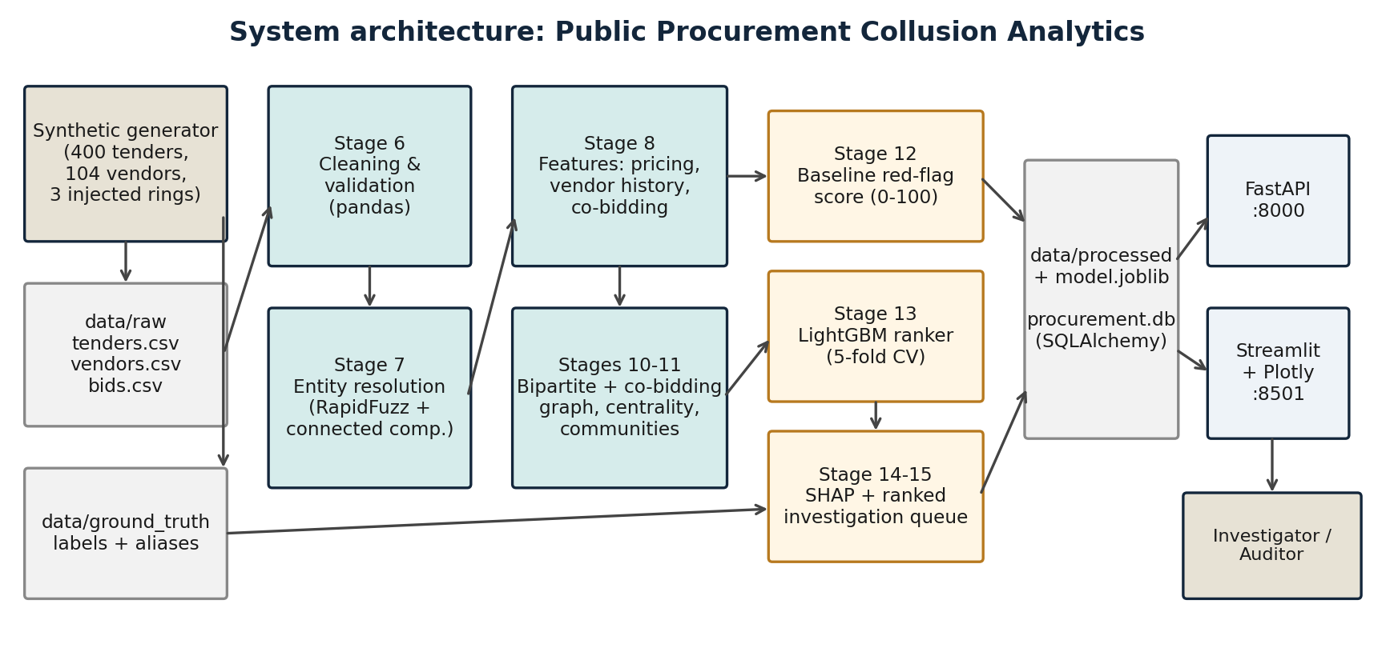
Figure 3.1: System architecture

3.1 MODULE DIVISION
The source code is organised into the following modules (Python packages under src/, plus the API and the dashboard):
Module | Files | Responsibility
1. Data generation | src/data_generation/generator.py | Vendors, tenders and bids; injection of cover-bidding, bid-rotation and market-allocation rings and of alias vendors; ground-truth files
2. Data cleaning | src/preprocessing/cleaner.py | Deduplication, text standardisation, date parsing, value validation, tender duration, referential integrity
3. Entity resolution | src/preprocessing/entity_resolution.py | Name normalisation, fuzzy name and address similarity, connected components, canonical vendor IDs
4. Feature engineering | src/features/feature_engineering.py | Tender pricing features, vendor behavioural features, co-bidding counts, merged feature table
5. Graph analytics | src/graph/bipartite_graph.py | Bipartite graph, co-bidding projection, centrality metrics, community detection and ring flags
6. Baseline model | src/models/baseline_rules.py | Five weighted red-flag rules, 0–100 score, flag descriptions
7. Risk ranker | src/models/anomaly_ranker.py | LightGBM classifier, stratified 5-fold CV, risk probability and priority rank, save / load
8. Explainability | src/models/explainability.py | SHAP TreeExplainer, per-case top factors and plain-language summaries
9. Orchestration | src/pipeline.py, src/train.py | Stages 6–8 pipeline; stages 10–15 and 22 training, ranking and evaluation
10. Persistence | src/database.py | SQLAlchemy engine; loads processed tables into SQLite or PostgreSQL; SQL queries
11. API | api/main.py | FastAPI endpoints for health, KPIs, cases, case detail, vendor profile and network graph
12. Dashboard | dashboard/app.py | Five-tab Streamlit + Plotly investigator interface
13. Tests and deployment | tests/, Dockerfile, docker-compose.yml | 15 pytest tests; container image; API and dashboard services

3.2 GANTT CHART
The work was planned in overlapping weekly phases that follow the blueprint stages, from problem study to the final report.
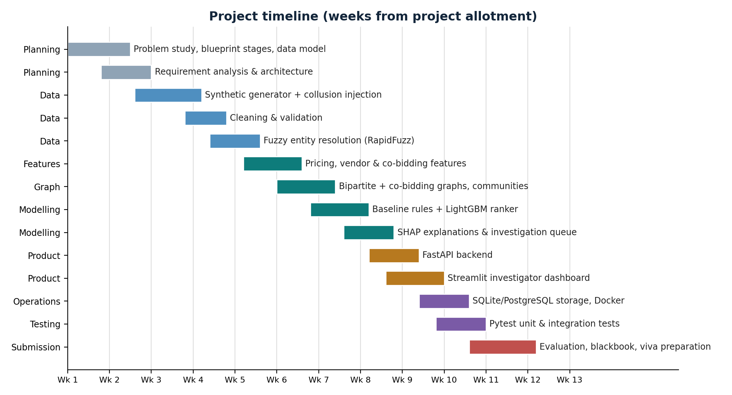
Figure 3.2: Project timeline in weeks from project allotment
Phase | Blueprint stages | Deliverable
Planning | 1 | Problem study, data model, requirements, architecture
Data | 2–7, 9 | Synthetic generator with injected rings, cleaner, entity resolver
Features and graphs | 8, 10, 11 | Feature table, co-bidding network, communities
Modelling | 12–15, 22 | Baseline, LightGBM ranker, SHAP, queue, metrics
Product | 16, 17 | FastAPI service and Streamlit dashboard
Operations and testing | 18, 20, 21 | Database, pytest suite, Docker
Submission | — | Evaluation, blackbook, presentation, viva

3.3 E-R DIAGRAM
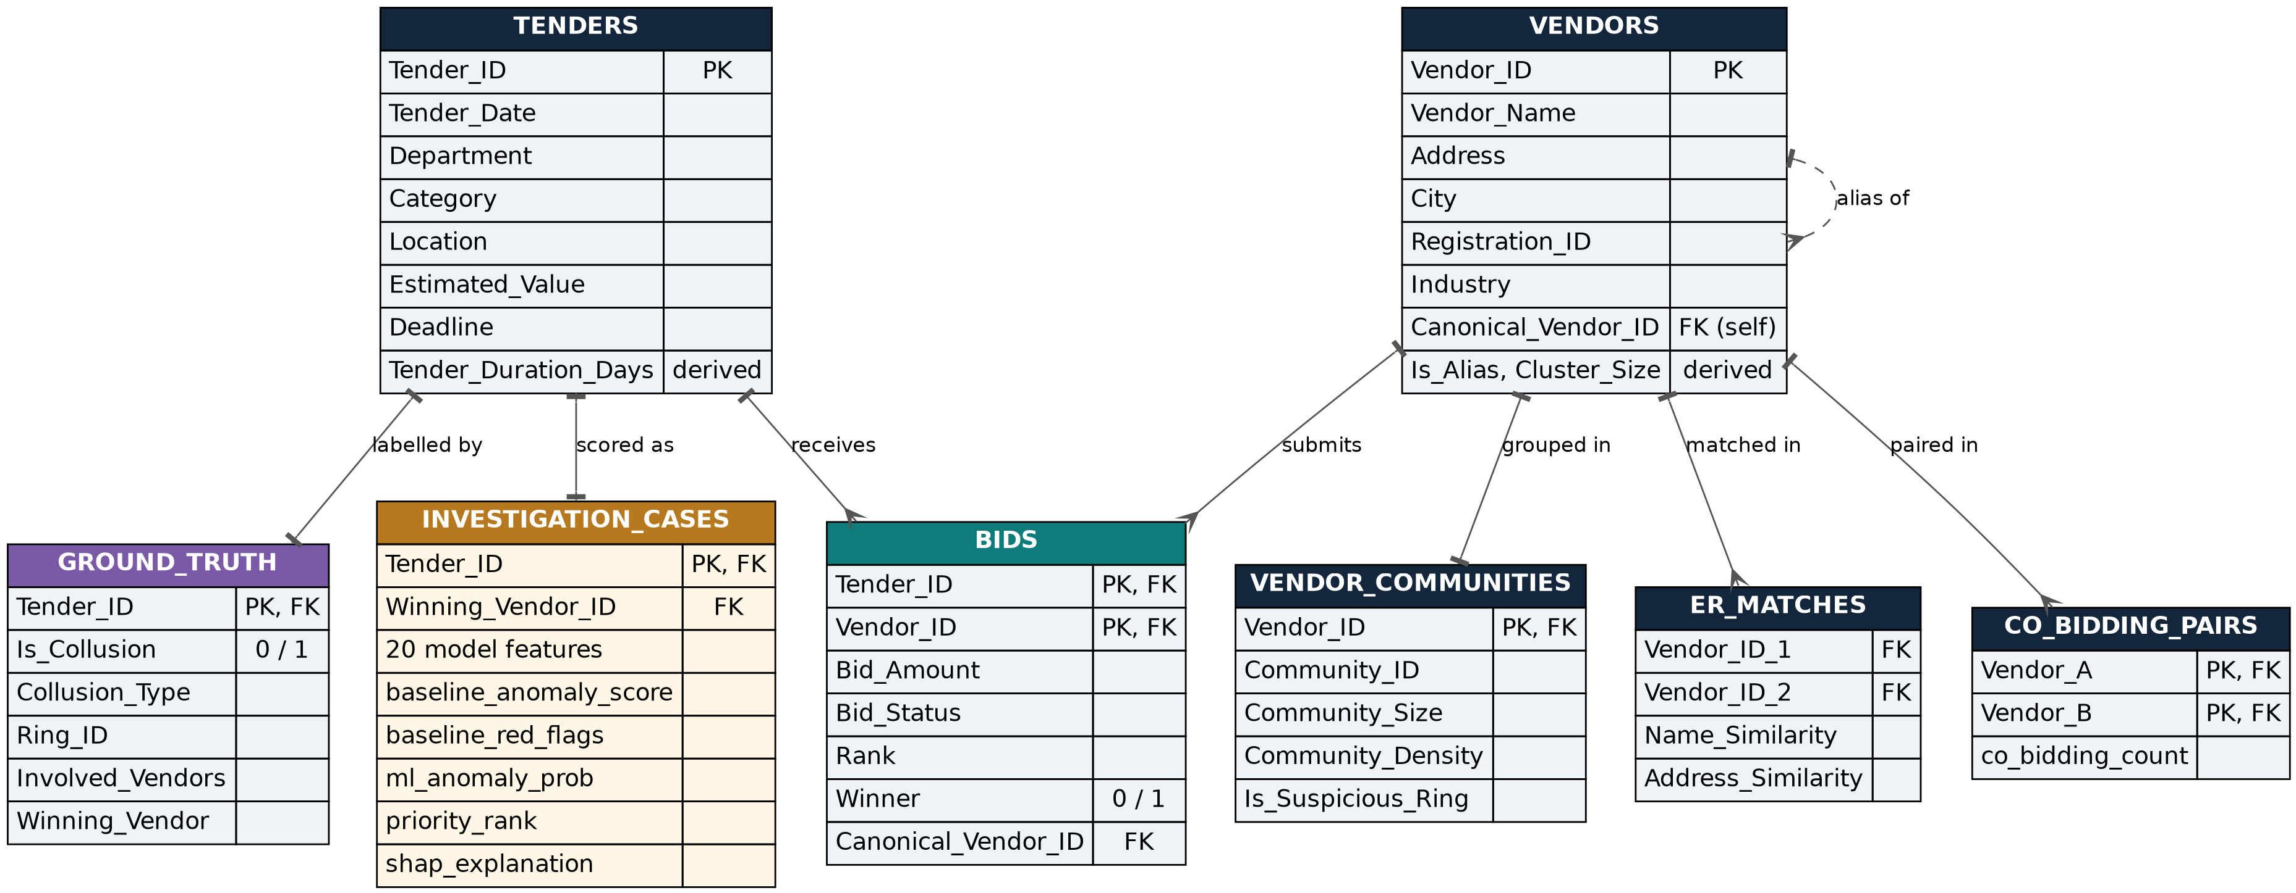
Figure 3.3: Entity-relationship diagram
TENDERS and VENDORS are the master entities. BIDS resolves the many-to-many relationship between them: one tender receives many bids and one vendor submits many bids, and the pair (Tender_ID, Vendor_ID) is unique. Each bid carries its amount, rank and a winner flag (the lowest bid has rank 1). Entity resolution adds a self-relationship on VENDORS: an alias row points to its canonical vendor through Canonical_Vendor_ID, and every bid is mapped to the canonical ID before analysis. ER_MATCHES is the audit log of matched vendor pairs with their name and address similarity. CO_BIDDING_PAIRS stores how many tenders each pair of vendors bid on together, and VENDOR_COMMUNITIES stores the community, its size, its density and the suspicious-ring flag of each vendor. GROUND_TRUTH (one row per tender) is used only for training labels and evaluation. INVESTIGATION_CASES is the final output: one row per tender with its features, baseline score and red flags, model probability, priority rank and SHAP explanation. The database module stores TENDERS, VENDORS, BIDS and INVESTIGATION_CASES as SQL tables.

3.4 DATA FLOW REPRESENTATION
Data moves in one direction, from raw records to the investigator. The context diagram (level 0) shows the system as a single process with its external entities; the level-1 diagram opens it into six processes and five data stores.
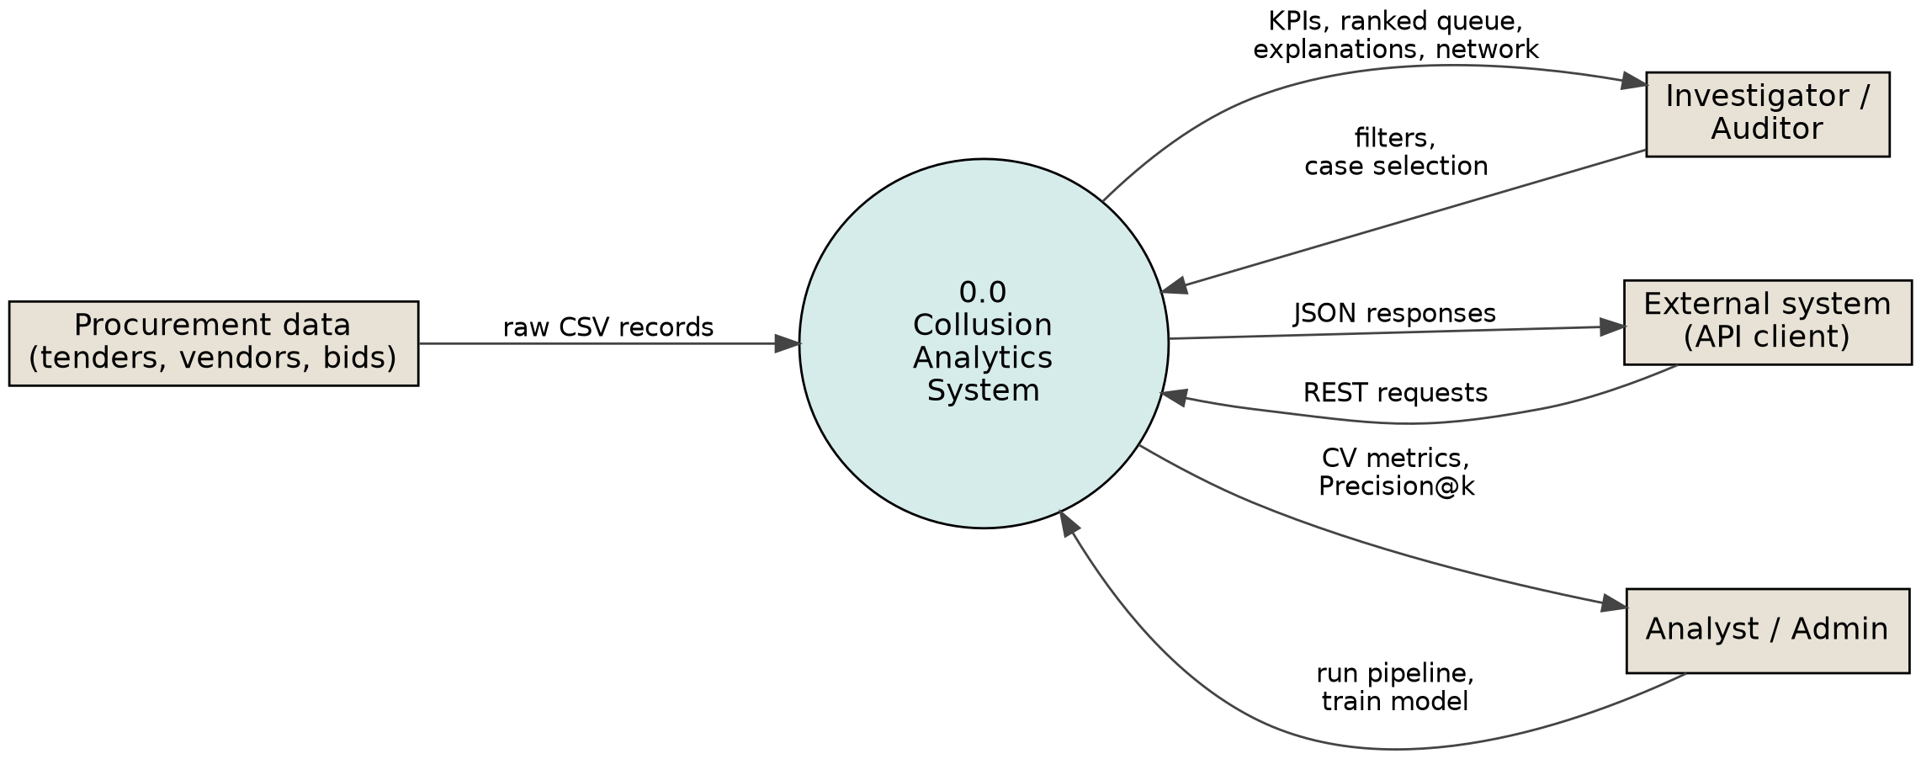
Figure 3.4: Context (level-0) data flow diagram

3.4.1 DATA FLOW DIAGRAM
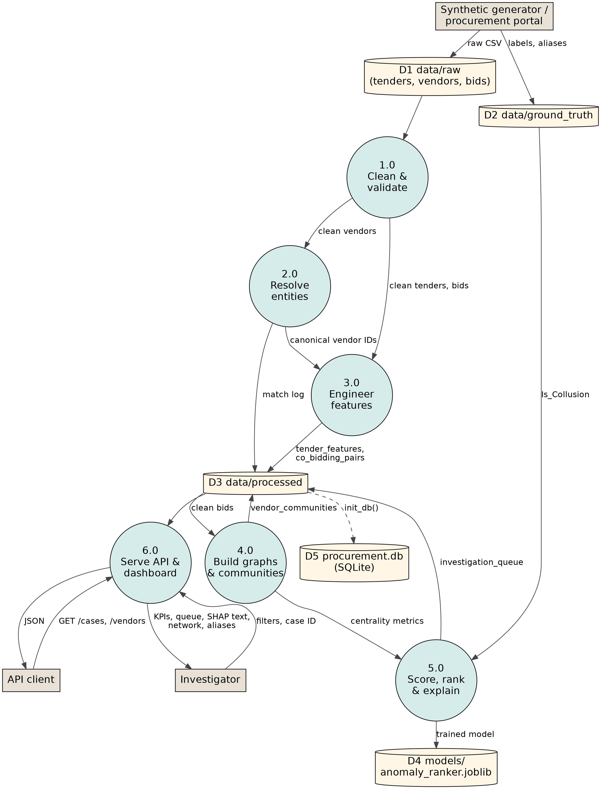
Figure 3.5: Level-1 data flow diagram
Process 1.0 cleans the raw files from D1. Process 2.0 resolves vendor identities and writes the match log. Process 3.0 combines clean tenders, canonical bids and vendors into features and co-bidding pairs (D3). Process 4.0 builds the graphs, writes the vendor communities and passes centrality metrics to process 5.0, which also reads the labels from D2, trains and saves the model (D4) and writes the ranked investigation queue (D3). Process 6.0 serves the processed data to the investigator through the dashboard and to external systems through the API; the database D5 is loaded from D3 on demand.

3.5 UML DIAGRAMS

3.5.1 CLASS DIAGRAM
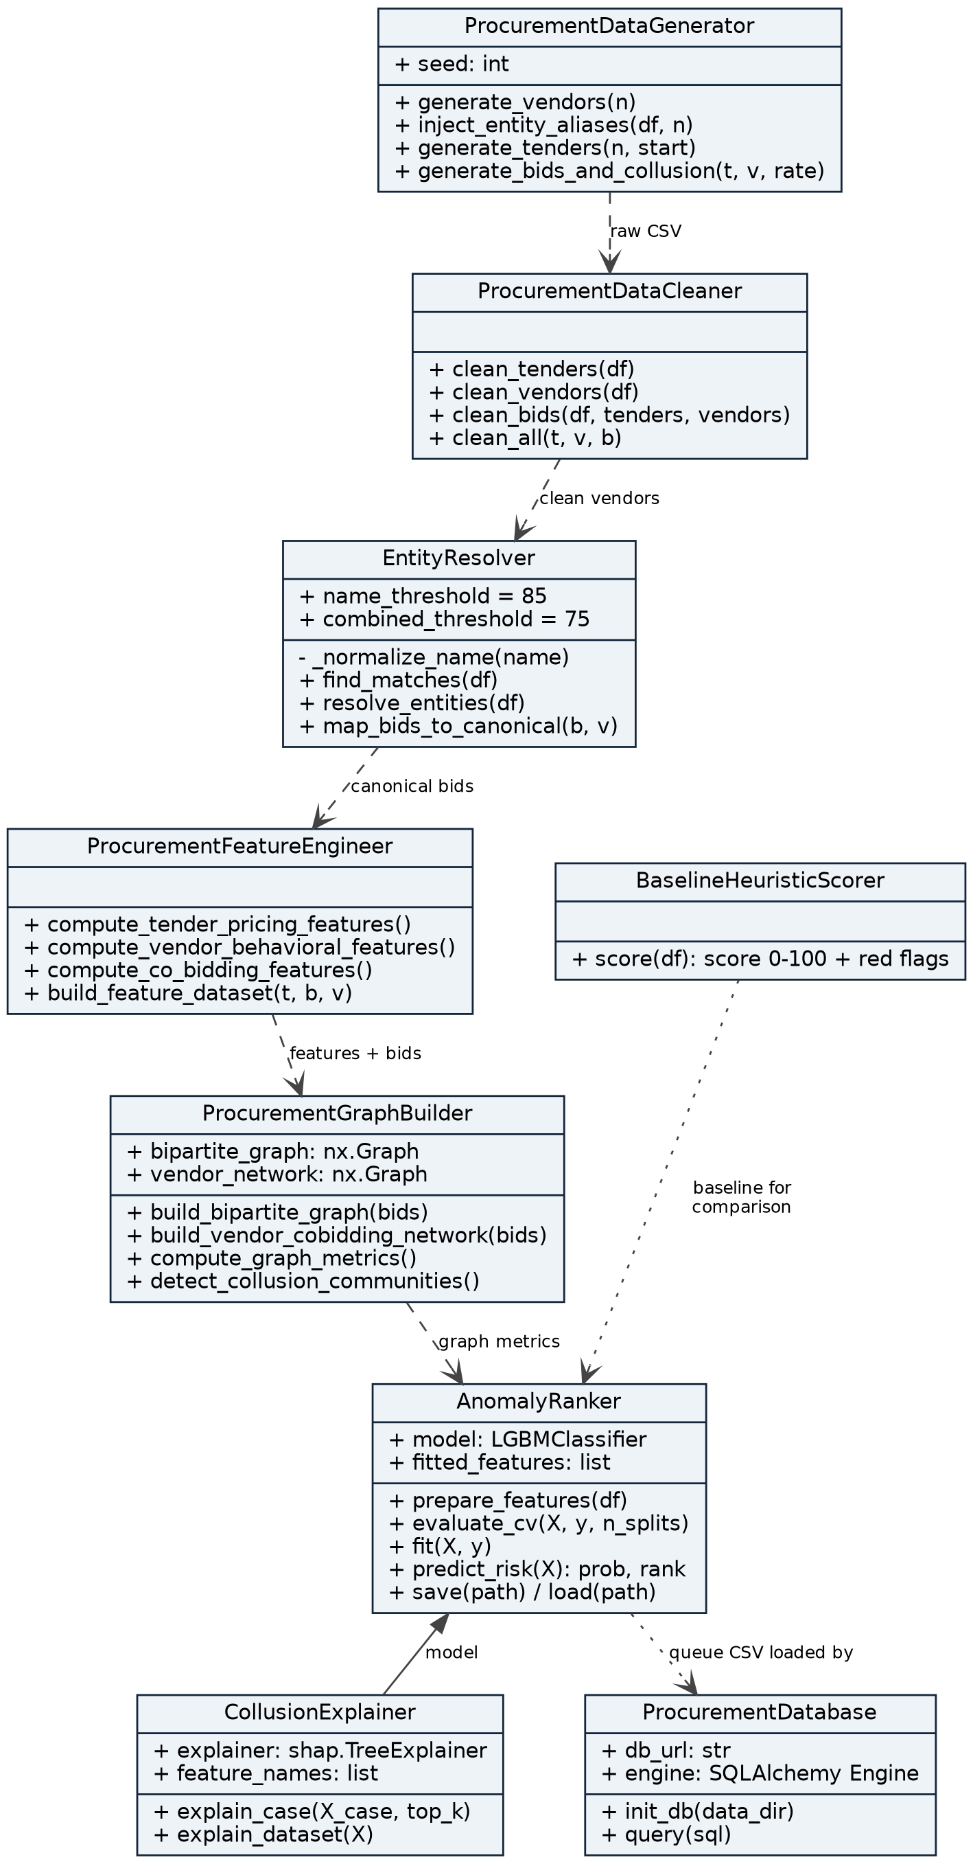
Figure 3.6: Class diagram of the main classes
- ProcurementDataGenerator creates the raw data and the ground truth; ProcurementDataCleaner validates it.
- EntityResolver (thresholds 85 and 75) finds matching vendors and maps bids to canonical IDs.
- ProcurementFeatureEngineer builds the tender feature table; ProcurementGraphBuilder owns the bipartite graph and the vendor network and adds graph metrics and communities.
- BaselineHeuristicScorer produces the rule-based score; AnomalyRanker wraps the LightGBM model, and CollusionExplainer is built around the trained model.
- ProcurementDatabase loads the processed tables, including the investigation queue, into SQL.

3.5.2 SEQUENCE DIAGRAM
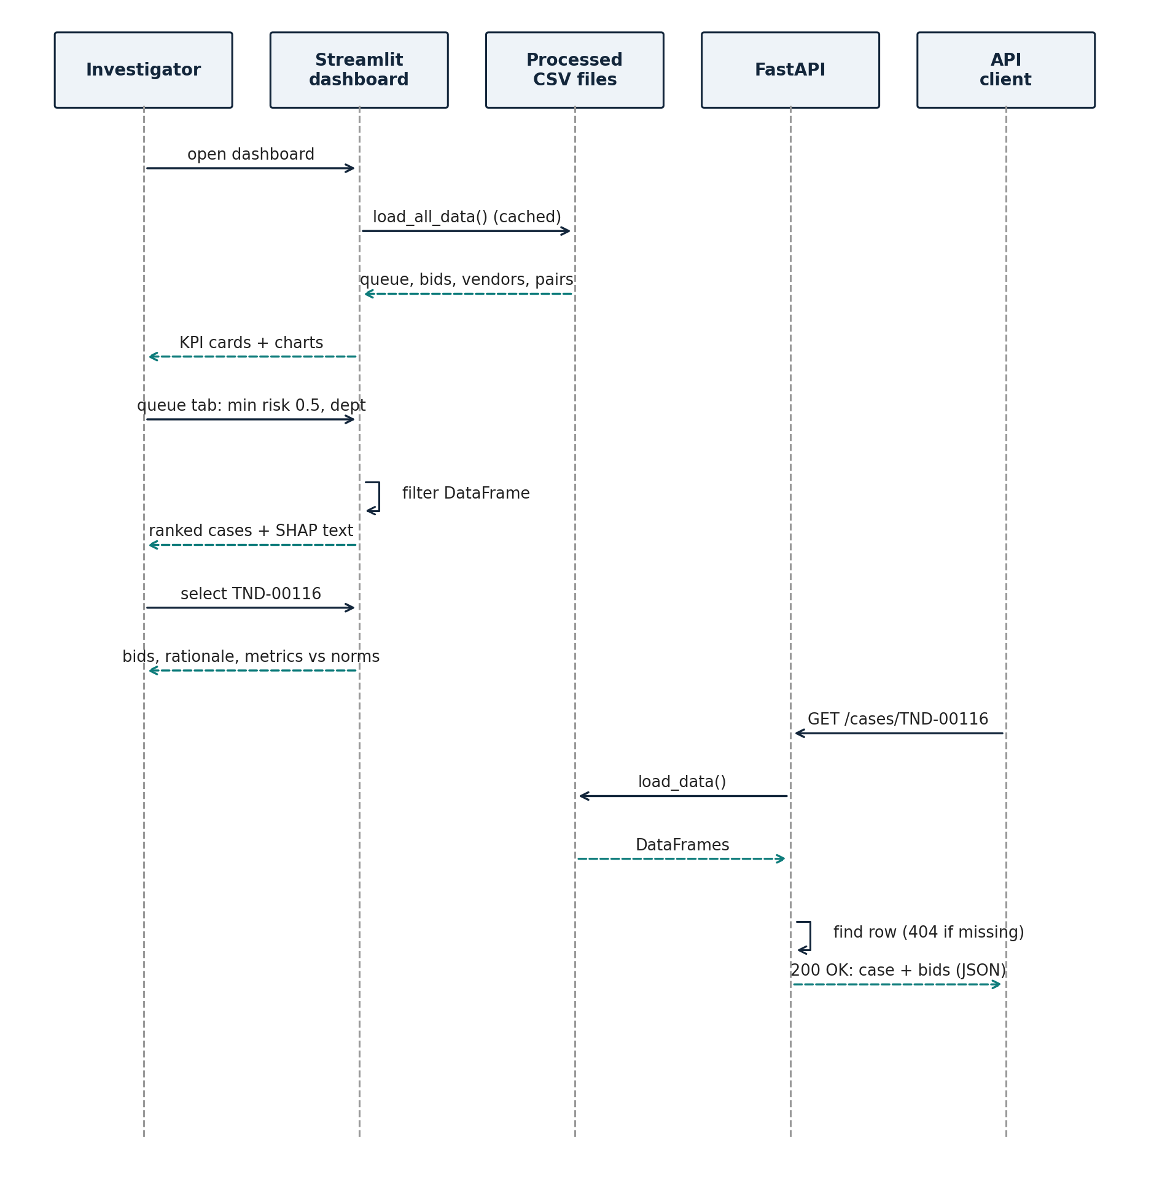
Figure 3.7: Sequence diagram of reviewing a case in the dashboard and through the API
The investigator opens the dashboard, which loads the processed CSV files once and caches them. Filtering the queue happens in memory, and selecting a tender shows its bids, rationale and metrics. An external system asks the API for the same case: FastAPI loads the processed data, returns HTTP 404 if the tender does not exist, and otherwise returns the case overview and its submitted bids as JSON.

3.5.3 STATE CHART DIAGRAM
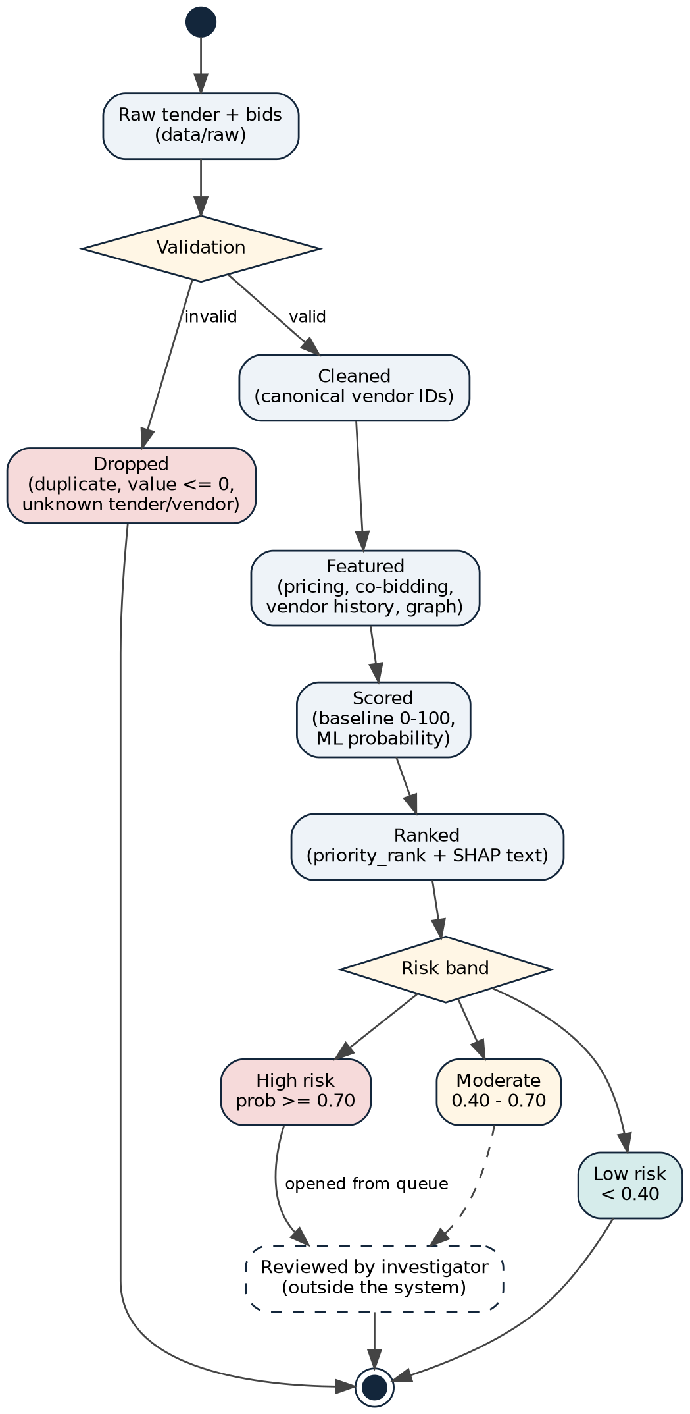
Figure 3.8: State chart of a tender case
- A raw tender with its bids enters validation. Duplicate tenders, non-positive values and bids for unknown tenders or vendors are dropped.
- A valid tender becomes cleaned; its bids now refer to canonical vendor IDs.
- It becomes featured once pricing, co-bidding, vendor-history and graph features are computed, then scored by the baseline and the model, and ranked with a SHAP explanation.
- The dashboard and API place it in a risk band: High (probability ≥ 0.70), Moderate (0.40 to 0.70) or Low (below 0.40).
- High-risk cases are opened by an investigator. The review itself happens outside the system: recording the outcome is part of the future feedback loop.

3.5.4 USE-CASE DIAGRAM
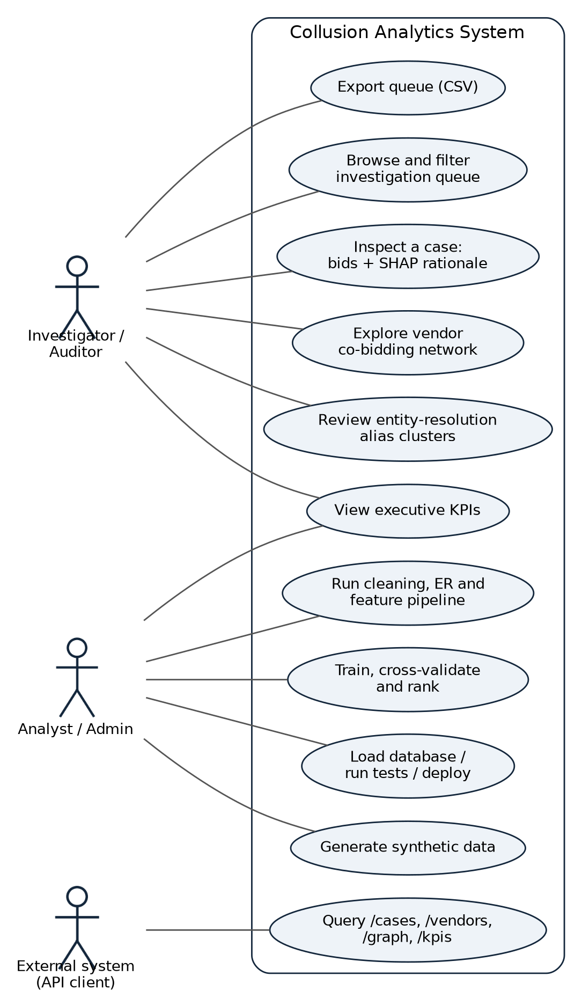
Figure 3.9: Use-case diagram
The investigator or auditor views the KPIs, browses and filters the queue, inspects cases with their SHAP rationale, explores the vendor network, reviews alias clusters and exports the queue. The analyst or administrator generates data, runs the cleaning and feature pipeline, trains and evaluates the model, loads the database, runs the tests and deploys the containers. An external system queries the REST endpoints.

CHAPTER 4 IMPLEMENTATION AND TESTING

4.1 CODE
The system is implemented in about 1,600 lines of Python in the source modules, plus about 290 lines of tests. The listings below show the key parts of each module (shortened; comments and some lines removed).

4.1.1 Synthetic data with injected collusion
Honest tenders receive 3 to 7 bids around 98% of the estimate (standard deviation 5%). Twenty per cent of tenders are made collusive, choosing one of three patterns. In cover bidding the designated winner of ring A bids 96 to 98.5% of the estimate and the other ring members bid 115 to 130%; in bid rotation the four members of ring B take turns to win at 92 to 95% while the others bid 108 to 122%; in market allocation one member of ring C bids alone at 95 to 99%.
Listing 4.1: Collusion injection (src/data_generation/generator.py)
ring_cover = vendor_ids[2:6] # VND-0003 to VND-0006
ring_rotation = vendor_ids[10:14] # VND-0011 to VND-0014
ring_market = vendor_ids[20:23] # VND-0021 to VND-0023
collusive_indices = set(random.sample(range(num_tenders), collusion_target_count))

if collusion_type == "Cover Bidding":
winner_bid = round(est_value * np.random.uniform(0.96, 0.985), 2)
for cb in cover_bidders: # deliberately non-competitive cover bids
cover_bid = round(est_value * np.random.uniform(1.15, 1.30), 2)
elif collusion_type == "Bid Rotation":
designated_winner = ring_rotation[rotation_counter % len(ring_rotation)]
rotation_counter += 1
else: # Market Allocation: single uncontested bid
designated_winner = ring_market[idx % len(ring_market)]

# genuine competition: 3-7 independent vendors around the market rate
ratio = np.clip(np.random.normal(0.98, 0.05), 0.85, 1.15)

Alias vendors are created by changing the legal suffix ("Pvt Ltd" to "Private Limited", "Limited" to "Ltd.") or appending "Group"; half of them share the parent's exact address. The generator writes tenders.csv, vendors.csv, bids.csv, ground_truth_collusion.csv and ground_truth_aliases.csv. With seed 42 it produces 400 tenders, 104 vendor records, 1,842 bids and 80 collusive tenders.

4.1.2 Data cleaning
Listing 4.2: Bid cleaning (src/preprocessing/cleaner.py)
df = df.drop_duplicates(subset=["Tender_ID", "Vendor_ID"])
df["Bid_Amount"] = pd.to_numeric(df["Bid_Amount"], errors="coerce")
df = df[df["Bid_Amount"] > 0]
df["Winner"] = df["Winner"].fillna(0).astype(int)
if valid_tenders is not None: # referential integrity
df = df[df["Tender_ID"].isin(valid_tenders["Tender_ID"])]
if valid_vendors is not None:
df = df[df["Vendor_ID"].isin(valid_vendors["Vendor_ID"])]

Tenders are deduplicated on Tender_ID, text columns are stripped, dates are parsed (invalid dates become missing), non-positive estimated values are removed and the tender duration in days is derived. Vendor names also get a normalised lower-case form without punctuation.

4.1.3 Fuzzy entity resolution
Listing 4.3: Matching rule and clustering (src/preprocessing/entity_resolution.py)
name_sim = fuzz.token_sort_ratio(n1, n2) # word order ignored
addr_sim = fuzz.token_set_ratio(addr1, addr2) if (addr1 and addr2) else 0.0
is_match = (name_sim >= self.name_threshold # 85
or (name_sim >= self.combined_threshold # 75
and addr_sim >= 85.0))

G = nx.Graph() # one node per vendor
for m in matches:
G.add_edge(m["Vendor_ID_1"], m["Vendor_ID_2"], weight=m["Name_Similarity"])
for component in nx.connected_components(G): # one real company
canonical_id = sorted(list(component))[0]

Before matching, company suffixes are normalised ("private limited" to "pvt ltd", "infrastructure" to "infra", "enterprises" to "ent" and so on) and punctuation is removed. All pairs of vendors are compared; matched pairs become edges, and each connected component becomes one canonical vendor whose ID is the smallest ID in the cluster. Every bid is then mapped to its canonical vendor.

4.1.4 Feature engineering
Twenty numeric features are computed for every tender. Pricing: number of bids, winning bid ÷ estimate, mean and standard deviation of bid ÷ estimate, spread (highest − lowest bid) ÷ estimate, coefficient of variation, and the gap between the winner and the runner-up ÷ estimate. Co-bidding: the largest and the mean number of tenders that each pair of bidders in this tender have bid on together. Winning-vendor history: total bids, total wins, win rate, average and standard deviation of its bid ratio, and its category concentration. Graph: degree centrality, weighted degree, betweenness, clustering coefficient and PageRank of the winning vendor in the co-bidding network.
Listing 4.4: Pricing and co-bidding features (src/features/feature_engineering.py)
sorted_bids = group.sort_values("Bid_Amount").reset_index(drop=True)
min_bid, max_bid = sorted_bids["Bid_Amount"].iloc[0], sorted_bids["Bid_Amount"].iloc[-1]
winning_bid_ratio = min_bid / est_val
bid_spread = (max_bid - min_bid) / est_val
if n_bids > 1: # key indicator for cover bidding
winner_to_second_gap = (sorted_bids["Bid_Amount"].iloc[1] - min_bid) / est_val

for tender_id, vendors in tender_vendors.items(): # co-bidding pairs
v_list = sorted(list(vendors))
for i in range(len(v_list)):
for j in range(i + 1, len(v_list)):
pair_counts[(v_list[i], v_list[j])] = pair_counts.get(...) + 1

4.1.5 Bid graph and communities
Listing 4.5: Graph construction and ring detection (src/graph/bipartite_graph.py)
G.add_node(f"TND_{row['Tender_ID']}", bipartite=0, node_type="tender")
G.add_node(f"VND_{row[vendor_col]}", bipartite=1, node_type="vendor")
G.add_edge(tender_node, vendor_node, bid_amount=..., is_winner=..., rank=...)

betweenness = nx.betweenness_centrality(G, weight="weight")
clustering = nx.clustering(G, weight="weight")
pagerank = nx.pagerank(G, weight="weight")
communities = nx.community.greedy_modularity_communities(G, weight="weight")
for comm_id, members in enumerate(communities, start=1):
density = nx.density(G.subgraph(members))
is_suspicious_ring = len(members) >= 3 and density >= 0.70

4.1.6 Baseline red-flag scorer
Red flag | Condition | Points
Gap between 1st and 2nd bid (cover bids) | ≥ 15% of estimate / ≥ 8% | 30 / 15
Repeated co-bidding pair | ≥ 15 shared tenders / ≥ 8 | 25 / 12
Low bidder turnout | 2 bids or fewer | 15
Winner near the ceiling with wide spread | win ratio ≥ 95% and spread ≥ 15% | 15
Dominant winner | ≥ 5 bids and win rate ≥ 50% | 15

The points are added and capped at 100. Every flag that fires is written out as a sentence, for example "Repeated co-bidding ring (paired 33 times) | Winning bid near ceiling (97.6%) with wide bid spread (30.9%)".

4.1.7 LightGBM risk ranker
Listing 4.6: Cross-validation and ranking (src/models/anomaly_ranker.py)
self.model = LGBMClassifier(n_estimators=100, learning_rate=0.05, num_leaves=15,
min_child_samples=5, random_state=42, verbose=-1)

skf = StratifiedKFold(n_splits=5, shuffle=True, random_state=self.random_state)
for train_idx, val_idx in skf.split(X, y):
clf.fit(X.iloc[train_idx], y.iloc[train_idx])
preds = clf.predict_proba(X.iloc[val_idx])[:, 1]
auc_scores.append(roc_auc_score(y_val, preds))
pr_auc_scores.append(average_precision_score(y_val, preds))
top_10 = np.argsort(preds)[::-1][:10] # Precision@10 per fold

probs = self.model.predict_proba(X_clean)[:, 1]
ranks = np.argsort(np.argsort(-probs)) + 1 # 1 = highest risk

4.1.8 SHAP explanations
Listing 4.7: Plain-language explanation of each case (src/models/explainability.py)
self.explainer = shap.TreeExplainer(model)
shap_values = self.explainer.shap_values(X_clean)
for i in range(len(X_clean)):
row_sv = sv_matrix[i]
for idx in np.argsort(row_sv)[::-1][:2]: # top two positive drivers
if row_sv[idx] > 0.01:
drivers.append(f"{fname} = {fval}")
explanations.append(f"Flagged due to: {', '.join(drivers)}" if drivers
else "Normal competitive bidding behaviour")

4.1.9 Training pipeline and investigation queue
src/train.py ties the stages together: it builds the graphs, merges the winning vendor's graph metrics into the feature table, applies the baseline scorer, joins the ground-truth label, runs 5-fold cross-validation, fits the final model on all tenders, attaches probabilities, ranks and SHAP explanations, computes Precision@50, Precision@80 and the share of injected collusive tenders inside the top 100, and saves models/anomaly_ranker.joblib, investigation_queue.csv and vendor_communities.csv.

4.1.10 REST API
Listing 4.8: Case-detail endpoint (api/main.py)
@app.get("/cases/{tender_id}")
def get_case_detail(tender_id: str):
df_queue, df_bids, df_vendors, _ = load_data()
case_row = df_queue[df_queue["Tender_ID"] == tender_id]
if case_row.empty:
raise HTTPException(status_code=404, detail=f"Tender {tender_id} not found.")
bids = df_bids[df_bids["Tender_ID"] == tender_id].sort_values("Rank")
return {"case_overview": case_row.iloc[0].to_dict(),
"submitted_bids": bids.to_dict(orient="records")}

Method and path | Purpose
GET /health | Service health check
GET /kpis | Tenders analysed, high-risk (≥ 0.70) and moderate (0.40–0.70) cases, vendors, aliases resolved
GET /cases?min_risk=&department=&limit= | Prioritised queue with validated filters (risk 0–1, limit 1–500)
GET /cases/{tender_id} | Case overview and submitted bids; 404 for an unknown tender
GET /vendors/{vendor_id} | Vendor profile, known aliases and top 10 co-bidding partners
GET /graph/network?min_cobids= | Nodes and weighted edges for network visualisation

4.1.11 Dashboard, database and deployment
The Streamlit dashboard (dashboard/app.py) loads the processed files once with st.cache_data and offers five tabs: Executive KPIs (metric cards, risk histogram, flagged cases by department), Investigation Queue (risk slider, department and type filters, formatted table, CSV export), Case Inspector & SHAP (rank, probability, baseline score, rationale, bids and metrics), Vendor Network Graph (Plotly network of pairs above a co-bidding threshold) and Entity Resolution (alias clusters).
Listing 4.9: Database persistence (src/database.py)
DEFAULT_DB_URL = os.getenv("DATABASE_URL", "sqlite:///data/procurement.db")
self.engine = create_engine(db_url, echo=False)
df_q.to_sql("investigation_cases", self.engine, if_exists="replace", index=False)

Listing 4.10: Dockerfile (docker-compose adds the dashboard service on port 8501)
FROM python:3.11-slim
COPY requirements.txt .
RUN pip install --no-cache-dir -r requirements.txt
COPY . .
EXPOSE 8000 8501
CMD ["uvicorn", "api.main:app", "--host", "0.0.0.0", "--port", "8000"]

4.2 TESTING APPROACH
The project is tested with pytest. The suite has 15 tests in 7 files and covers every module from data generation to the API. All 15 tests pass in about 3 seconds.

4.2.1 Unit Testing
Unit tests check each building block with small inputs whose correct answer is known by hand: for example, for bids of ₹900 and ₹1,100 on a ₹1,000 tender, the winning bid ratio must be 0.90 and both the spread and the winner-to-runner-up gap must be 0.20; two vendors that meet in two tenders must have a co-bidding count of 2; "Apex Infra Pvt Ltd" and "Apex Infrastructure Private Limited" at the same address must share a canonical ID while "Zenith Solutions" stays separate.

4.2.2 Integration Testing
Integration tests run against the real processed outputs: FastAPI's TestClient calls the health, KPI, case-list and network endpoints, and the database test loads all processed tables into an in-memory SQLite database and queries the investigation cases.

4.2.3 Model Testing
Model tests train the LightGBM ranker on a small labelled example and check that a suspicious case is ranked in the top three and that SHAP returns top factors and an explanation. The baseline test checks that a tender with a 20% gap and 20 co-bids scores at least 50 while a normal tender scores below 20.

4.2.4 Testing Tools
Tool | Purpose
pytest 9.1 | Test discovery and execution (15 tests)
FastAPI TestClient (httpx) | API tests without starting a server
SQLite in-memory database | Isolated database test
Fixed random seeds | Reproducible synthetic data and models

4.2.5 Test Environment
Component | Details
Operating system | Windows 10/11 (development); Linux (independent re-run of the full suite)
Language | Python 3.14 virtual environment (.venv); Python 3.11 in Docker
Data | Synthetic benchmark generated with seed 42 (data/processed)
Database | SQLite in memory for tests; data/procurement.db for the application

4.2.6 Tested Features
Feature | Test Case ID | Tests | Status
Data generation and collusion injection | TC_01 | 3 | Passed
Cleaning and entity resolution | TC_02 | 2 | Passed
Feature engineering | TC_03 | 2 | Passed
Graph analytics | TC_04 | 1 | Passed
Baseline, LightGBM and SHAP | TC_05 | 2 | Passed
Database persistence | TC_06 | 1 | Passed
REST API | TC_07 | 4 | Passed

4.2.7 Test Case Details
TC_01 Data generation (tests/test_data_generation.py)
ID | Scenario | Test steps | Expected output | Status
TC_01.1 | Vendor pool | Generate 50 vendors with seed 123 | 50 rows, unique IDs, name and registration columns present | Passed
TC_01.2 | Alias injection | Generate 20 vendors, inject 3 aliases | 23 vendors with unique IDs, 3 alias log entries | Passed
TC_01.3 | Tenders, bids and collusion | 50 tenders, 30 vendors, collusion rate 0.20 | Exactly 10 collusive tenders; one winner per tender; all bids positive | Passed

TC_02 Cleaning and entity resolution (tests/test_preprocessing.py)
ID | Scenario | Test steps | Expected output | Status
TC_02.1 | Invalid tenders | Clean a duplicate tender and one with a negative value | One tender left, whitespace stripped, duration 19 days | Passed
TC_02.2 | Alias clustering | Resolve "Apex Infra Pvt Ltd", "Apex Infrastructure Private Limited", "Zenith Solutions" | First two share a canonical ID (second marked alias); third separate | Passed

TC_03 Feature engineering (tests/test_features.py)
ID | Scenario | Test steps | Expected output | Status
TC_03.1 | Pricing features | Bids ₹900 and ₹1,100 on a ₹1,000 tender | Winner V1; win ratio 0.90; spread 0.20; gap 0.20 | Passed
TC_03.2 | Co-bidding counts | V1 and V2 meet in two tenders | One V1–V2 pair with count 2 | Passed

TC_04 to TC_06 Graph, models and database
ID | Scenario | Test steps | Expected output | Status
TC_04.1 | Bipartite and co-bidding graphs | 2 tenders, 3 vendors, 5 bids | 5 bipartite nodes; 3 vendor nodes; V1–V2 edge weight 2; centrality columns | Passed
TC_05.1 | Baseline scorer | Score a suspicious and a normal tender | Suspicious ≥ 50; normal < 20 | Passed
TC_05.2 | LightGBM + SHAP | Fit on 6 labelled rows and explain one case | Suspicious case ranked in top 3; top factors and text returned | Passed
TC_06.1 | Database | Load processed tables into in-memory SQLite; query 5 cases | 5 rows with Tender_ID and ml_anomaly_prob | Passed

TC_07 REST API (tests/test_api.py)
ID | Scenario | Test steps | Expected output | Status
TC_07.1 | Health | GET /health | 200, status "healthy" | Passed
TC_07.2 | KPIs | GET /kpis | 200, total tenders analysed > 0 | Passed
TC_07.3 | Case list | GET /cases?limit=10 | List of at most 10 cases with Tender_ID, probability and rank | Passed
TC_07.4 | Network graph | GET /graph/network?min_cobids=2 | 200, nodes and edges keys | Passed

4.2.8 Manual and Exploratory Testing
Besides the automated suite, the API was exercised manually (an unknown tender returns 404, a risk threshold above 1 returns 422 validation error) and every dashboard tab was opened and used. Response times measured over 30 requests per endpoint on a 2-core machine were a median of 1 ms for /health and 14 to 22 ms for the data endpoints, which read the processed CSV files on each request.

4.2.9 Defect Summary
ID | Description | Severity | Status
D-01 | Vendor Network tab stopped with an error under Plotly 7 because the colour-bar property titleside was removed; replaced by title=dict(text=..., side="right") | High | Fixed
D-02 | Entity resolution merged 8 unrelated vendors whose names contain the same two words in a different order (token_sort_ratio = 100) | Medium | Open (Chapter 6)
D-03 | SHAP text "Flagged due to …" is also written for low-risk tenders, because the rule checks for positive SHAP values, not for a high score | Medium | Open
D-04 | "Market Median" column in the Case Inspector uses fixed numbers instead of values computed from the data | Low | Open
D-05 | README states 14 tests; the suite contains 15 | Low | Open

CHAPTER 5 RESULTS AND DISCUSSIONS

5.1 FUNCTIONALITY EVALUATION
The complete pipeline was run from a clean state with the three commands python -m src.data_generation.generator, python -m src.pipeline and python -m src.train. It finished in about 5.5 seconds and printed the following summary:
Stage | Result
Data generation | 400 tenders, 104 vendor records (100 + 4 aliases), 1,842 bids; 80 collusive tenders (20.0%)
Cleaning | All 400 tenders and 1,842 bids passed validation; tender duration 14 to 45 days
Entity resolution | 13 matched vendor pairs; 12 vendor records marked as aliases of a canonical vendor
Feature engineering | Feature table of 400 tenders × 22 columns; 2,250 co-bidding vendor pairs
Graph analytics | Vendor network of 92 canonical vendors and 2,250 edges; 5 communities, 3 flagged as dense candidate rings
Model | 5-fold CV ROC-AUC 1.000, PR-AUC 1.000, Precision@10 1.000
Queue | Precision@50 100%, Precision@80 100%, all 80 collusive tenders inside the top 100

Running the generator twice with the same seed produced identical files, so every number in this chapter can be reproduced. The screenshots below show the investigator dashboard on these results.
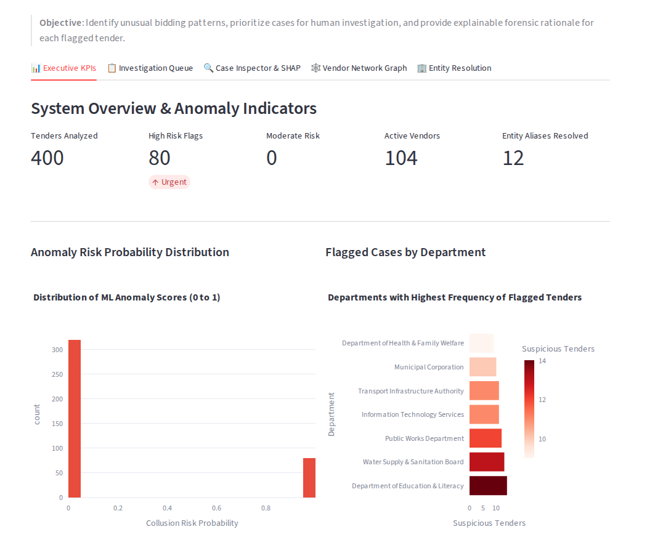
Figure 5.1: Executive KPIs: tenders analysed, high and moderate risk flags, vendors, aliases resolved, risk distribution and flagged cases by department
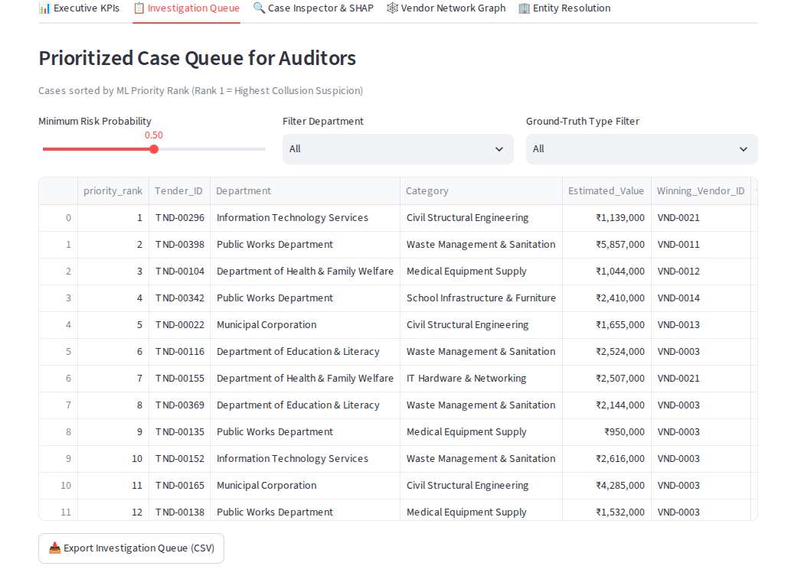
Figure 5.2: Investigation queue: risk, department and type filters, ranked cases and CSV export
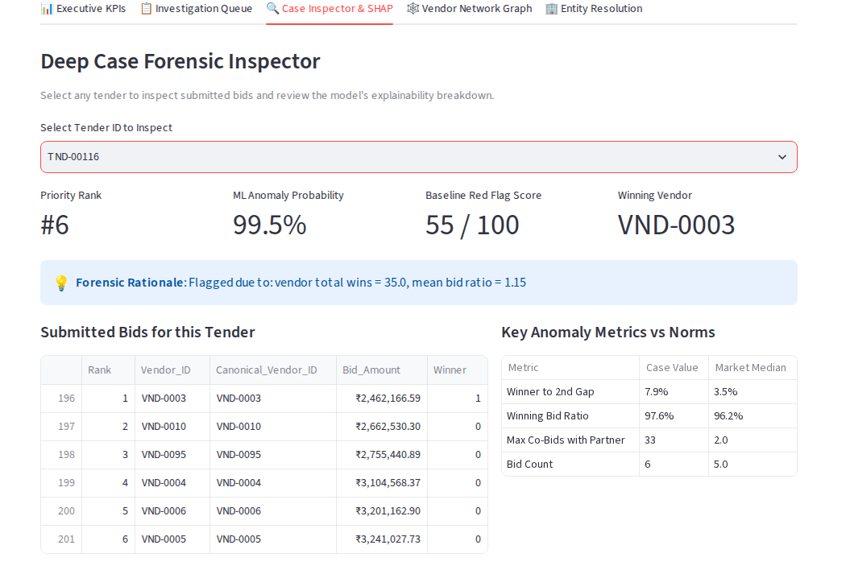
Figure 5.3: Case inspector for a cover-bidding tender (TND-00116): rank, probability, baseline score, SHAP rationale and submitted bids
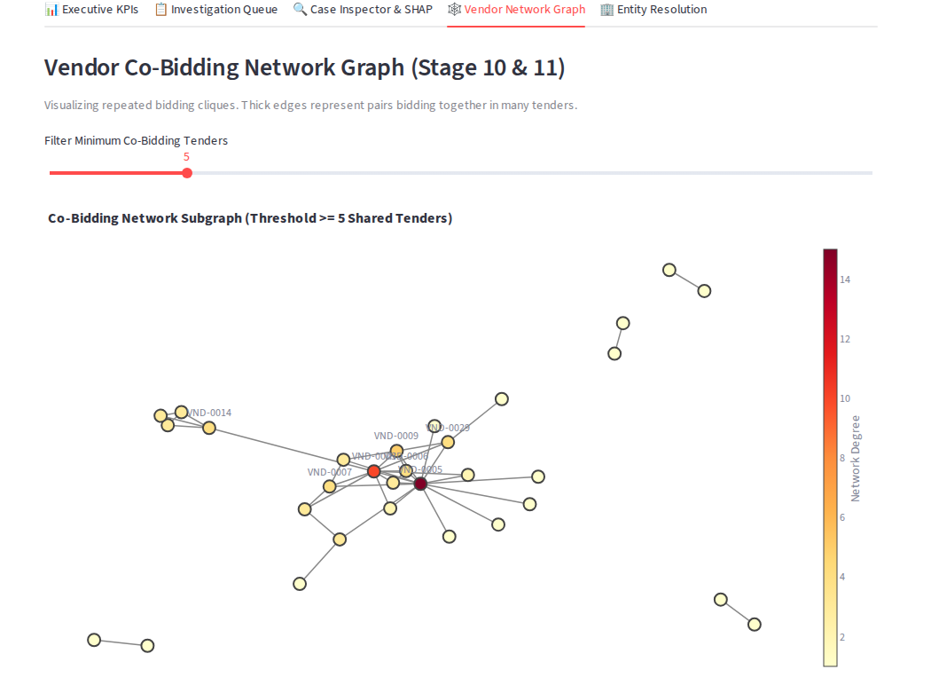
Figure 5.4: Vendor co-bidding network (pairs with at least 5 shared tenders, colour = network degree)
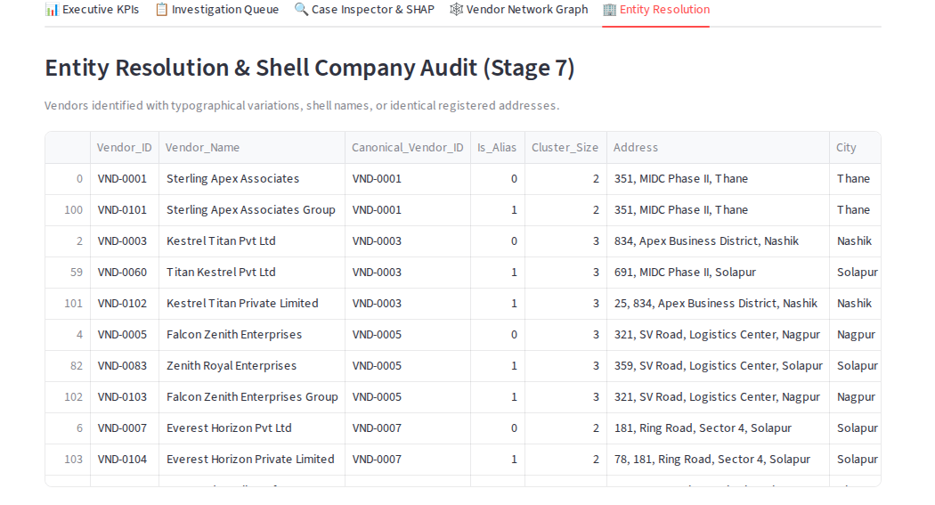
Figure 5.5: Entity-resolution audit: alias clusters with their canonical vendor, cluster size and address
The case in Figure 5.3 shows how the evidence reads for an investigator. Vendor VND-0003 won with a bid of ₹24.6 lakh, 97.6% of the estimate. Two independent vendors bid 105% and 109% of the estimate, while the other three members of the cover ring (VND-0004, VND-0005, VND-0006) bid between ₹31.0 and ₹32.4 lakh, 23 to 28% above the estimate. The baseline fired three flags (pair seen together 33 times, winner near the ceiling with a 30.9% spread, winner with a 53% win rate across 66 tenders), and the SHAP rationale points to the winner's 35 previous wins.
API check
The API returned the same information as JSON. GET /kpis returned 400 tenders, 80 high-risk cases, 0 moderate cases, 104 vendors and 12 aliases; GET /vendors/VND-0003 listed its linked aliases and its top co-bidding partners; GET /graph/network?min_cobids=5 returned 31 nodes and 43 edges.

5.2 MODEL PERFORMANCE

5.2.1 Baseline versus LightGBM
Both methods score all 400 tenders. The LightGBM figures are from the 5-fold cross-validation (every tender scored by a model that did not see it); the out-of-fold top-k precision gives the same values as the final model's queue. The baseline needs no training, so its scores are directly comparable.
Metric | Baseline red flags | LightGBM ranker
ROC-AUC | 0.987 | 1.000
PR-AUC (average precision) | 0.941 | 1.000
Precision@10 | 100% | 100%
Precision@50 | 100% | 100%
Precision@80 (= number of collusive tenders) | 93.8% | 100%
Recall of cover bidding in top 80 | 100% | 100%
Recall of bid rotation in top 80 | 100% | 100%
Recall of market allocation in top 80 | 81.5% | 100%

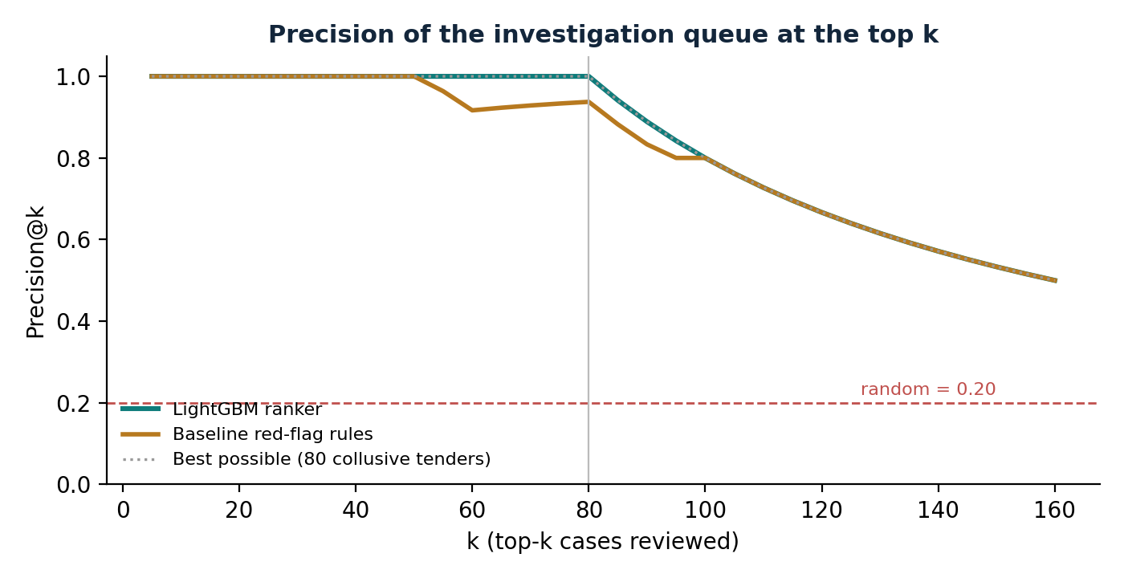
Figure 5.6: Precision@k of the investigation queue for k = 5 to 160
The baseline is already strong because the injected patterns are strong. It is weakest on market allocation: a single uncontested bid scores only 15 points for low turnout (plus 15 if the winner is dominant), so some of these tenders fall below honest tenders that happen to trigger a gap flag. LightGBM combines the features and separates all three patterns perfectly. Precision@100 is 80% for both methods simply because only 80 tenders are collusive.
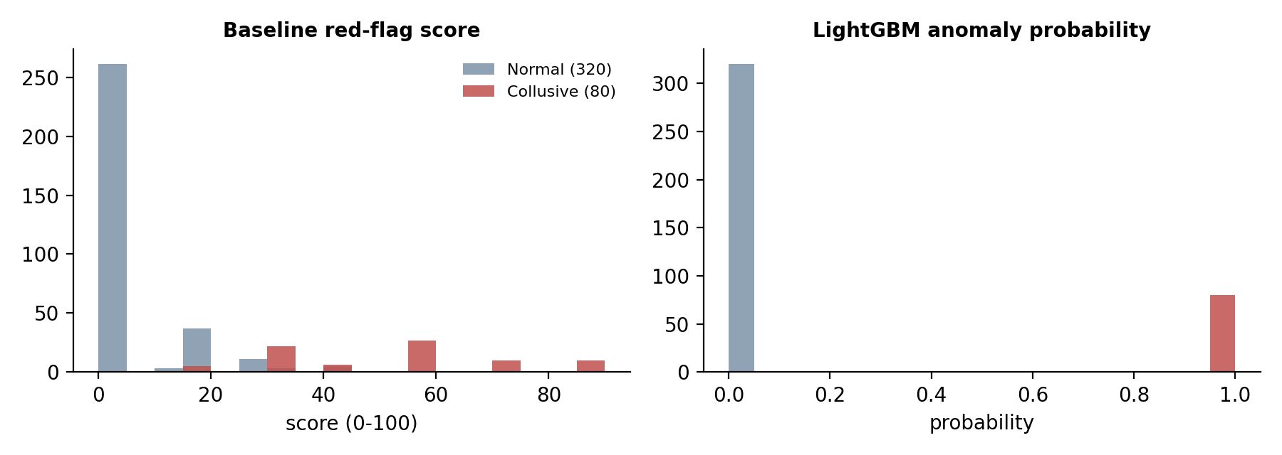
Figure 5.7: Score distributions for normal and collusive tenders
The right-hand chart shows a warning sign: the LightGBM probabilities take only two values, 0.0013 for every normal tender and 0.9948 for every collusive tender. The model is not ranking degrees of suspicion; it has found a rule that splits the synthetic data perfectly. This is why no tender falls into the moderate band (0.40 to 0.70).

5.2.2 False-positive rate
Rule | Flagged | Precision | Recall | False-positive rate
Baseline score ≥ 30 | 83 | 90.4% | 93.8% | 2.5%
Baseline score ≥ 50 | 47 | 100% | 58.8% | 0.0%
LightGBM out-of-fold probability ≥ 0.5 | 79 | 100% | 98.8% | 0.0%

For the baseline, a threshold of 30 points catches almost all collusive tenders while wrongly flagging 8 of the 320 honest tenders (2.5%). A threshold of 50 removes all false positives but misses 41% of the collusive tenders. This trade-off is what a real investigation team would have to choose.

5.2.3 What drives the model: SHAP and ablation
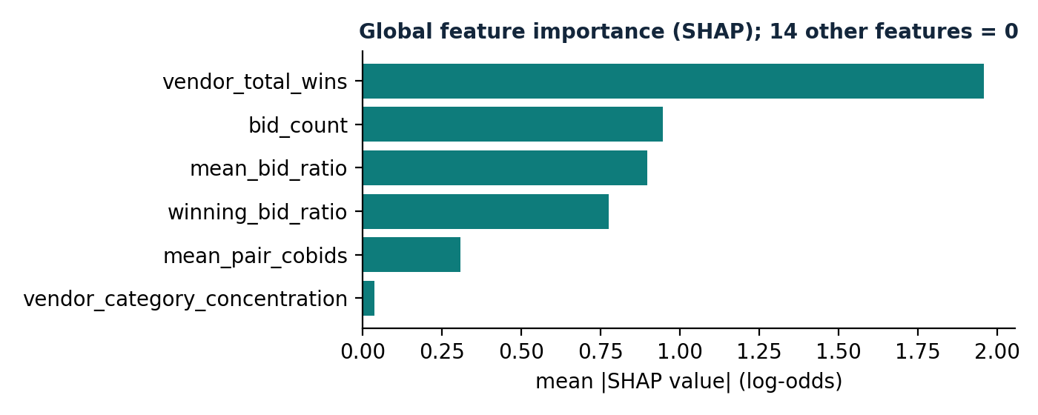
Figure 5.8: Global SHAP importance (mean absolute SHAP value)
Only six of the twenty features have any SHAP importance. The model relies on the winning vendor's total wins (ring members win many tenders), the number of bids (market-allocation tenders have exactly one), the mean and winning bid ratios (cover bids push the mean far above the estimate) and the mean co-bidding count. The five graph centrality features have zero importance: the trees never needed them.
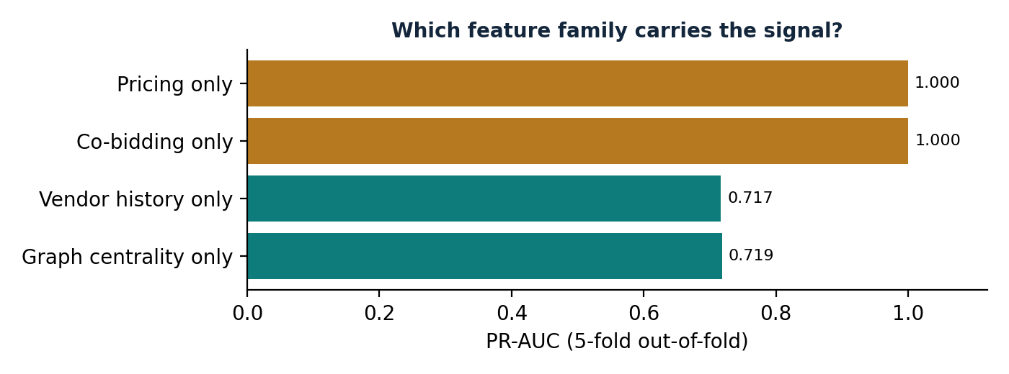
Figure 5.9: PR-AUC when the model is trained on one feature family only (5-fold out-of-fold)
The ablation confirms it. Pricing features alone (PR-AUC 0.9998) or co-bidding counts alone (1.000) are enough to recover the planted cartels; vendor history alone (0.717) or graph centrality alone (0.719) are much weaker. Removing any single family leaves the full model at 1.000, because the remaining families still contain a perfect separator. On this benchmark the graph features therefore add no measurable value beyond the simpler features; the graph is useful here for community detection and visual investigation rather than for the classifier.

5.2.4 Graph communities and injected rings
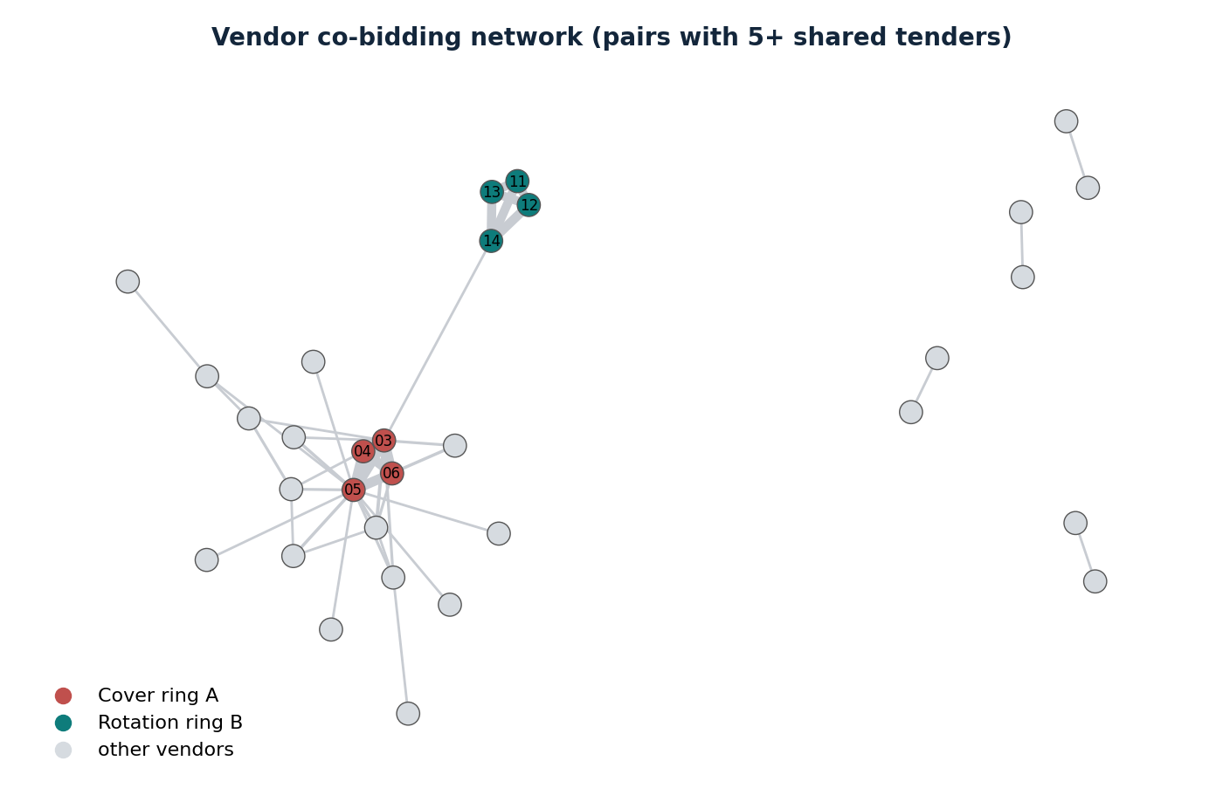
Figure 5.10: Co-bidding network (pairs with 5 or more shared tenders) coloured by injected ring
Community | Vendors | Density | Flagged as ring | Contains
COMM_005 | 6 | 1.00 | Yes | All 4 members of the bid-rotation ring
COMM_004 | 10 | 0.80 | Yes | All 4 members of the cover-bidding ring
COMM_003 | 20 | 0.73 | Yes | No injected ring (false alarm)
COMM_001 | 30 | 0.63 | No | 2 market-allocation members
COMM_002 | 26 | 0.58 | No | 1 market-allocation member

Community detection recovered the two rings that bid together, and the 33 and 27 shared tenders of their pairs stand out clearly in Figure 5.10. It cannot see the market-allocation ring, whose members never meet in a tender: that pattern is visible only through single-bid tenders and dominant winners. One of the three flagged communities is a false alarm, which shows why a density rule alone is not enough.

5.2.5 Entity-resolution accuracy
Measure | Value
Planted aliases | 4
Planted aliases linked to the correct parent (recall) | 4 of 4 (100%)
Vendor records marked as aliases | 12
Correct alias flags (precision) | 4 of 12 (33%)
Wrong merges | 8 (for example "Kestrel Titan Pvt Ltd" with "Titan Kestrel Pvt Ltd", "Falcon Zenith Enterprises" with "Zenith Royal Enterprises")

Recall is perfect, but precision is low. The synthetic vendor names are built from 20 seed words, so two unrelated companies often share the same two words in a different order, and token_sort_ratio (which ignores word order) gives them a similarity of 100. One wrong merge joins an innocent vendor (VND-0083) to a member of the cover ring, so its bids would be counted as the ring's. In a real deployment the registration ID, which the generator already provides, should be used as a blocking key before fuzzy matching.

5.2.6 Robustness and stability
Experiment | Result
Five regenerated datasets (seeds 7, 21, 99, 123, 2026) | LightGBM CV ROC-AUC 1.00 and Precision@80 100% on every seed; baseline Precision@80 74% to 93%; entity-resolution recall 100% and precision 25% to 50%
Ranking stability: five model seeds with row and feature subsampling | Identical top-80 set every time (Jaccard 1.00)
Time-based split: train on January–August 2025 (271 tenders), test on September 2025–January 2026 (129 tenders, 29 collusive) | ROC-AUC 1.00, Precision@29 100%

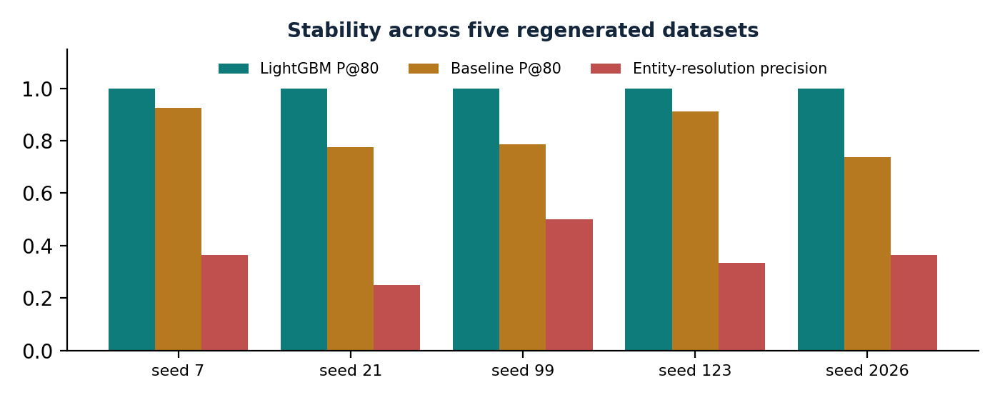
Figure 5.11: Stability of the main metrics across five regenerated datasets
The results are stable across datasets and model seeds. Two caveats apply. First, within the top 80 all collusive tenders share the same probability, so their order inside the top tier is arbitrary; a tie-breaker such as the baseline score or the contract value would make the order meaningful. Second, the co-bidding counts and vendor statistics are computed over the whole year, so in the time-based split the test tenders' features still use later tenders. A strict point-in-time version of these features is listed as future work.

5.2.7 Evaluation against the capstone metrics
Capstone metric | Result | Comment
Precision at top-k | 100% at k = 10, 50, 80 (LightGBM); 93.8% at k = 80 (baseline) | Met on the synthetic benchmark
Injected-ring recovery | All 80 collusive tenders in the top 80; 2 of 3 rings found as dense communities | Market-allocation ring invisible to co-bidding
False-positive rate | 0% (LightGBM ≥ 0.5); 2.5% (baseline ≥ 30) | Benchmark easier than reality
Ranking stability | Top-80 Jaccard 1.00 across seeds | Order within the top tier is tied
Entity-resolution accuracy | Recall 100%, precision 33% | Needs registration-ID blocking
Investigator usefulness | Red flags and SHAP text per case; network and alias views | Not yet tested with real investigators

5.3 USER EXPERIENCE ASSESSMENT
The dashboard was assessed against the needs of an investigator who is not a programmer:
- Start from the right place. The KPI cards answer "how many cases need attention?" before anything else, and the queue is already sorted by priority rank, so the first row is the first case to open.
- Readable evidence. Each case shows the bids in rank order with rupee formatting, the winner, the baseline red flags and a one-line SHAP rationale; the "Key Anomaly Metrics vs Norms" table compares the case with typical values.
- Exploration without code. Sliders and drop-downs filter by minimum risk, department and collusion type; the network slider hides weak links so a ring becomes visible; hovering over a vendor shows its number of connections.
- Export for case files. The filtered queue can be downloaded as CSV with one click.
- Responsive. All tabs open instantly after the first load because the data is cached; API calls answer in 1 to 22 ms.
Issues found
- The SHAP rationale for most low-risk tenders still begins "Flagged due to …" (225 of 320 honest tenders), which can confuse a user; it should only be shown above a risk threshold (defect D-03).
- The "Market Median" column in the case inspector uses fixed numbers rather than values computed from the data (defect D-04).
- The queue's ground-truth type filter is useful for evaluation but must be removed when the system runs on real data, where the type is unknown.
- There is no way to record the outcome of a review (confirmed, dismissed, referred) or to log in, so the dashboard is a viewer, not yet a case-management tool.

CHAPTER 6 CONCLUSION AND FUTURE WORK

6.1 CONCLUSION
This project built a working, end-to-end public procurement collusion analytics system. Starting from tender, vendor and bid records, it cleans and validates the data, links alias vendors with fuzzy entity resolution, engineers pricing, co-bidding and vendor-history features, models the market as a bipartite tender–vendor graph and a vendor co-bidding network, scores every tender with a transparent red-flag baseline and a LightGBM ranker, explains each score with SHAP, and delivers a ranked investigation queue through a FastAPI service, a Streamlit dashboard and a SQL database, packaged with Docker and covered by 15 automated tests.
On a synthetic benchmark with 80 planted collusive tenders, the system recovered every planted case at the top of the queue, found the cover-bidding and bid-rotation rings as dense communities, and linked all four planted aliases. The comparison with the baseline showed where machine learning helps (the market-allocation pattern, which the rules partly miss), and the ablation and SHAP analysis showed where it does not (graph centrality adds nothing on this benchmark).
The most important lesson is about evaluation. Perfect scores do not mean the problem is solved; they mean the planted patterns are much cleaner than real cartels, whose bids overlap with honest competition and whose members adapt. The value of the project is the complete, explainable and testable pipeline, which can now be pointed at harder synthetic scenarios and at real open-contracting data. Throughout, the system respects its boundary: it prioritises and explains cases for human investigation and never declares a vendor guilty.

6.2 FUTURE SCOPE
- Harder and more realistic benchmark: cover bids that overlap honest bids, rings that change members over time, partial collusion, honest thin markets and dominant local suppliers as false-positive traps, and noise in the data.
- Real data: load published tenders in the Open Contracting Data Standard (OCDS) format from Indian e-procurement portals, and validate against tenders named in Competition Commission of India orders.
- Point-in-time features and a time-based evaluation: compute co-bidding counts, vendor statistics and graph metrics only from tenders published before the tender being scored.
- Better entity resolution: block on registration ID and city before fuzzy matching, use word-order-sensitive similarity together with token sorting, and add directors, phone numbers and bank accounts when available.
- Temporal collusion patterns: features for winner rotation (who won the previous tenders between the same group), inter-bid timing and seasonality, and graph models that change over time.
- Investigator feedback loop: let investigators mark cases as confirmed, dismissed or referred, store the decision with user and time, and retrain the model on confirmed outcomes.
- Experiment tracking and monitoring (blueprint stages 19 and 23): log parameters, metrics and model versions with MLflow; add structured logs, data-drift checks and alerting.
- Security: authentication and role-based access on the API and dashboard, restricted CORS, rate limiting and secrets in environment variables.
- CI/CD: run tests, linting and dependency scans on every push with GitHub Actions and build the Docker image automatically.

6.3 LIMITATIONS
- Synthetic data only. All results come from a generated benchmark with known answers; they show that the pipeline works, not how it would perform on real tenders.
- Benchmark too easy. Cover bids at 115–130% and single-bid market allocation are perfectly separable, so the model's probabilities collapse to two values and cannot rank degrees of suspicion.
- Features use the whole period. Co-bidding counts and vendor statistics are computed over all tenders, including later ones, which would not be available when a new tender is scored.
- Graph features unused by the model. On this benchmark, centrality measures have zero SHAP importance; the graph contributes through communities and visualisation only.
- Entity-resolution precision of 33%. Word-order swaps of common name words cause wrong merges, one of which links an innocent vendor to a cartel member.
- Explanations shown for low-risk cases and fixed "market median" values in the case inspector.
- Blueprint stages not yet built: experiment tracking (MLflow is listed in the requirements but not used), monitoring and logging, authentication, the investigator feedback loop and a CI pipeline.
- No user study. Investigator usefulness was assessed by the author, not with real auditors.

CHAPTER 7 REFERENCES
- OECD (2009). Guidelines for Fighting Bid Rigging in Public Procurement. Organisation for Economic Co-operation and Development, Paris. https://www.oecd.org/competition/cartels/
- Government of India (2002). The Competition Act, 2002, Section 3(3)(d) (bid rigging and collusive bidding). Competition Commission of India. https://www.cci.gov.in
- Imhof, D., Karagök, Y. and Rutz, S. (2018). Screening for bid rigging: does it work? Journal of Competition Law & Economics, 14(2), 235–261.
- Huber, M. and Imhof, D. (2019). Machine learning with screens for detecting bid-rigging cartels. International Journal of Industrial Organization, 65, 277–301.
- Wachs, J. and Kertész, J. (2019). A network approach to cartel detection in public auction markets. Scientific Reports, 9, 10818.
- Fellegi, I. P. and Sunter, A. B. (1969). A theory for record linkage. Journal of the American Statistical Association, 64(328), 1183–1210.
- Levenshtein, V. I. (1966). Binary codes capable of correcting deletions, insertions and reversals. Soviet Physics Doklady, 10(8), 707–710.
- Clauset, A., Newman, M. E. J. and Moore, C. (2004). Finding community structure in very large networks. Physical Review E, 70, 066111.
- Freeman, L. C. (1977). A set of measures of centrality based on betweenness. Sociometry, 40(1), 35–41.
- Brin, S. and Page, L. (1998). The anatomy of a large-scale hypertextual web search engine. Computer Networks and ISDN Systems, 30, 107–117.
- Ke, G., Meng, Q., Finley, T., et al. (2017). LightGBM: A highly efficient gradient boosting decision tree. Advances in Neural Information Processing Systems 30.
- Lundberg, S. M. and Lee, S.-I. (2017). A unified approach to interpreting model predictions. Advances in Neural Information Processing Systems 30.
- Lundberg, S. M., Erion, G., Chen, H., et al. (2020). From local explanations to global understanding with explainable AI for trees. Nature Machine Intelligence, 2, 56–67.
- Pedregosa, F., et al. (2011). Scikit-learn: Machine learning in Python. Journal of Machine Learning Research, 12, 2825–2830.
- Hagberg, A., Schult, D. and Swart, P. (2008). Exploring network structure, dynamics, and function using NetworkX. Proceedings of the 7th Python in Science Conference, 11–15.
- McKinney, W. (2010). Data structures for statistical computing in Python. Proceedings of the 9th Python in Science Conference, 56–61.
- Open Contracting Partnership. Open Contracting Data Standard (OCDS) documentation. https://standard.open-contracting.org
- RapidFuzz documentation. https://rapidfuzz.github.io/RapidFuzz/
- NetworkX documentation. https://networkx.org/documentation/stable/
- LightGBM documentation. https://lightgbm.readthedocs.io
- SHAP documentation. https://shap.readthedocs.io
- FastAPI documentation. https://fastapi.tiangolo.com
- Streamlit documentation. https://docs.streamlit.io; Plotly Python documentation. https://plotly.com/python/
- SQLAlchemy documentation. https://docs.sqlalchemy.org; pytest documentation. https://docs.pytest.org; Docker documentation. https://docs.docker.com
- KES' Shroff College (2026). BSc Data Science Capstone Project Portfolio 2026–27, topic BDS-31, and the project System Blueprint.

