**How to Play:**

1. **Objective:**
2. **Setting the game:**
   1. The player starts by choosing a customer persona that his/her idea will serve.
   2. The player has to click on one of the persona cards and click on **save persona** button to save the persona.
   3. The player has 100% equity at the start, and an amount of ₹1 lakh to invest.

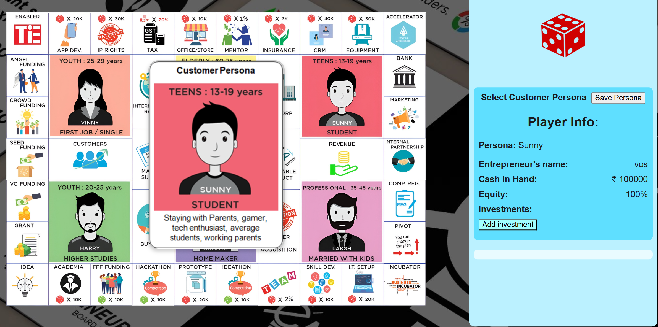

1. **Press esc key to close the card popup.**

**RULES:**

1. Click on the dice image to roll a number, then drag the pawn to the desired block.
   1. This is an self exploration game, so there is no specific direction to move into, an entrepreneur can start from the middle and go to any other block.
2. Once landed on a block, click on it to read what the card instructs to do. There are two types of blocks:
   1. One with red dice on it:
      1. In these blocks money would outflow (expense)
   2. One with green dice on it:
      1. In these blocks money would inflow (income)
   3. Each card has details specified on it once clicked on.
3. After reading the cards instructions, if the player decides to invest in it, then they have to “add investment” and fill the fields, if there is no cash transaction or equity dilution, they would fill it as 0.
4. After submitting the investment, the respective icon appears below, indicating the investment history of the player.

**The player continues to explore the paths they can take to launch their venture as an entrepreneur.**

**Hope you enjoy the game!!!**