Lydia Seils
Documentation: A Framework for Assessing Balcony Plug-and-Play Solar Photovoltaics
Spring 2026
Patrick Kastner

Introduction
There has been more support for solar panels for residential areas for a number of reasons, but upfront costs, complex installations, and the inability to easily move the panels has prevented solar panels from being more widespread. To resolve some of these issues, there has been the creation of Plug-and-play solar photovoltaic systems. These systems allow residents to attach solar panels right onto their balconies and plug them into a household outlet, producing solar energy (Mundada et al., 2017). The Plug-and-play systems have a capacity up to 600 W which can have great affects on lowering resident’s monthly electricity bill (Faculty of Energy Technology, University of Maribor. Slovenia et al., 2024). Plug-and-play sytems have the potential to help lower income neighborhoods that do have a lot of balconies. However, to assess the potential of these Plug-and-Play systems, urban studies need to be conducted, specifically on possible balconies. The task of collecting data on viable residential balconies within a neighborhood and collecting the possible solar watt hours an applied system could produce requires a new framework.
There are many current methods of extracting roof top geometry for PV potential as well as methods of extracting façade features for energy modelling. Extracting the rooftop geometry really only requires publicly available LiDAR and building footprint data (Vangelova & Kastner, 2024). Facades requires LiDAR and images from street-level which is already more difficult because there are more sides of a building that may not have available images. To be able to assess PV potential at the urban scale, it will likely require multiple types of data to cover what is required (Salimzadeh & Hammad, 2017). Façade feature detection has also been done for PV assessment but the current frameworks do not usually detect more than just walls and windows (Lu et al., 2021) and (Martínez-Rubio et al., 2016). Balconies tend to be left out, or technically detected but not semantically separated for PV potential assessments. However, there are existing Façade feature extractions for other purposes that do collect the geometry of balconies and semantically separate them (Kong & Fan, 2021), (Su et al., 2023), (Mao & Li, 2019).
Assessing the potential of Plug-and-Play PV systems in a given neighborhood is very possible with the existing frameworks and technologies. However, there currently is not a framework specifically to look at balconies for solar studies. Reworking existing frameworks to create a new workflow could allow PV potential assessments of balcony mounted solar panels.
Annotated Bibliography

Faculty of Energy Technology, University of Maribor. Slovenia, Seme, S., Strojansek, L., . Simonic, E., Sredensek, K., & Faculty of Electrical Engineering and Computer Science, University of Maribor. Slovenia. (2024). Balcony solar photovoltaic plug-and-play systems. Renewable Energies, Environment and Power Quality Journal, 2, 276–282. https://doi.org/10.24084/reepqj24.422
This sources explains what Plug-and-play PV systems are as well as the benefits and uses.

Kong, G., & Fan, H. (2021). Enhanced Facade Parsing for Street-Level Images Using Convolutional Neural Networks. IEEE Transactions on Geoscience and Remote Sensing, 59(12), 10519–10531. https://doi.org/10.1109/TGRS.2020.3035878
This source uses street-level images and Neural networks to detect façade features with high-percision. It produces outputs for Level of Detail 3 and works at the urban scale.

Lu, X., Li, G., Wang, A., Xiong, Q., Lin, B., & Lv, G. (2021). Estimating the Photovoltaic Potential of Building Facades and Roofs Using the Industry Foundation Classes. ISPRS International Journal of Geo-Information, 10(12). https://doi.org/10.3390/ijgi10120827
This source uses existing IFC data to extract facades and windows for PV energy generation potential. It shows a method of PV assessment however, does not detect balconies and likely leaves out a lot of current information since not every built building has IFC documentation.

Mao, B., & Li, B. (2019). Graph-Based 3D Building Semantic Segmentation for Sustainability Analysis. Journal of Geovisualization and Spatial Analysis, 4(1), 4. https://doi.org/10.1007/s41651-019-0045-y
This source shows a framework for automatic segmentation of 3D models like obj into semantically independent features like walls, roofs, balconies, and windows. It contains specific balcony logic and the framework is designed for assessment at the urban level.

Martínez-Rubio, A., Sanz-Adan, F., Santamaría-Peña, J., & Martínez, A. (2016). Evaluating solar irradiance over facades in high building cities, based on LiDAR technology. Applied Energy, 183, 133–147. https://doi.org/10.1016/j.apenergy.2016.08.163
This source uses LiDAR and monthly horizontal irradiance data to assess the energy potential of different areas on building facades. Does not include balconies but does include a good framework for precise resolution and reflected diffuse irradiance.

Mundada, A. S., Prehoda, E. W., & Pearce, J. M. (2017). U.S. market for solar photovoltaic plug-and-play systems. Renewable Energy, 103, 255–264. https://doi.org/10.1016/j.renene.2016.11.034
This source provides good information on what plug-and-play systems are and the potential of their use in the United States.

Salimzadeh, N., & Hammad, A. (2017). High-Level Framework for GIS-Based Optimization of Building Photovoltaic Potential at Urban Scale Using BIM and LiDAR. 123–134. https://doi.org/10.1061/9780784481196.012
This source provides a framework for detecting façade features at an urban scale using multiple data sources. It detects balconies specifically to not include in PV potential due to their focus on façade PV placement. There is also an account for material which can affect reflections and available mounting.

Su, Y., Cheng, M., Yuan, Z., Liu, W., Zeng, W., Zhang, Z., & Wang, C. (2023). Spatial Adaptive Fusion Consistency Contrastive Constraint: Weakly Supervised Building Facade Point Cloud Semantic Segmentation. IEEE Transactions on Geoscience and Remote Sensing, 61, 1–14. https://doi.org/10.1109/TGRS.2023.3297631
This source provides a framework for semantic segmentation of building facade point cloud data. The framework includes a balcony class and works at the urban scale.

Vangelova, S., & Kastner, P. (2024, November 14). A Computational Framework for Assessing Solar Photovoltaic Potential of Buildings Based on LiDAR and Building Footprint Data. https://doi.org/10.52842/conf.sigradi.2024.2779
This source provides a framework for using open source data to assess PV potential at the neighborhood scale.

Literature Review
- Search Process
  - Search using keywords and synonyms in Google Scholar, Journals, and databases. Download relevant titles.
  - Skim abstracts and filter out resources that are less relevant. Take notes on:
    - What?
    - Why?
    - How?
    - Results?
    - Relevancy?
  - Read resources’ conclusions and methods while taking notes
  - Synthesize findings in order of Chronological, Topical, General to Specific
  - Determine implications, conclusions, and the future of the work
- 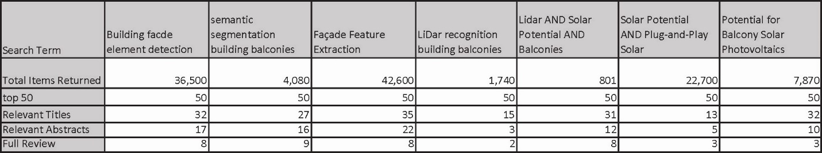
- State of the art is described in introduction
- Existing Methods/Models to keep track of
  - Locate-3D
    - Locate objects in pointcloud
  - SAM3D
    - Semantically separate and generate pointcloud
  - Depth-Anything-3
    - Creates 3D point cloud from images
  - YOLO
    - Detection model
  - Mask3D
    - Predicts accurate 3D semantic instances
  - Cylinder3D
    - Semantic Segmentation
  - SOLO
    - Instance segmentation algorithm
  - Line Segment Detector (LSD)
  - RANSAC
    - Planes from Pointclouds

Testing and Findings
- Image Pull from Google Maps API
  - See https://github.com/lseils/2D_to_3D_Testing
  - Python script that would grab images from google street view and create folder of these images in your repo
  - DO NOT PUT YOUR API KEY IN YOUR PUBLIC GITHUB REPO
  - Put google maps API key in your virtual environment and put virtual environment on the .gitignore
  - The script Inputs:
    - Latitude
    - Longitude
    - Heading (XY Plane Angle Rotation)
    - Pitch (Vertical Angle Rotation)
    - FOV
  - Inputs depend on what the images are being used for
    - Apparently optimal image inputs for 3D point cloud generation is:
      - ***INSERT OPTIMAL***
    - For balcony detection and segmentation, parallel to façade and camera placed at midpoint might be more optimal
- Depth Anything 3
  - See https://github.com/lseils/2D_to_3D_Testing
  - Takes Street images and generates 3D point cloud with estimated depths
  - 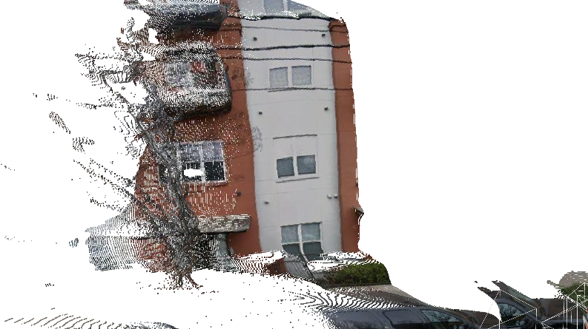
  - ***INSERT OPTIMAL***
- SAM3
  - See https://github.com/lseils/SAM3_Testing
  - Search Term “Balcony” did not produce desired results
- Any Labeling
  - See https://github.com/lseils/AnythingLabeling
  - Program to label images
  - Ideally source more than 400 images
  - My method was literally going around on google street view images, screen shotting buildings with balconies at different angles and FOVs, getting probably at least 5 images per building façade
  - Questions that came up for me
    - At what distance do I include balconies?
    - At what amount of obstruction/occlusion do I include balconies?
    - What parts of the balcony are worth including for my use case?
  - Note: Patrick did say that maybe my trained model would have worked better and would be more effective for my specific project if I had taken all the images perpendicular to the façade and more like the center of the façade.

  - 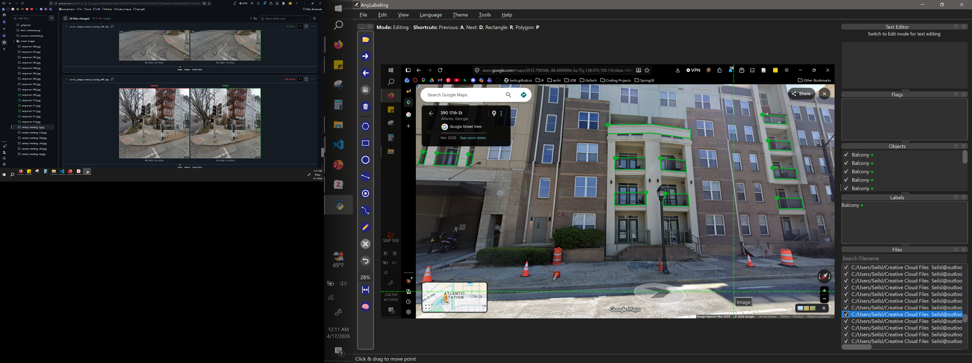
  - 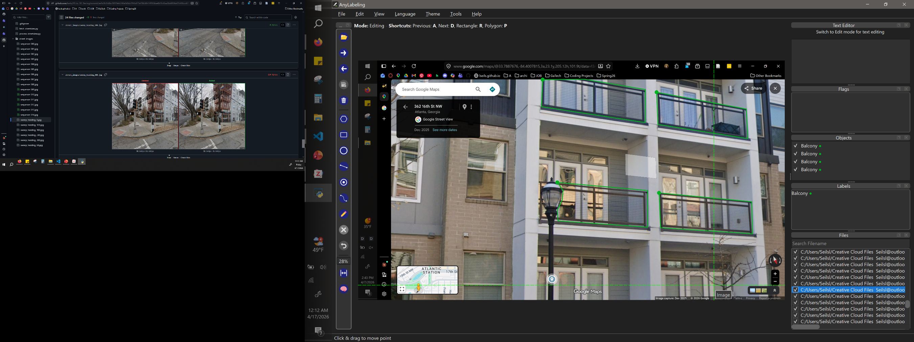
- Yolo8
  - See
  - Trained Detection Model that puts bounding boxes around what it believes is a balcony
  - Performance Metrics:
    - Box(P) - Precision: `0.771` (77.1%)
      - What it means: When your model draws a bounding box and says, "I found something," it is correct 77.1% of the time. In plain terms: This measures your *False Positive* rate. A lower precision means the model is "hallucinating" objects where there are none or guessing the wrong class.
    - R - Recall: `0.637` (63.7%)
      - What it means: Out of the 546 actual objects that exist in those 54 images, your model successfully found 63.7% of them. In plain terms: This measures your *False Negative* rate. A lower recall means the model is missing objects entirely and leaving them undetected.
      - 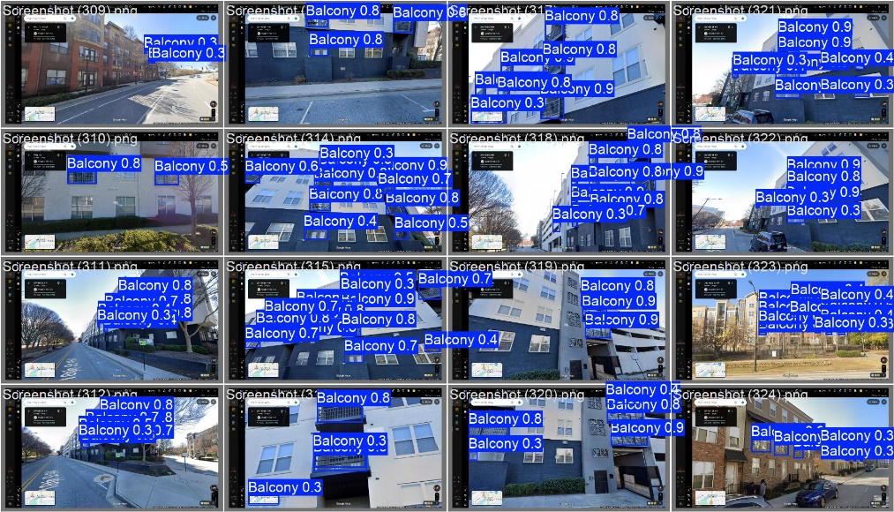
  - SAM3D

Using Colmap Pipeline (and Google street images API)
- Phase 1: Image Scraping
  - Using Google’s API, collect google street images (GSI) along a street to collect the façade of a building
  - Side note: Had to set up Google API key in the venv and have the venv in the gitignore
- Phase 2: COLMAP
  - CLI-only on HPC, exporting to mesh for CAD/BIM
  - Run_colmap.sh – full pipline
    - Feature extraction (SIFT)
    - Sequential matching – chosen specifically because your images are ordered along a walking path, so each frame overlaps its neighbors
    - Sparse SfM -> camera poses
    - PatchMatch stereo -> fused.ply dense cloud
    - Both Poisson + Delaunay mesh (try both – Delaunay often looks cleaner on flat building facades)
- Phase 3: Open3d_postprocess.py – cleans up the mesh for BIM
  - Removes outlier noise points
  - Voxel downsamples (default 5cm resolution – tune with –voxel)
  - Estimates + Orients normals
  - Exports mesh_cleaned.obj which imports to Rhino
- Results:
  - Note the tests I have below is once I got Colmap to work
    - Issues I ran into and had to work through to get Colmap to work was
      - Not enough overlap of source images

  - Test 1:
    - Output pretty much just a flat surface, granted, that part of the façade, except the orange left part of it, was close to flat. However, still expected to see some variations
    - Some inputs to note (image scrape):
      - 12 images
      - Façade headings = [260, 270, 280]
        - (I had to change this from something with more headings, because more headings was actually making it not work)
      - Optimal pitch = 20
      - Optimal FOV = 90
    - 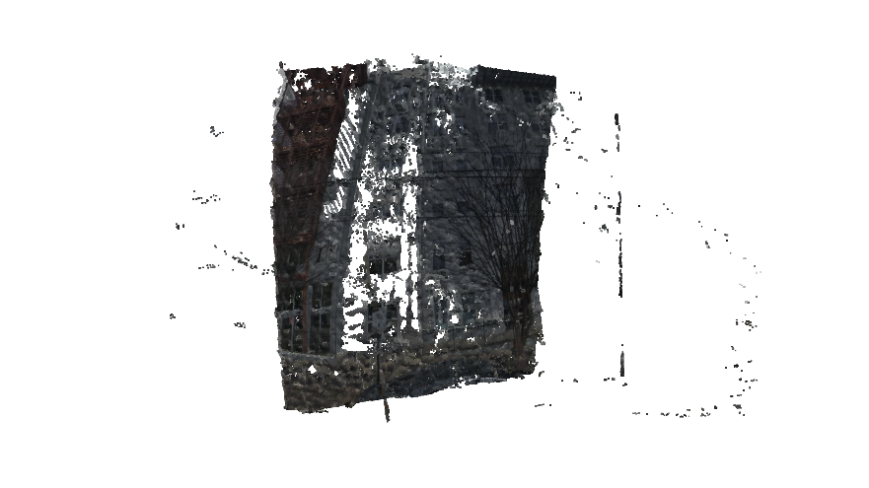
    - 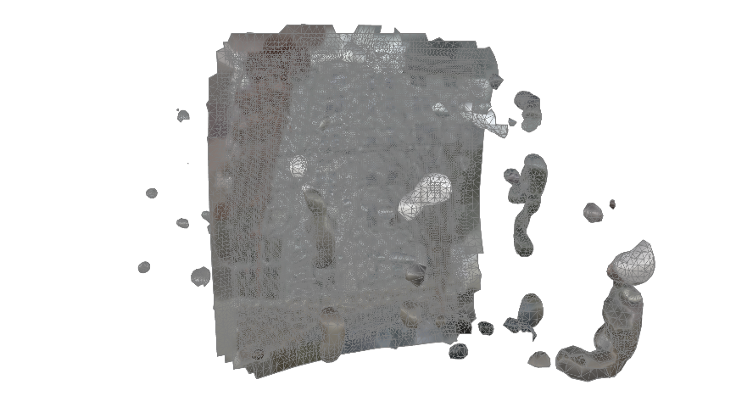
  - Test 2:
    - I decided to move the coordinates further down the street to where there were actually balconies, to actually see what kind of results I would get.
    - The results came out much worse, potentially because of many of the scraped images being the exact same image. This is from the fact that when giving coordinates to scrape the google street images from, they snap to when the panorama images were actually taken from. They are not actually taken from every foot down the street.
    - Inputs (scraped images):
      - 12 images
      - Façade headings = [260, 270, 280]
      - Optimal pitch = 20
      - Optimal FOV = 90
    - 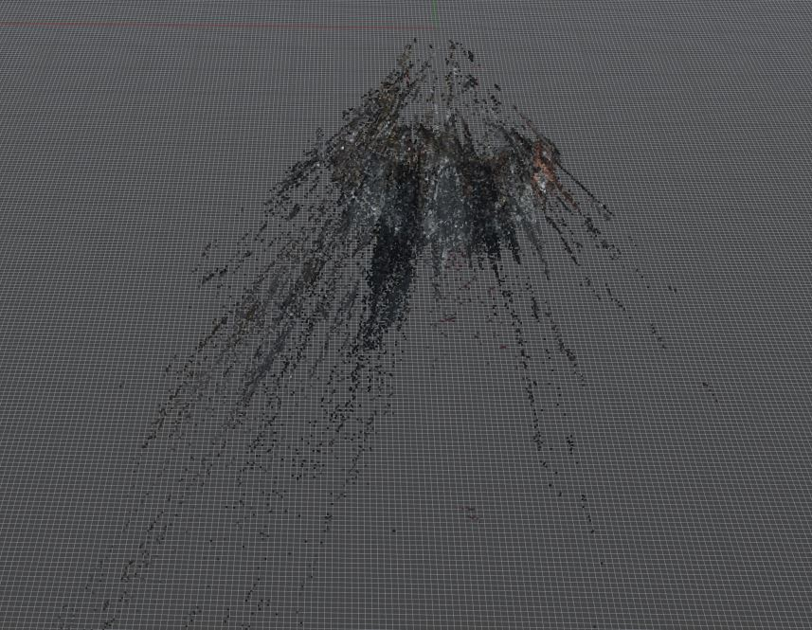
    - 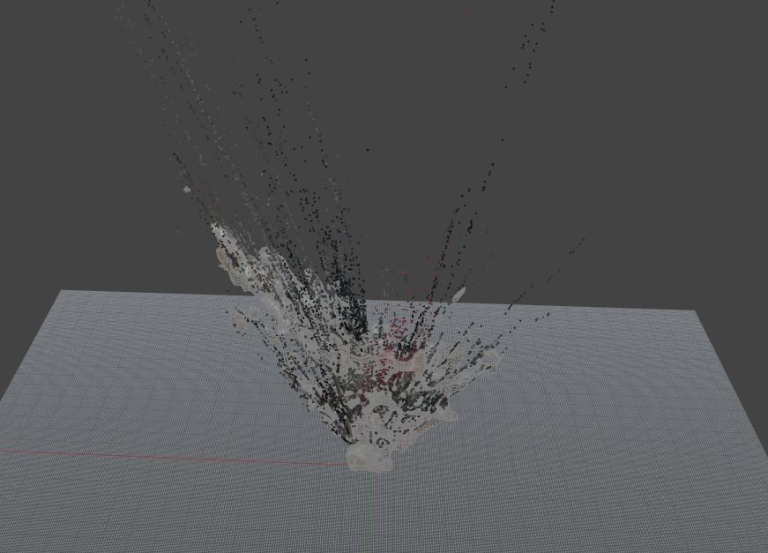
  - Test 3:
    - Since the bad output from the last test was potentially from duplicate images, in the scraping python script, I implemented a portion that would skip duplicate images
    - This gave me a better mesh than test 2, however, the very clear balconies that were supposed to be included in the depth did not at all affect the output, aka, the mesh was still pretty much flat
    - Inputs (scraped images):
      - 12 images
      - Façade headings = [260, 270, 280]
      - Optimal pitch = 20
      - Optimal FOV = 90
    - This is one of the images scraped, as you can see there are clear balconies
      - 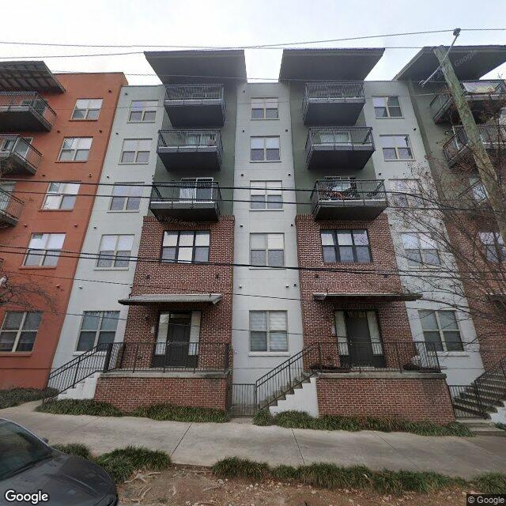
    - 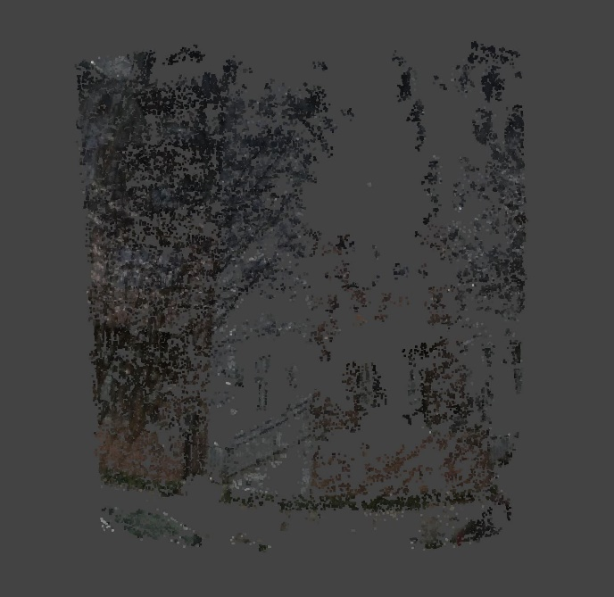
    - 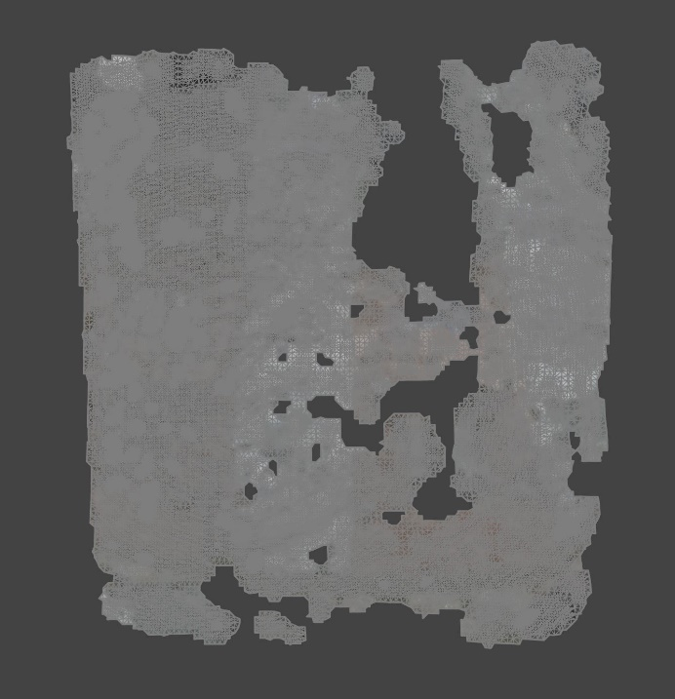
- Pivot: Clearly something is not working here, Colmap is a robust industry standard for generating semi-accurate depth accounted 3D point clouds. From conversations with Claude, it seems to think the issue might be still the input images. The way that my scraping python script gets images is from Google Street View API. I wanted to go with this API to keep the pipeline open source and free as well as keep the level of detail you get from street level. The problem with these google street view images is that they are cropped images of 3D panorama images that make the distance calculations strange. So to potentially fix some of the issues, I am going to try Street View Tiles API which hopefully should download the whole panorama
- Using Colmap (and Street View Tiles API)
  - Note to myself because I didn’t know the usage limit before, but for the Map Tiles API, the limit is 15,000 Street view tile queries per project per day. So I should be alright for my project
  - Order of execution:
    - python fetch_streetview_tiles.py (in venv)
    - python generate_colmap_poses.py (in venv)
    - ./run_colmap.sh (OUTSIDE of venv)
  - More note
    - 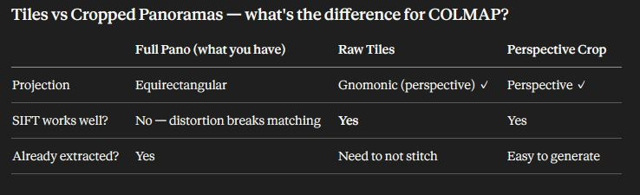
  - Order or operations
    - rm -rf street_images/ colmap_workspace/
    - python fetch_streetview_tiles.py # download tiles
    - python generate_colmap_poses.py # generate pose priors
    - bash run_colmap.sh # run COLMAP
  - Was using py360convert to crop the stiched tiles, that was not working. was trying to then use crop_perspective on top of that and that was double cropping so of course that was also not working
  - fetch_streetview_tile.py
    - Changing fetch_streetview_tile.py to NOT crop, only downloads tiles and stitches them into a raw equilrectangular
    - Added a tile size probe on the first tile before building the canvas, so it handles both 256px and 512px tiles correctly instead of assuming 512
    - Added a failed tile threshold — if more than 25% of tiles fail, the pano is skipped rather than saved with big black holes that would confuse COLMAP
  - crop_perspective.py
    - crop happens only here now
    - some other adjustments I do not understand

