
BL62 Label GUI
User Manual
English Edition · Version 2026-10-12
GPU-Assisted Particle Segmentation and COCO Dataset Preparation
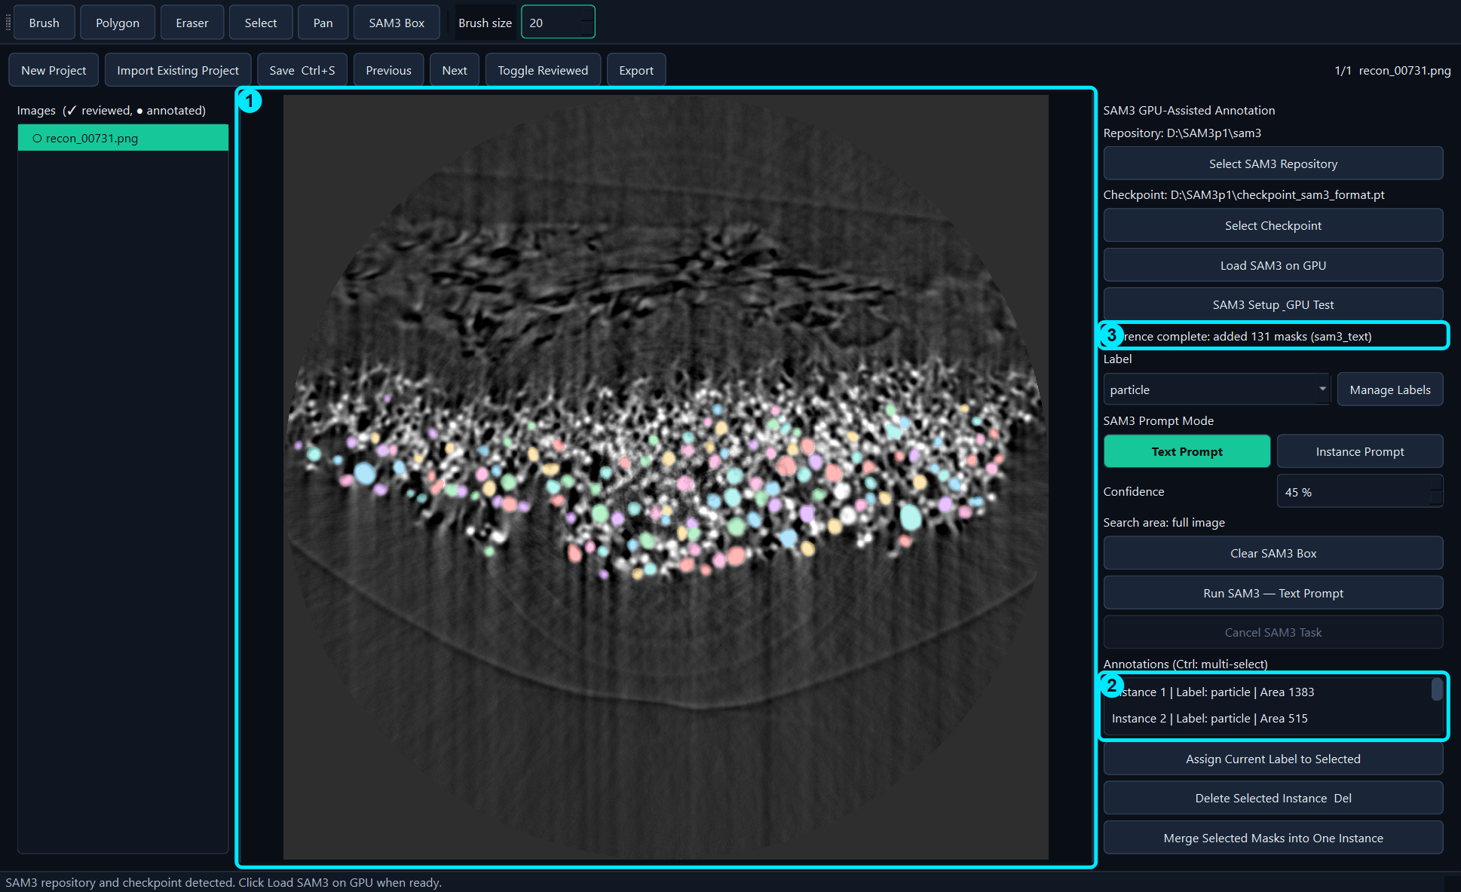

Document Control
Application | BL62 Label GUI
Manual version | 2026-10-12
Language | English
Demonstration image | recon_00731.png
Demonstration result | 131 SAM3 particle masks at 45% confidence
Scope. This manual covers installation, SAM3 configuration, project management, manual and SAM3-assisted annotation, review, saving, COCO export, update, and troubleshooting.
Data safety. All examples were created in a separate demonstration project. The original NMC811 dataset was not modified.

Contents
- 1. Purpose and Interface
- 2. Installation and First Launch
- 3. SAM3 Configuration
- 4. Projects and Images
- 5. Labels and Manual Tools
- 6. Text Prompt Annotation
- 7. Instance Prompt Annotation
- 8. Selecting and Editing Masks
- 9. Saving and Exporting
- 10. Fastest Workflow for One Image
- 11. Training Data Structure
- 12. Recommended Production Workflow
- 13. Updating or Moving the Application
- 14. Troubleshooting
- 15. Keyboard Shortcuts and Terminology

1. Purpose and Interface
BL62 Label GUI creates instance-segmentation annotations for scientific images. It combines manual tools with SAM3 Text Prompt and Instance Prompt inference, then saves annotations in COCO-compatible JSON format.
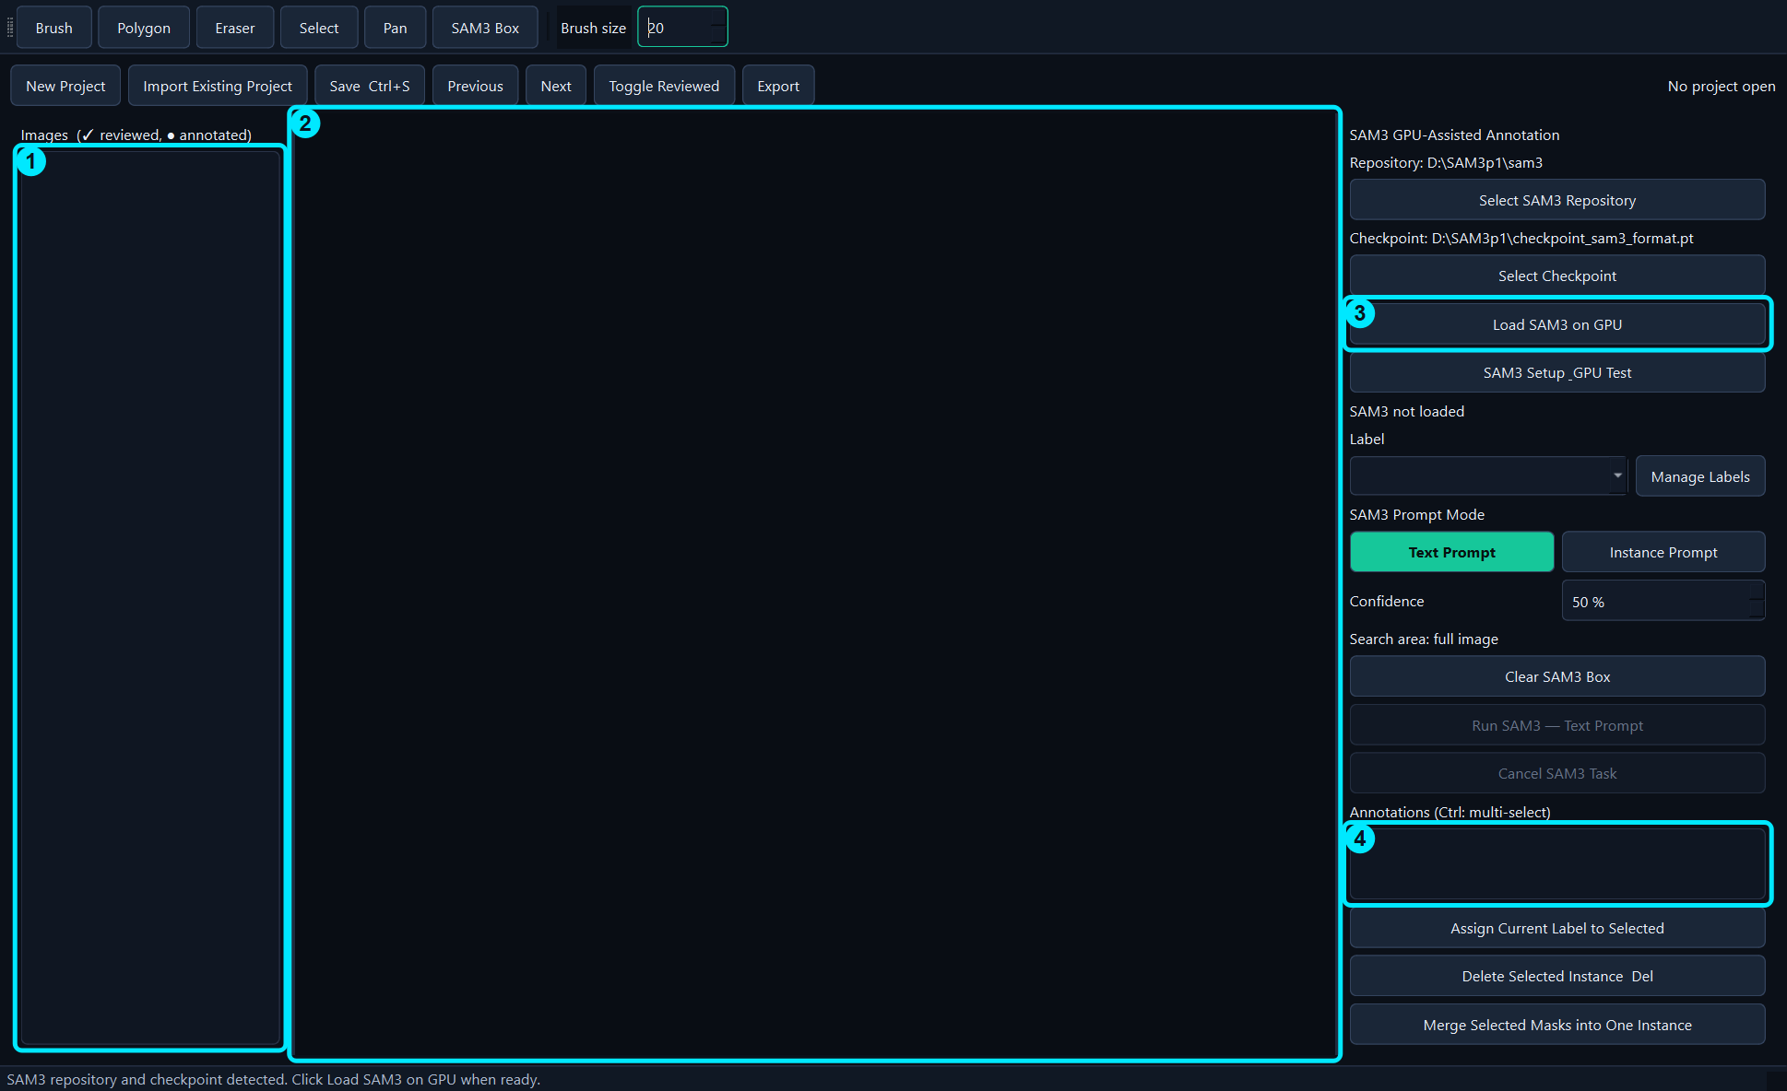
Figure 1. Main interface: 1 image list, 2 image canvas, 3 SAM3 and label controls, 4 annotation list.

1.1 Main areas
- Top toolbar: Brush, Polygon, Eraser, Select, Pan, SAM3 Box, and Brush size.
- Left panel: imported images and review/annotation status.
- Center canvas: source image and colored instance masks.
- Right panel: SAM3 setup, labels, prompt modes, confidence, and annotation list.
- Top project row: New Project, Import, Save, navigation, review, and Export.

2. Installation and First Launch

2.1 Install on a GPU computer
- Copy the complete BL62_Label_GUI_Release folder to the target computer.
- Run install_windows.bat. The installer creates or validates the dedicated application environment.
- Do not copy SAM3 source code or checkpoints into the application repository unless your local policy requires it.
- Run create_shortcut.ps1 or use the supplied BL62 Label GUI shortcut.
- Double-click the desktop icon. The English GUI opens without a console window.
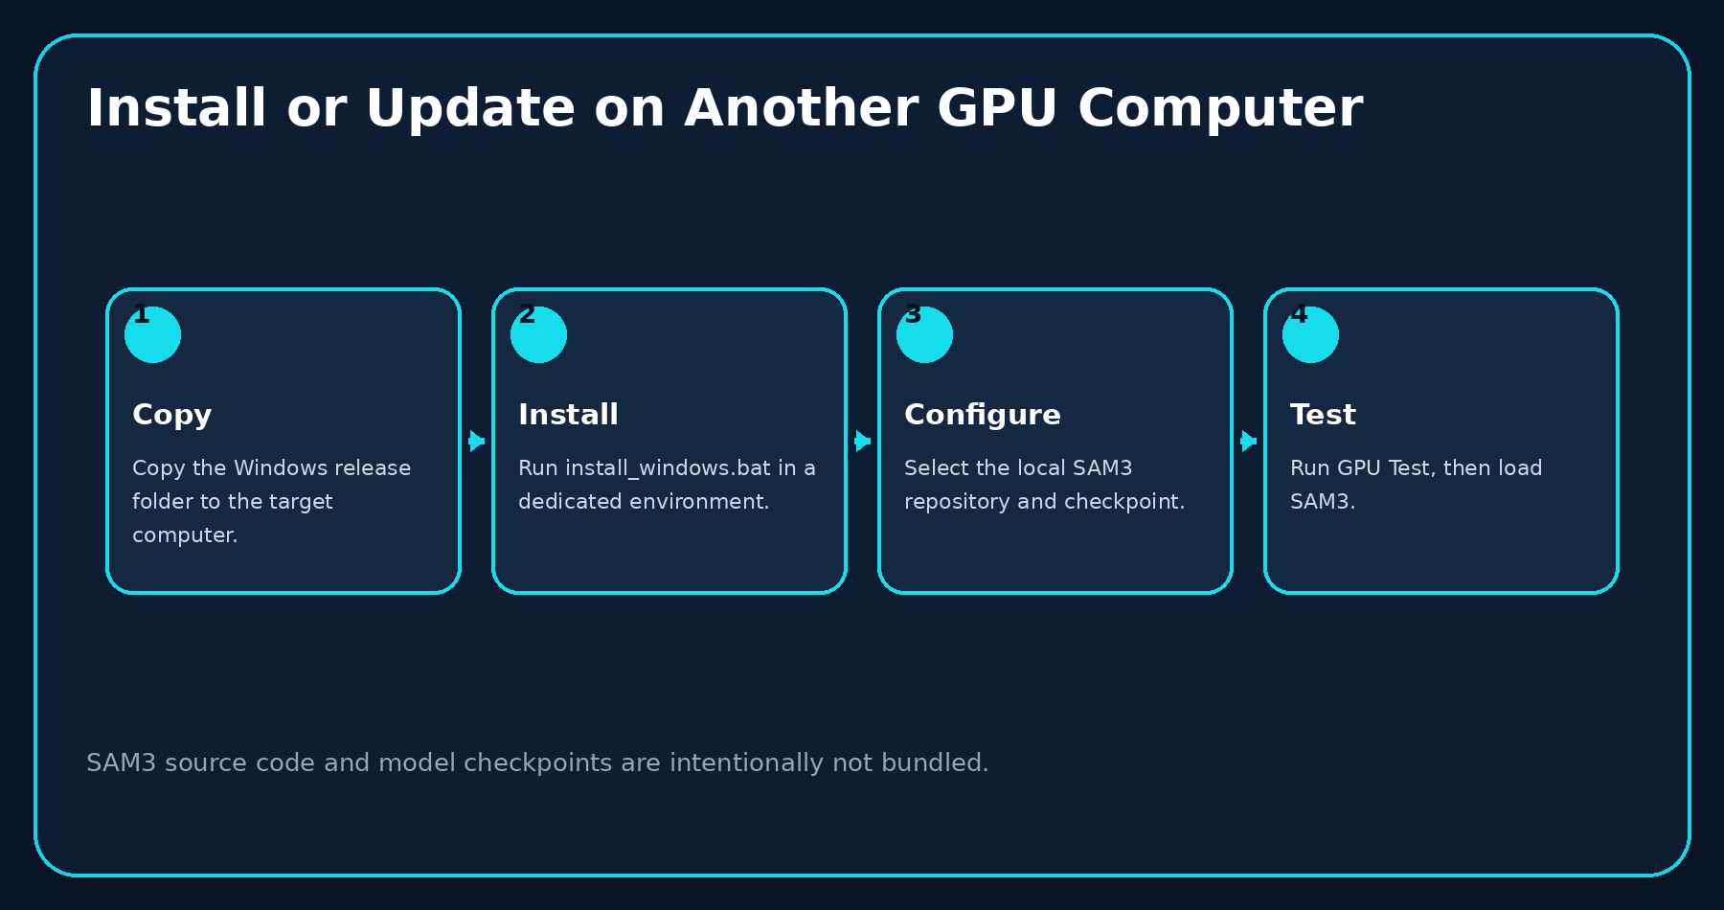
Figure 2. Safe installation and update sequence.

2.2 Requirements
- Windows 10/11 with an NVIDIA GPU and a compatible driver.
- A local SAM3 source repository.
- A compatible SAM3 checkpoint (.pt, .pth, or .ckpt).
- Sufficient GPU memory for the selected image size.
- Write access to the project and export folders.

3. SAM3 Configuration

3.1 Configure paths
- Click SAM3 Setup & GPU Test.
- Select the folder that contains the sam3 Python package.
- Select the compatible checkpoint file.
- Click Auto Detect if common local paths should be searched.
- Click Run GPU Test to verify PyTorch, CUDA, and the NVIDIA GPU.
- Click Save Configuration.
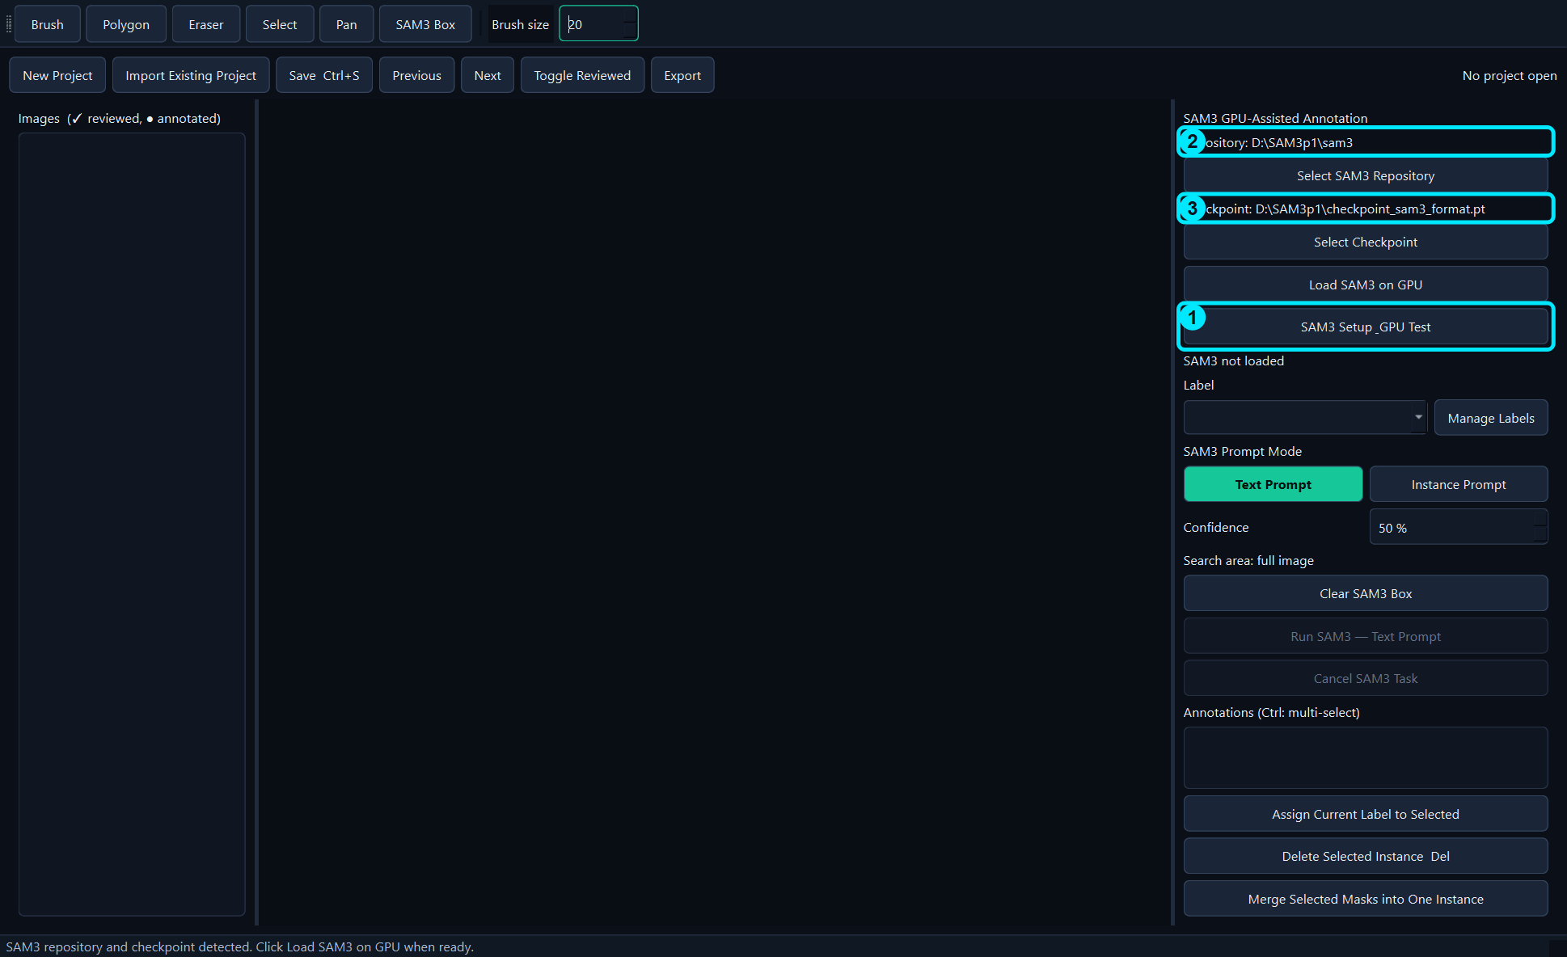
Figure 3. 1 Setup button, 2 repository path, 3 checkpoint path.

3.2 Load SAM3
- Click Load SAM3 on GPU.
- Wait for the status message to report a successful load test.
- The GUI remains responsive because model loading runs in an isolated process.
- Use Cancel SAM3 Task if loading or inference must be stopped.
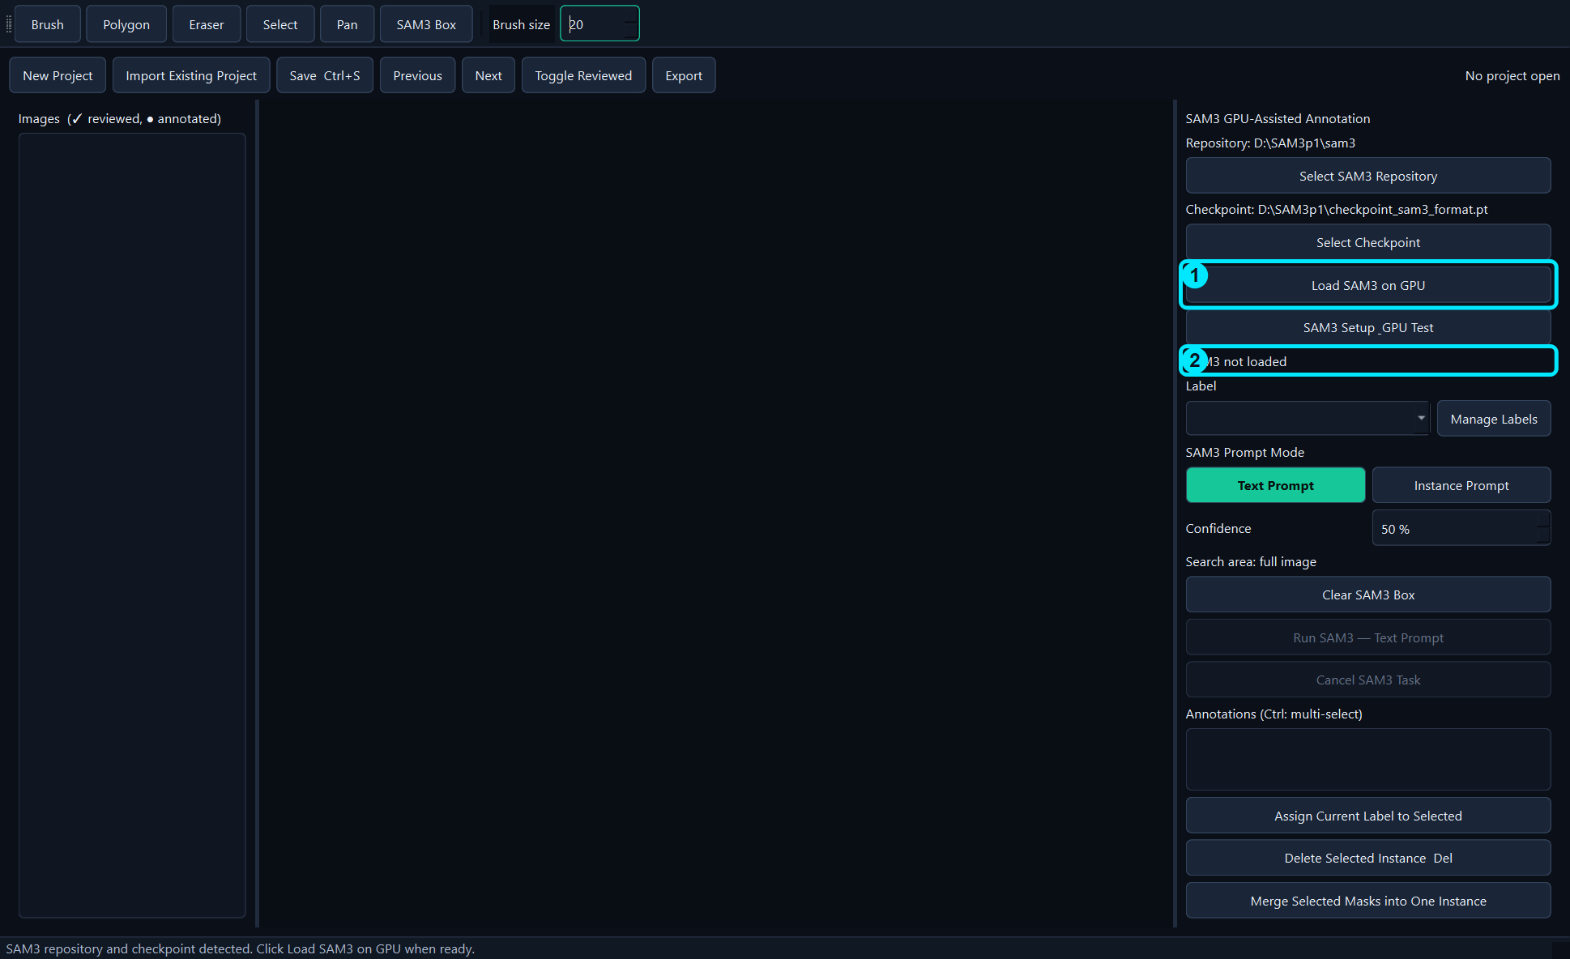
Figure 4. 1 Load SAM3 button and 2 load status.
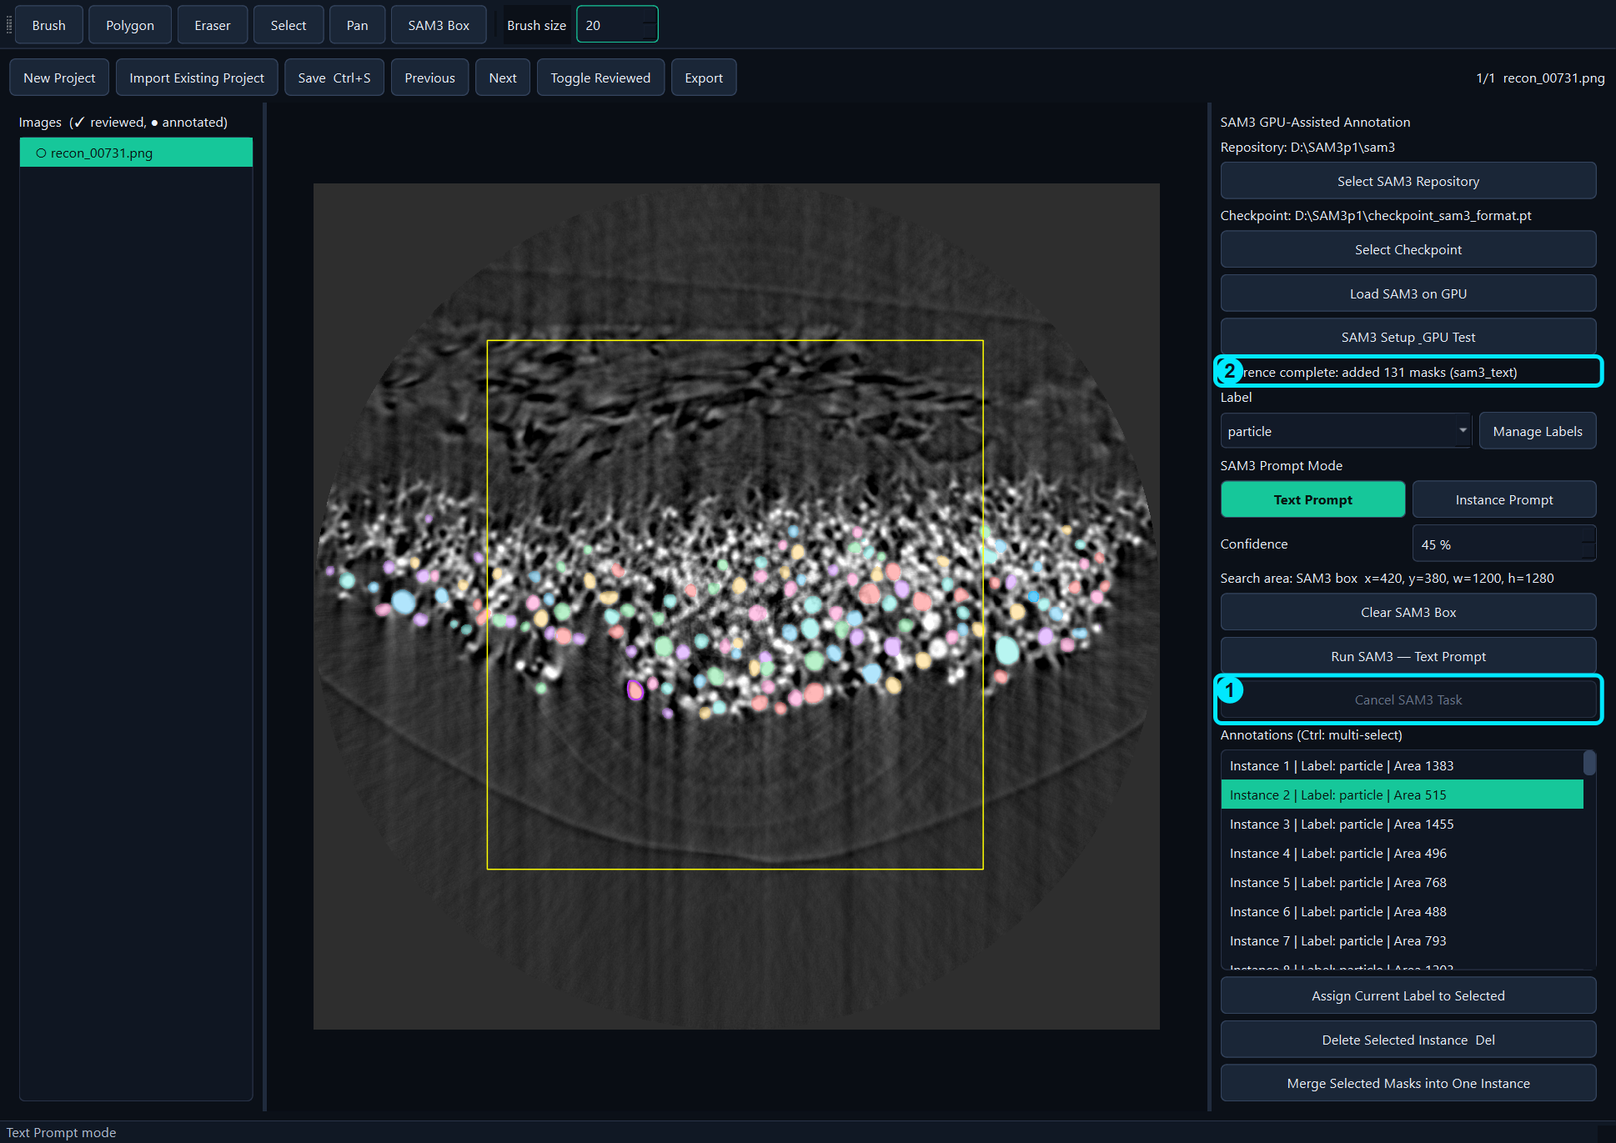
Figure 5. Cancel an active SAM3 load or inference task.

4. Projects and Images

4.1 Create a new project
- Click New Project.
- Choose either a folder or one or more supported images.
- For a single image, dragging the image into an empty GUI is the fastest method.
- Confirm that the image appears in the left list and center canvas.
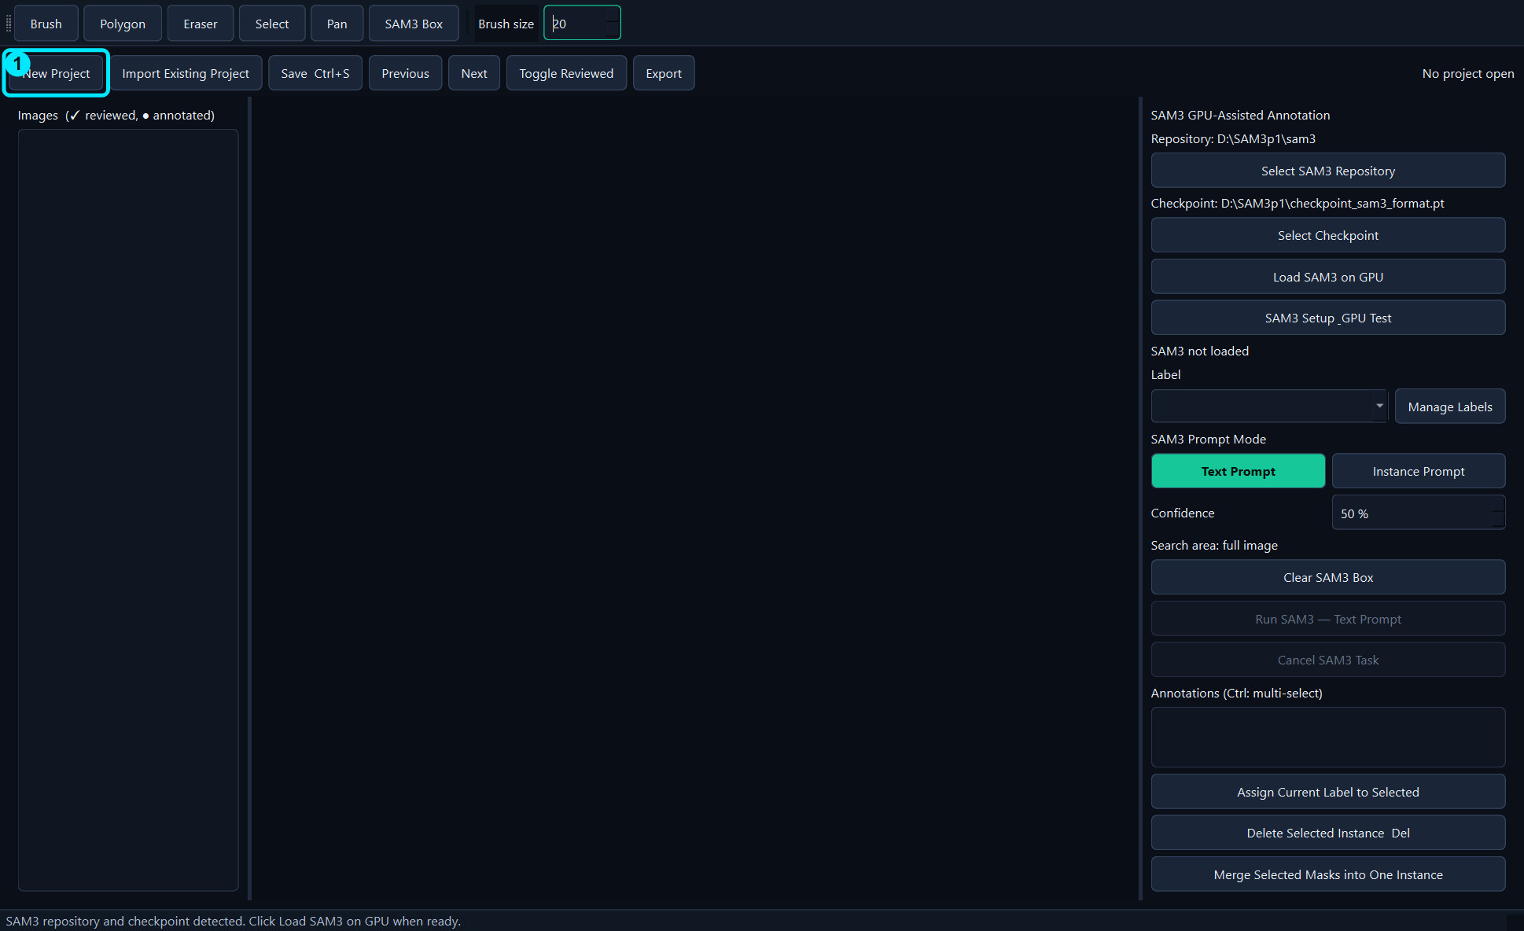
Figure 6. New Project starts a folder-based or image-based project.
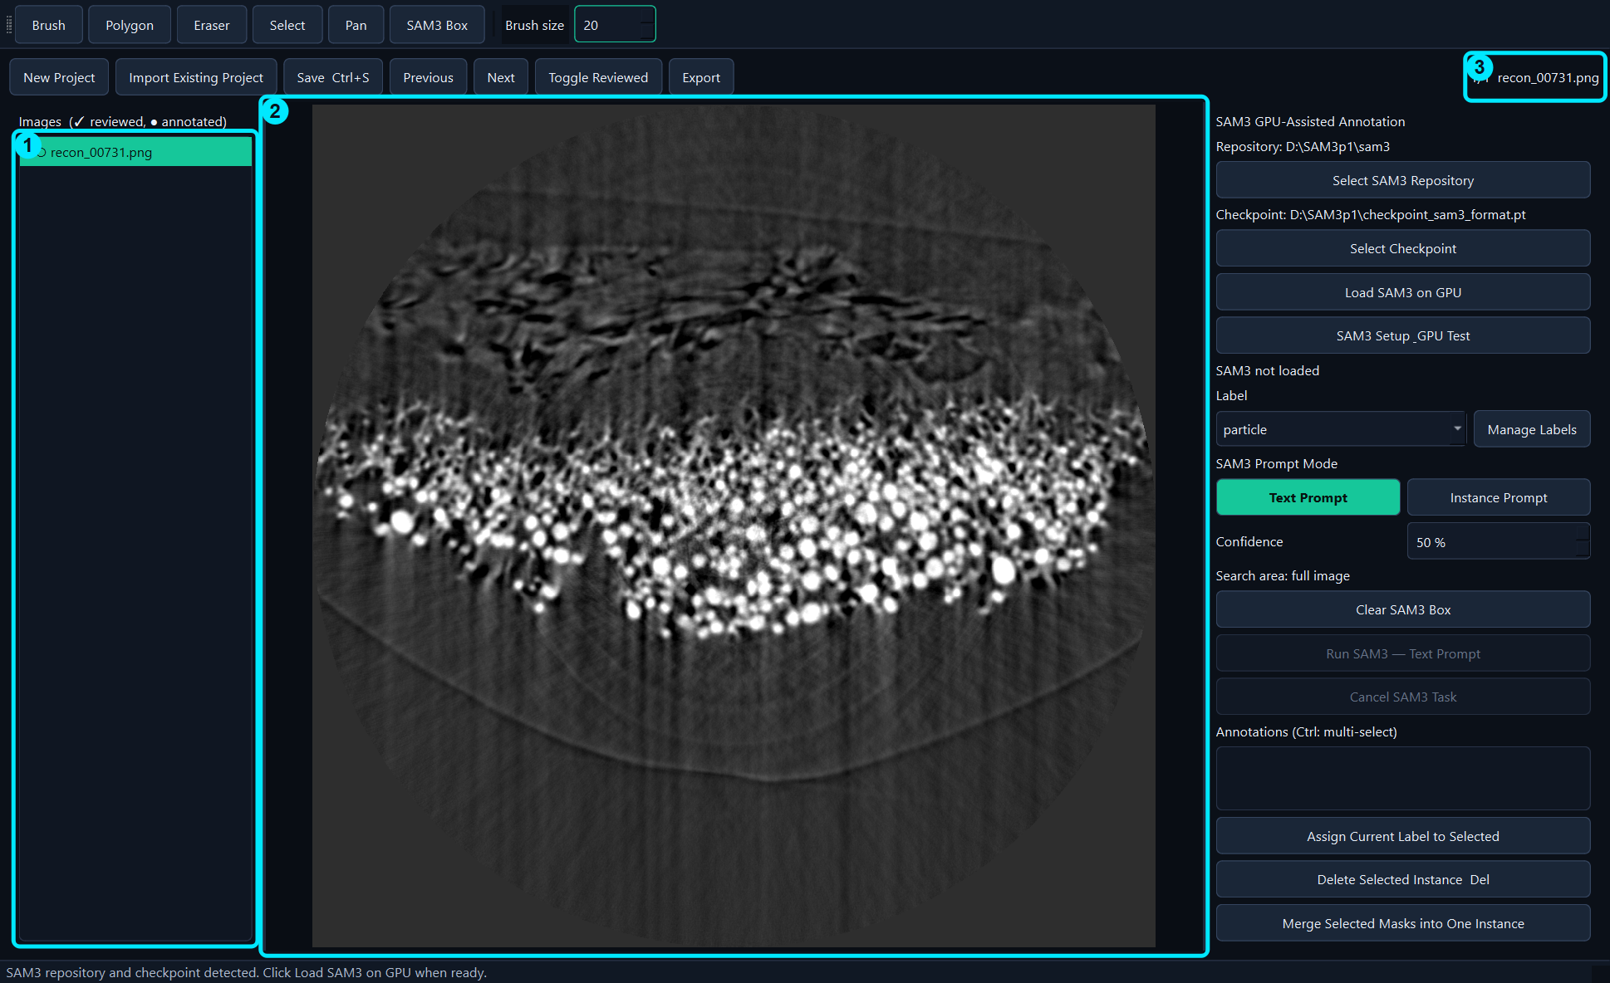
Figure 7. recon_00731.png loaded as a one-image project.

4.2 Import an existing project
- Click Import Existing Project.
- Select the project's annotations.json file—not an image file.
- Verify that images and masks appear correctly.
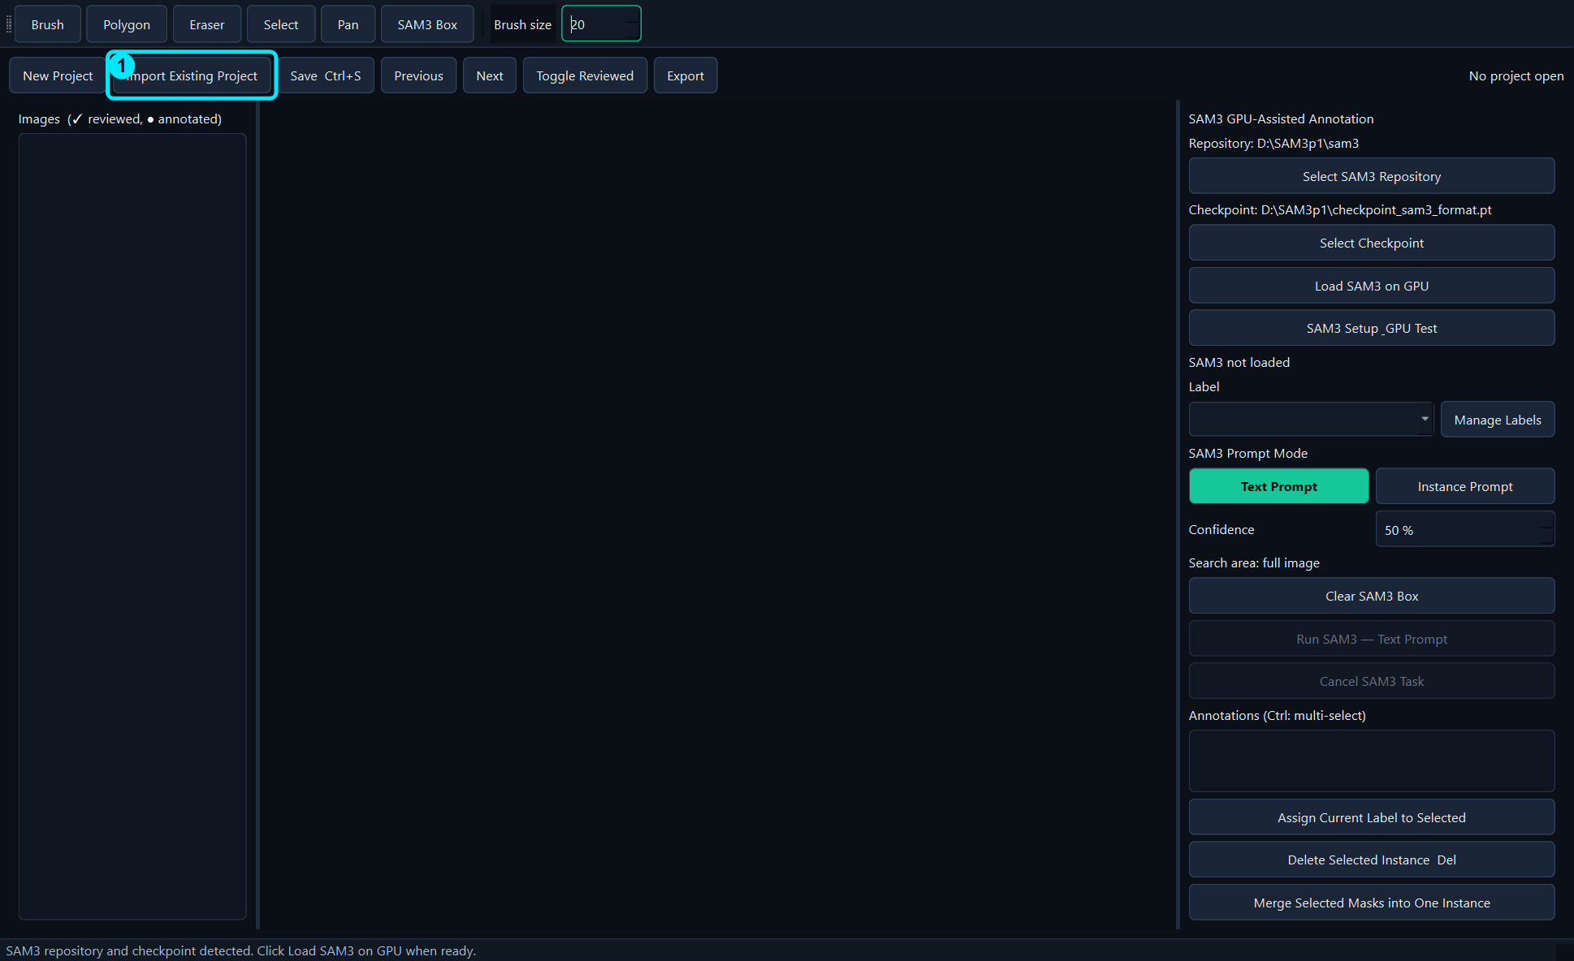
Figure 8. Import an existing COCO project by selecting annotations.json.

4.3 Navigate and remove images
- Use Previous and Next, or click an image in the left list.
- Ctrl-click or Shift-click to select multiple image entries.
- Right-click the selected entries and choose Remove from Project.
- The original image files remain on disk; only project references and associated annotations are removed.
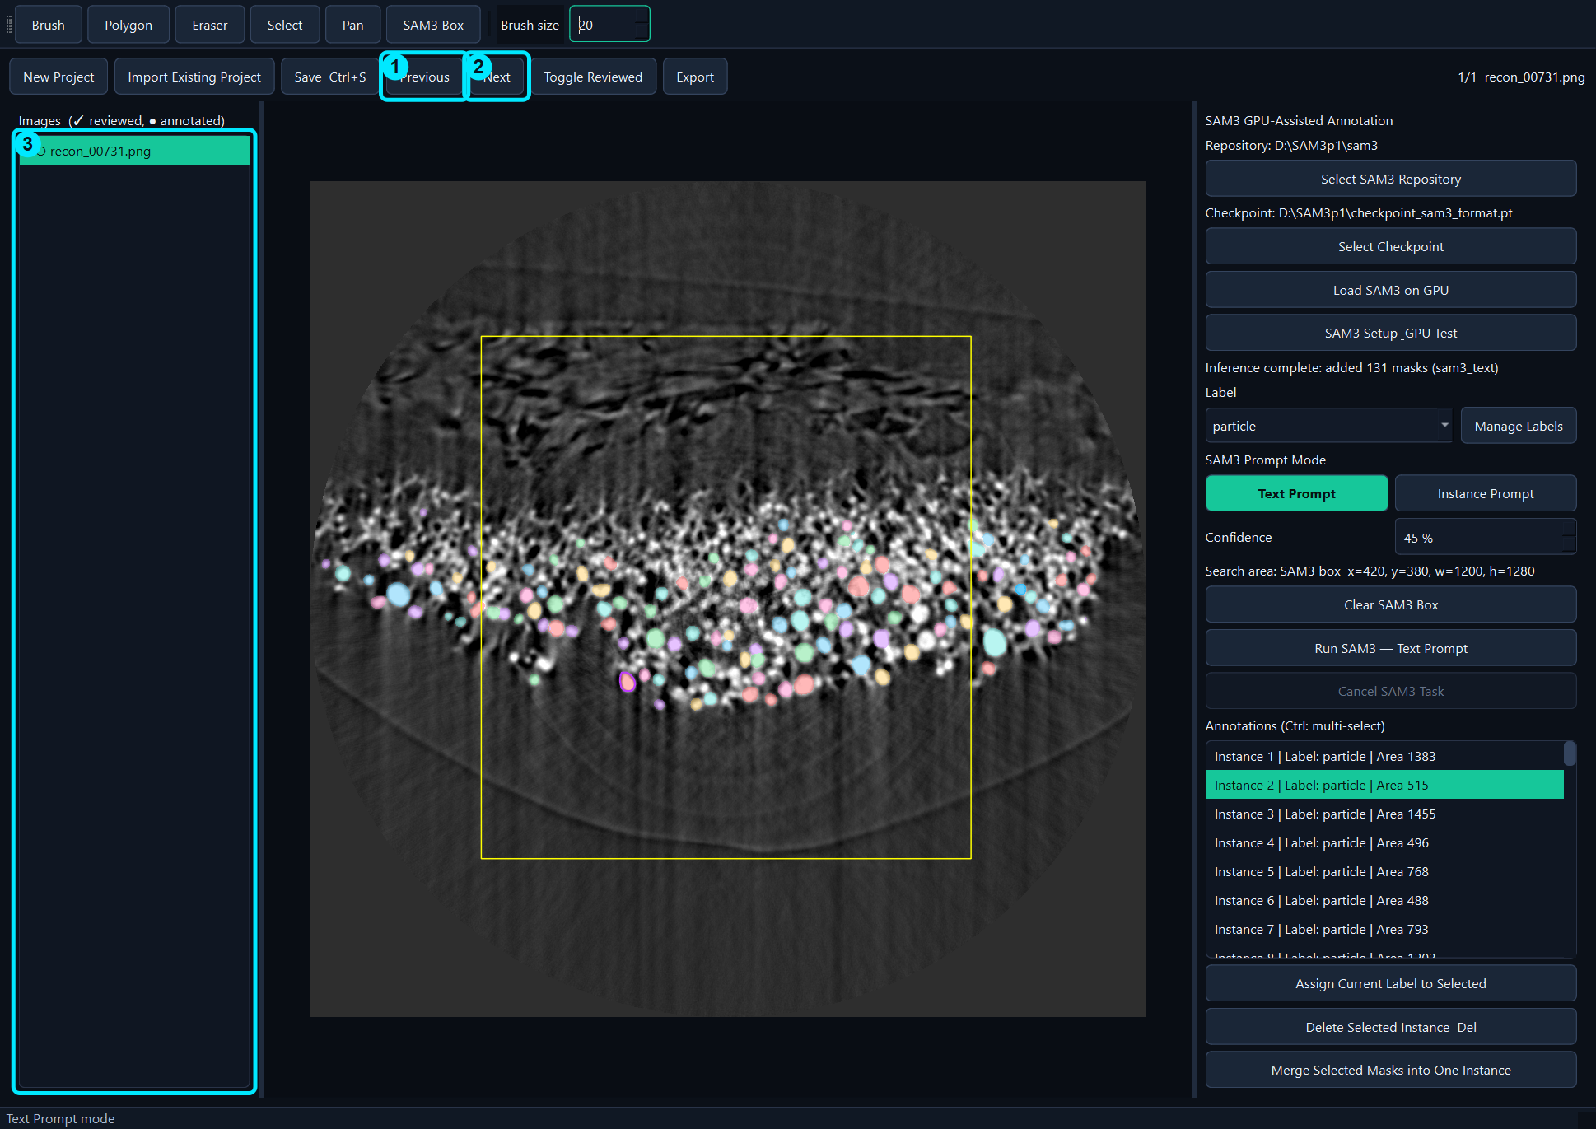
Figure 9. Previous, Next, and the image list.
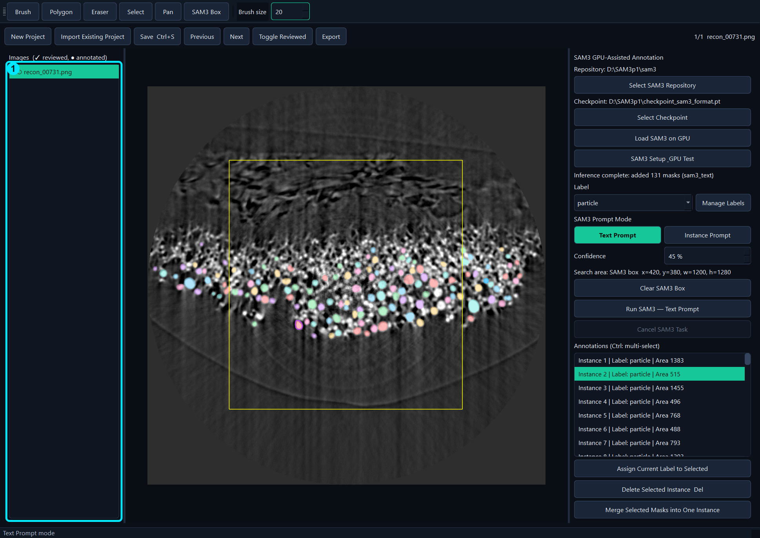
Figure 10. Select one or more images before opening the right-click removal menu.

5. Labels and Manual Tools

5.1 Labels
A Label is the feature name used by both annotation and training. One image may contain multiple labels. For this example, the label is particle.
- Select the required Label before drawing or running SAM3.
- Click Manage Labels to create, rename, merge, or delete labels.
- To relabel existing instances, select them and click Assign Current Label to Selected.
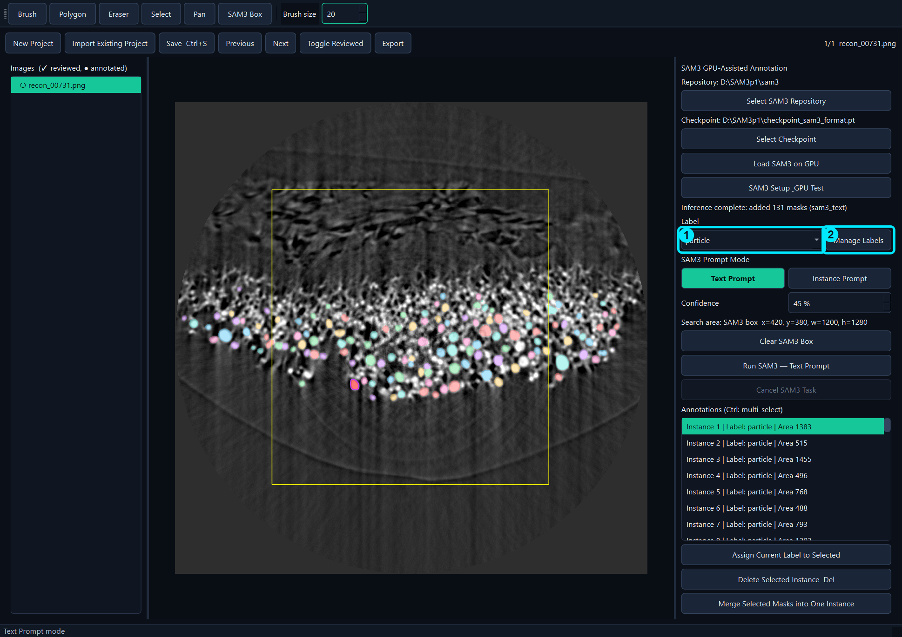
Figure 11. Select particle or open Manage Labels.

5.2 Manual tools
Tool | Use | Finish/Exit
Brush | Create or add pixels to an instance | Enter, Esc, or click Brush again
Polygon | Create a closed polygon instance | Enter or right-click
Eraser | Remove pixels from the selected instance | Enter or Esc
Select | Select an instance on the image | Esc or click Select again
Pan | Move/zoom the image | Esc or click Pan again
SAM3 Box | Limit the SAM3 search region | Drag a box; Clear SAM3 Box to remove

5.3 Brush and Eraser
- Select a mask to modify, or leave all masks unselected to create a new mask with Brush.
- Click Brush and paint over missing pixels.
- Click Eraser and paint over unwanted pixels.
- Press Enter to finish the current instance. The selection clears automatically.
- If an instance contains fewer than 10 pixels, choose whether to delete it.
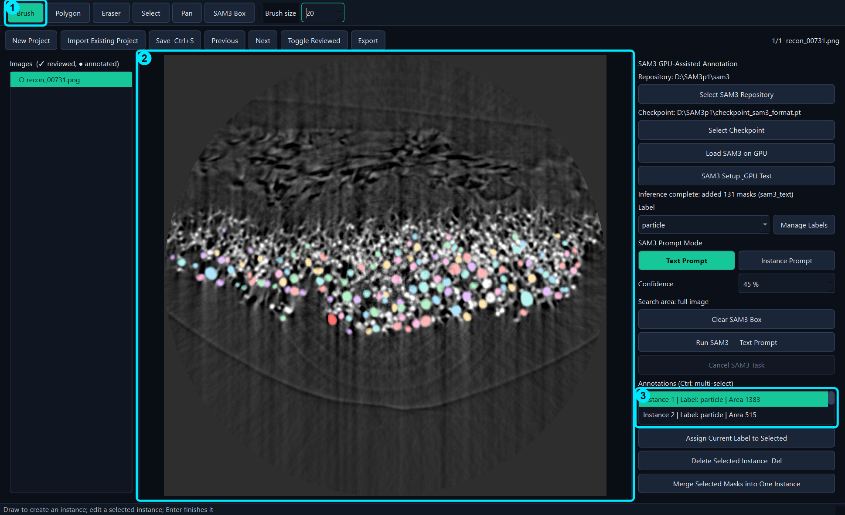
Figure 12. Brush mode: 1 tool, 2 canvas, 3 selected instance.
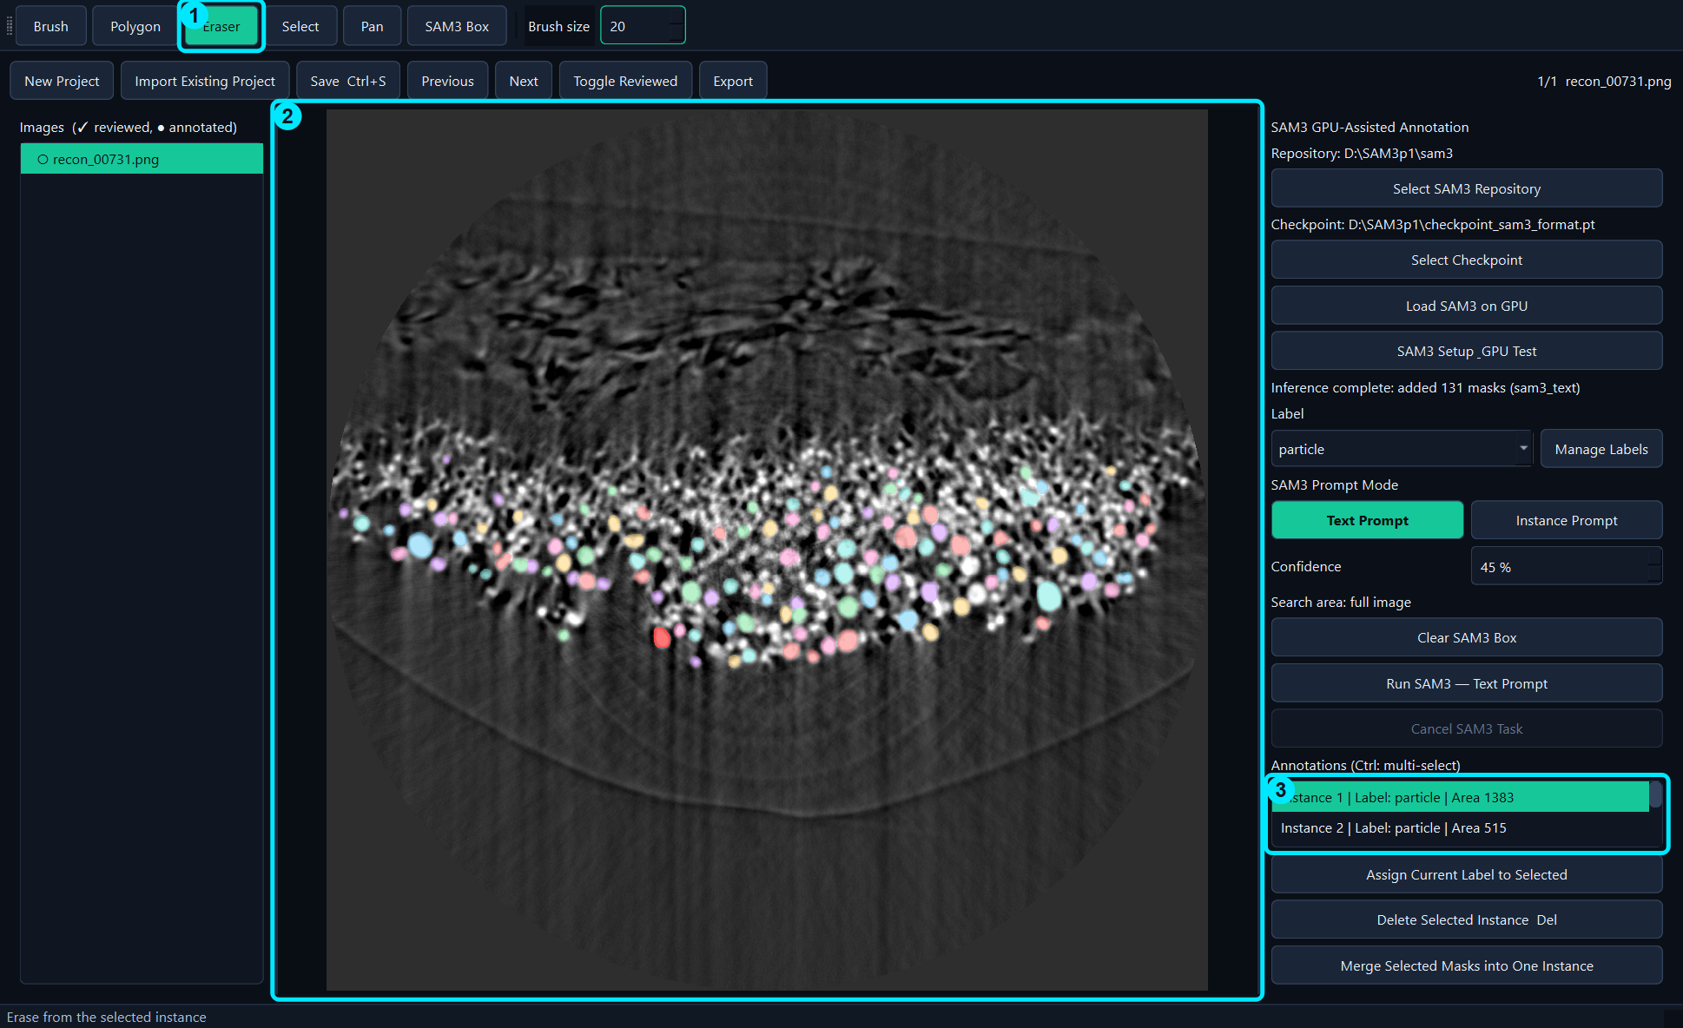
Figure 13. Eraser mode edits only the selected instance.

6. Text Prompt Annotation
Text Prompt is the fastest starting point when many objects share one semantic feature. The current Label supplies the prompt name.

6.1 Configure Text Prompt
- Select the particle Label.
- Select Text Prompt.
- Set Confidence. For recon_00731.png, 45% is used in this manual.
- Optionally draw a SAM3 Box to restrict inference to a region.
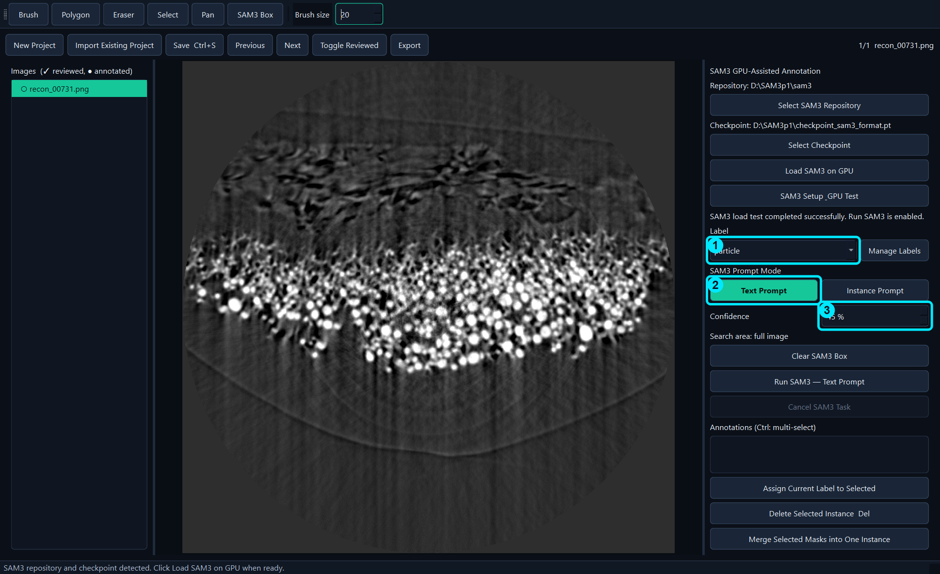
Figure 14. 1 Label, 2 Text Prompt, 3 Confidence.

6.2 Run inference
- Click Run SAM3 — Text Prompt once.
- Wait while the button is disabled and progress is shown.
- Do not click Run repeatedly. Use Cancel SAM3 Task only when cancellation is required.
- Review every predicted mask before marking the image as reviewed.
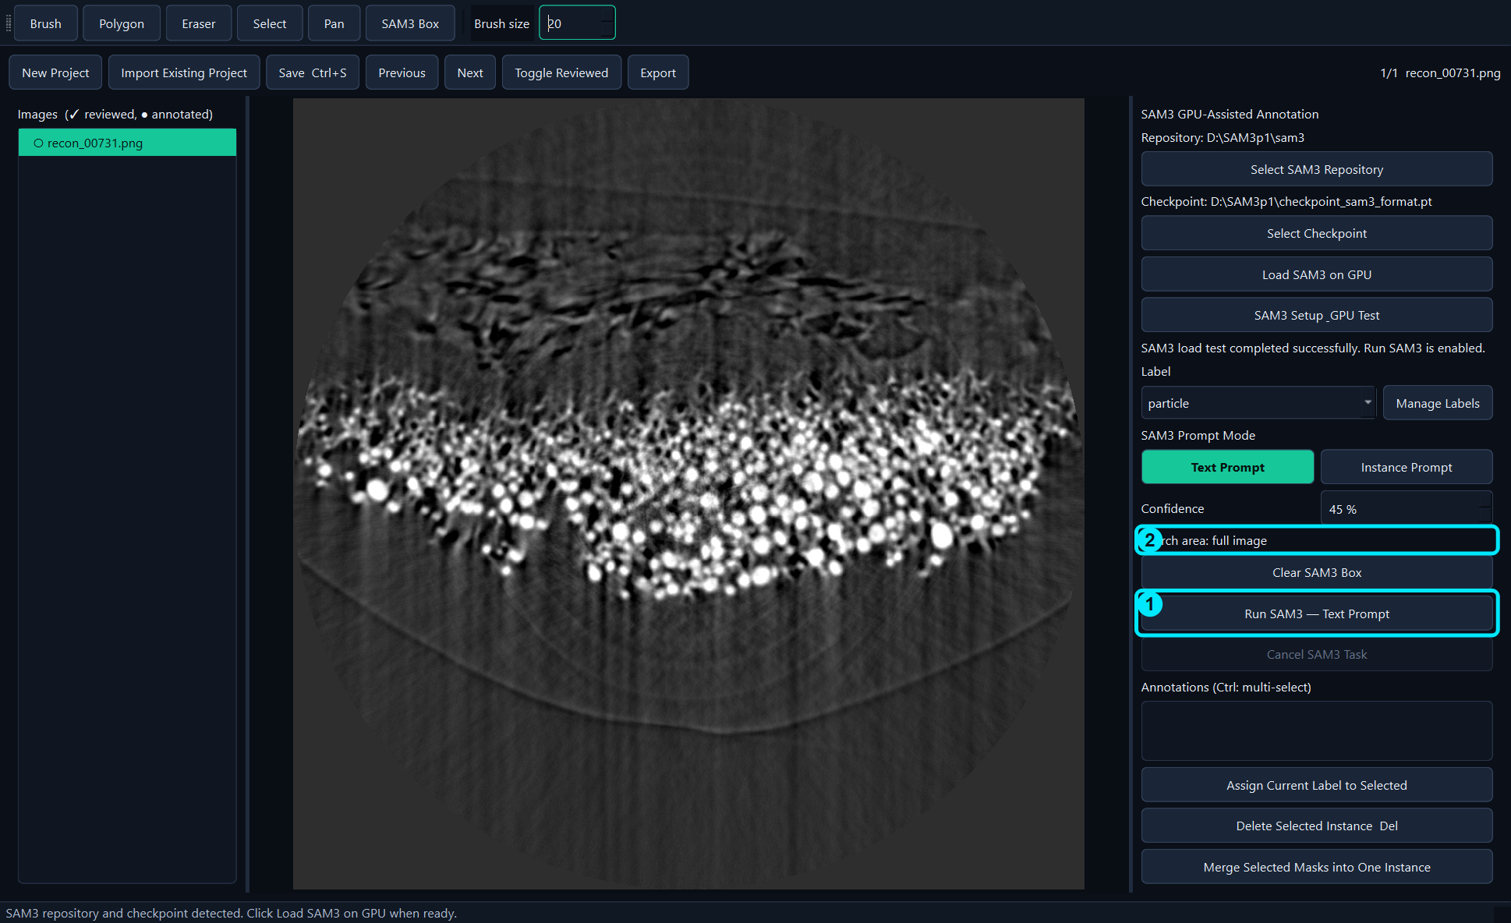
Figure 15. Run Text Prompt on the full image or inside a SAM3 Box.
Figure 16. Actual result on recon_00731.png: 131 particle masks at 45% confidence.

6.3 Use a SAM3 Box
- Click SAM3 Box in the toolbar.
- Drag a rectangle over the desired search area.
- Verify the coordinates in Search area.
- Run Text Prompt.
- Click Clear SAM3 Box to restore full-image search.
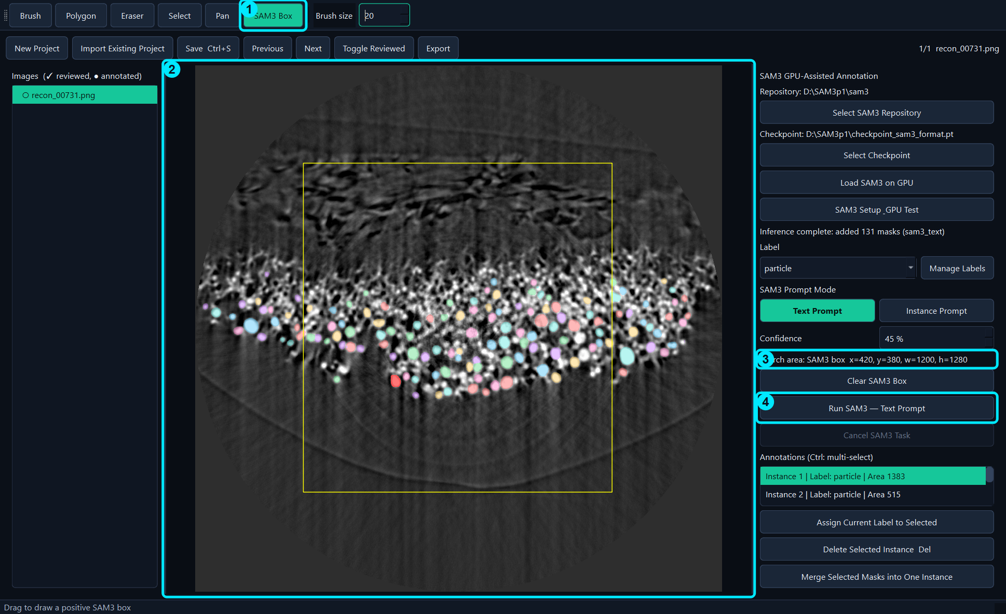
Figure 17. 1 SAM3 Box tool, 2 selected region, 3 region status, 4 Run button.

7. Instance Prompt Annotation
Instance Prompt uses an example mask to find visually similar instances. Use it when a text description is too broad or when one morphology should be tracked consistently.
- Select a high-quality existing instance.
- Click Instance Prompt.
- Click Use Selected Instance, or draw a new prompt mask.
- Confirm that the prompt status and purple exemplar outline are visible.
- Click Run SAM3 — Instance Prompt.
- Review and correct the predicted instances.
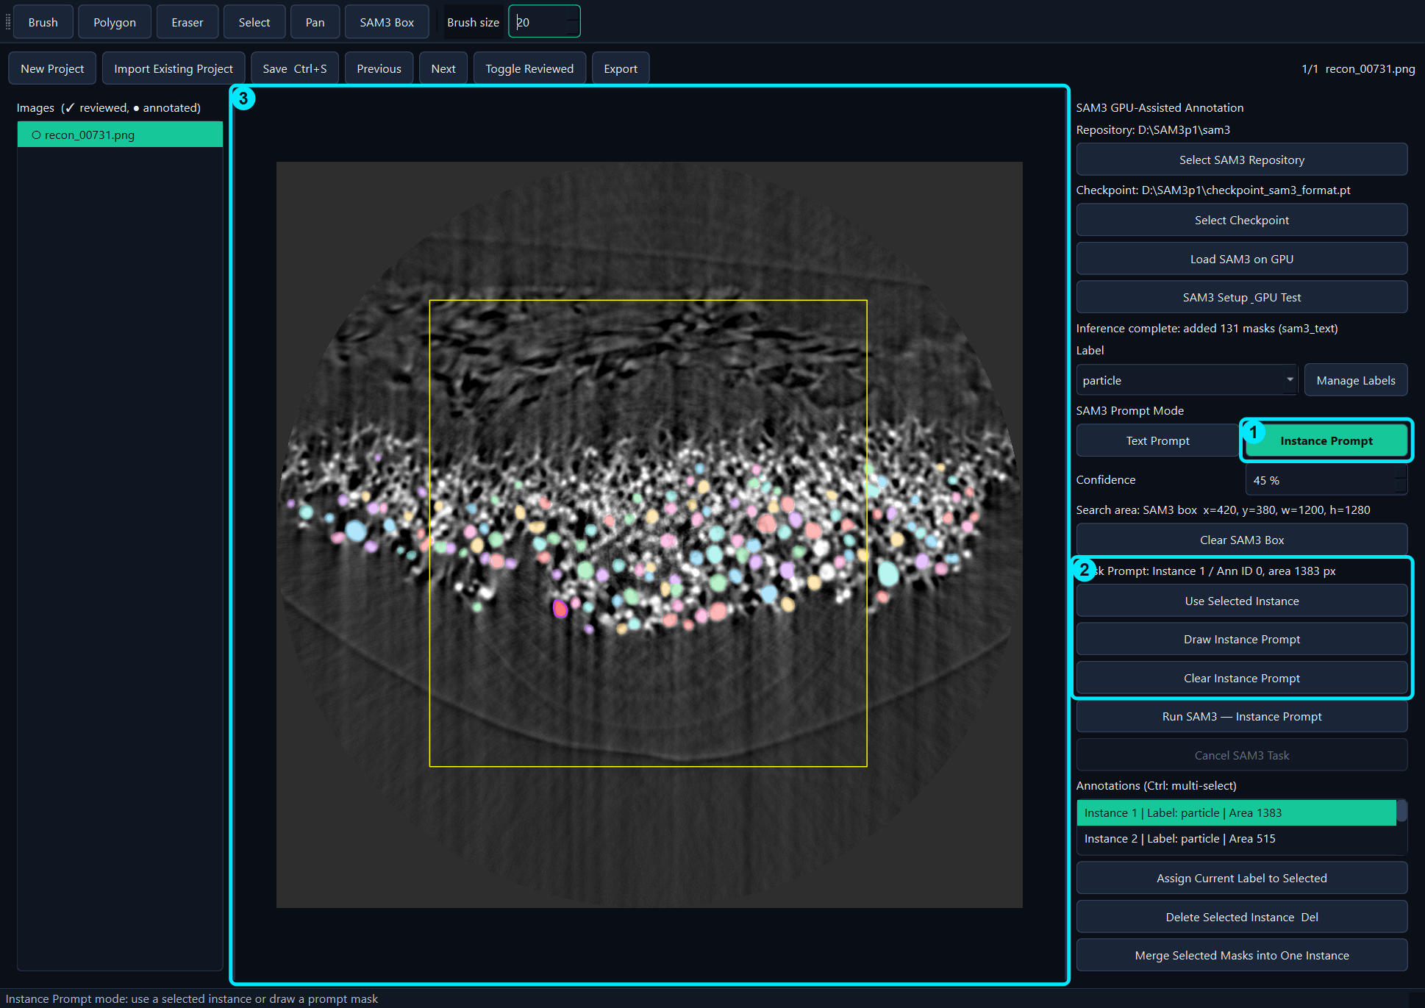
Figure 18. 1 Instance Prompt mode, 2 prompt controls, 3 exemplar shown on the image.

8. Selecting and Editing Masks

8.1 Select and inspect
- Click a colored mask on the image or click its row in the annotation list.
- The image highlight and list selection remain synchronized.
- Read the Label and Area value in the list.
- Ctrl-click rows to select multiple instances.
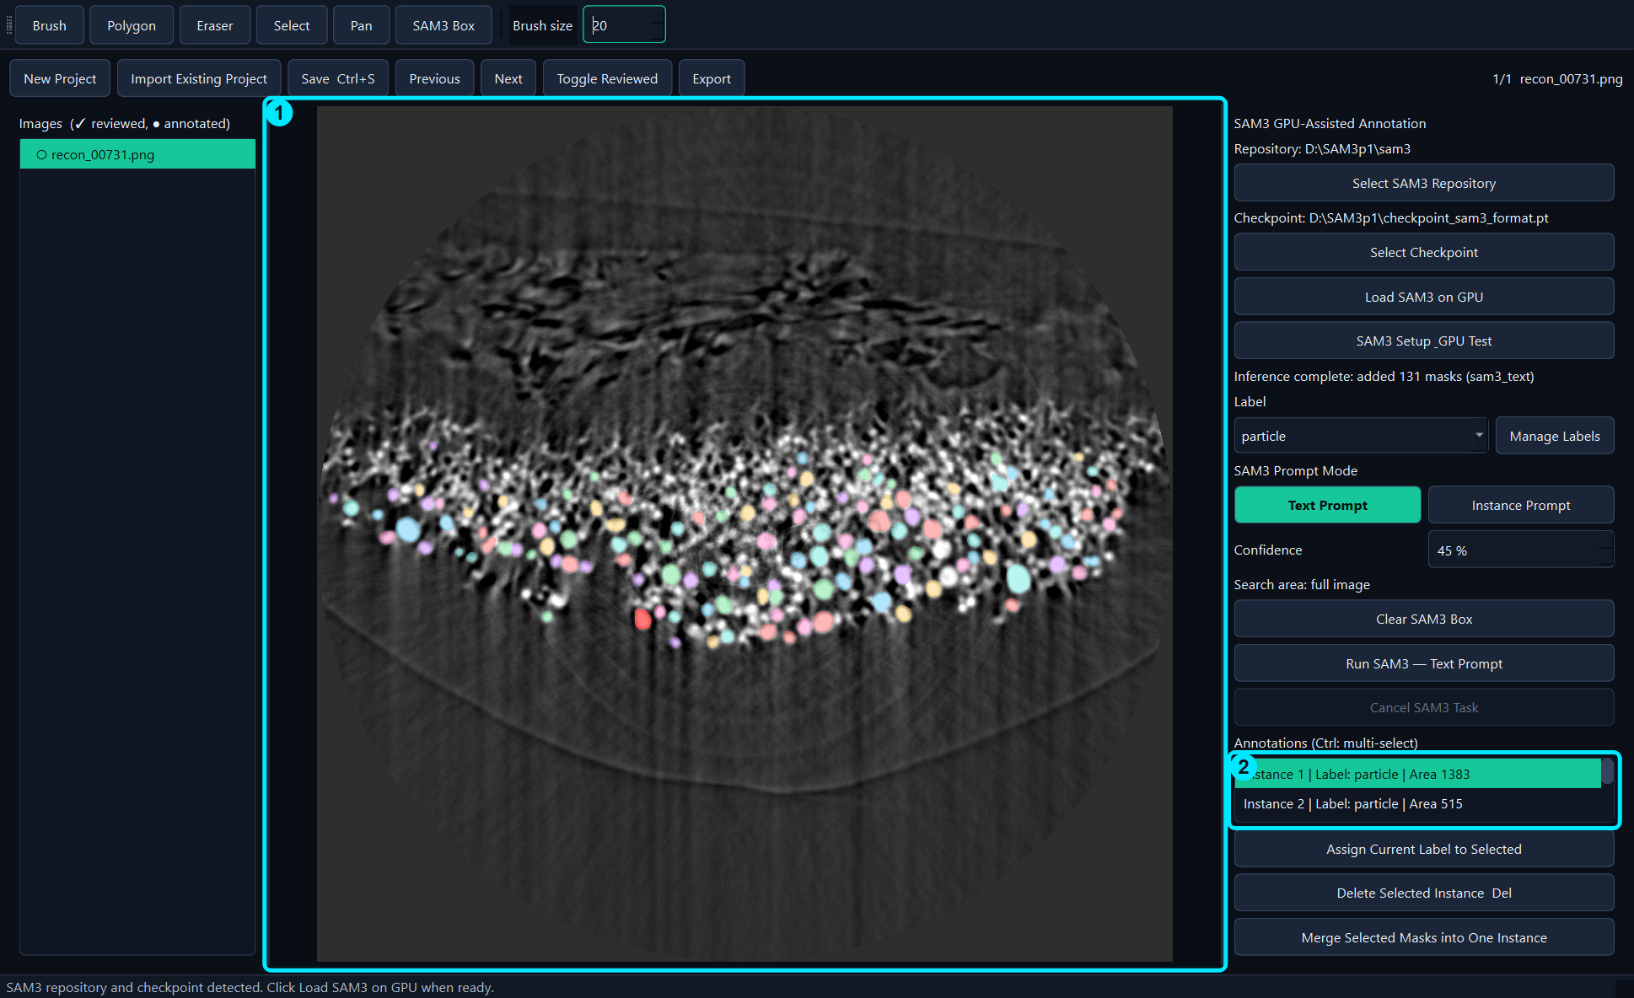
Figure 19. Image selection and annotation-list selection are synchronized.
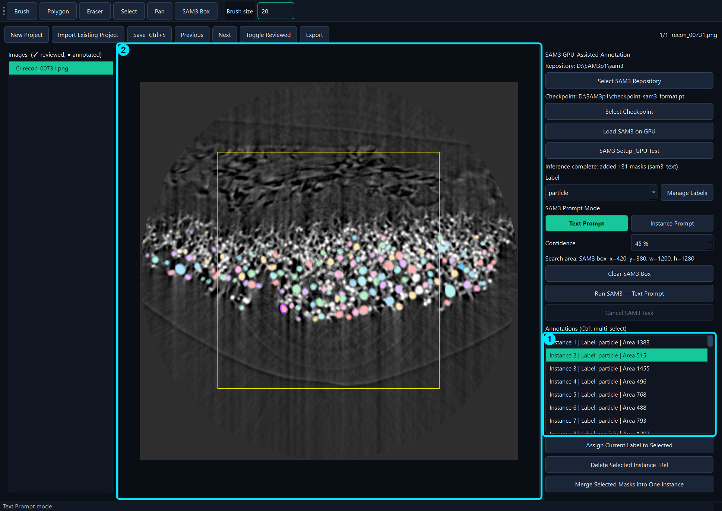
Figure 20. 1 annotation list and 2 selected mask.

8.2 Delete, merge, and relabel
- Select one or more instances.
- Press Delete or click Delete Selected Instance to remove them.
- Select at least two instances and click Merge Selected Masks into One Instance when fragments belong to one object.
- Choose a Label and click Assign Current Label to Selected to relabel without redrawing.
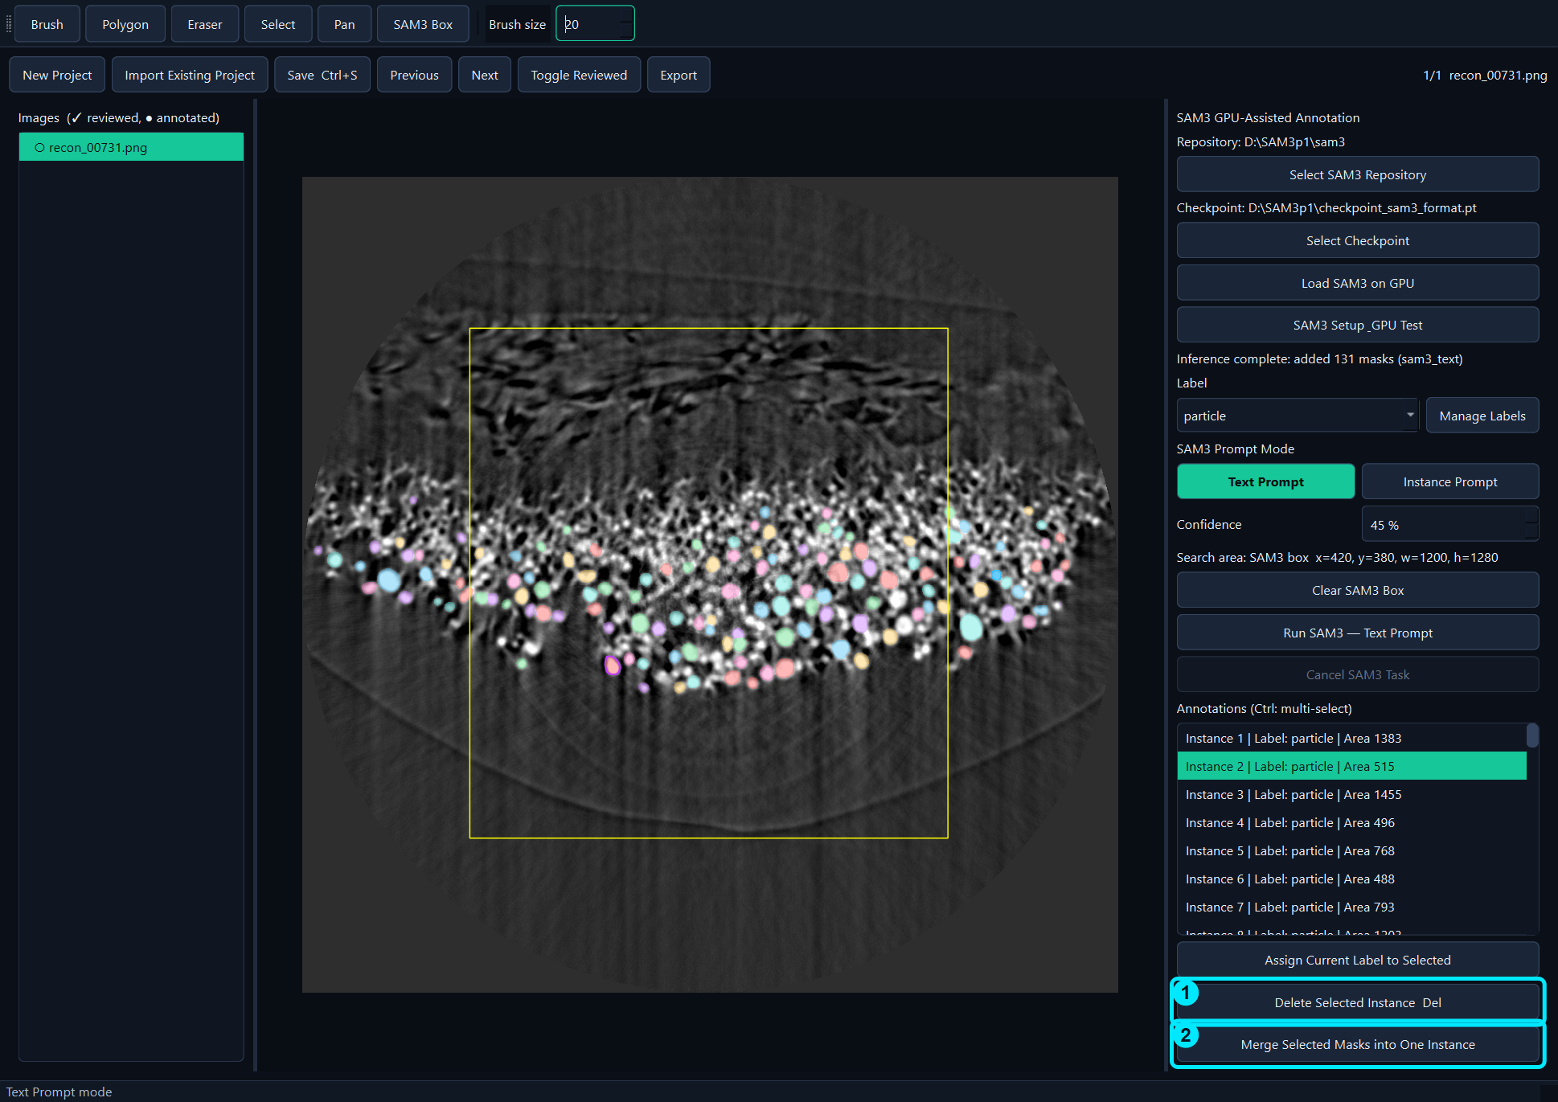
Figure 21. Delete and Merge operations for selected instances.

9. Saving and Exporting

9.1 Save
Save updates the working project's annotations.json. Use Ctrl+S frequently. Save does not create the separated training/auxiliary export structure.
- Finish the current mask with Enter.
- Click Save Ctrl+S.
- Confirm that no error message appears.
- Optionally mark the image as reviewed after visual inspection.
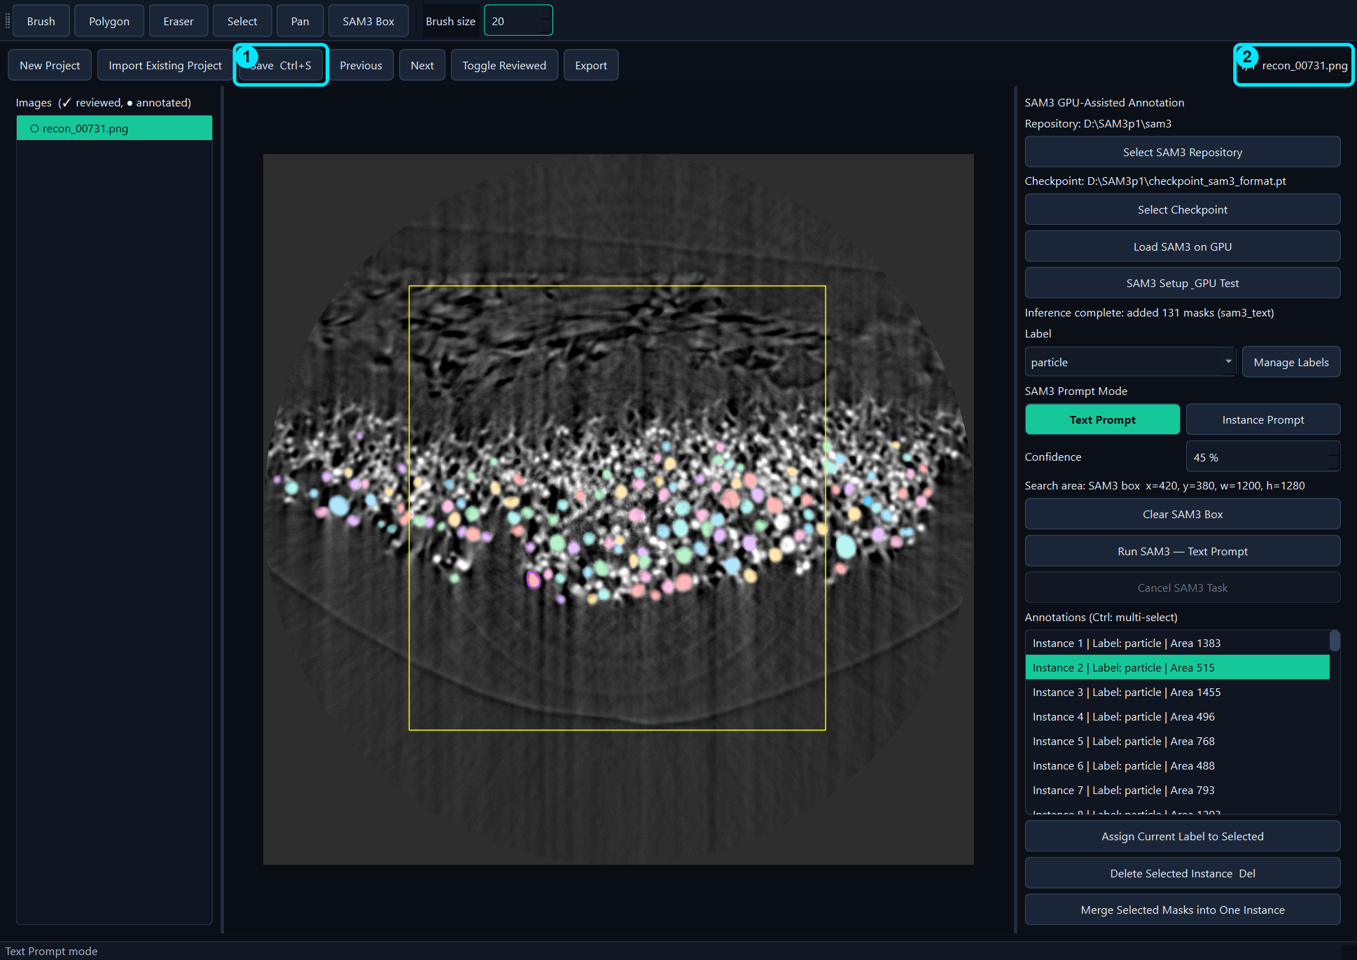
Figure 22. Save writes the current working project.
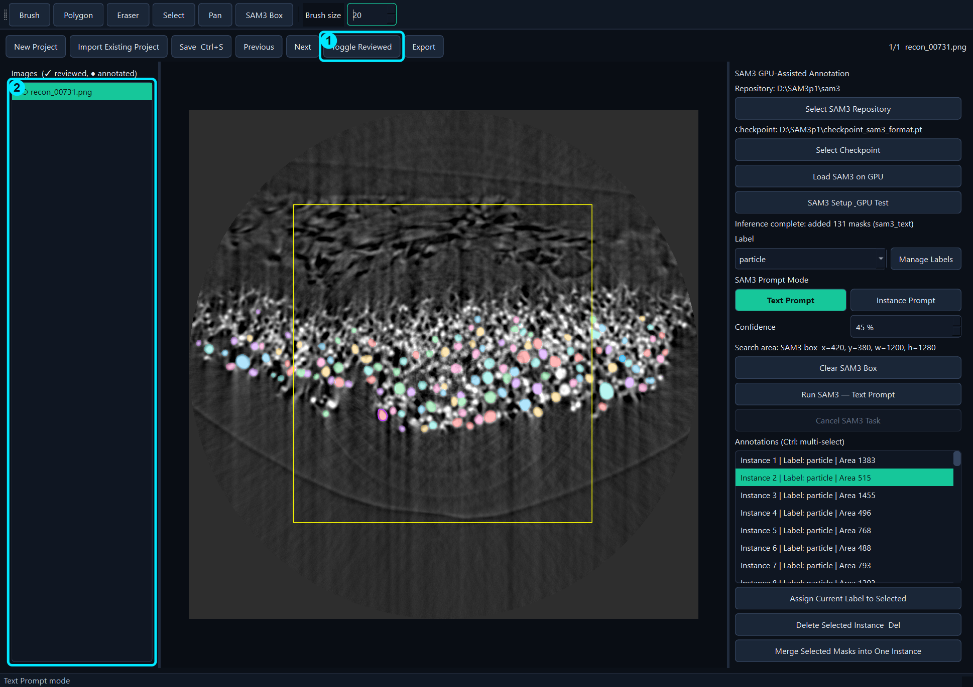
Figure 23. Toggle Reviewed only after checking all masks.

9.2 Export
Export creates a portable training dataset plus optional QA outputs. The export runs in a separate worker so the main GUI remains responsive.
- Click Export.
- Choose an empty output folder.
- Monitor the progress window.
- Use Cancel only if the export must stop; incomplete output is clearly marked.
- For training, use training_dataset/images and training_dataset/annotations.json.
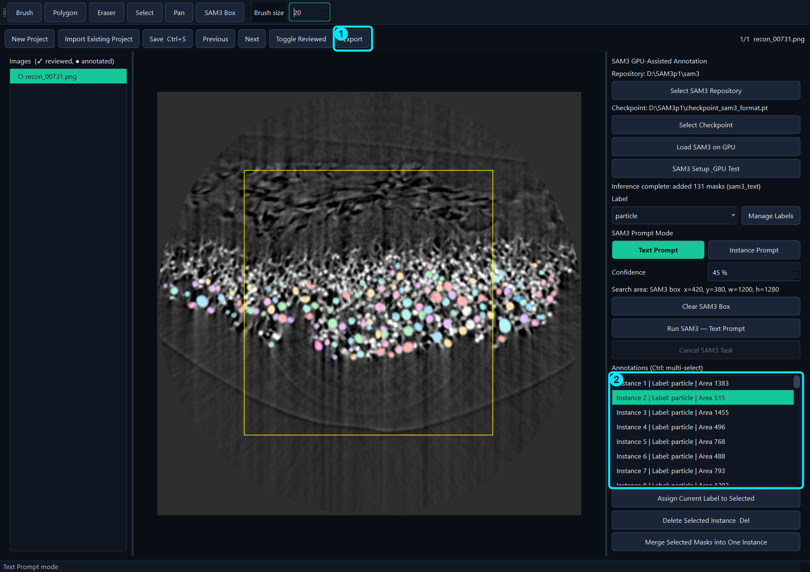
Figure 24. Export the reviewed project to training and auxiliary outputs.
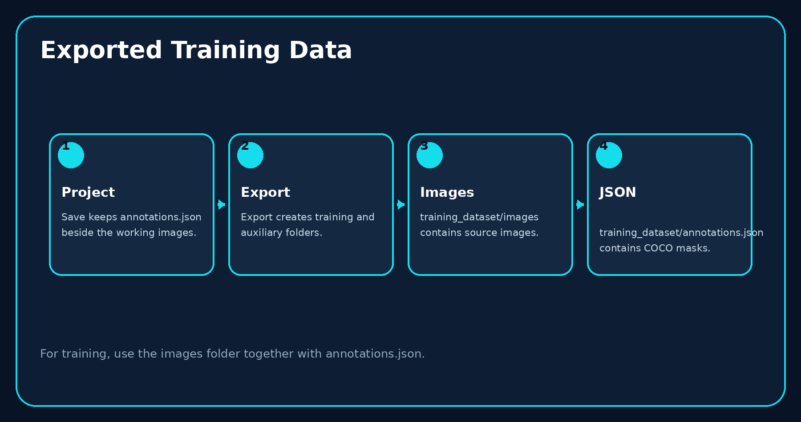
Figure 25. Save and Export produce different outputs.

10. Fastest Workflow for One Image
This worked example is the recommended minimum-click workflow for one image. It uses recon_00731.png for every sample-dependent step.
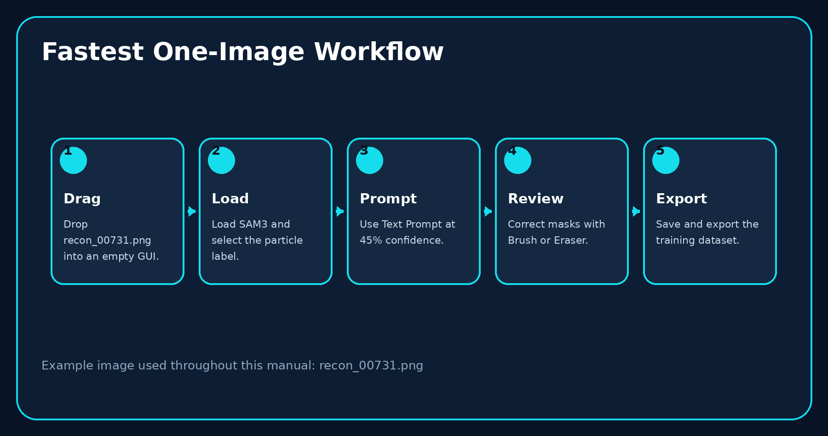
Figure 26. Five-stage one-image workflow.

10.1 Detailed worked example

Step 1. Drag the image
Drag recon_00731.png into an empty GUI. The GUI creates a one-image project.
One-image example, Step 1: Drag the image.

Step 2. Load SAM3
Click Load SAM3 on GPU and wait for successful completion.
One-image example, Step 2: Load SAM3.

Step 3. Select the label
Choose particle. This name is saved with every instance.
One-image example, Step 3: Select the label.

Step 4. Configure Text Prompt
Select Text Prompt and set Confidence to 45%.
One-image example, Step 4: Configure Text Prompt.

Step 5. Run SAM3
Click Run SAM3 — Text Prompt once and wait for completion.
One-image example, Step 5: Run SAM3.

Step 6. Review automatic masks
Inspect the 131 predicted masks and the annotation list.
One-image example, Step 6: Review automatic masks.

Step 7. Select an error
Click the mask on the image or in the list.
One-image example, Step 7: Select an error.

Step 8. Add missing pixels or a missing object
Use Brush. If nothing is selected, Brush creates a new instance.
One-image example, Step 8: Add missing pixels or a missing object.

Step 9. Remove unwanted pixels
Select the instance and use Eraser.
One-image example, Step 9: Remove unwanted pixels.

Step 10. Finish the instance
Press Enter. Verify that Area updates immediately and selection clears.
One-image example, Step 10: Finish the instance.

Step 11. Save
Press Ctrl+S or click Save Ctrl+S.
One-image example, Step 11: Save.

Step 12. Export
Click Export and use images plus annotations.json from training_dataset.
One-image example, Step 12: Export.

11. Training Data Structure
The export separates files that are required for training from files intended for visual verification.
Path | Purpose | Required for training
training_dataset/images/ | Input images | Yes
training_dataset/annotations.json | COCO instances, labels, polygons/RLE | Yes
auxiliary_outputs/previews/ | Colored QA previews | No
auxiliary_outputs/instance_labels/ | Indexed instance-label images | No
auxiliary_outputs/dataset_statistics.csv | Dataset summary | No
Figure 27. Files required for training and optional QA outputs.

12. Recommended Production Workflow
- Create or import the project.
- Verify SAM3 paths and load SAM3.
- Define the Label before annotation.
- Run Text Prompt or Instance Prompt.
- Inspect every mask; correct with Brush/Eraser.
- Press Enter after each manual edit.
- Mark the image as reviewed.
- Save with Ctrl+S.
- Export and verify the training dataset.
- Back up the project and exported training data.
Figure 28. Recommended sequence for efficient, repeatable annotation.

13. Updating or Moving the Application
- Back up projects and exports. They should remain outside the application folder.
- Download or copy the latest Windows release folder.
- Keep the existing SAM3 repository and checkpoint in their current locations.
- Run the installer/update script in the dedicated environment.
- Start the new GUI and verify the configured paths.
- Run GPU Test and a one-image inference before production use.
Figure 29. Update sequence for another GPU computer.

14. Troubleshooting
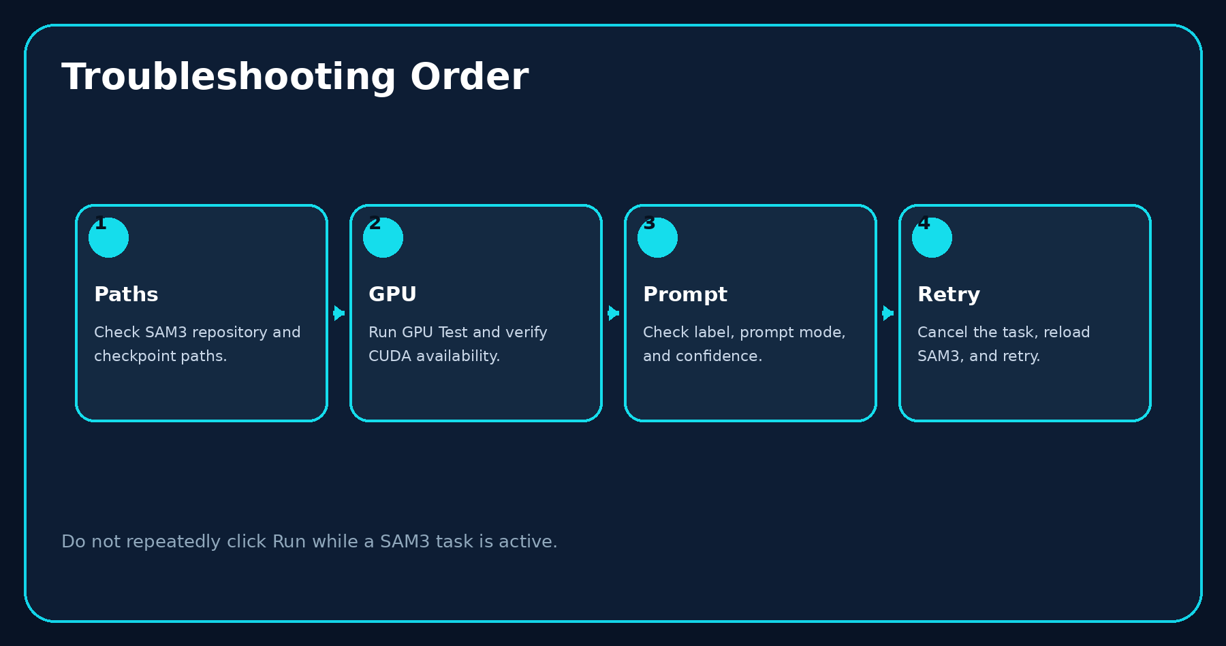
Figure 30. Diagnose path, GPU, and prompt issues in this order.
Problem | Action
SAM3 repository not found | Select the folder that directly contains pyproject.toml and the sam3 package.
Checkpoint not found | Select a compatible .pt/.pth/.ckpt file. Check that it was not moved or renamed.
CUDA unavailable | Verify the NVIDIA driver and run GPU Test inside the dedicated environment.
Load SAM3 takes time | A first model load may take tens of seconds. The GUI should remain responsive.
No Text Prompt result | Confirm Text Prompt mode, the particle Label, confidence, and search area.
Too many false masks | Increase Confidence or restrict inference with a SAM3 Box.
Objects are missed | Lower Confidence, enlarge the SAM3 Box, or add instances with Brush.
An annotation cannot be deleted | Select it on the image or in the list, then press Delete.
Export was cancelled | Do not train from an output folder marked EXPORT_INCOMPLETE. Run Export again.
An existing project does not open | Select annotations.json and keep referenced images in the expected project folder.

15. Keyboard Shortcuts and Terminology
Shortcut | Action
B | Brush
P | Polygon
E | Eraser
S | Select
H | Pan
G | SAM3 Box
Enter | Finish current polygon/brush edit
Esc | Return to the default cursor
Delete | Delete selected instance(s)
Ctrl+S | Save
Ctrl+Z | Undo
Ctrl+Y | Redo

Glossary
Label: The feature/class name assigned to an instance.
Instance: One independently selectable object mask.
Text Prompt: Semantic grounding from a label name.
Instance Prompt: Grounding from an example mask.
Confidence: Minimum SAM3 prediction score accepted by the GUI.
SAM3 Box: Optional rectangular search region.
Reviewed: A user-confirmed image status; not an automatic quality guarantee.
COCO JSON: The annotation file containing images, categories, and instances.
End of manual.

