
BL62 Reconstruction GUI
User Manual
English Edition · October 26, 2026
Tomography, Laminography and Intelligent Data Analysis
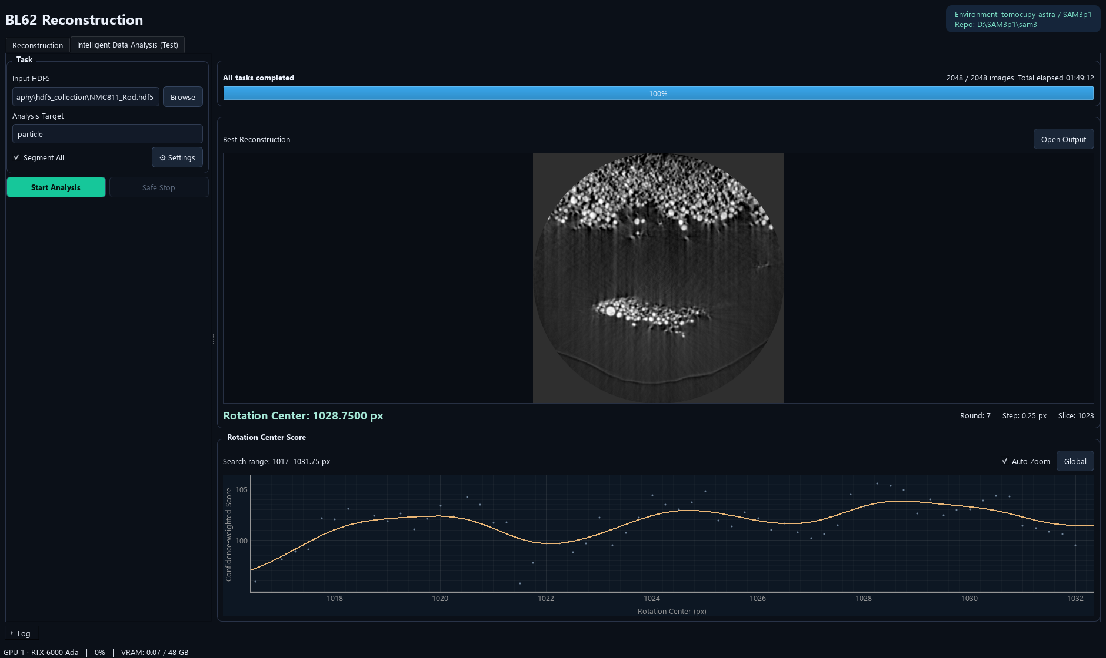
Verified against the current Windows application and source snapshot.

Document Control
Item | Value
Application | BL62 Reconstruction GUI
Application release | 1.0.1
Manual edition | 2026-10-26
Language / formats | English · editable Word and fixed-layout PDF
Scope | Tomography, Laminography and Intelligent Data Analysis
Version evidence | Released source commit 0ddce1e: accurate analysis phases, elapsed time, segmentation timings and search-range curve zoom.
Source / releases | https://github.com/Sususu-slac/BL62_Reconstruction_GUI

How to use this manual
Start with installation and the interface overview, then follow the numbered workflow sections. Screenshots show the current GUI; button names match the English interface. The PDF contents/bookmarks and Word contents link to the relevant chapters.

Examples and verification
Documentation screenshots use copied annotation examples or read-only existing reconstruction results. No scientific source data was overwritten. No training, GPU inference, full reconstruction or model conversion was launched just to create these manuals. Dialog illustrations and previously completed results are identified in their captions.
Note. Workstation paths are examples, not required paths on every computer. Model files and scientific datasets remain external. Only implemented behavior in the stated release is documented.

Contents
1. Purpose and Interface 4
2. Windows Installation and Environments 5
3. Input HDF5 and Data Checks 6
4. Inspect Input Images 7
5. Reconstruction Parameters 8
6. Choose a Tomography Method 9
7. Manual Find Center 10
8. Laminography Mode 11
9. Manual Find Angle 12
10. Run, Stop and Inspect Reconstruction 13
11. Export Images and Preserve Values 14
12. Intelligent Data Analysis: Start 15
13. Analysis Settings: Reconstruction 16
14. Analysis Settings: Center Search 17
15. Analysis Settings: SAM3 18
16. Automatic Center Search: What Happens 19
17. Confidence-weighted Scoring 20
18. Global Filtering and Local Curve View 21
19. Progress and Best Reconstruction 22
20. Understand Each Progress Stage 23
21. Segment All: Results and Overlap 24
22. Automatic Output Folder 25
23. Timing, GPU Use and Logs 26
24. Safe Stop and Partial Results 27
25. Quick Workflow: Manual Reconstruction 28
26. Quick Workflow: Intelligent Analysis 29
27. Updating and Moving the Application 30
28. Troubleshooting 31
29. Terminology and Output Reference 32

1. Purpose and Interface
BL62 Reconstruction provides manual tomography/laminography reconstruction and a separate Intelligent Data Analysis (Test) workflow for automatic tomography rotation-center search.
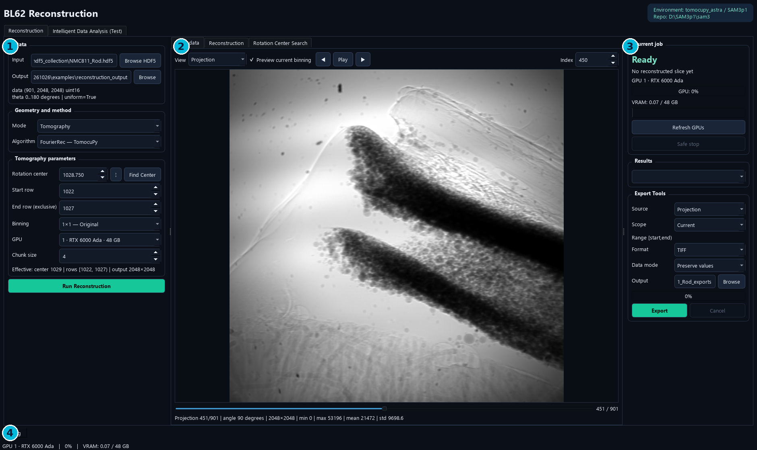
Reconstruction tab. 1 Data, geometry and parameters; 2 input/result/search previews; 3 current job, GPU and export; 4 collapsed Log.
- Reconstruction retains the original three-column manual workflow.
- Intelligent Data Analysis (Test) searches the center, reconstructs data and optionally segments every reconstructed slice.
- The latest progress text distinguishes center search, reconstruction, segmentation and final report saving.

2. Windows Installation and Environments
1. Install an NVIDIA driver and Miniforge on the target Windows computer.
2. Run BL62_Reconstruction_GUI_Setup_1.0.1.exe, or extract the entire portable ZIP.
3. Use Install Environments to prepare the isolated native Windows runtimes.
4. Launch BL62 Reconstruction and check Environment / Repo in the header.
5. For automatic analysis, verify Settings → SAM3 paths and checkpoint.
Component | Current runtime
GUI EXE | Bundled Qt/display dependencies
Reconstruction backend | tomocupy_astra; native Windows Python 3.10
SAM3 inference backend | SAM3p1; native Windows Python 3.12
SAM3 source | D:\SAM3p1\sam3 preferred; tested source also supplied with the release
Checkpoint | D:\Chcekpoints\checkpoint_demo_05142026.pt by default

Note. This reconstruction release does not require WSL. GPU drivers, Conda and model weights are external. Environment creation downloads several GB; copying only the EXE is not a complete portable installation.

3. Input HDF5 and Data Checks
1. In Reconstruction, click Browse HDF5 and select the input .h5 or .hdf5 file.
2. Read the dimensions, stored dtype and angle information under Data.
3. Inspect a representative projection and the flat/dark images before reconstruction.
4. Choose an output parent folder and begin with a small detector-row range.
Required HDF5 dataset | Meaning
/exchange/data | 3D projection stack: projections × detector rows × detector columns
/exchange/data_white | Flat-field images
/exchange/data_dark | Dark-field images
/exchange/theta | One finite angle per projection

Note. The GUI checks required datasets and angle count/finite values. It identifies degree/radian units from stored values and reports angle uniformity. A detector midpoint is an initial suggestion, not a validated rotation center for every specimen.

4. Inspect Input Images
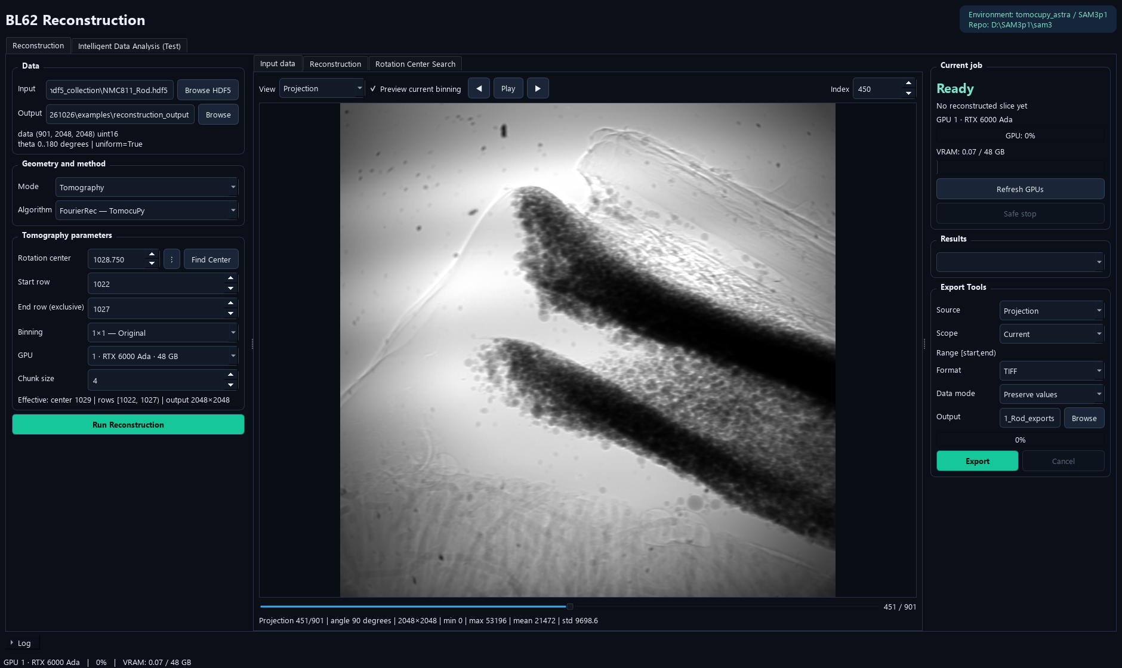
Input data preview from NMC811_Rod.hdf5. Selecting a preview does not start reconstruction.
1. Choose View: Projection, Flat, Dark, Flat/Dark Corrected or -Log Attenuation.
2. Use arrows, slider or Index to inspect individual frames; Play advances frames.
3. Use Preview current binning to view the reduced preview associated with the selected binning.
4. Read frame position, angle and intensity statistics below the image.
Note. Frame Index is a zero-based projection/flat/dark frame index. It is different from Start/End Row, which select detector rows for reconstructed slices. Preview contrast is not a change to source intensities.

5. Reconstruction Parameters
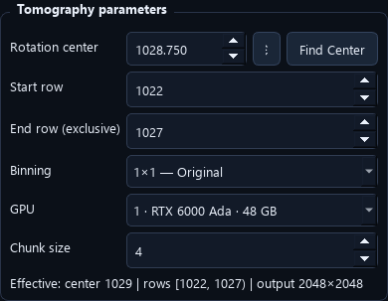
Compact parameter panel in Tomography mode.
Parameter | Meaning
Rotation center | Axis position in original detector-pixel coordinates
Start row / End row (exclusive) | Original detector rows in [start, end)
Binning | 1×1, 2×2, 4×4 or 8×8; backend adapts effective geometry
GPU | Physical NVIDIA device for this job
Chunk size | Rows handled in a backend batch; affects memory/performance
Iterations | Used by SIRT_CUDA and CGLS_CUDA

Note. Rows 0–2048 means 2048 rows, numbered 0 through 2047. Keep center/row entries in original coordinates; do not manually divide the center again when choosing binning. Check Effective geometry below the parameters.

6. Choose a Tomography Method
- Compare methods with the same source, center, row range and binning.
- Use a few central rows to confirm a finite and visually plausible reconstruction before a full run.
- LpRec uses a lightweight external-link HDF5 view with uniform angles; the original HDF5 is preserved.
- Laminography offers its own supported method list; it is not the same geometry as parallel-beam tomography.
Method | Practical description | Important condition
FourierRec | Fourier-based TomocuPy reconstruction | Analytic; no iteration count
LpRec | Log-polar TomocuPy reconstruction | Uses a uniform-angle approximation view
LineRec | Direct line/backprojection TomocuPy reconstruction | Analytic; often more computational work
FBP_CUDA | ASTRA filtered backprojection | Analytic GPU baseline
SIRT_CUDA | ASTRA iterative reconstruction | Iteration count affects result and runtime
CGLS_CUDA | ASTRA iterative least-squares reconstruction | Iteration count affects result and runtime

Note. An algorithm choice is not a guarantee of image quality. Angle coverage, calibration, center and acquisition geometry remain important.

7. Manual Find Center
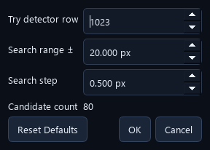
Gear button beside Rotation center opens the manual sweep settings.
1. Enter an initial Rotation center estimate.
2. Open the adjacent gear and set Try detector row, Search range ± and Search step.
3. Confirm the settings and click Find Center.
4. Inspect candidates in the Rotation Center Search preview using its slider.
5. Click Apply Selected Center for the visually preferred candidate, then run the desired full reconstruction.
Note. This manual button reconstructs a user-defined sweep for visual selection. It does not perform SAM3 confidence scoring. With an ASTRA full-reconstruction method selected, the center sweep uses FourierRec and preserves the selected full-reconstruction method.

8. Laminography Mode
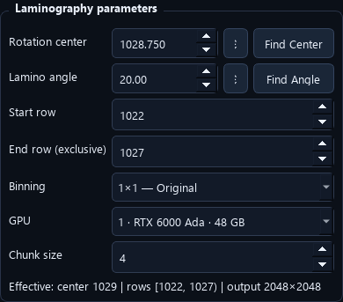
The parameter panel follows the selected Tomography/Laminography mode. Lamino angle is directly below Rotation center.
1. Choose Geometry and method → Mode → Laminography for a laminography acquisition.
2. Choose a supported laminography algorithm: FourierRec or LineRec.
3. Set Rotation center, Lamino angle and the desired row range.
4. Use a small reconstruction to verify geometry before scaling up.
Note. Mode changes enable/disable the relevant fields and methods automatically. Merely selecting Laminography does not make an ordinary tomography dataset a laminography measurement. Automatic Intelligent Data Analysis in this release estimates tomography center only.

9. Manual Find Angle
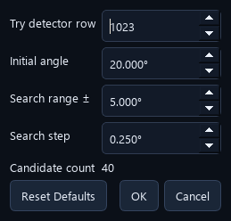
Laminography angle-sweep settings: detector row, initial angle, range and step.
1. Select Laminography mode.
2. Open the gear beside Lamino angle and set the initial angle, range ± and angle step.
3. Click Find Angle. The manual sweep uses LineRec.
4. Compare reconstructed candidates in the search preview.
5. Apply the selected angle and reconstruct with the intended final settings.
Note. Find Angle is a manual visual sweep. There is no automatic SAM3-driven laminography-angle optimizer in the current release. Tomography mode disables this control.

10. Run, Stop and Inspect Reconstruction
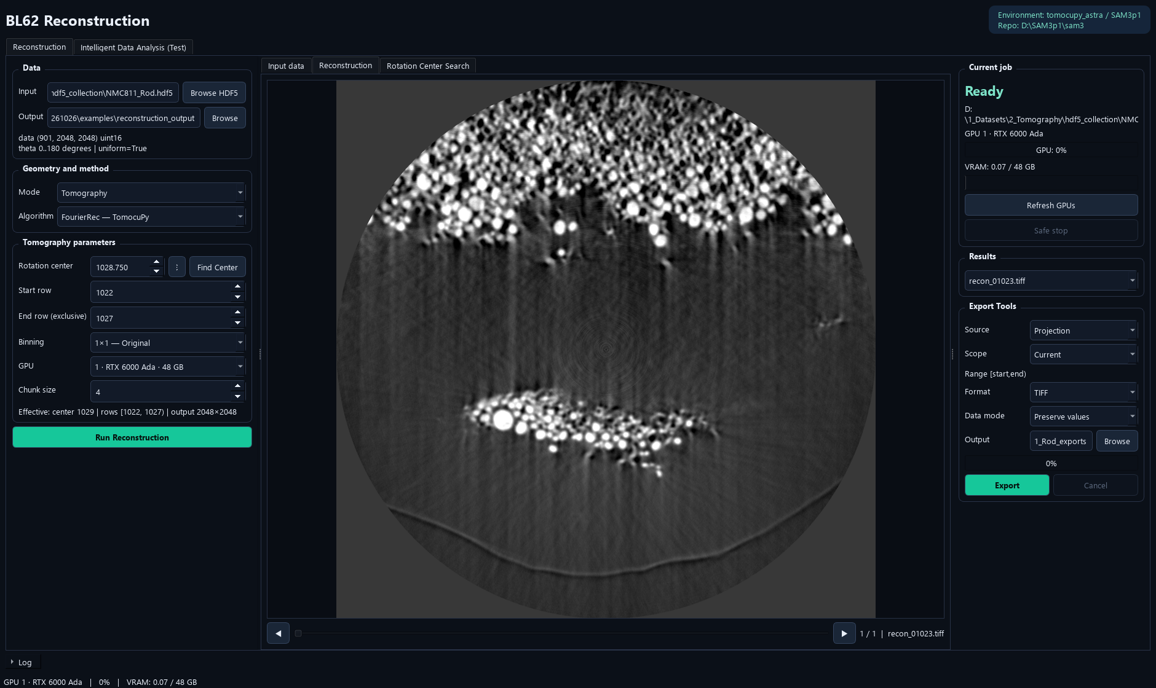
A previously completed reconstruction slice displayed in the current GUI. No new reconstruction was run to create this manual.
1. Confirm input, output parent, geometry/method, center, rows, binning and GPU.
2. Click Run Reconstruction; the application creates an isolated run directory.
3. Inspect output slices as they become available in Reconstruction and Results.
4. Use result arrows/slider to move through available slices.
5. Use Safe stop to stop this job if needed, then wait for its backend to exit.
Note. The original input HDF5 is preserved. A stopped/failed job can leave partial outputs; do not treat those as a completed full volume. A successful small test should precede a full-volume run.

11. Export Images and Preserve Values
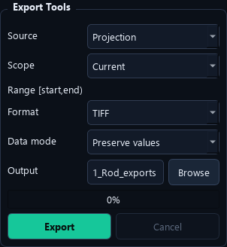
Export Tools on the right of the Reconstruction tab.
1. Choose Source: Projection, Flat, Dark, Corrected, -Log Attenuation or Reconstruction results.
2. Choose Scope: Current, Range or All; Range uses [start, end).
3. Choose TIFF or PNG and the desired Data mode.
4. Choose an output folder and click Export; Cancel stops the export worker.
Data mode | Use
Preserve values / TIFF | Retain the data array values and dtype
Float32 / TIFF | Write numeric values as float32
Display 8-bit / 16-bit | Map the 1–99 percentile range for viewing
PNG | Requires 8-bit or 16-bit display mapping; incompatible value modes are changed automatically

Note. Display conversion changes exported viewing values. Use preserve-value TIFF for quantitative downstream processing. export_metadata.json records output dtype, dimensions and mapping.

12. Intelligent Data Analysis: Start
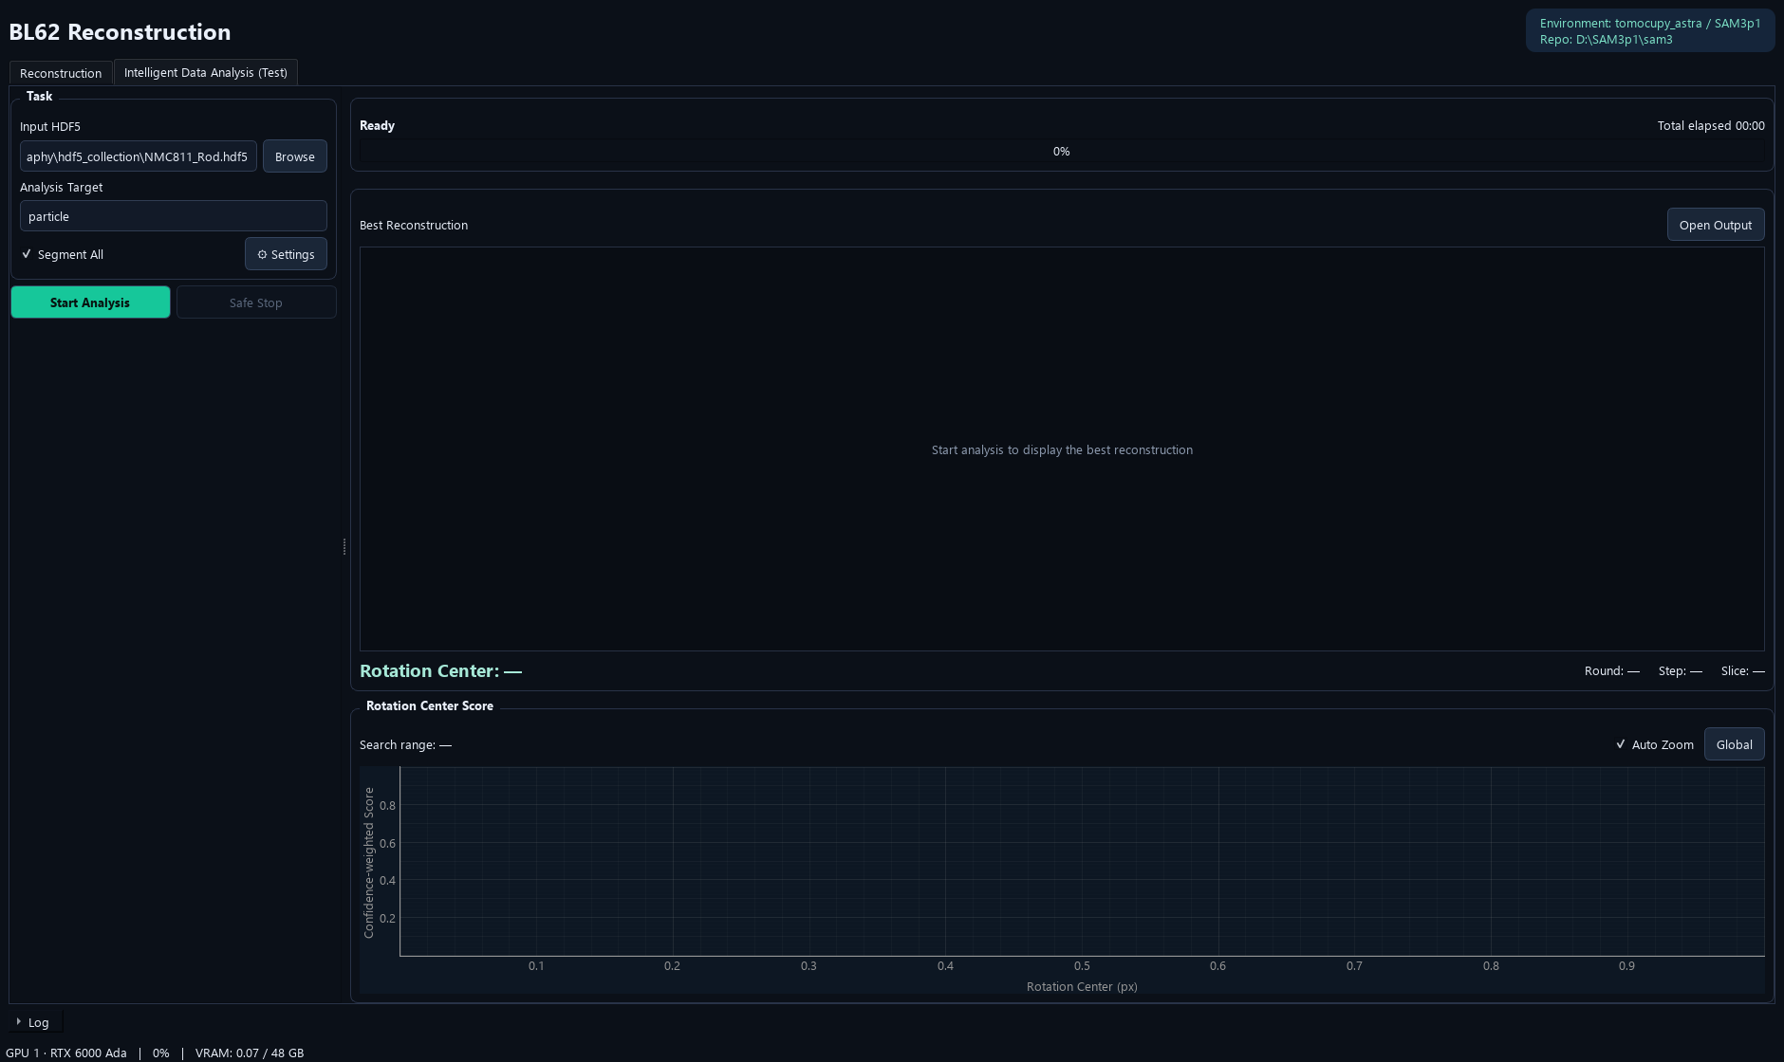
Minimal automatic-analysis task panel: Input HDF5, Analysis Target, Segment All and Settings.
1. Open Intelligent Data Analysis (Test).
2. Browse to the HDF5 file and enter Analysis Target, for example particle.
3. Leave Segment All checked to segment every reconstructed output slice, or uncheck it for center search plus reconstruction only.
4. Use Settings only when defaults need changing.
5. Click Start Analysis and monitor the current phase.
Note. By default the application creates {input_name}_analysis_{timestamp} beside the HDF5 file. Automatic analysis is currently a tomography rotation-center workflow, followed by reconstruction and optional per-slice segmentation.

13. Analysis Settings: Reconstruction
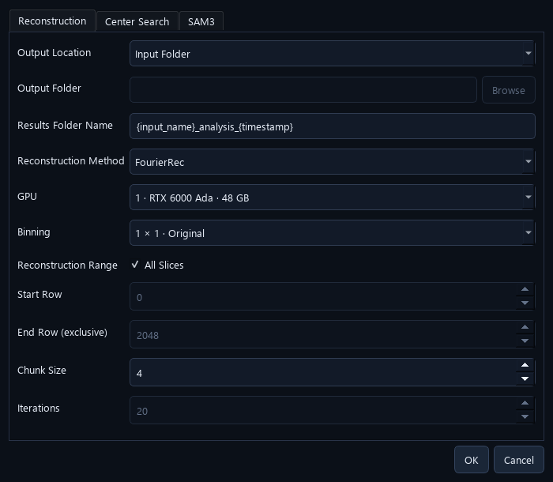
Settings → Reconstruction. This dialog is scrollable.
- Output Location selects Input Folder or a Custom Folder parent. Each run still gets a timestamped child directory.
- Reconstruction Method and GPU select the final reconstruction backend/device.
- All Slices uses the full detector-row extent; otherwise set Start Row and End Row (exclusive).
- Binning, Chunk Size and iterative-method Iterations control full reconstruction.
- All entered rows and center coordinates refer to the original detector geometry.

14. Analysis Settings: Center Search
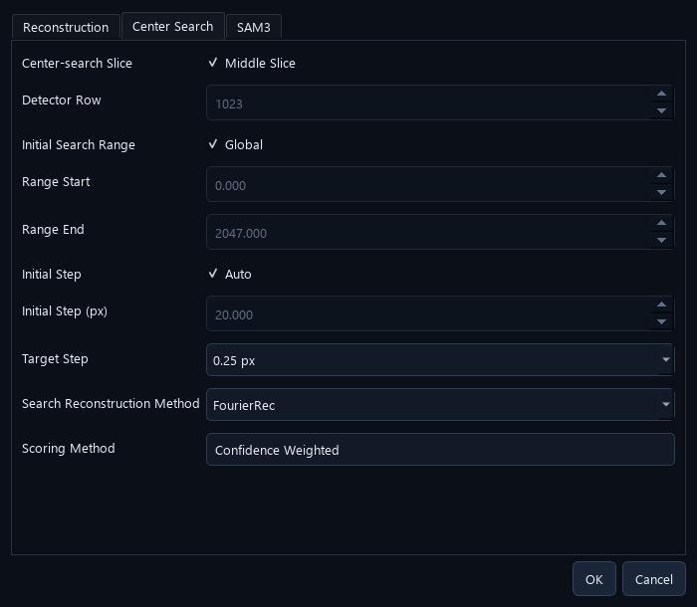
Settings → Center Search. Global range and automatic initial step are enabled by default.
- Middle Slice uses detector row floor((height−1)/2); for a 2048-row detector this is row 1023.
- Global searches centers from 0 through detector width−1. Disable it to set a custom initial range.
- Auto initial step uses max(1, round(width/100)) pixels; a 2048-column detector starts at 20 px.
- Target Step defaults to 0.25 px; 0.5 px and 1 px are available.
- Search Reconstruction Method is separate from the final full-volume method.
- Scoring Method is Confidence Weighted in the current release.
Note. The target step is the search-grid resolution, not a guarantee of physical center accuracy to that many pixels.

15. Analysis Settings: SAM3
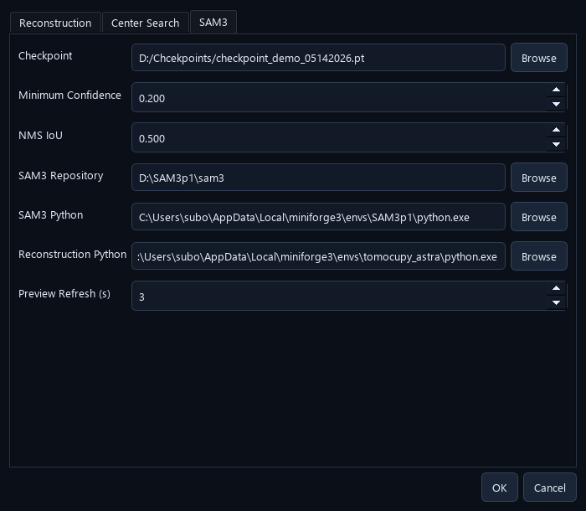
Settings → SAM3: checkpoint, confidence, duplicate-removal threshold, source and Python paths, and preview interval.
Field | Current default / purpose
Checkpoint | Shared inference model at D:\Chcekpoints\checkpoint_demo_05142026.pt
Minimum Confidence | 0.20
NMS IoU | 0.50; duplicate mask suppression
SAM3 Repository / Python | External native Windows SAM3 source and inference runtime
Reconstruction Python | External tomography reconstruction runtime
Preview Refresh | 3 seconds; updates best image and score view

Note. One automatic job loads SAM3 once and reuses it for center candidates and optional full-data segmentation. The worker releases the model when the job exits. It is not a model shared with a separately running Label GUI.

16. Automatic Center Search: What Happens
1. Read the selected middle/custom detector row and build the initial center grid.
2. Reconstruct that same row at each new candidate center.
3. Normalize a viewing/inference copy and run SAM3 with the Analysis Target.
4. Remove duplicate masks using the configured mask-IoU threshold and compute the confidence-weighted score.
5. Combine all evaluated points from this and previous rounds; apply global Gaussian smoothing.
6. Choose supported peak neighborhoods, narrow/refine the search and reuse candidates already evaluated.
7. Repeat until the target step and peak-support checks are satisfied, then save the selected center.
Note. Only one detector row is evaluated during center search by default. Full-volume reconstruction happens afterward. Multiple supported peaks can be refined; an empty/flat score curve fails the estimate rather than silently reporting a reliable center.

17. Confidence-weighted Scoring
A more confidently recognized particle contributes more to the candidate-center score. The score uses SAM3 evidence, rather than a manual image-sharpness measurement.
- The table describes the current fixed 0.20–0.80 reward mapping.
- The inference confidence setting first determines which predictions are available; NMS removes duplicate masks.
- A larger score means stronger combined model evidence, not a percentage accuracy.
- Confirm the selected reconstruction visually. Different prompts/checkpoints can change the score curve and preferred center.
Particle confidence | Contribution
0.20 | 0
0.40 | 0.3333
0.60 | 0.6667
0.80 or higher | 1.0000

For each retained particle with confidence p:
reward = clip((p − 0.20) / 0.60, 0, 1)
Candidate score = sum of the retained-particle rewards

18. Global Filtering and Local Curve View
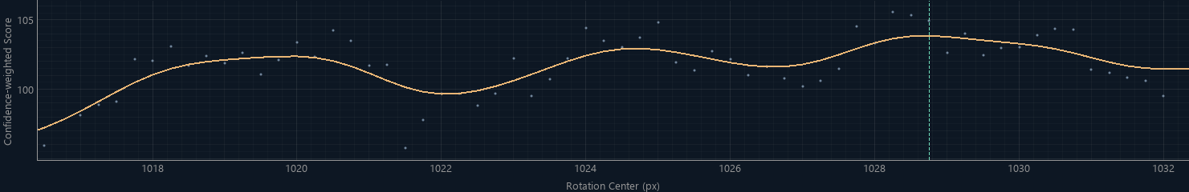
Local curve view at the recorded final search interval. The same archived candidate scores and global smoothing are used; the viewport interval comes from that run's history.
- Every round uses all previously evaluated points when calculating the smoothed score curve.
- Auto Zoom follows the current search interval and adjusts the visible score range.
- Global shows the full center range; turning Auto Zoom back on restores interval following.
- Raw points and the smoothed curve are separate plot elements. The selected-center marker identifies the displayed recommendation.
Note. Zooming changes display bounds only. It does not discard old samples or recompute filtering from only the visible points. Smoothing reduces isolated spikes but does not prove that a model-selected peak is the physically exact center.

19. Progress and Best Reconstruction
Actual archived NMC811_Rod result shown in the current viewer: center 1028.75 px, row 1023, seven rounds. The completed example's total time was 01:49:12.
- During search, progress counts new centers in the current round. Adaptive later rounds can have different totals.
- The best image, Rotation Center, Round, Step and Slice belong to the same current status.
- The preview refresh interval defaults to three seconds, so it need not change after every candidate.
- Total elapsed includes center search, reconstruction, optional segmentation and final saving.
Note. A best-so-far image during search is provisional. All tasks completed indicates that all enabled phases and the final summary have finished. The example's center/time are dataset-specific, not defaults for other datasets.

20. Understand Each Progress Stage
Display / phase | Current task
Preparing analysis | Validating/initializing this job
Stage 1: Reconstructing center candidates | Generating candidate images for the current round
Stage 1: Finding rotation center | SAM3 recognition, score computation and adaptive refinement
Stage 2: Reconstructing all data | Writing the requested reconstruction slices
Stage 3: Reconstruction completed — segmenting all data | Reconstruction is finished; SAM3/label generation/saving continues
Saving the final analysis report | Writing completion summaries
All tasks completed | All enabled phases have completed
Stopped / Failed | Partial results only; check Log

Note. Without Segment All there are two numbered stages. An indeterminate bar means that phase has no useful fixed count. The current-stage bar is not an estimated whole-job percentage or remaining-time prediction.

21. Segment All: Results and Overlap
1. Keep Segment All enabled before Start Analysis when masks are needed for the full reconstruction.
2. After reconstruction completes, wait for each slice to be read, recognized, de-duplicated, labeled and saved.
3. Inspect label TIFFs and instances.csv under segmentation/.
4. Use the packed instance-mask NPZ when separate overlapping object masks are required.
Output | Meaning
recon_XXXXX.tiff in segmentation/ | Integer instance-label image; 0 is background
recon_XXXXX_instances.npz | Packed independent masks, scores and image shape
instances.csv | Slice, local instance ID, confidence and original mask area
timings.csv / timing_summary.json | Per-step and aggregate segmentation timing

Note. A label TIFF has one ID per pixel; the first retained mask wins at overlap pixels. NPZ preserves individual overlaps, so its mask area can exceed that instance's visible area in the label TIFF. IDs restart on each slice: Segment All does not perform 3D particle tracking.

22. Automatic Output Folder
- Open Output in the analysis preview opens the current run directory.
- The center-search summary is not proof that later reconstruction/segmentation has finished.
- For a successful full analysis, check analysis_summary.json and its reconstructed/segmented slice counts.
- Keep input HDF5, model identity and configuration with results for reproducibility.
{input_name}_analysis_{timestamp}/
analysis_job.json # submitted GUI settings
pipeline_config.json # worker settings / input fingerprints
status.json # live/final worker status
analysis_summary.json # final successful completion summary
center_search/
summary.json
scores.csv
history.json
adaptive_search.png
best_reconstruction.tiff
best_input.png
best_overlay.png
reconstruction/ # full numeric reconstructed TIFFs
segmentation/ # only when Segment All is enabled

23. Timing, GPU Use and Logs
Log expands below both main pages and is collapsed by default.
- A new job clears the displayed log; each run keeps its own results and worker records.
- GPU utilization and VRAM describe the selected physical device, including activity from other programs.
- SAM3 GPU inference is only one part of segmentation. CPU mask processing, label creation, compression and disk writes also take time.
- timings.csv separates image reading/normalization, inference, score/NMS, label statistics, TIFF writing, mask packing, NPZ writing and progress/log overhead.
- Use timing_summary.json / analysis_summary.json to distinguish search time from complete-job time.
Note. This manual covers released version 1.0.1. Proposed or isolated benchmark optimizations are not described as installed features. Long elapsed times display HH:MM:SS.

24. Safe Stop and Partial Results
1. Use Safe Stop on Intelligent Data Analysis, or Safe stop in the manual Current job panel.
2. Wait while the recorded worker and its child reconstruction processes exit.
3. Inspect the final state and Log, and keep useful completed files if needed.
4. When starting a new GUI analysis, select the input/settings again; the GUI creates a new timestamped run.
- Stopping targets this job's processes, not unrelated GPU tasks.
- A stopped or failed run is never labeled All tasks completed.
- The GUI does not offer a one-click Resume Analysis button in this release.
- The same GUI does not run a manual reconstruction and an automatic analysis at the same time.
Note. Do not delete an output directory while its worker is still writing. A retained partial reconstruction is useful for diagnosis but must be identified as incomplete.

25. Quick Workflow: Manual Reconstruction
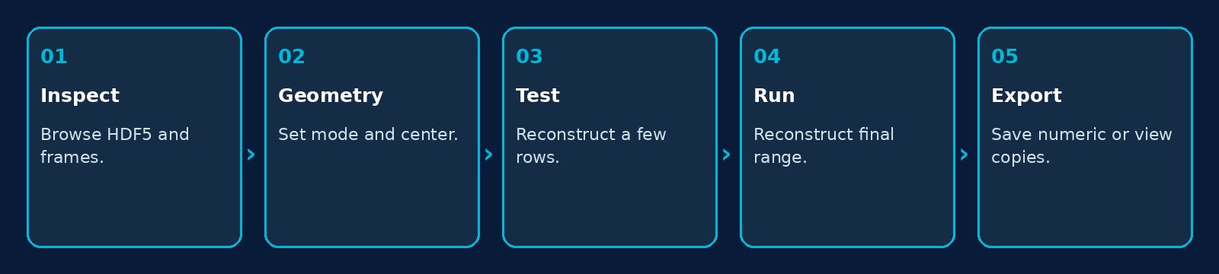
Inspect input, test a few rows, choose geometry and reconstruct.
1. Browse HDF5, inspect projections/flat/dark and choose the output parent.
2. Select Tomography or Laminography and a supported method.
3. Set/inspect the center; use manual Find Center / Find Angle when needed.
4. Test a few central detector rows; confirm geometry and image quality.
5. Set the final row range and Run Reconstruction.
6. Inspect slices and export preserve-value TIFF or a separate viewing copy as needed.

26. Quick Workflow: Intelligent Analysis
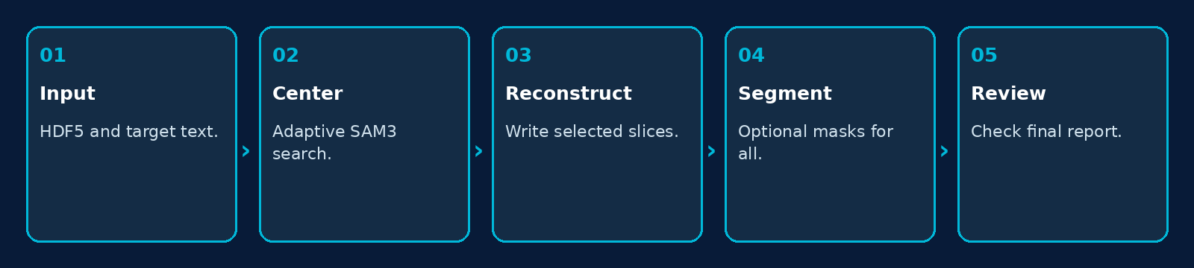
Automatic center search, reconstruction, optional segmentation and final reports.
1. Open Intelligent Data Analysis (Test), choose HDF5 and enter particle or another meaningful target.
2. Check Segment All and Settings. Use the global search defaults when no defensible initial range is known.
3. Start Analysis. Inspect the evolving best image and curve.
4. Wait through reconstruction and, if enabled, the explicit segmenting-all-data stage.
5. Check All tasks completed, final counts, selected center and output files.
6. Review masks on representative slices before downstream measurements.
Note. A global search can be more expensive than a justified limited range. Disabling Segment All removes full-data segmentation, but center-search SAM3 scoring still runs.

27. Updating and Moving the Application
1. Finish or safely stop running jobs and back up result/configuration files.
2. Install the new release, or extract the entire portable folder together.
3. Use Install Environments when the target runtimes do not exist or need preparation.
4. Verify both Python paths, SAM3 repository and checkpoint in Settings.
5. Run a small manual reconstruction and a restricted small automatic analysis before a full production run.
- Keep scientific data and central checkpoints outside the application folder.
- Per-user application settings can differ on another Windows account/computer.
- Updating a checkpoint path/file does not change the model inside a job already running; start a new job to load it.
- Use the selected dataset's geometry; do not reuse a previous specimen's center without checking.
Note. The GitHub release and the installer/portable package are application distributions, not datasets or model-weight archives.

28. Troubleshooting
Symptom | Check / action
HDF5 validation fails | Check exchange datasets, 3D data shape, angle count and finite theta values.
Backend cannot start | Verify the native reconstruction Python environment and complete application folder.
SAM3 cannot load | Check SAM3p1 Python, repository, compatible inference checkpoint and CUDA.
Center estimate is poor | Inspect best reconstruction, prompt, checkpoint and curve; compare nearby centers. A strong model score alone does not prove physical correctness.
Find Angle disabled | Select Laminography. Automatic analysis does not search laminography angles.
Center value looks scaled | Check original versus effective geometry and binning. Do not divide twice.
Reconstruction is complete but job runs | Read Stage 3: full-data segmentation and saving can continue after reconstruction.
GPU is quiet during segmentation | CPU mask work, compression or disk I/O may be active; inspect per-step timing.
Saved PNG values differ | PNG uses display mapping. Use preserve-value TIFF for quantitative output.
Same particle IDs on different slices | IDs are local per slice; no z-tracking is performed.

Note. Include version, input shape, mode/method, binning, center/range, GPU ID, checkpoint and final log lines when reporting a problem.

29. Terminology and Output Reference
Term | Meaning
Projection | A measured detector frame at one acquisition angle
Detector row / slice | A selected detector row used for a reconstructed output slice
Rotation center | Axis coordinate along detector columns, in original pixels
Binning | Spatial reduction by the selected power-of-two factor
Center candidate | One reconstruction evaluated at a particular center
Confidence-weighted score | Sum of normalized retained-particle confidences
NMS IoU | Overlap threshold for suppressing duplicate predicted masks
Safe Stop | Requested cancellation of this job and its child workers
Preserve-value TIFF | Numeric image output retaining the selected value representation
Instance NPZ | Compressed independent binary masks and scores, including overlaps

Note. For packed masks, read shape=(height,width) and unpack bits along axis 1, truncate to height×width, then reshape to (instances,height,width). The scientific TIFF and viewing PNG serve different purposes.

