UT DALLAS | Early Cognition and Communication Lab
————
Have a question or comment?
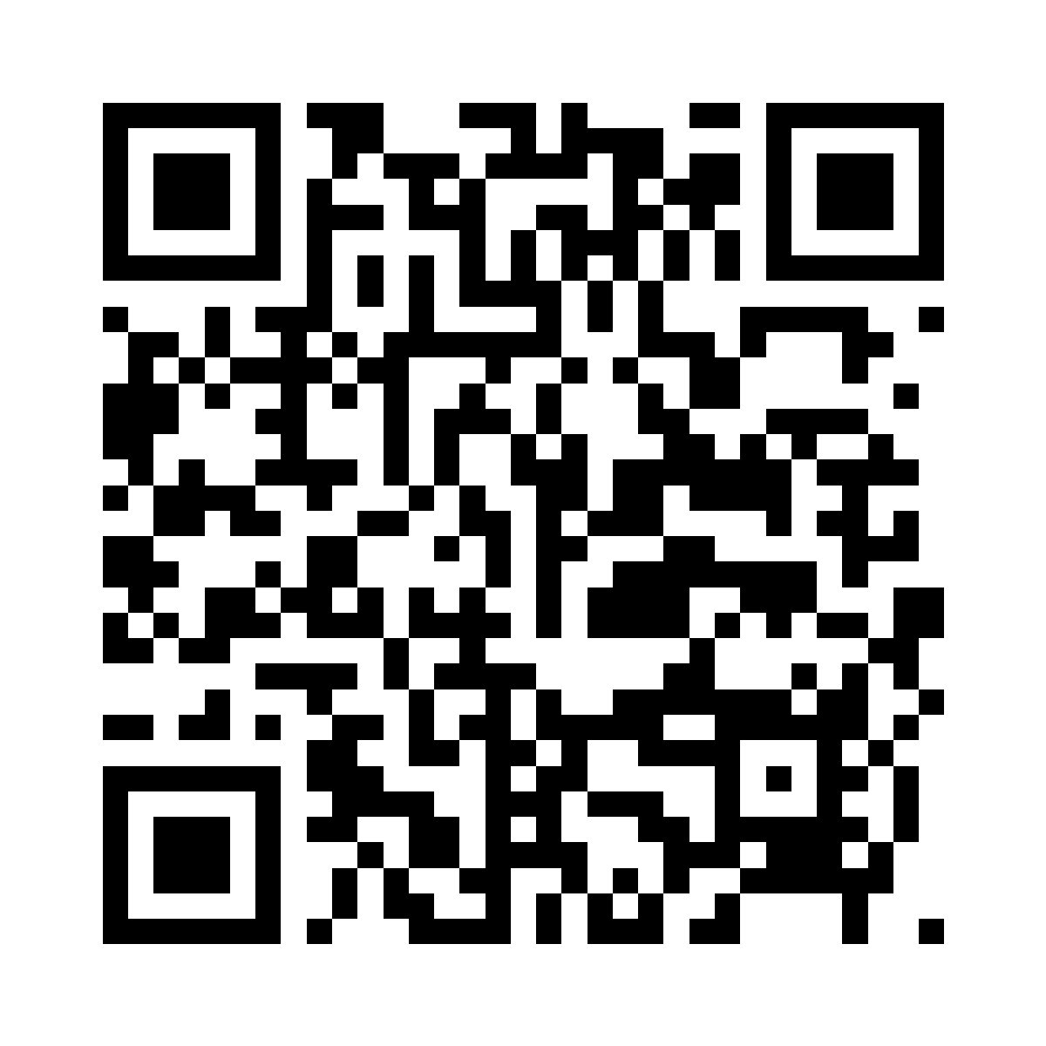
Scan to leave a question — we'll follow up by email.
Learning “same” and “different” in infancy
————
Early Cognition and Communication Lab · The University of Texas at Dallas

UT DALLAS | Early Cognition and Communication Lab
————
Interested in this study?
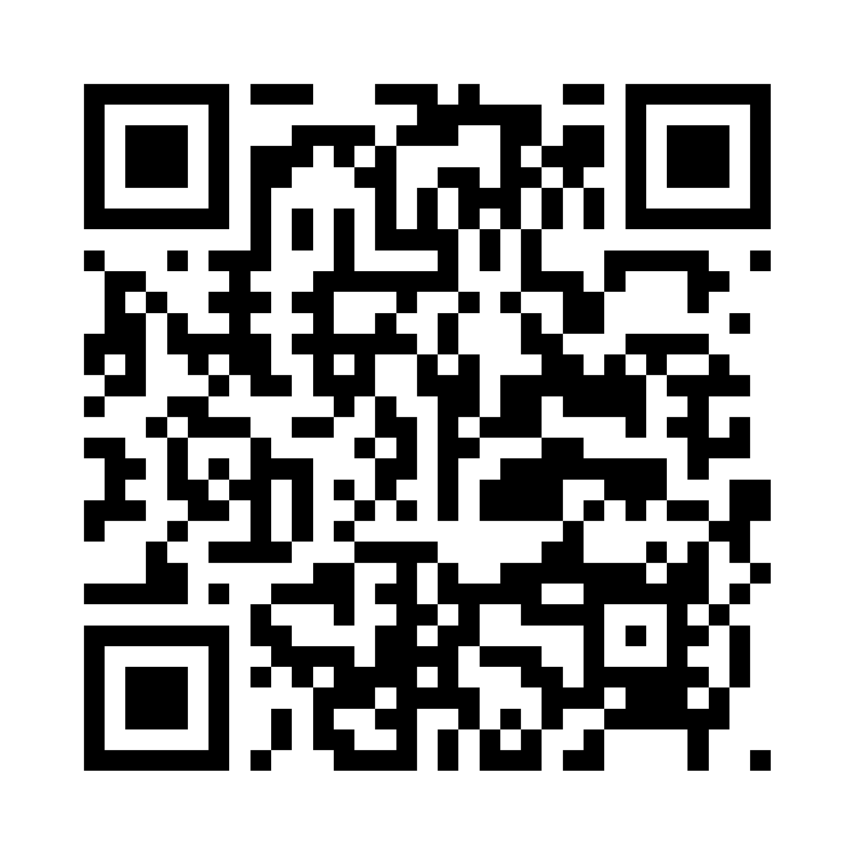
Scan to ask a question or share a comment.
How infants represent unseen objects
————
Early Cognition and Communication Lab · The University of Texas at Dallas

