

Report 3

CSE523 Machine Learning Section-1

Group members:

Kushalkumar Suthar (AU2140122)

Dhruvin Prajapati (AU2140064)

Rohit Rathi (AU2140023)

Krutarth Trivedi (AU2140141)

**Problem Statement :**

Fuzzy Logic for Vehicle Motion Direction Detection

There are many different types of membership functions, used to represent the degree of membership of an element in a fuzzy set. The most commonly used membership functions are Triangular, Trapezoidal, Gaussian, Piecewise linear, Sigmoidal, and Bell-shaped.

* **Input data**

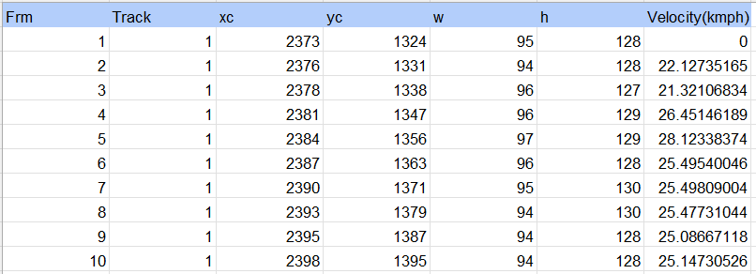

1. **Triangular**

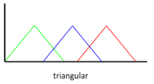

The triangular membership function involves three parameters: left edge, peak, and right edge. This resembles a triangle shape hence its name. Fuzzy systems commonly use these functions to represent qualitative linguistic variables where the maximum value represents the most typical or prototypical value. Membership degree increases linearly from the left edge up to the summit point and decreases linearly from the peak point down to the right edge.

* **Predicted direction**

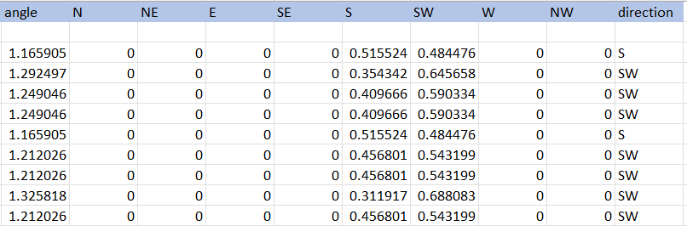

1. **Trapezoidal**

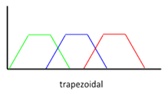

Trapezoidal membership functions are generally extended for triangular functions with a flat top. They are specified by four parameters: the base’s left and right edges as well as the peak’s left and right edges. It is suitable for these functions to be used in situations where the fuzzy set has a defined range and not just a single peak since it allows for a wider range of uncertainty representation. Trapezoidal functions are often used in control systems and decision-making processes where multiple conditions need to be examined.

* **Predicted direction**

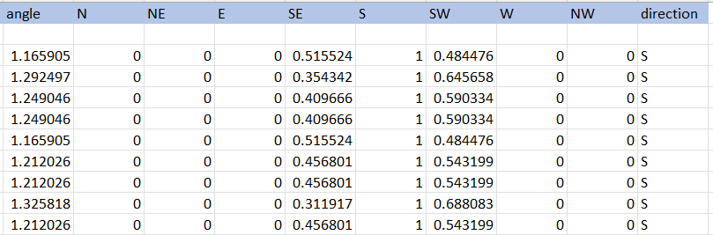

1. **Gaussian**

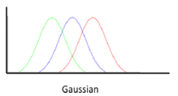

Continuous domain uncertainty is often represented using Gaussian membership functions. The former assumes a bell-shaped curve which has a central peak and tails that drop away gradually. The level of membership assigned to an element within the fuzzy set depends on how close it is to the center of the bell. These functions are especially useful when there is an expectation that the values will follow a normal distribution, as in statistical processes.

* **Predicted direction**

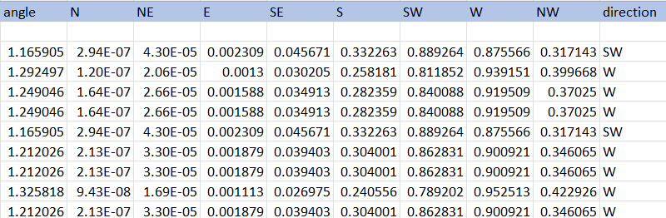

1. **Piecewise linear**

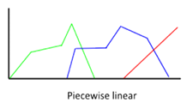

The piecewise linear membership function is created using linear segments, which can be formed from points where the slope of the function changes. They allow different shapes to be approximated by manipulating the number as well as the position of segments. When it needs to be exactly controlled or if complex patterns in underlying data cannot be properly mapped by other types of functions, a piecewise-linear function may come in handy.

* **Predicted direction**

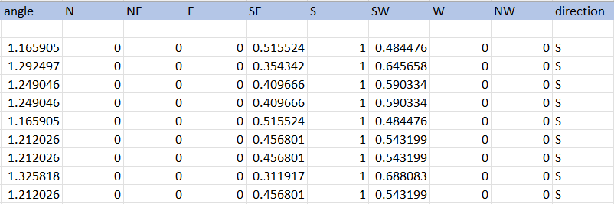

1. **Sigmoidal**

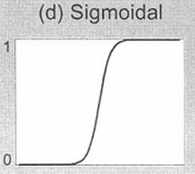

Sigmoidal membership functions look like an “S” curve that gradually changes its value from 0 to 1 or vice versa around some midpoint. They are widely applied for gradual or sigmoidal relationships between the variables such as logistic growth models or representing fuzzy linguistic terms with gradual transitions. Depending on the chosen parameters, sigmoidal functions can take both increasing and decreasing values of membership.

* **Predicted direction**

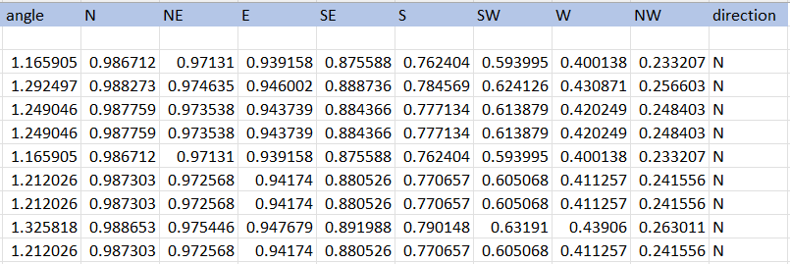

1. **Bell-shaped**

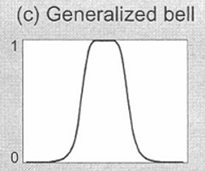

Bell-shaped membership functions, which resemble Gaussian functions, have central peaks and tails that taper off gently. However, they may differ in parameters allowing flexibility in modeling. They work best when the uncertainty or variability is focused around a central value but the distribution might not follow exactly normal distribution. For instance, bell-shaped functions find their applications in such areas as fuzzy control systems, pattern recognition, and decision support systems.

* **Predicted direction**

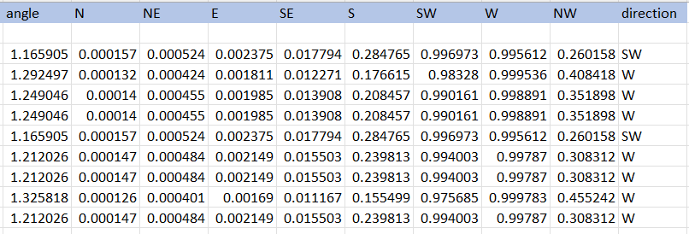

* **Comparison Table**

|  |  |  |  |  |
| --- | --- | --- | --- | --- |
| **Method** | **Shape Flexibility** | **Computational Complexity** | **Interpretability** | **Applicability** |
| Triangular | Limited flexibility, can represent simple shapes | Low complexity, uses simple mathematical functions | Easy to interpret, represents a symmetric triangular shape | Suitable for categorical variables or when only rough estimates are needed |
| Gaussian | Highly flexible, can represent a wide range of shapes | Moderate complexity due to the Gaussian function | Easy to interpret the center and spread of the curve | Suitable for continuous variables and when a smooth, bell-shaped curve is desired |
| Trapezoidal | Moderate flexibility can represent trapezoidal shapes | Low to moderate complexity, depending on the parameters | Fairly easy to interpret, it represents a trapezoidal shape with varying slopes | Suitable for variables with defined upper and lower bounds, such as thresholds |
| Bell-shaped | Highly flexible, can represent various shapes similar to the Gaussian | Moderate complexity due to the bell-shaped function | Easy to interpret, similar to Gaussian but with more parameters to adjust | Suitable for continuous variables and when a smooth, bell-shaped curve is desired |
| Sigmoidal | Moderate flexibility can represent S-shaped curves | Low complexity, often uses simple mathematical functions | Fairly easy to interpret, it represents an S-shaped curve | Suitable for variables with sigmoidal relationships, such as growth curves |
| Piecewise Linear | Limited flexibility, represents piecewise linear shapes | Low complexity, uses linear interpolation between points | Easy to interpret, represent straight line segments | Suitable for categorical or ordinal variables with discrete breakpoints |

**References:**

[**https://in.mathworks.com/help/fuzzy/foundations-of-fuzzy-logic.html**](https://in.mathworks.com/help/fuzzy/foundations-of-fuzzy-logic.html)

[**https://www.philadelphia.edu.jo/academics/qhamarsheh/uploads/Lecture%2018_Different%20Types%20of%20Membership%20Functions%201.pdf**](https://www.philadelphia.edu.jo/academics/qhamarsheh/uploads/Lecture%2018_Different%20Types%20of%20Membership%20Functions%201.pdf)

[**https://www.ripublication.com/gjpam16/gjpamv12n2_04.pdf**](https://www.ripublication.com/gjpam16/gjpamv12n2_04.pdf)

[**https://cse.iitkgp.ac.in/~dsamanta/courses/archive/sca/Archives/Chapter%203%20Fuzzy%20Membership%20Functions.pdf**](https://cse.iitkgp.ac.in/~dsamanta/courses/archive/sca/Archives/Chapter%203%20Fuzzy%20Membership%20Functions.pdf)