**PHASE -4 INNOVATION**

**SMART PARKING SYSTEM**

**INTRODUCTION:**

This project primarily aims to create a smart parking system with the help ofMATLAB programming and Arduino Uno which can automatically lift the bar,indicate traffic lights, and show the number of available parking spots to the driver.

Command window of MATLAB after the execution of code.

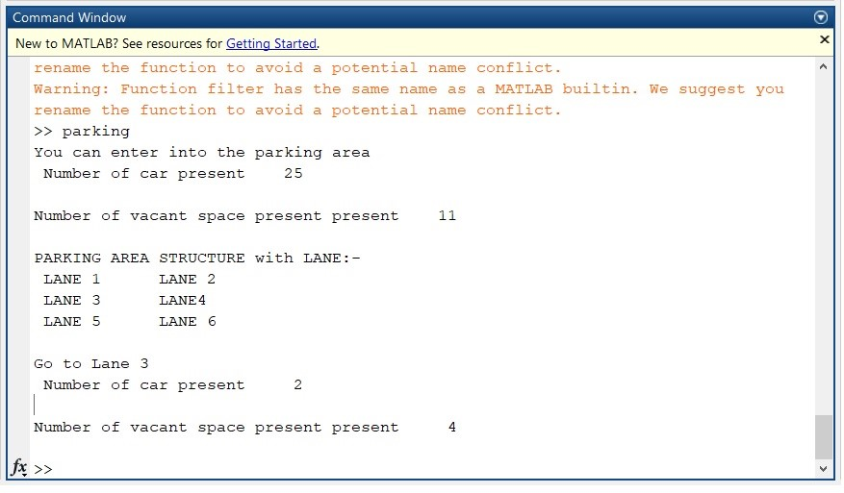

**Two output figures are there after the execution of code.**

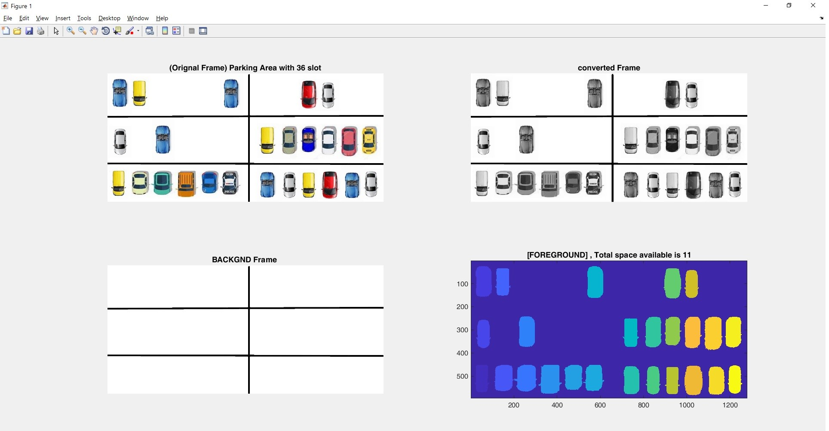Figure 1 – Observation of the Whole parking area

Figure 2 – Observation of the each lane in parking area and the vacant lane is shown.

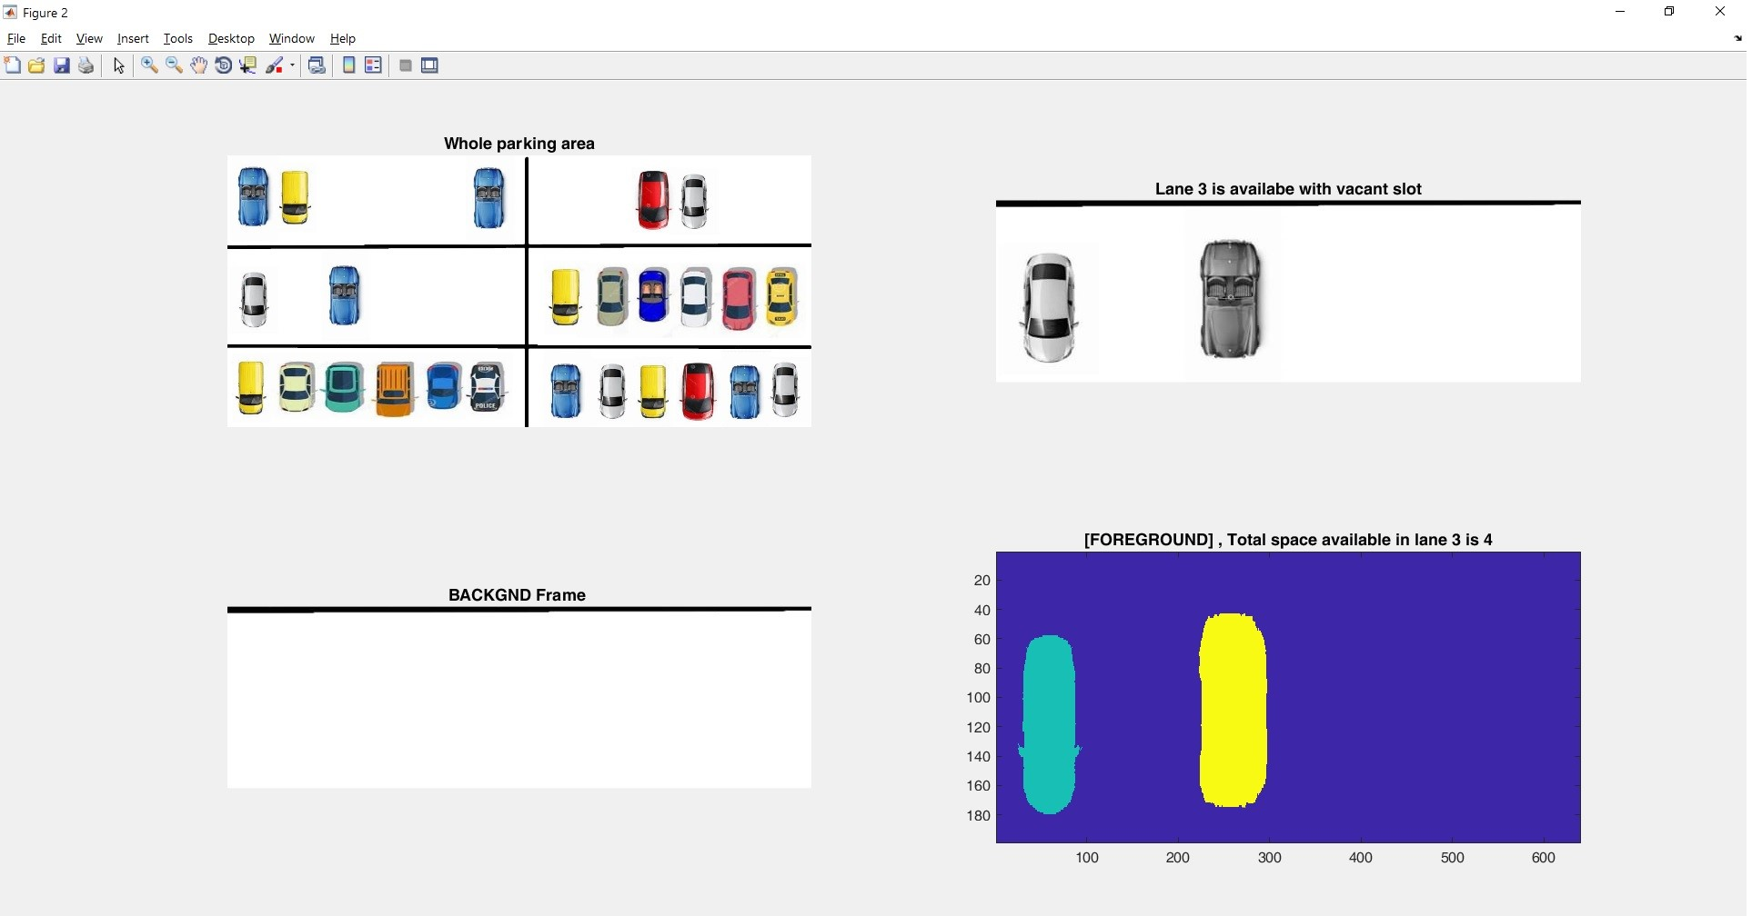

**CONCLUSION** **:**

The parking space detection system based on imageprocessing in MATLAB was designed and tested. It ispossible to manage large area by just using several cameras.It is consistent in detecting incoming cars because it usesactual car images. It is cheap and easy-installed because of the simple equipment. Drivers can get useful real-timeparking lot information from this system by the guidanceinformation display.