Sutheesh Vishal N

Software Engineer/Analyst

**A result-oriented individual with an in-depth knowledge of development tools and an eye for details. Methodical in demonstrating knowledge for professional growth.**

**Certifications/Trainings**

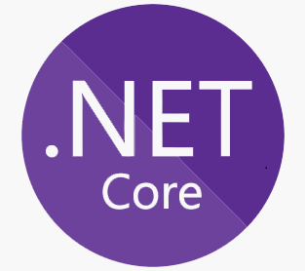

**Completed L&D in ASP .NET Core with MVC and Web API Controller.**



**Trained by L&D in Azure cloud.**



**Completed L&D in Angular.**

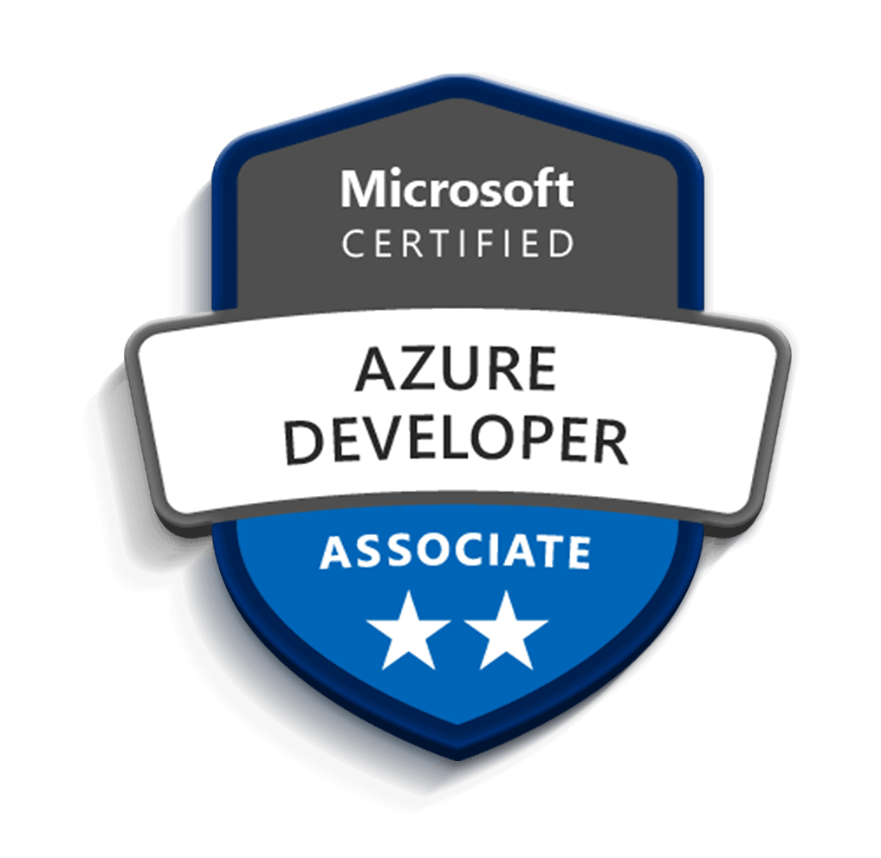

**Certified with Microsoft Azure AZ-900 & AZ-204**



**Agile Software Development Certification from Coursera**



**Completed Jenkins course in Udemy.**

**Professional Summary**

* Worked as .Net developer in App Modernization project (**Client**: Wells Fargo, **Application**: APESW).
* A qualified software engineer who successfully completed L&D in .NET Core with MVC and Web API Controller.

**Experience**

1. **Billable Role:** App Modernization - APESW (**Client name**: Wells Fargo)
2. **Shadow:** Azure cloud – IIB Project_2024 (**Client name**: MBRDI)
3. **Sprint Project Name**: Car Info Management System (L&D)

Car Info Management System is a development project. Where we performed CRUD operations using REST API. **Phase 1**: was development of the web app – backend: .Net Core, frontend : Angular , Database : MS SQL , **Phase 2**: Was Deployment using Azure Cloud

**Technologies used:**

Asp.NET Core, Azure cloud, Web API and Angular.

**Roles and Responsibilities**

* Worked as a backend developer in APP MOD - APESW application for **Wells Fargo** client.
* Working as a Azure cloud developer in IIB Project_2024 – **MBRDI** client
* Deployed and migrated Sprint project in azure cloud.
* Independently worked on Admin login part (authentication).
* Maintained Database for smooth running of operations.
* Created the frontend of the application for the login part.
* Tested the application from user perspective.

**Skillsets**

|  |  |
| --- | --- |
| Web Tools | HTML/CSS/Typescript |
| Programming Languages | C#, Typescript, SQL |
| Cloud Platform | Microsoft Azure Cloud |
| Database | MS SQL Server |
| Web Framework | Angular |
| Tools | Swagger, Microsoft Visual Studio, Microsoft Visual Studio Code, Postman |
| Operating Systems | Windows, Linux |
| Version Control | GIT |
| Framework | Asp.NET Core with Web API Controller |
| Project management | Agile Jira |
| Document management | confluence |

**Rah.bhragu@capgemini.com hul.bhragu@capgemini.com**

**Training**

* L&D Training on .Net core, azure cloud, angular and SQL
* Agile SDLC methodology in Coursera.
* Microsoft Azure in Hyperscaler Training.

**Education**

|  |  |  |  |
| --- | --- | --- | --- |
| **Degree** | **Institution** | **Year of Passing** | **% or CGPA** |
| BE(EIE) | SRM Valliammai Engineering College | 2022 | 77.3% |
| HSC | DVD Hr Sec School | 2018 | 65% |
| SSLC | Kumari Matric Hr Sec School | 2016 | 92.4% |

**Personal Details**

Contact No: 7904001375

Email ID[: sutheesh-vishal.nagarajan@capgemini.com](mailto::%20%20sutheesh-vishal.nagarajan@capgemini.com)

Nationality: Indian

Gender: Male

Languages Known: English, Tamil, Malayalam.

Marital Status: Unmarried

Birth Date: 26/10/2000

Permanent Address: 275, Chetty Street, Kottar, Nagercoil-2, Pin code: 629002, Tamil Nadu.