AI Usage DISCLOSURE FORM

1. Team Details
Team Name: AetherX
Project / Product Name: Theme2 – Smart Guide Troubleshooting
Organization / Institution (if any): VIT Vellore
Submission Date: 30.09.2026

2. AI Usage Declaration
Did your team use any Artificial Intelligence (AI) in developing this project? Yes / No
Yes

3. Purpose of AI Usage ( Brief Details)
Idea generation / brainstorming - Used sparingly to focus solution presentation and to delve into alternative communication of the project architecture and workflow.
Code generation or assistance - Limited support (where relevant) in reviewing and/or refining implementation approaches. The team created and incorporated core project logic and architecture.
UI / UX design - For UI refinement of concepts, architecture diagrams, product walkthroughs and presentation layouts.
Content creation - Appropriate for editing word, technical descriptions, and to enhance clarity of project documentation and presentation content.
Data analysis - Not used
Testing / debugging - Used sparingly for review of possible implementation concerns and during development to enhance clarity.
Other - It was used as a supporting mechanism for technical communication and the fine-tuning of visual details; the team discussed and revised final designs, implementation choices, and integration of the project.

4. Feature Origin Classification ( Please add/delete based on the number of the feature)
(i) 1. Feature Name - Hybrid Retrieval Architecture
2. Self-Generated/AI-Generated/Both - Both
3. Description -
AI Tool: ChatGPT.
Prompt: BM25 + semantic retrieval + Reciprocal Rank Fusion pipeline to be presented again, with a focus on refining the presentation.
Output Summary: Proposals for the representation of lexical retrieval, semantic retrieval, ranking and decisioning based on confidence.
Modification: Picked and tweaked the concepts that were appropriate actual retrieval pipeline.

(ii) 1. Feature Name - Development & Debugging Assistance
2. Self-Generated/AI-Generated/Both - Both
3. Description -
AI Tool: Claude
Prompt used: Reviewing the issues of implementation, interpretation of errors, and possible fixes.
Output Summary: Explanations and alternative ways of doing the work.
Modification: Discussed the suggestions and only those that considered relevant were incorporated; the team then tested the implementation and reported on that.

(iii) 1. Feature Name - Technical Content & Presentation Refinement
2. Self-Generated/AI-Generated/Both - Both
3. Description - AI Tool: ChatGPT.
Prompt Used: Clarifications of technical explanations, architectural descriptions, points of the solution, and presentation wording.
Output Summary: Provided alternative technical wording and organisation to communicate the system.
Modification: Reviewed, edited and adapted the content in line with the actual implementation, project needs and presentation format.

5. Ethical & Compliance Confirmation
AI usage complies with guidelines and policies. Yes
No proprietary or copyrighted data misused. I Agree

6. Declaration & Sign-Off
Name of Team Representative: Deepak PT
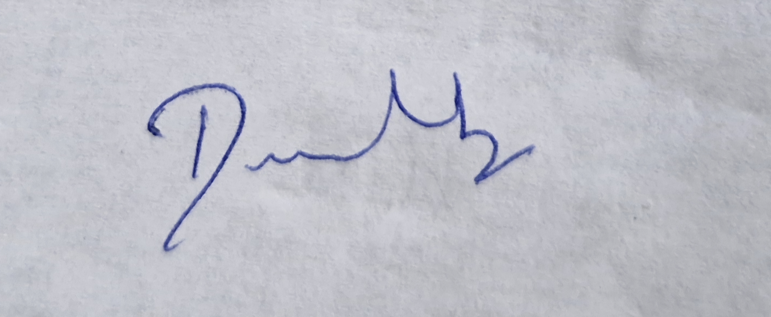
Role: Team Lead
Signature:
Date: 30.09.2026

