**Netaji Subhash Engineering College**

**Department of Computer Science & Engineering**

**B. Tech CSE 2nd Year 3rd Semester**

**2021-2022**

_______________________________________________________________________________________________

**Name of the Course: IT Workshop**

**Course Code: PCC-CS393**

**Name of the Student: Sutonu Dhara**

**Class Roll No.: 150**

**University Roll No.: 10900120154**

**Date of Experiment: 28-09-2021**

**Date of Submission: 03-10-2021**

**_______________________________________________________________________________________**

* **Assignment No.: 1**

**Problem Statement:** Write a program to convert temperature from degree Celsius to degree Fahrenheit.

**Python Code:**



**Sample Output(s):**

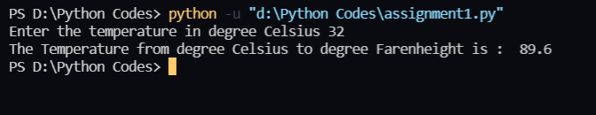

* **Assignment No.: 2**

**Problem Statement:** Write a program to calculate the area and perimeter of a rectangle.

**Python Code:**



**Sample Output(s):**

* **Assignment No.: 3**

**Problem Statement:**Write a program to swap the value of two variables using a third variable and without using a third variable.

**Python Code:**



**Sample Output(s):**

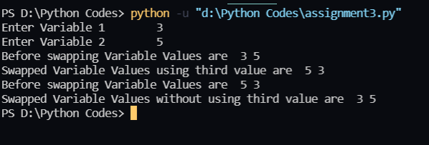

* **Assignment No.: 4**

**Problem Statement:**Write a program to swap two numbers using bitwise operators.

**Python Code:**



**Sample Output(s):**

* **Assignment No.: 5**

**Problem Statement:**Write a program to rotate the value of x, y, z such that x has the value of y, y has the value of z and z has the value of x.

**Python Code:**



**Sample Output(s):**

* **Assignment No.: 6**

**Problem Statement:**Write a program to display the following numbers: 5678, 678, 78, 8, where the given number is 5678.

**Python Code:**



**Sample Output(s):**

* **Assignment No.: 7**

**Problem Statement:**Write a program to add two complex numbers by reading the numbers from the user.

**Python Code:**



**Sample Output(s):**

* **Assignment No.: 8**

**Problem Statement:**Write a program to accept the principal amount, rate of interest, and duration from the user, hence, to display interest amount and the total amount (principal +interest).

**Python Code:**



**Sample Output(s):**

