***Critical Log***

***Website Link -*** [***https://sutton97.github.io/webauth/index.html***](https://sutton97.github.io/webauth/index.html)

***Youtube Link - https://www.youtube.com/watch?v=MqGXRtOFLkw***

For this assignment, using Notepad++ was the easiest option due to already having previous knowledge of the program. Throughout this assignment I was able to use CSS3, HTML5 and JavaScript to ensure I could create a fully functioning website.

***Best practise***

The below screen shots below show the file organisation of the website. I have used main folders to identify the different languages used throughout, also to help develop the structure of the site. This will also encourage to keep the main folder tidy and organised. This will prevent any unnecessary errors or mistakes from happening.

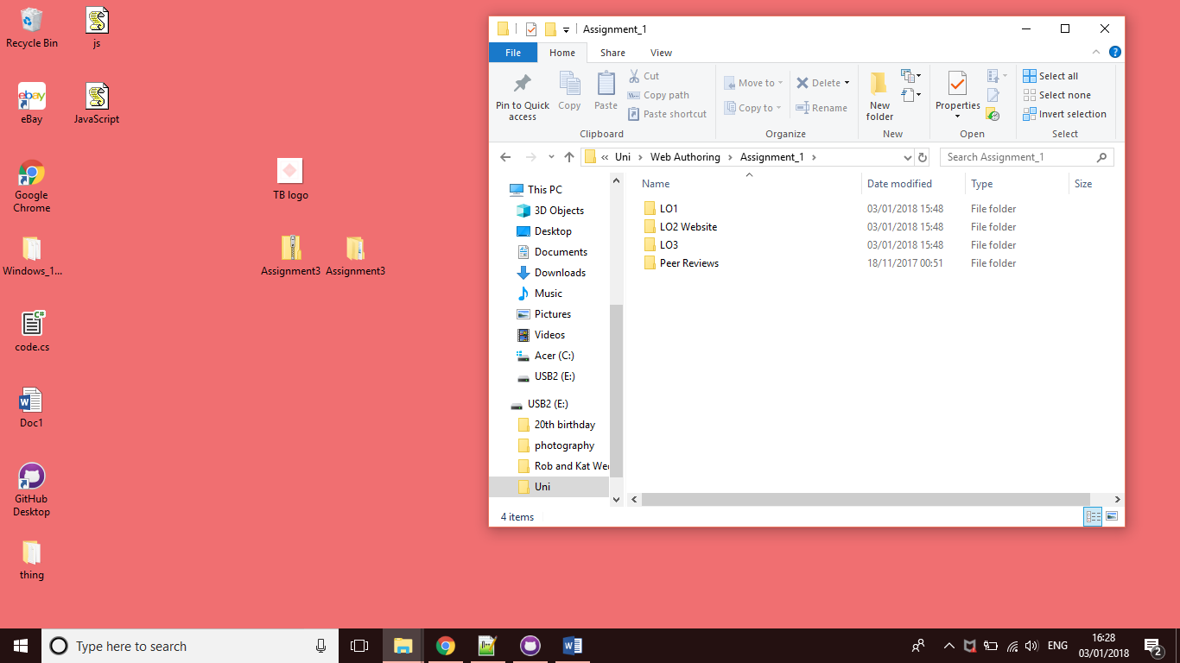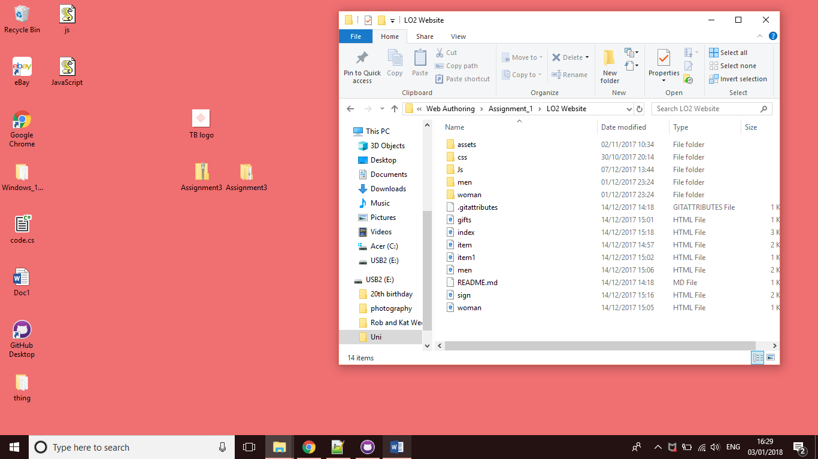

I have also carried out the same theme during the website, the theme is the central focus point of the website. By ensuring the same theme is continued throughout encourages professionalism and stability. It is also easier to maintain if any errors or warnings occurred.

***Mark-up structuring***

The assignment required some sort of customizer, for this website I found doing a colour selector on x2 of the images and an interactive questionnaire the most suitable. Below are screen shots of the JavaScript code I have used to create the different customizer for the website. The format is clear and understandable making any required changes easier to do, also shows how elements intricately define their use.

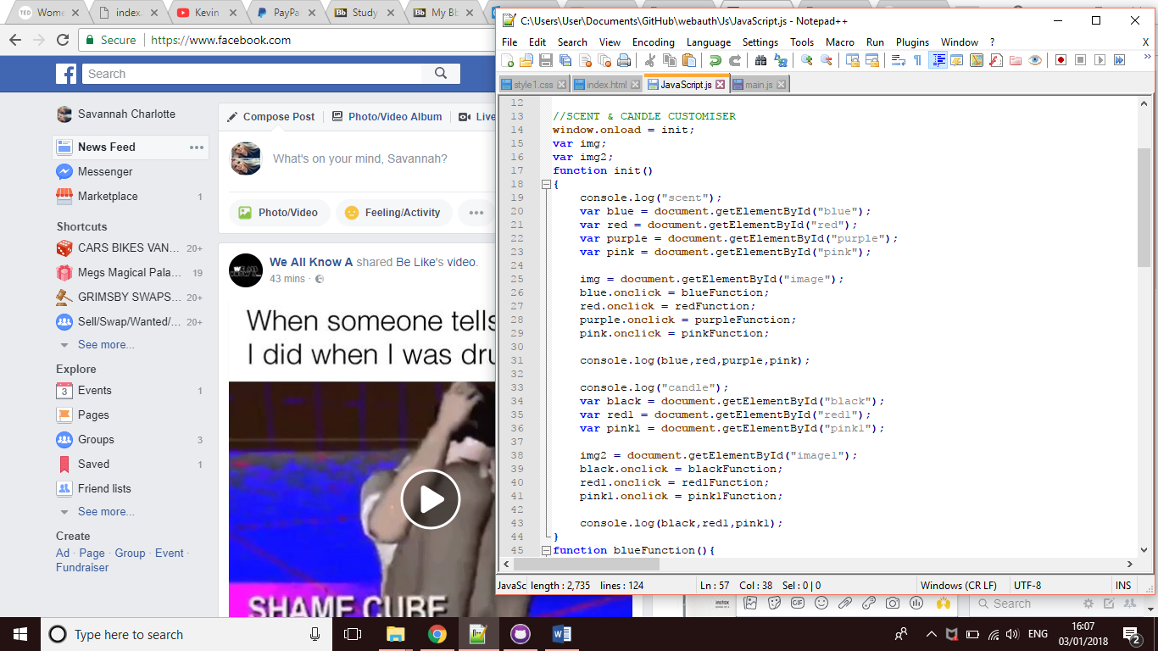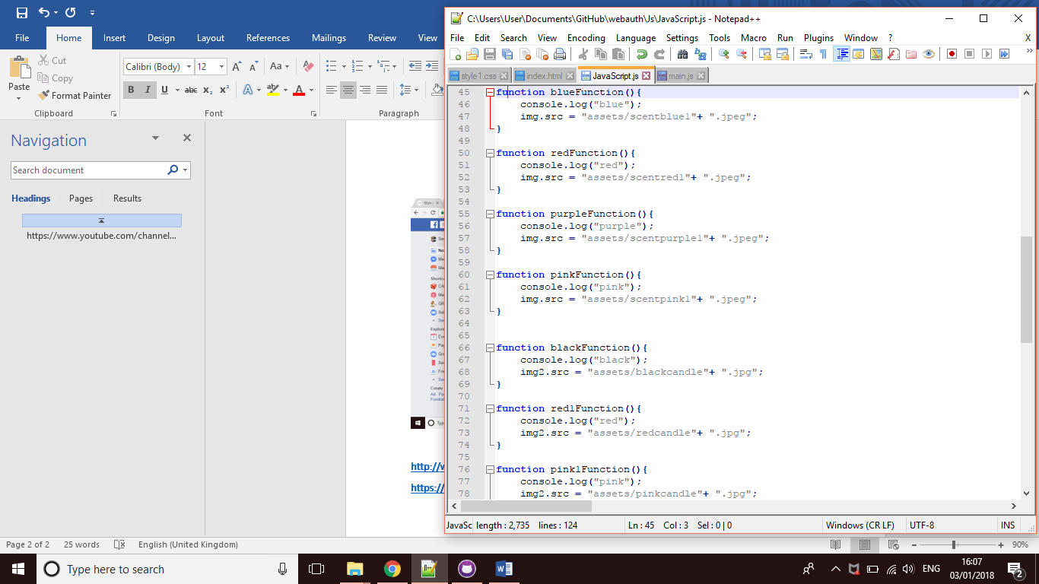

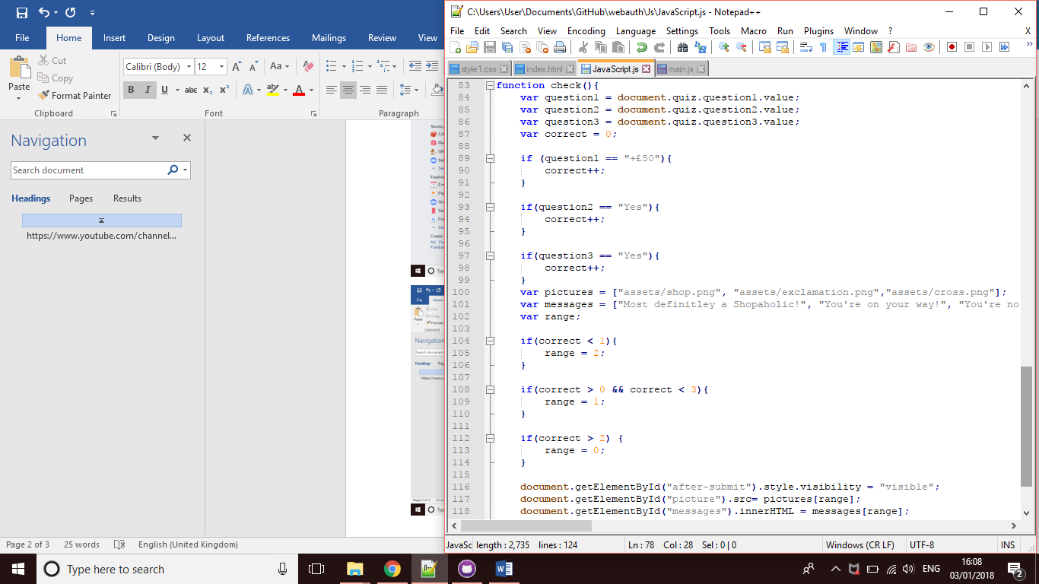

***Browser testing***

I have tested the website on numerous browsers, this includes, Safari for iPhones, Chrome, Explorer and Opera. The website is functional and works on each of the different browsers.

***Strengths and Weaknesses***

Whilst crating the website I found my strengths included being able to integrate hyperlinks which have been included in the website to enable the user to view the website on other pages such as Facebook and Twitter. This has been incorporated by adding multimedia, the Facebook and Twitter logos at the bottom of the site, so the user is able to access more information elsewhere, it will also allow the user to take away any extra information that isn’t on the current website.

The website has been created so the user is able to access it on more than just a laptop or computer. The website is fully functional anywhere, including phones and tablets.

***Weaknesses Areas of improvements***

Throughout completing this assignment, I found some weaknesses within my skills set. Firstly, I wanted to incorporate a ‘basket’ so the user would be able to add the selected items into a specific area which would then store them. This proved to be more difficult than I initially thought due to lack of knowledge with JavaScript.

After creating the Sign-in and Register page I found that it only works locally, once the file was uploaded, it wasn’t supported and didn’t work successfully. This was another area I found needed improving and caused a weakness within the site.

Media queries was another area of the site which wasn’t included. Although the site has no media queries set in place, the websites shrinks to the size requires and still works, although perhaps not as best it could.

***Technical features***

Local Web Storage has been included within the website, there for the user’s data can be stored. I have included local web storage within the customizers. When the user wishes to change the colour of one of the items, their choice will be stored within the local storage.

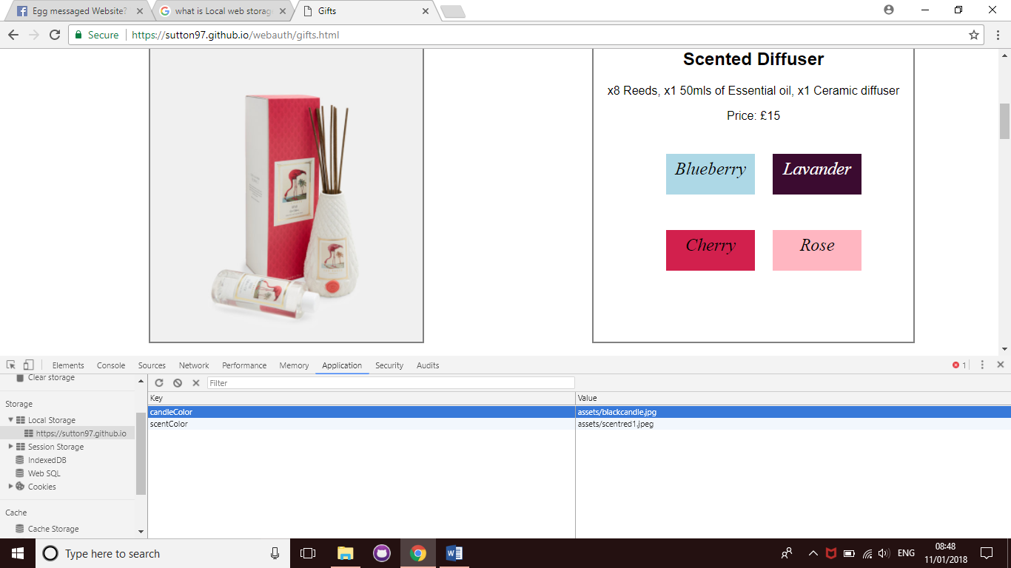

**Geo-location**

Geo-Location has been included within the website, so the user is able to identify the geographical location of where the websites business is based. I have done this by using JavaScript and HTML.

***W3 Validation***

Below are print screens of the validations I have carried out on each of my web pages. Each page has validated successfully with no errors or warnings found, apart from 2 pages which include CSS and the sign-in and register page.

***Home***

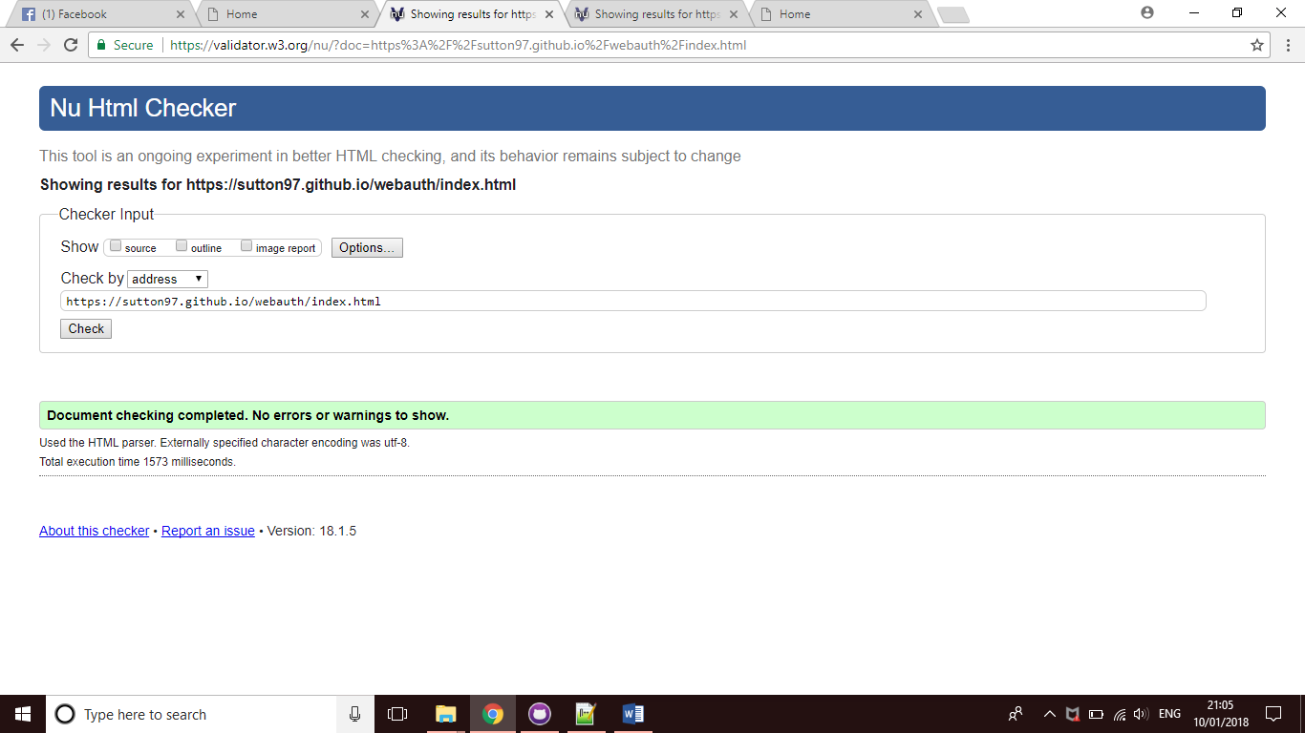

***Women***

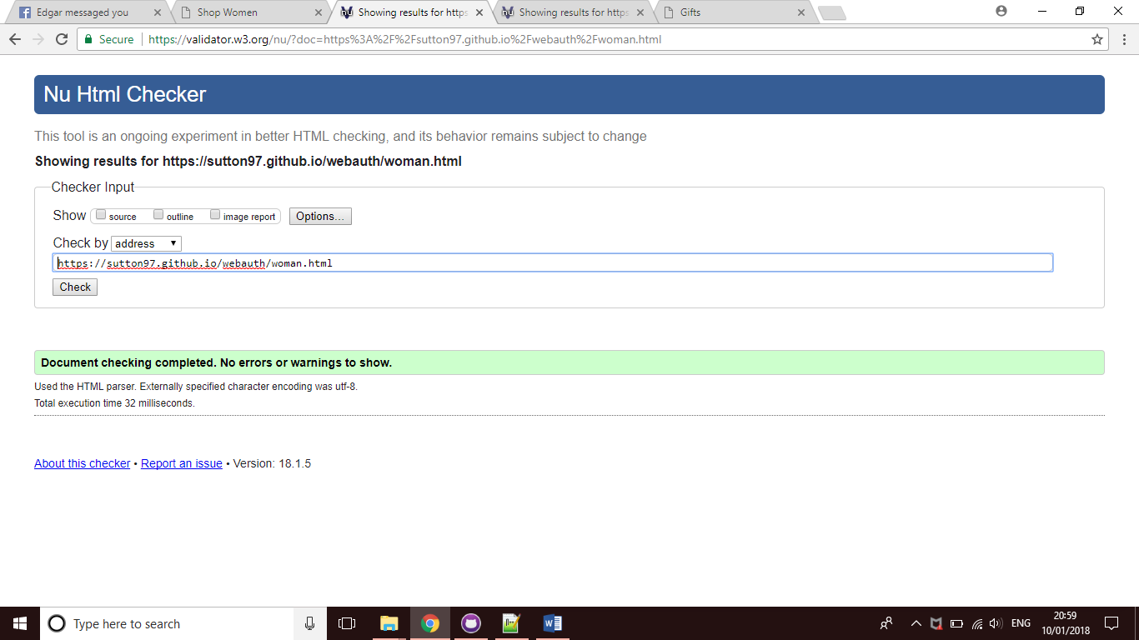

***Women items No. 1***

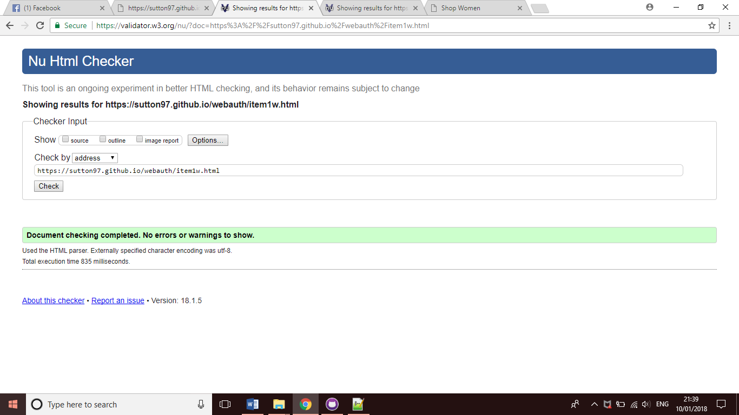

***Women item No.2***

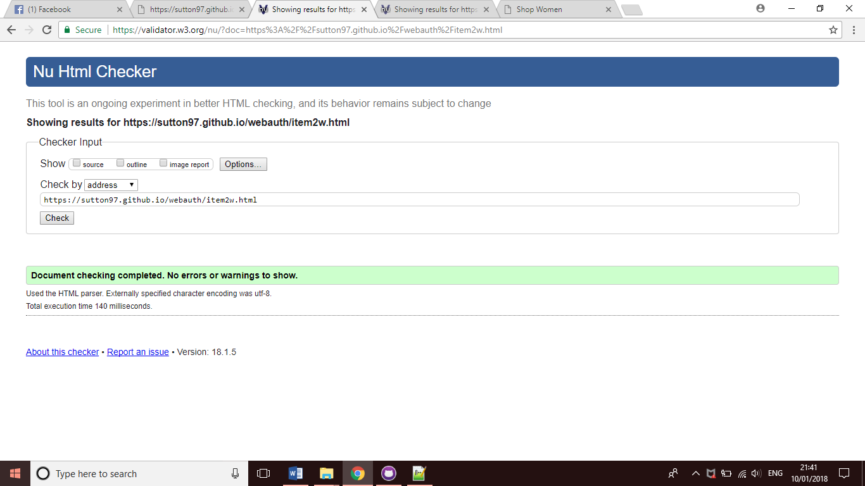

***Women Item No.3***

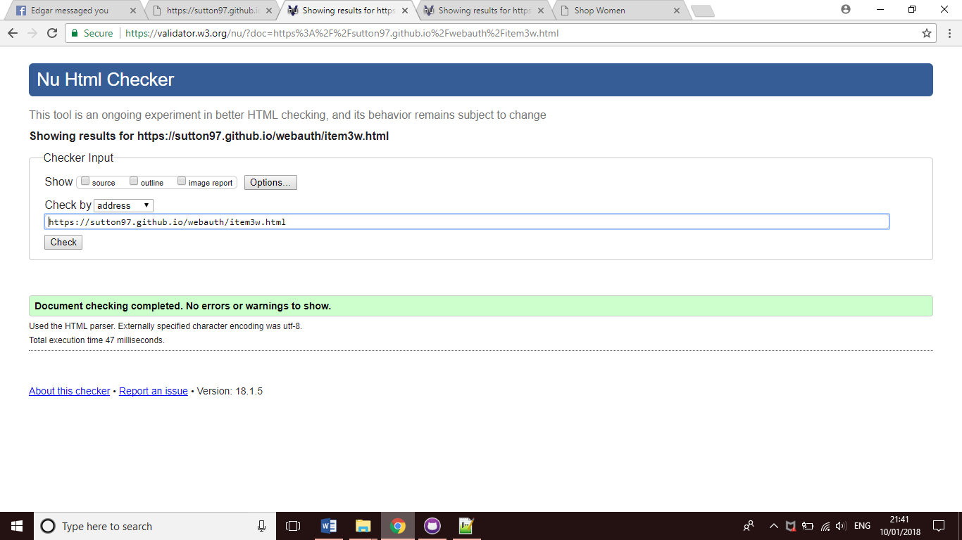

***Men***

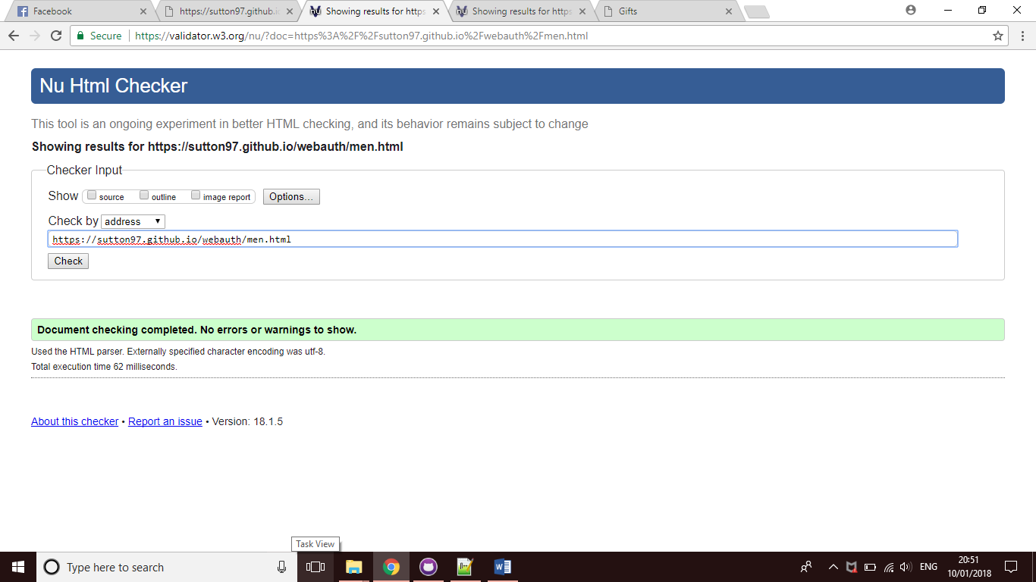

***Men Item No.1***

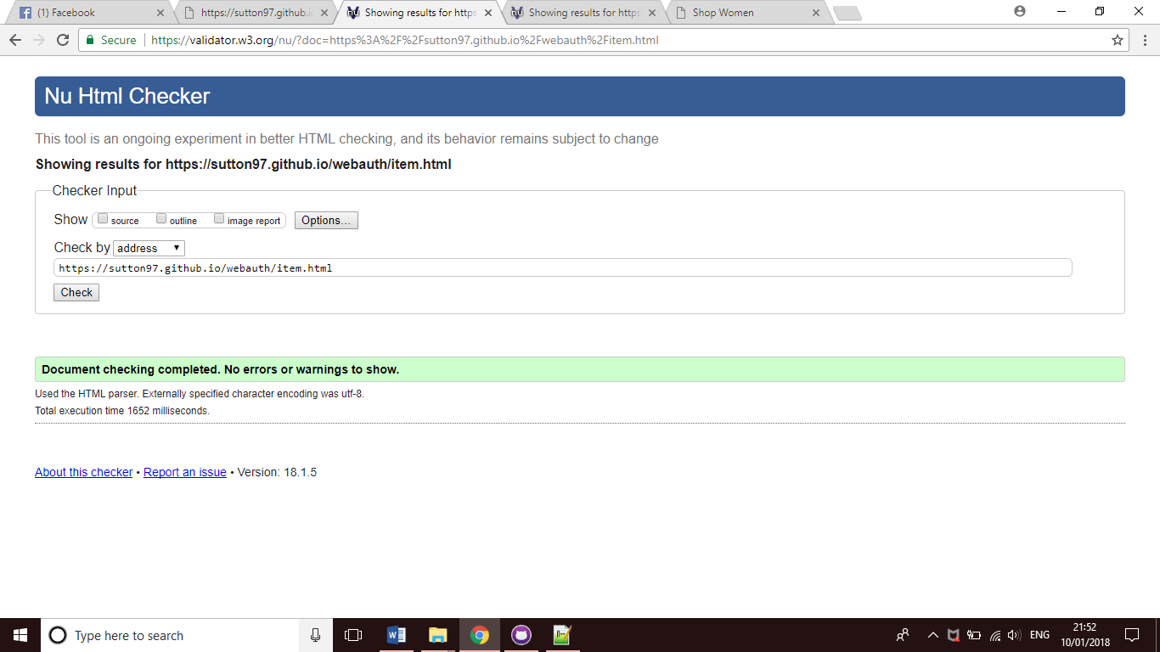

***Men Item No.2***

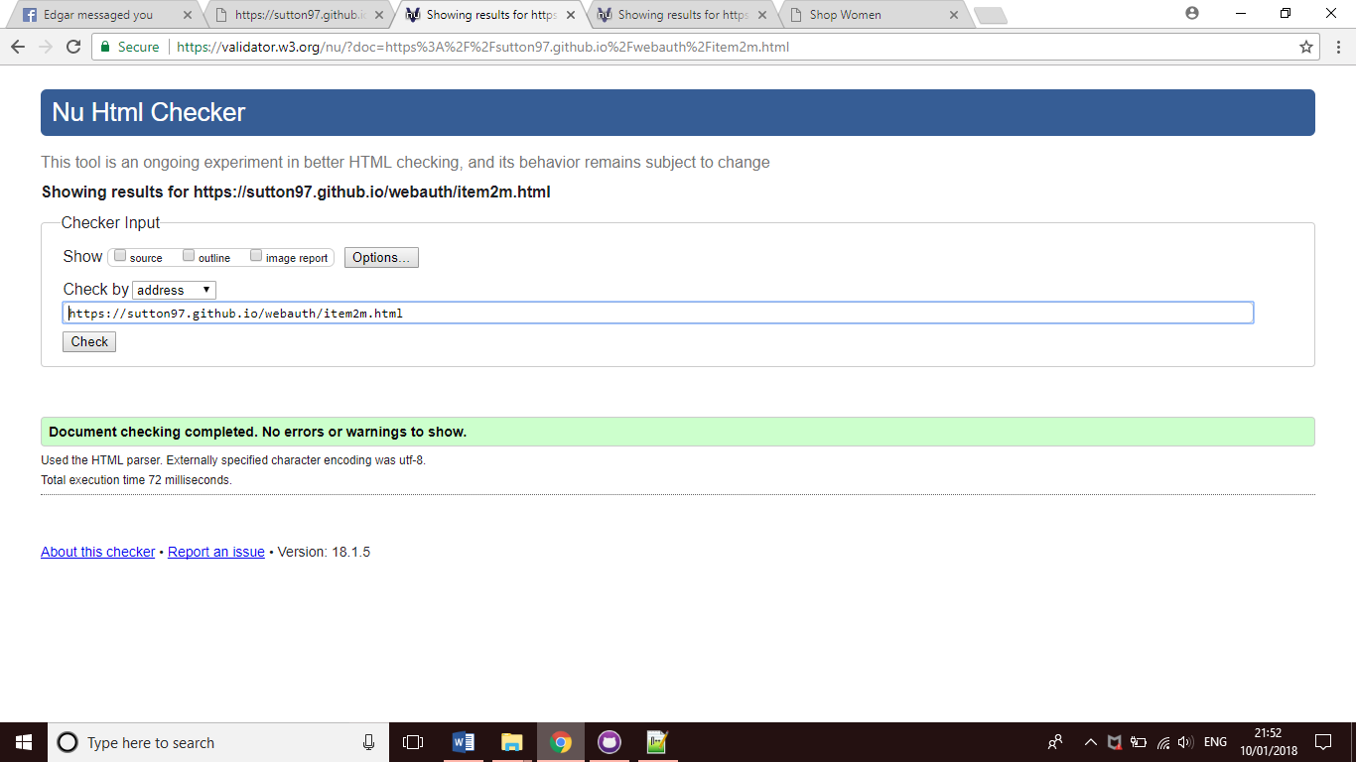

***Men Item No.3***

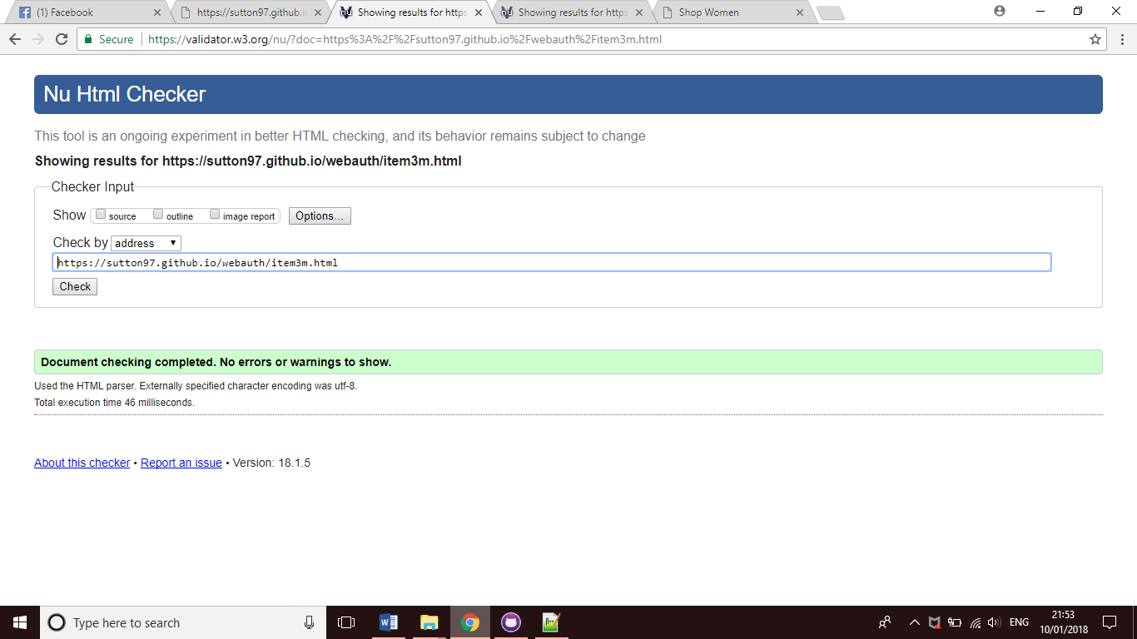

***Gifts***

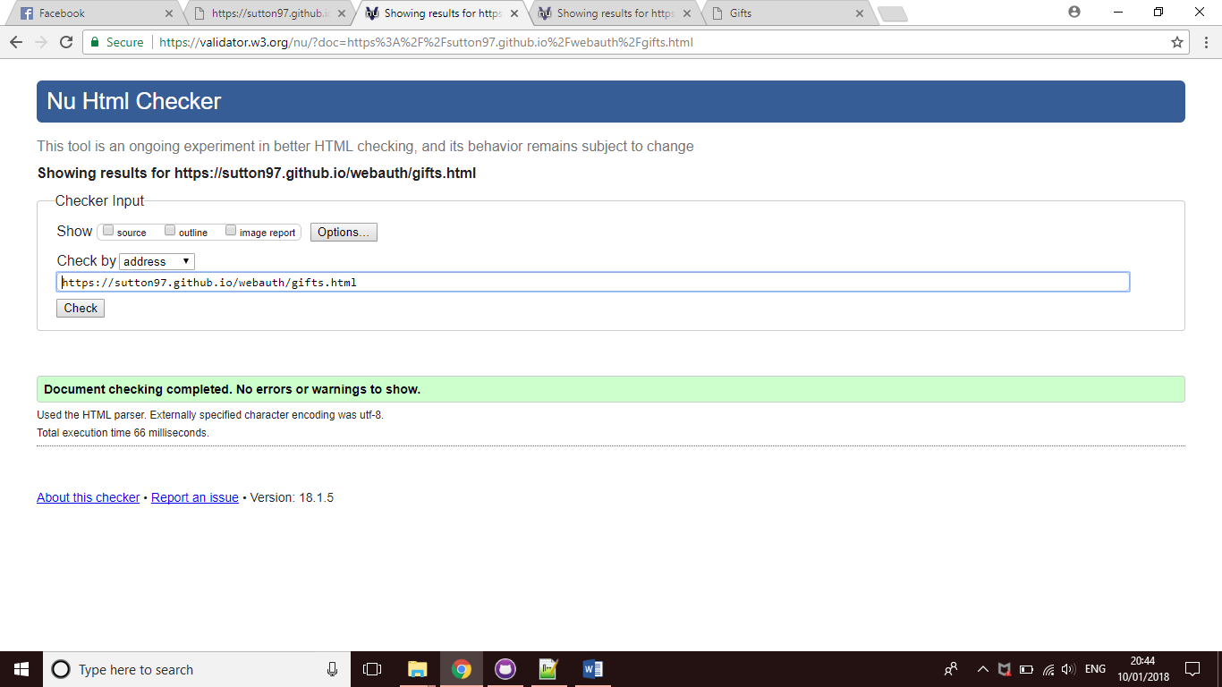

***Quiz***

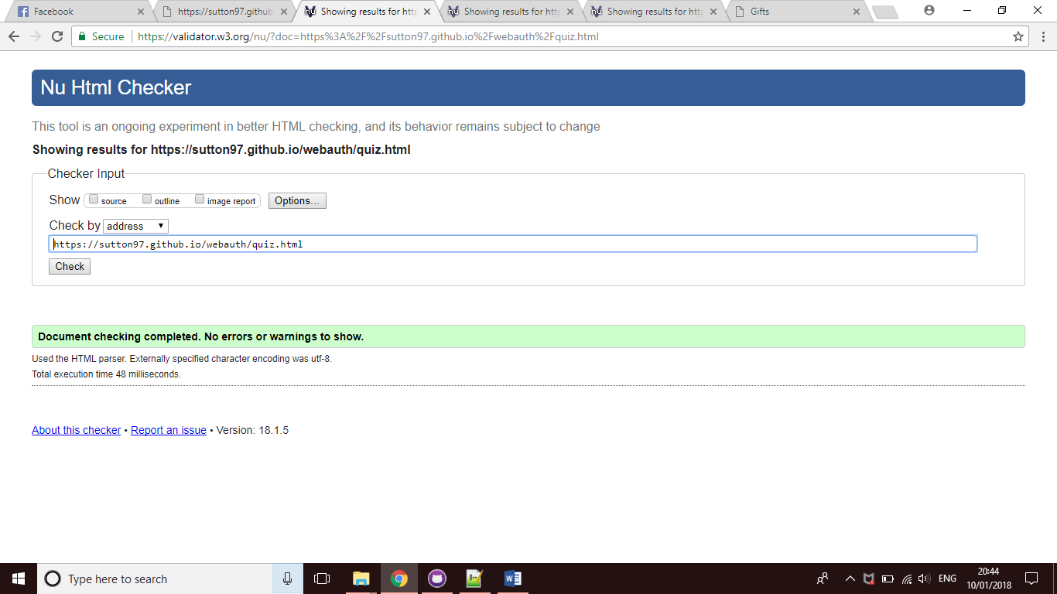

***Geo-Location***

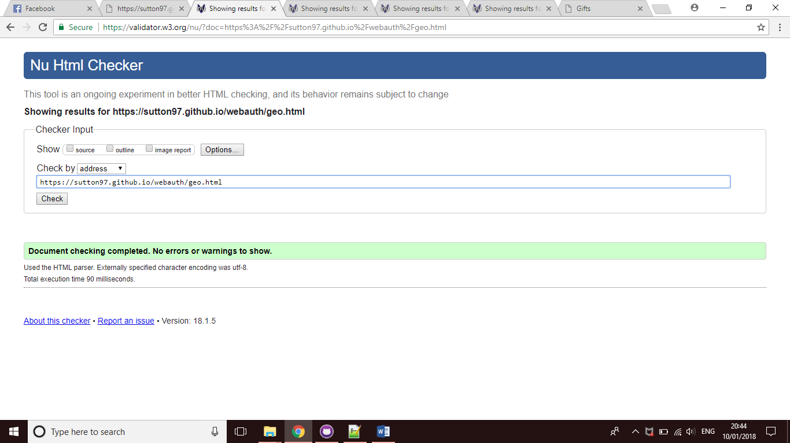

***Contact***

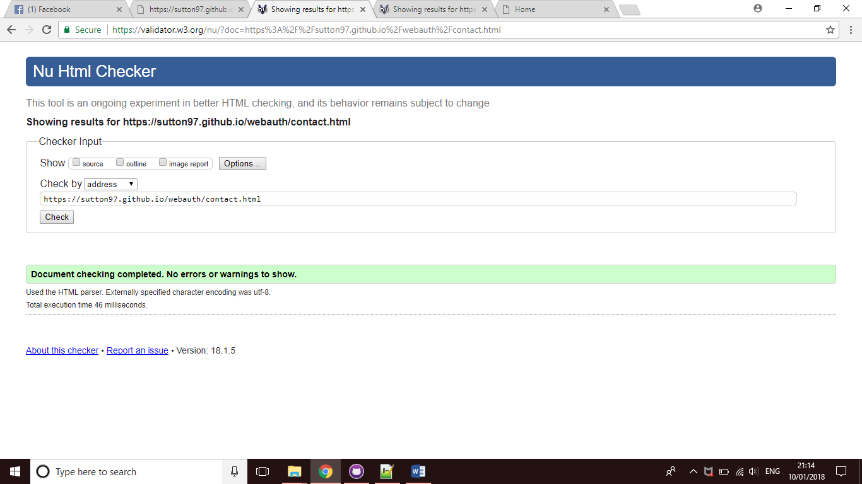

***Sign-In & Register***

***Account***

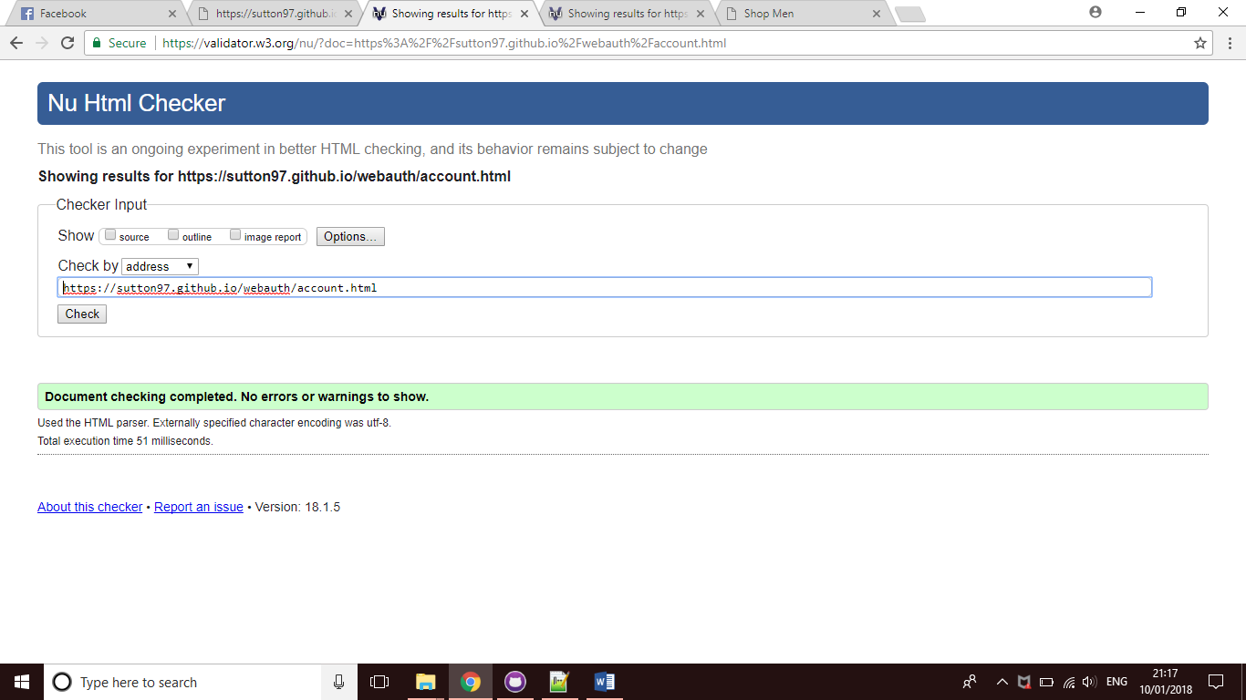

***CSS***

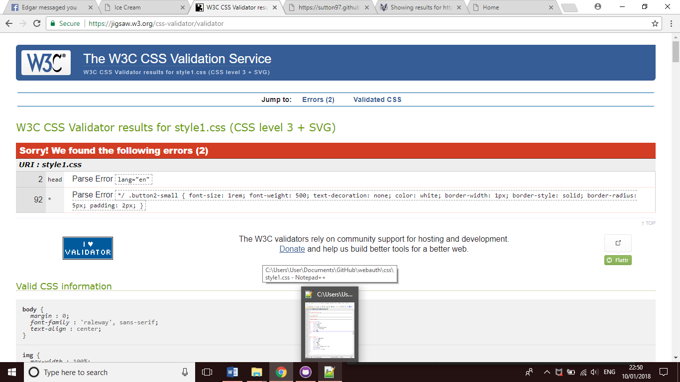

***JavaScript***

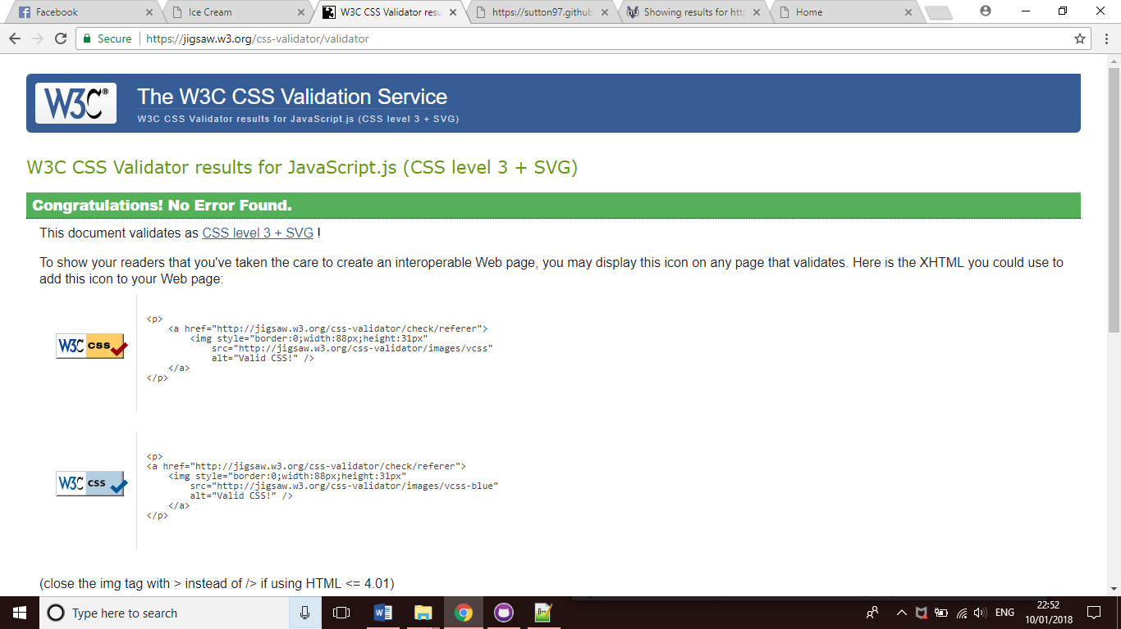

***Reference List***

[**http://www.tedbaker.com/uk/Womens/c/category_womens**](http://www.tedbaker.com/uk/Womens/c/category_womens) **-** Official Ted Baker Website.

[**https://www.youtube.com/channel/UCJZv4d5rbIKd4QHMPkcABCw**](https://www.youtube.com/channel/UCJZv4d5rbIKd4QHMPkcABCw) **-** Kevin Powell, YouTube.

# <https://www.facebook.com/TedBaker/> - Ted Baker Facebook Page.

# <https://twitter.com/ted_baker?ref_src=twsrc%5Egoogle%7Ctwcamp%5Eserp%7Ctwgr%5Eauthor> – Ted Baker Twitter page.

# <https://validator.w3.org/nu/> - Website used for Validating

[**https://www.w3schools.com/**](https://www.w3schools.com/) **-** W3Schools, helped with clarification on code.