PySpark Handson 2 - Feedback

2. Convert date to yyyymmdd format
employee_df.printSchema()
from pyspark.sql.functions import date_format,to_date, col
new_employee_df = employee_df.withColumn("Hiring_Date", date_format(to_date(col("Hiring_Date"),"dd-MMM-yyyy"), "yyyyMMdd"))
new_employee_df.show(5)

Output:

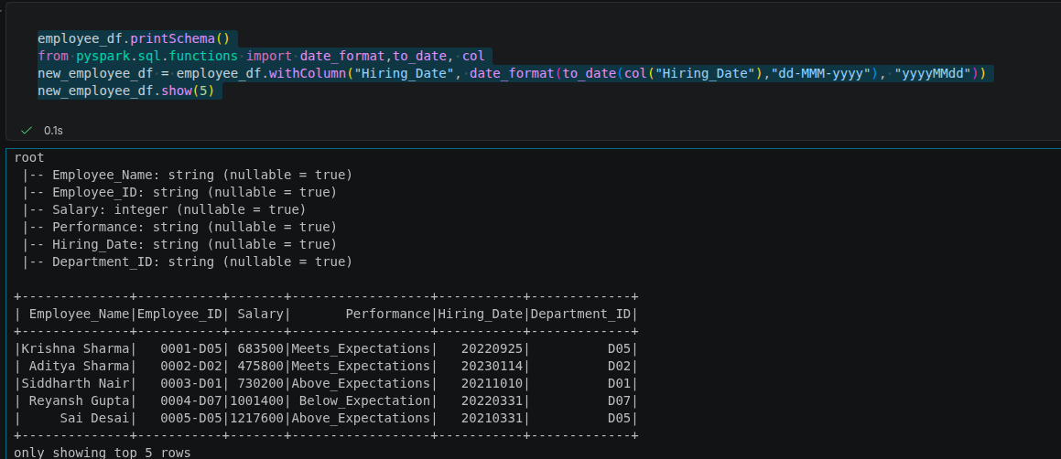

7. Add a new field with new salary based on Performance. Below_Expectation-2%, Meets_Expectations-5%, Above_Expectations-10%, Exceptional-15% increment.

Output:

increment_percent_mapping={"Meets_Expectations":0.05,"Above_Expectations":0.10,"Below_Expectation":0.02,"Exceptional":0.15}

new_data=[]
for employee in employee_df.collect():
increment = increment_percent_mapping[employee["Performance"]]
new_salary = employee["Salary"] + (employee["Salary"] * increment)
employee_Dict = employee.asDict()
employee_Dict["new_salary"] = new_salary
new_data.append(employee_Dict)

new_employee_df = spark.createDataFrame(new_data)
new_employee_df.show(5)

8. Split the output files per (department, year)

unique_dy_combinations = new_employee_df.select("Department_ID","Year").distinct().collect() # df - list of row of object holding department and year
department_year_wise_records =[]
# print(unique_dy_combinations)
for unique_comb in unique_dy_combinations:
department = unique_comb["Department_ID"]
year = unique_comb["Year"]
employees_per_dy = new_employee_df.filter((new_employee_df["Department_ID"]==department) & (new_employee_df["Year"] == year)) # filter dataframe based on the unique department and year
department_year_wise_records.append(employees_per_dy) # store each dataframe to a list

# now i have the list of dataframe seperated by unique (department ,year)
for i,df in enumerate(department_year_wise_records,start=1):
df.coalesce(1).write.mode("overwrite").option("header",True).csv(f"/home/sujay/Desktop/Python Learning/output/df_{i}")

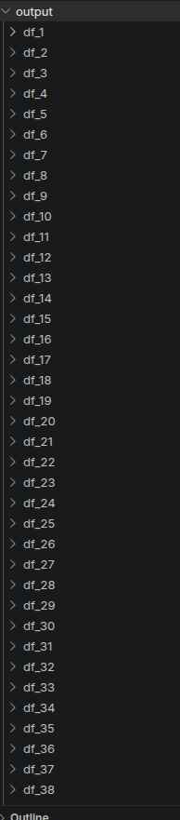
Output:

