**St Cross Thesis and Dissertation Writing**

*Overview of a Research Paper/Thesis*:

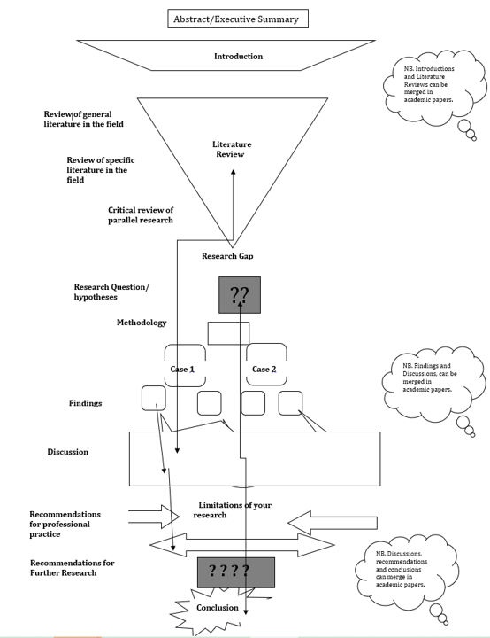

*Writing introductions*:

* Some common conventions include:
  + Introductions last around 10% of the overall word count for dissertations (up to 15,000 words) and MPhil theses (up to 35,000 words). For longer DPhil theses (of 80,000 words or more), the 10% rule may be excessive.
  + Introductions tend to follow these patterns: General to specific, old to new, real world to your text, and less critical to more critical
* Model for Academic Introductions:
  + A highly influential model for academic introductions - termed Creating A Research Space (C.A.R.S.) - was first developed by John Swales . The model proposes separate sections (Swales calls them “moves”) that reflect the traditional pattern found in scholarly introductions.
  + The C.A.R.S model assumes that writers follow a general organisational pattern in response to two challenges: 1) the challenge to create a research space and 2) the challenge to attract readers into that space.
* Introduction Model:
  + The table below outlines the broad moves, and specific steps, that are common to academic introductions. The three moves tend to always be present in long introductions (dissertations & theses). The number of steps that a writer includes in each move depends on the length of the introduction. The video below discusses how the full three-step introduction model would be represented within a dissertation or thesis.

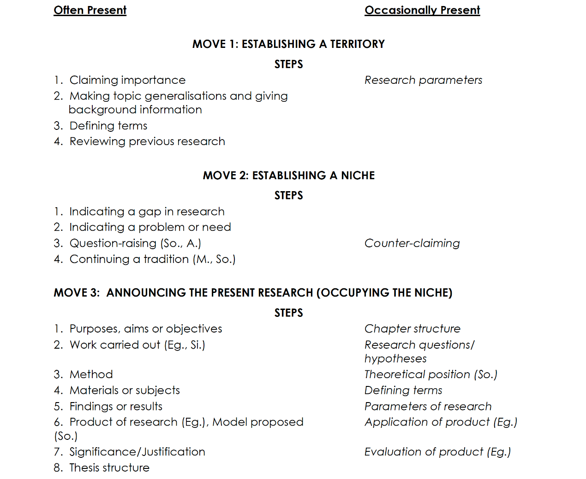

* Literature review model:

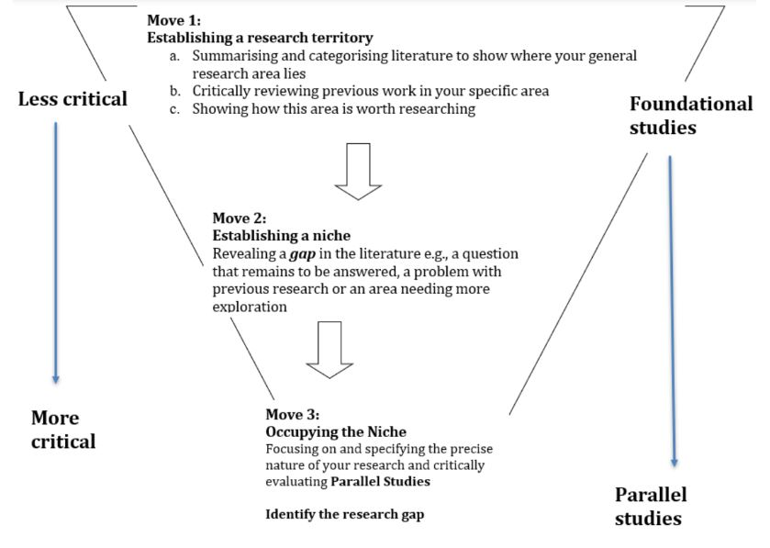

*Discussion*:

* If you are a scientist or a social scientist, you may need a separate "Discussion" section in which you comment on your data collection. Students of humanities may discuss ideas or opinions throughout their work. As discussions can become quite complex, let us first begin by reviewing paragraphing and then look at a possible structure for a Discussion section.

*Conclusion*:

* In the conclusion writers stand back from their work in order to view it in the wider context of the discipline as a whole or the real-world situation. Thus, the purpose of the conclusion is in direct contrast to that of the introduction: it leads out from the narrow thesis topic to more general concerns. Here, we will consider the content that is typically included in a conclusion and the expected order of this content. Below is a model for common patterns found in the conclusions to theses and dissertations:
  + Move 1: Summary of the Research
  + Social science/arts and humanities theses re-state and address aims, hypotheses and research questions. Natural science theses often re-state the work carried out.
  + May summarise the methods but, in all fields, highlights the Key Points established throughout. May include references to previous research (but not as many as in other chapters).
  + Move 2: (In applied fields only) Practical Applications of the Research
  + Indicates how the research may be used to deal with problems or issues in the real world. May give specific detailed recommendations to policy-makers, industries or companies.
  + Move 3: Evaluation of the Research
  + Assesses the extent to which the aims of the thesis have been achieved.
  + Step 1. Implication/Contribution of the Thesis
  + Indicates what the writer considers to be the most valuable aspects of the research.
  + Step 2. Limitations of the Thesis
  + Sets out the issues that have not been addressed, or not successfully dealt with in the study.
  + Move 4: Suggestions for Future Work
  + These suggestions follow from the gap set up in move 3: 2 Limitations of the Thesis.

*Useful links*:

* Oxford Research Archive (ORA) for sample thesis: <https://ora.ox.ac.uk/>.