Heart Disease Prediction: MLOps Final Pipeline Report

MLOPS_Assignment1 - Group 76
Contributors:
Name | BITS ID
SUVAM PATTNAIK | 2024AA05851
JITENDRA KUMAR CHAUDHARY | 2024AA05875
WANI ANIKET JAYANT | 2024AA05690
AKRAM SADIQ VALI PAMADI | 2024AA05054
SAMUJJWAL SINGH CHAUHAN | 2024AA05271

Registry: ghcr.io/suvamrx/mlops_assignment1:latest
Github Repository Link: https://github.com/suvamrx/MLOPS_Assignment1
Note: Please find the short video link at the end of the document.

Setup & Installation
The system is designed for reproducibility using a containerized approach.
Dependencies: Install required packages using:

Docker (optional): Build and run the API locally:

pip install -r requirements.txt

Training: Run the training script to clean the raw data, save the processed CSV, and generate the model.joblib artifact:

docker build -t heart-api:latest .
docker run -p 8000:8000 heart-api:latest

Kubernetes Deployment: Deploy the API to your local Kubernetes cluster using the provided manifests:

python scripts/train.py

kubectl apply -f kubernetes/deployment.yaml

What these commands actually do:
  - python scripts/train.py: This executes the script we modified earlier. It looks for the raw CSV, cleans it, saves the new processed_heart_disease.csv, and trains the model.
  - kubectl apply -f ...: This tells Kubernetes to read your configuration files. The deployment.yaml creates the pods (the "brain"), and the service.yaml creates the network path so you can actually visit the API in your browser.

EDA and Modelling Choices

Exploratory Data Analysis (EDA)
Before training, I conducted an analysis of the UCI Heart Disease dataset to understand feature distributions and target relationships.
Class Balance: As shown in the bar chart below, the dataset is relatively balanced between 'No Disease'
(0) and 'Disease' (1). This balance ensures that the model evaluation metrics like Accuracy and Precision are reliable.
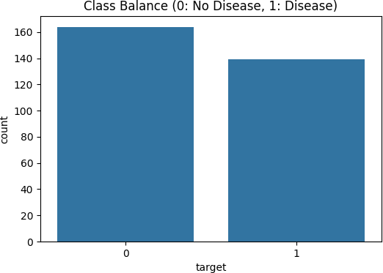

Feature Correlation: The heatmap reveals significant correlations. Features such as cp (chest pain type), thal, and ca show strong positive correlations with heart disease, while thalach (maximum

heart rate achieved) shows a strong negative correlation.

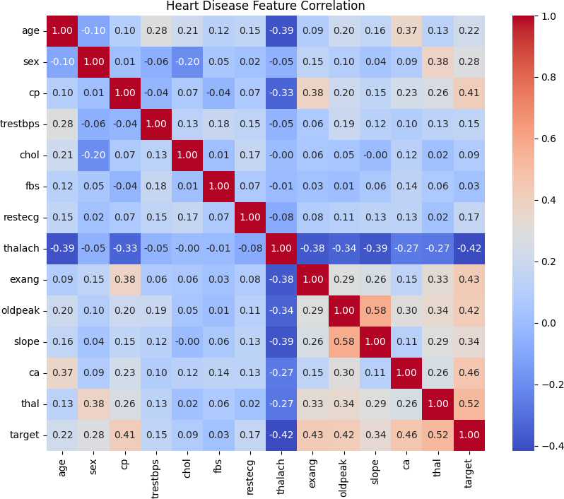

Feature Distribution: Example histogram showing the distribution of a key numerical feature (e.g.,
thalach).

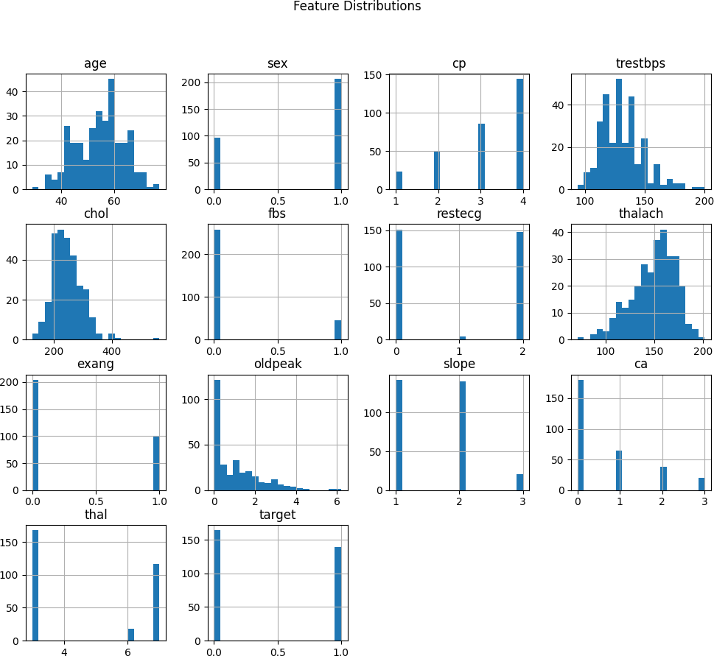

Modelling Choices
To meet the project requirements, a robust machine learning pipeline was constructed:
Data Cleaning: Missing values (marked as '?') were handled using median imputation to maintain data integrity without losing samples.
Preprocessing Pipeline: I implemented a ColumnTransformer to ensure training-serving consistency:
Numerical Features: Normalized using StandardScaler to ensure the model isn't biased by feature scales (e.g., Age vs. Cholesterol).
Categorical Features: Transformed using OneHotEncoder to convert text/categories into machine-readable format.
Algorithms Compared: 1. Logistic Regression: Used as a baseline for high interpretability. 2. Random Forest Classifier: Selected for production as it effectively captures the non-linear interactions between health features found during EDA.

Experiment Tracking Summary
To manage the model lifecycle and ensure reproducibility, MLflow was used to track all training experiments.

Experiment Details
Tool Used: MLflow Tracking UI.

Parameters Logged: Model hyperparameters (e.g., n_estimators for Random Forest, max_iter for Logistic Regression).
Metrics Tracked: Accuracy, Precision, Recall, and ROC-AUC.
Artifacts: For every run, the system logged the model.joblib and the cleaned
processed_heart_disease.csv dataset.

Performance Results
The comparison between the baseline and the optimized model is summarized below:

Model | Accuracy | Precision | Recall | ROC-AUC
Logistic Regression | 0.836 | 0.843 | 0.843 | 0.915
Random Forest | 0.868 | 0.928 | 0.812 | 0.945

Model Evaluation — Confusion Matrices
Below are the confusion matrices for the trained models, showing true vs predicted labels.
Logistic Regression

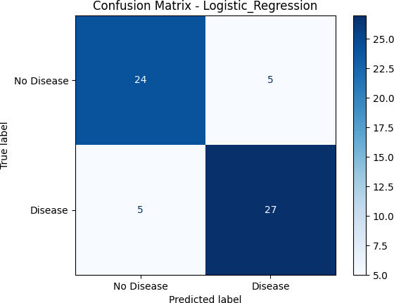

Random Forest

Analysis: The Random Forest model was selected for the production deployment due to its superior accuracy (86.8%) and excellent ROC-AUC (0.945), indicating strong discriminative power (ability to
distinguish between diseased and healthy patients). This model was successfully registered and dumped to model.joblib for deployment.

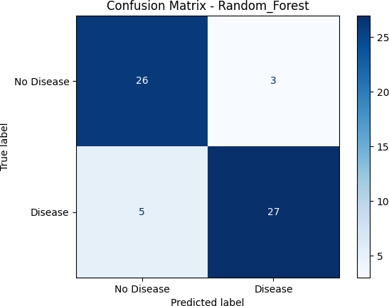
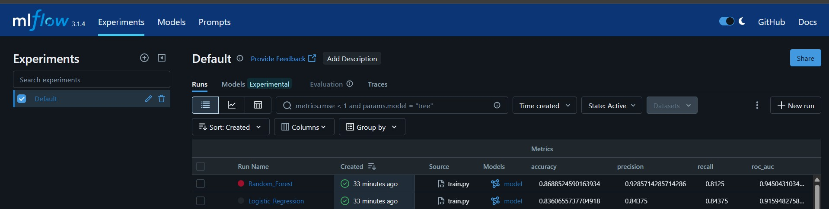
Architecture Diagram
The system architecture follows a production-grade "Push-to-Deploy" MLOps pattern. This design ensures that every update to the model or API is automatically validated, containerized, and orchestrated.

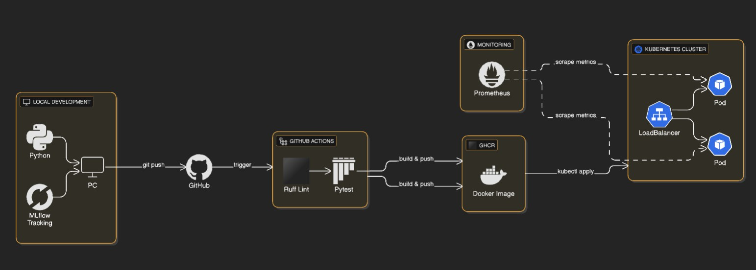

Architecture Overview
The pipeline is designed to eliminate "manual hand-offs." By integrating MLflow at the research stage and GitHub Actions at the deployment stage, we ensure that only models that pass quality gates (Ruff/Pytest) reach the Kubernetes production environment. This creates a closed-loop system where data science and software engineering are synchronized.

Component Breakdown:
  - Development (Local Machine): The project starts with local Python development. Training
experiments, including hyperparameters and metrics, are tracked locally using MLflow to ensure reproducibility.
  - Source Control (GitHub): The repository serves as the "Single Source of Truth." Any code push to the
main branch triggers the automated CI/CD pipeline.
  - CI/CD Pipeline (GitHub Actions): * Static Analysis: Runs Ruff to catch syntax errors and maintain code quality.
Unit Testing: Runs Pytest to ensure API endpoints and data logic are functional before deployment.
  - Container Registry (GHCR): Once tests pass, the application is packaged into a Docker image and pushed to the GitHub Container Registry (GHCR).
  - Orchestration (Kubernetes): * The Docker Desktop Kubernetes cluster pulls the latest image from GHCR.
A Deployment manifest manages 2 Pod replicas for high availability and self-healing. A Service (LoadBalancer) provides a stable entry point for user prediction requests.
  - Observability: The API integrates prometheus-fastapi-instrumentator to expose real-time technical metrics via the /metrics endpoint, allowing for continuous monitoring of system health.

CI/CD and Deployment Workflow Proof
This section provides visual evidence that the pipeline is fully operational, meeting the requirements for automated testing, high availability, and observability.

Requirement: Fail-Fast CI/CD (GitHub Actions)

The GitHub Actions pipeline is configured as a "quality gate." If the code fails linting (Ruff) or testing (Pytest), the build is terminated immediately, preventing broken code from reaching the registry.
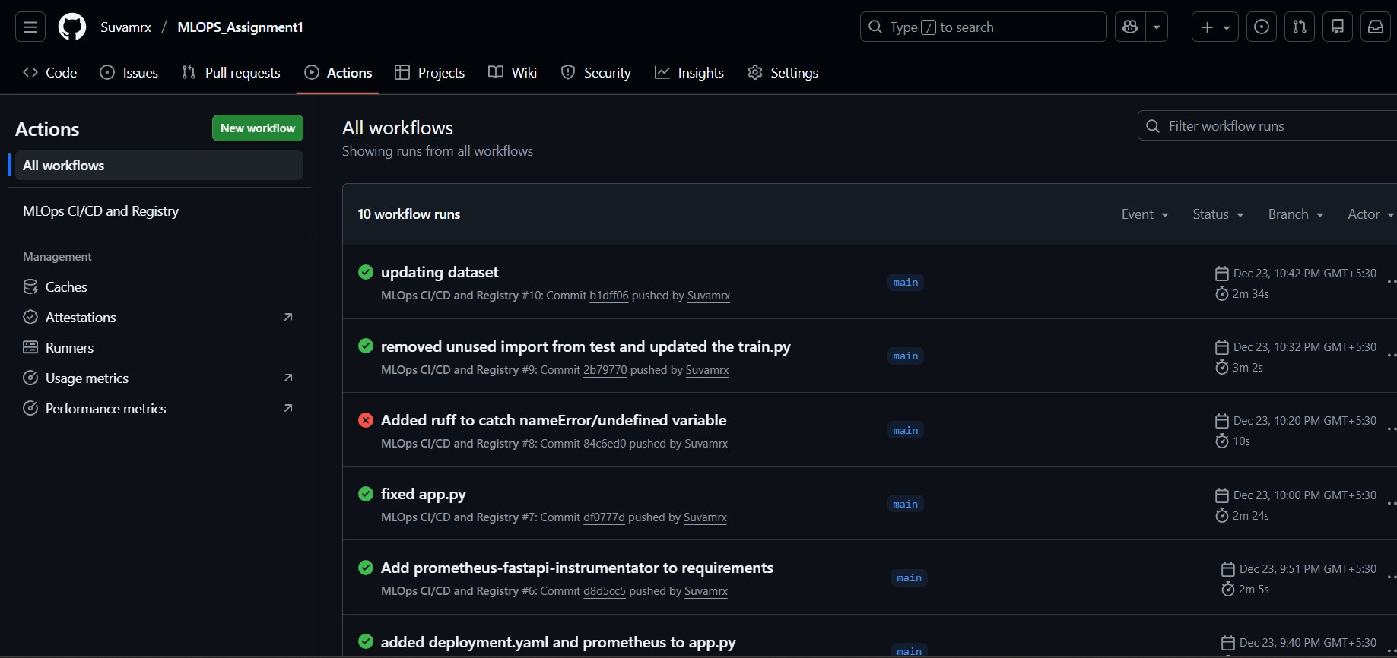

Requirement: High Availability (Kubernetes)
To ensure the Heart Disease Prediction API remains available even if a container crashes, the Kubernetes deployment is configured with two active replicas.
Pods: Two running instances of the API.
Service: A LoadBalancer providing a stable entry point.
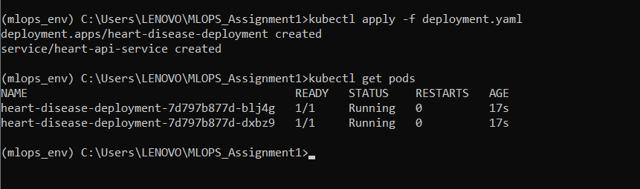
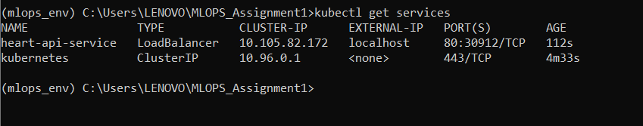

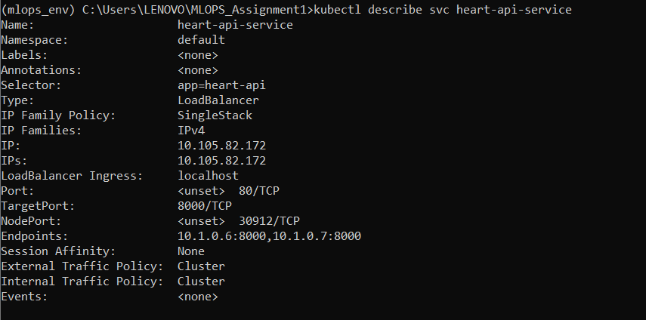

Requirement: Real-time Monitoring & Metrics
The API exposes technical performance metrics using the Prometheus format. This allows for real-time monitoring of request latency, error rates, and system resource usage.

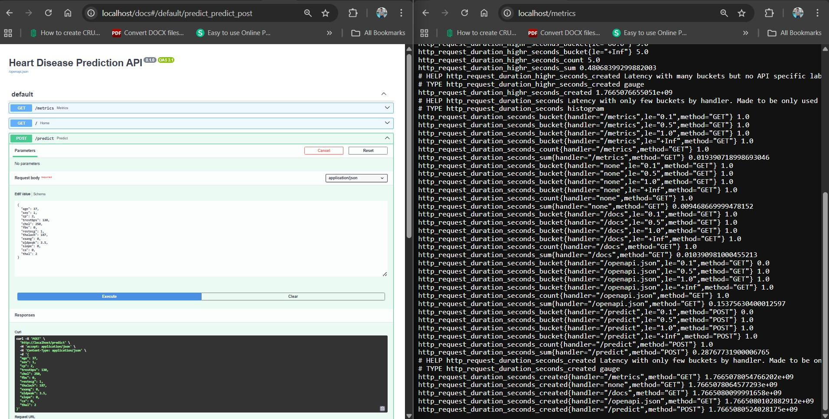

Inference: Standalone script for local model testing and batch prediction:

python scripts/inference.py

Conclusion
The implemented MLOps pipeline successfully bridges the gap between manual data science experimentation and automated cloud-native deployment. By leveraging MLflow for experiment tracking and Kubernetes for orchestration, the system is prepared for scalable production use with high reliability.

Short Video Link to show end to end pipeline: MLOPS-Assignment1-Group-76-end-to-end-pipeline-video

