**Step 1**:Login to GitHub and to the repo you have the Android code .Navigate to Settings>Integration & Services

Add Jenkins as a service

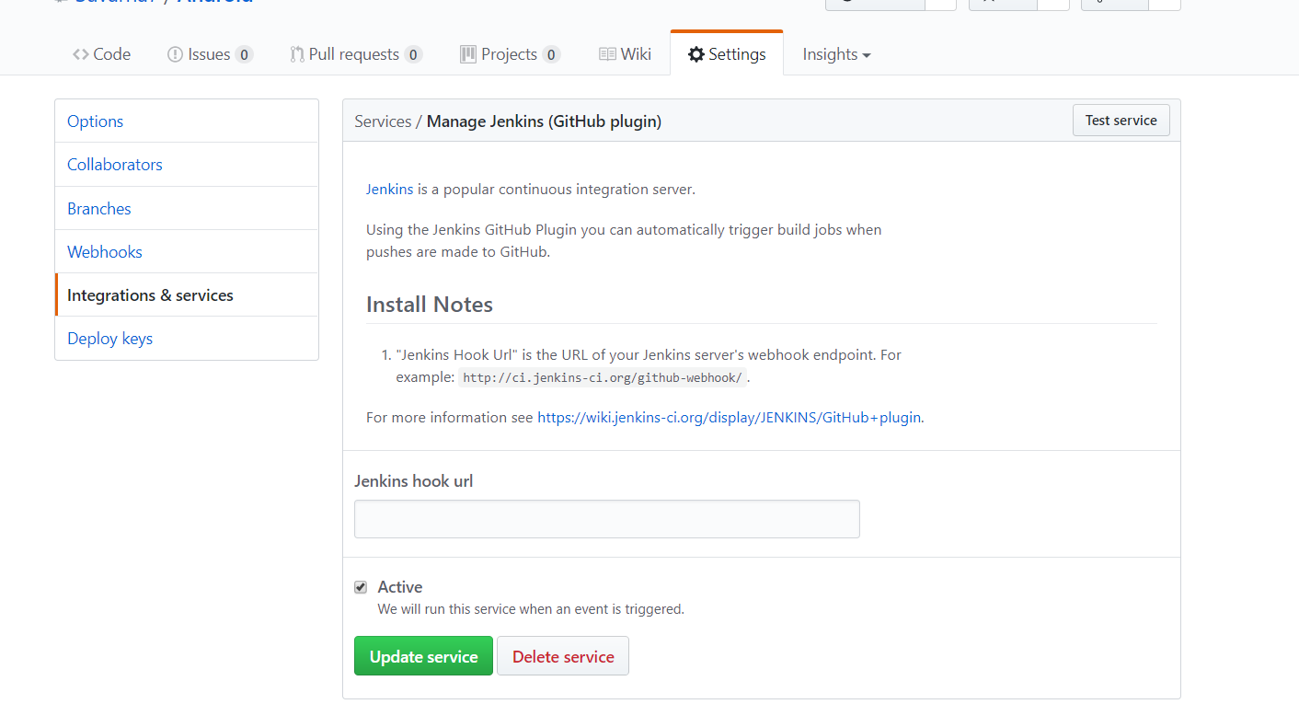

**Step 2**:Go to localhost:8080 and from the Jenkins Dashboard Click on Manage Jenkins>Configure System

Click on Environment variables and add ANDROID_HOME path as below

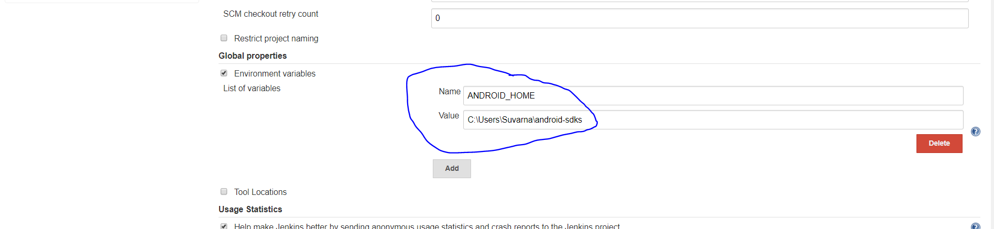

Now scroll down and set up GitHub Server by entering URL and then click on Advanced Setting option

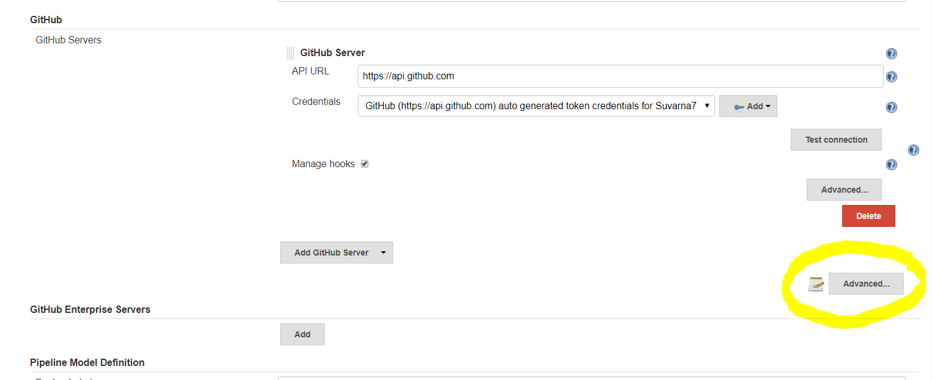

Using Additional GitHub action convert the GitHub login id and pwd to a token (screen not shown)

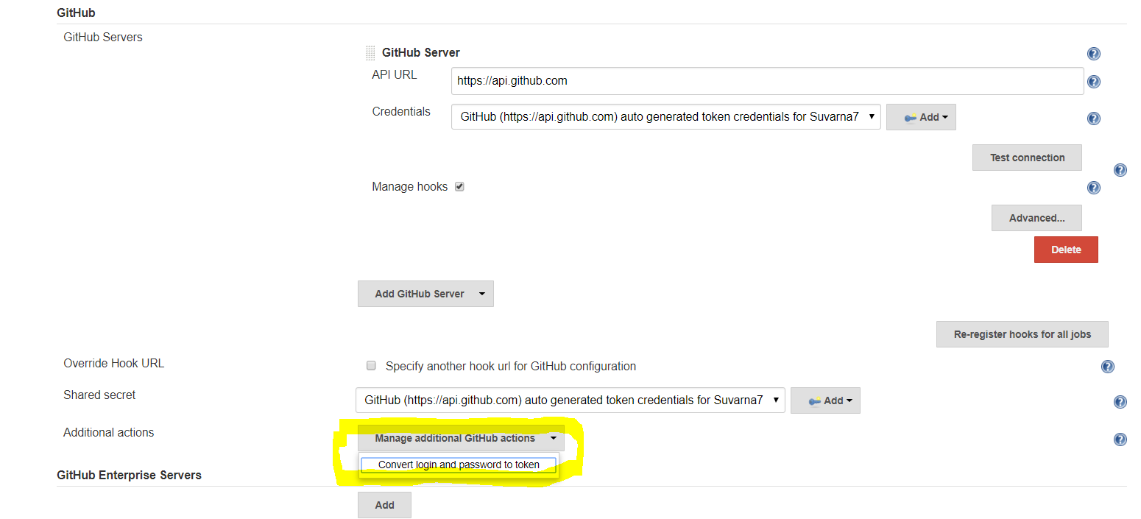

Once the token is generated save the settings and navigate to the same page again Manage Jenkins>Configure System under GitHub section choose the Credentials to be the token generated in previous step.

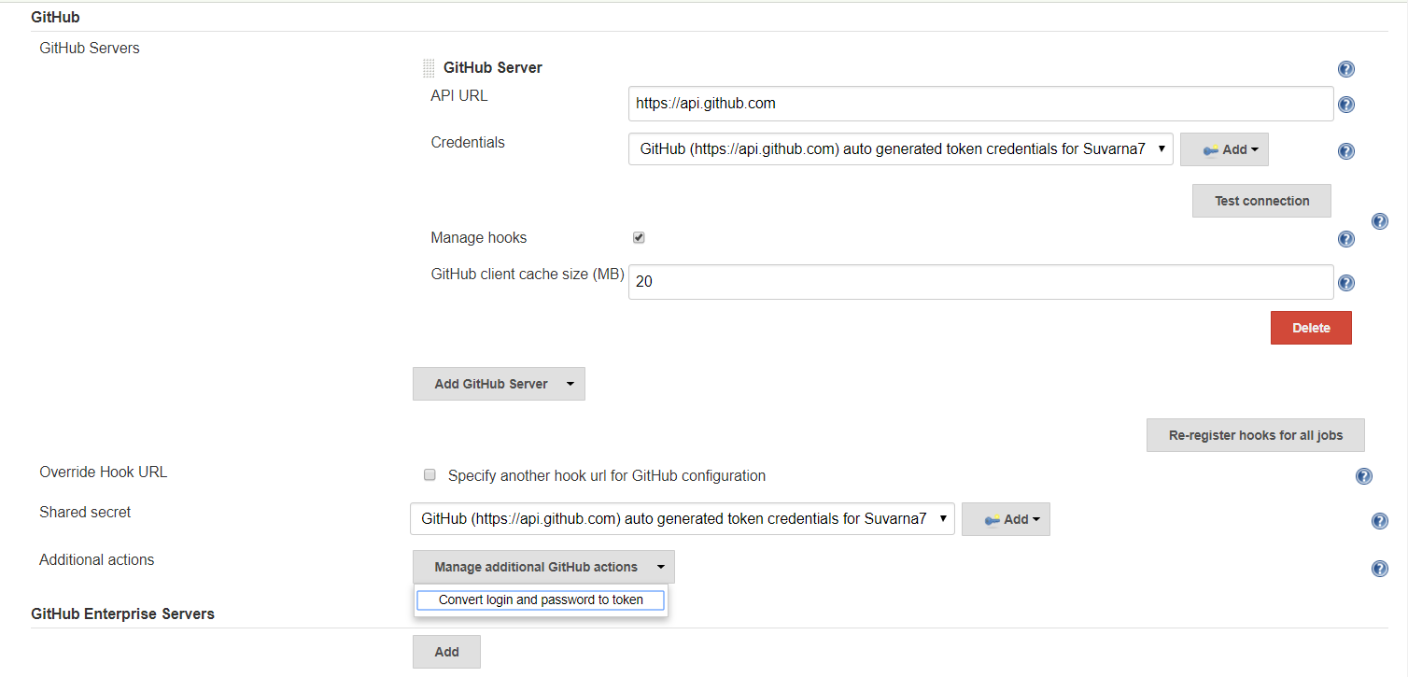



Now test the connection to GitHub and it should be successful

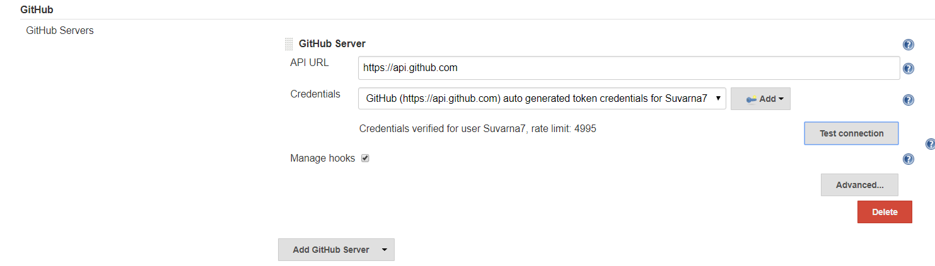

**Step 3-** From the Dashboard in Jenkins now click on Create new item and from the following screen select appropriate option in our case it is the GitHub Organization Option

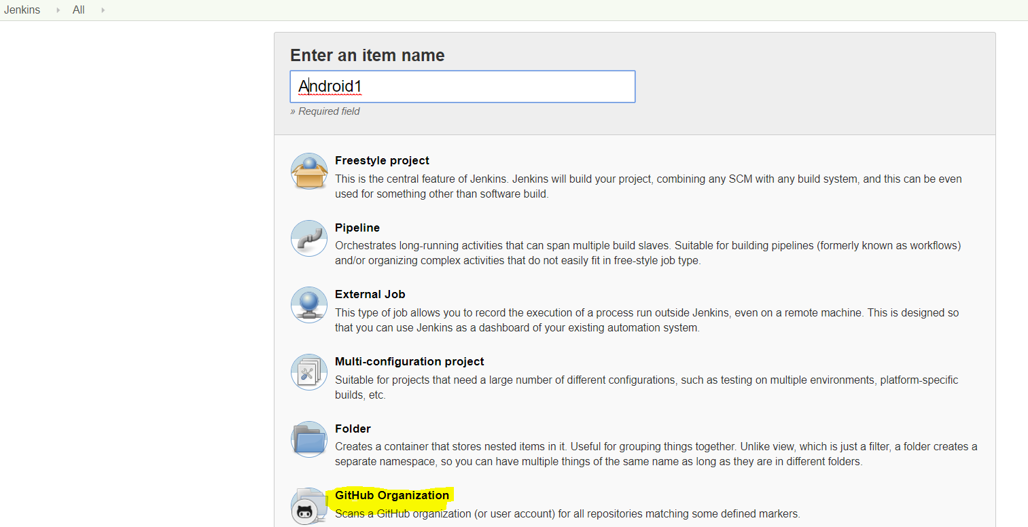

And click ok on the next screen enter the information as shown in screen below

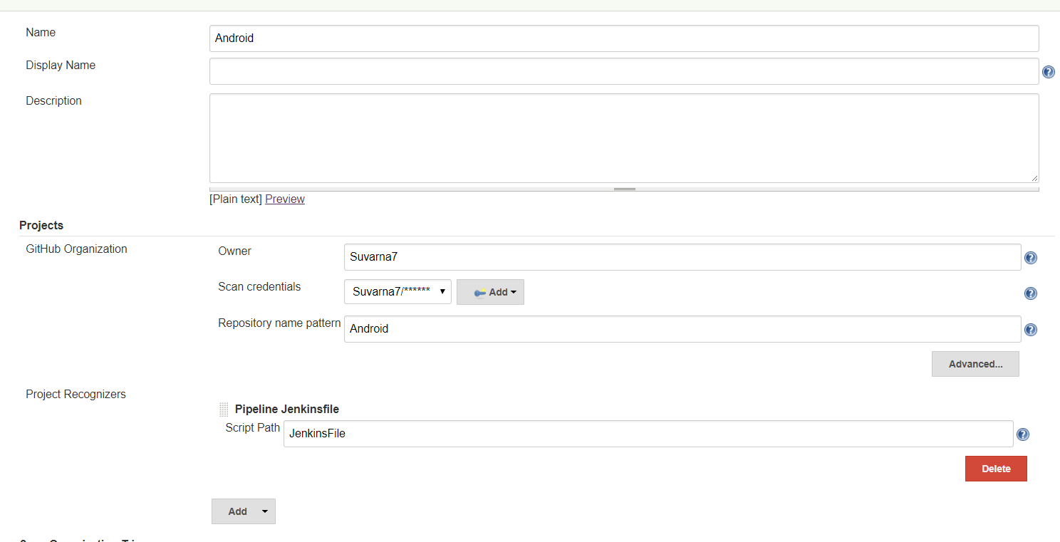



Once the above setting is done we apply the changes .

**Step 4-**Now once the job is set up we can click on the Scan Organization option from Dashboard to enable build also we can check out a lot more options as well.

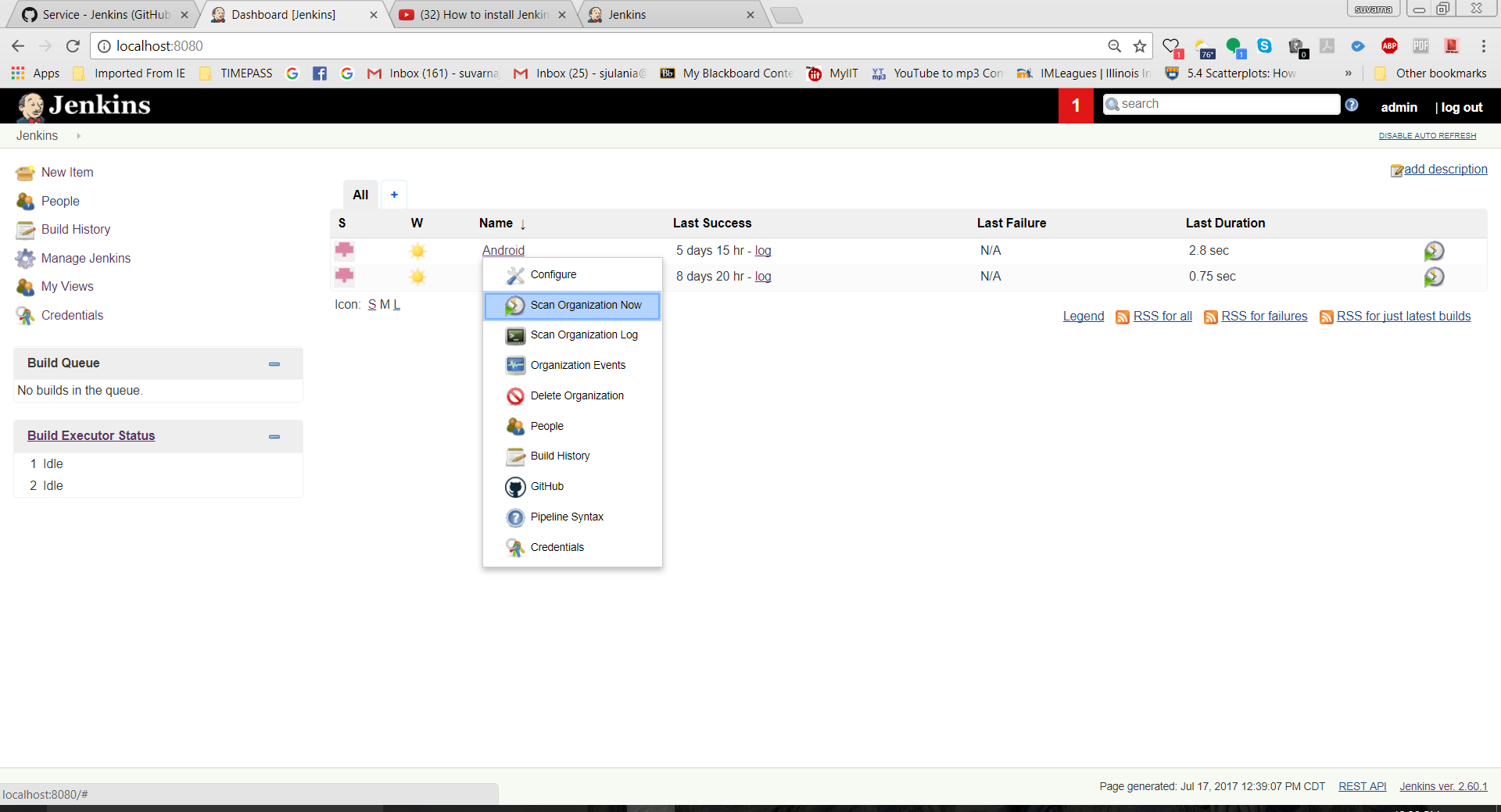

This will initiate the build given the repo has some new changes commited.

The Scan Organization Log shows up the result of the build