CAN WE PLACE ANY STATEMENTS EXACTLY BELOW BREAK; AND CONTINUE;?

Assignment: 8

Date: 17-08-2023

Name: Suvarna

E-mail id: [Suvarnaballid726@gmail.com](mailto:Suvarnaballid726@gmail.com)

**BREAK;**

In Java, the break; statement is used to exit from loops and switch statements. The code immediately following the break; statement within the loop or switch block will not be executed. Instead, this will give us error as “UNREACHABLE CODE”. As the control can never reach or execute this statement. But, we can place a statement after break; in the next block.

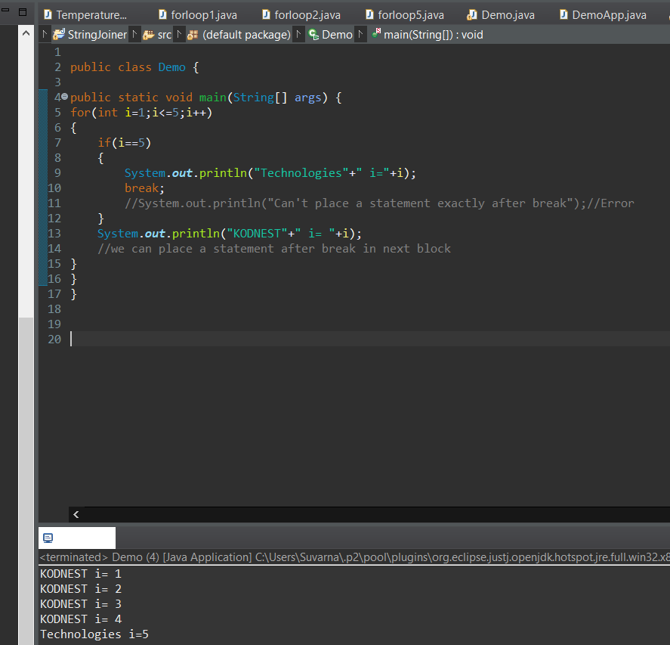

**CONTINUE;**

In Java, the continue; statement is used to skip the remaining code inside the loop for the current iteration and move on to the next iteration. If we try to place a statement below continue; this will give us error as “UNREACHABLE CODE”. As the control can never reach or execute this statement. But, we can place a statement after break; in the next block.

