Date:30/08/2023

Name:Suvarna

Email:Suvarnaballid726@gmail.com

Assignment:10

**RANDOM CLASS**

Random class is used to generate pseudo-random numbers in java. An instance of this class is thread-safe. The instance of this class is however cryptographically insecure. This class provides various method calls to generate different random data types such as float, double, int.

**Constructors:**

* Random(): Creates a new random number generator
* Random(long seed): Creates a new random number generator using a single long seed

**Declaration:**

public class Random

extends Object

implements Serializable

It's a predefined class in Java which gives a random number between a range of specified number.

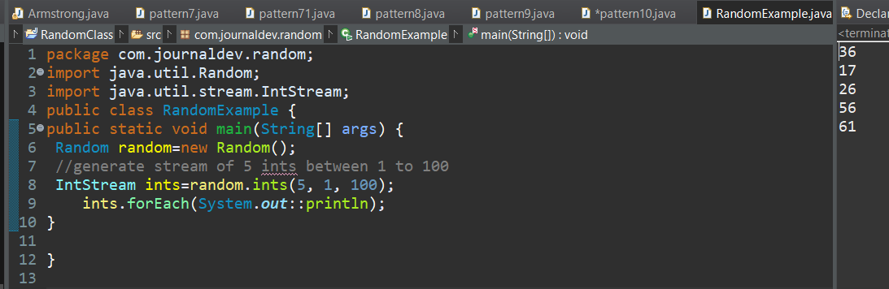

The Random class is a generator of pseudorandom numbers. These are called pseudorandom numbers because they are simply uniformly distributed sequences. Random defines the following constructors:

Random( )

Random(long seed)

The first version creates a number generator that uses the current time as the starting, or seed, value. The second form allows you to specify a seed value manually.

java.util.Random class used to generate random numbers. Create an instance of this class and use range of methods available in this class based on exact requirement. Details of most used methods is below:

nextInt() - Gives any random integer number within integer range

nextInt(int) - Gives any random number between 0 and the int passed as parameter (exclusive)

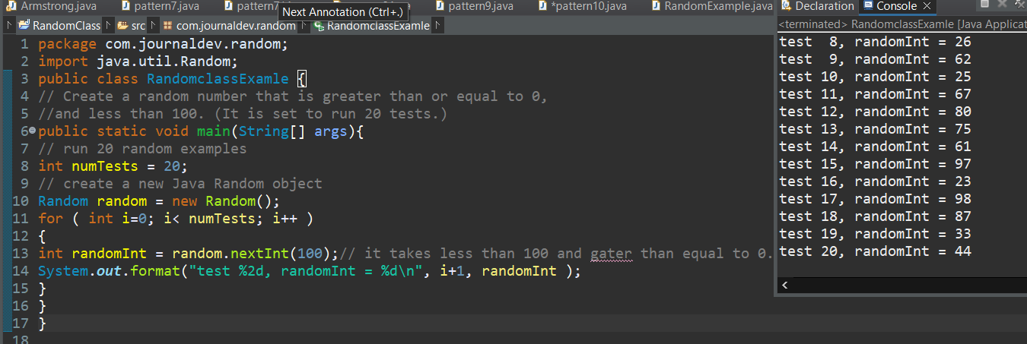

Random class in java is used to to put random numbers or digits in your program.

For example a website that uses captcha code or random numbers occurs on each refresh of the webpage or software.

An instance of java Random class is used to generate random numbers. This class provides several methods to generate random numbers of type integer, double, long, float etc. Random number generation algorithm works on the seed value.

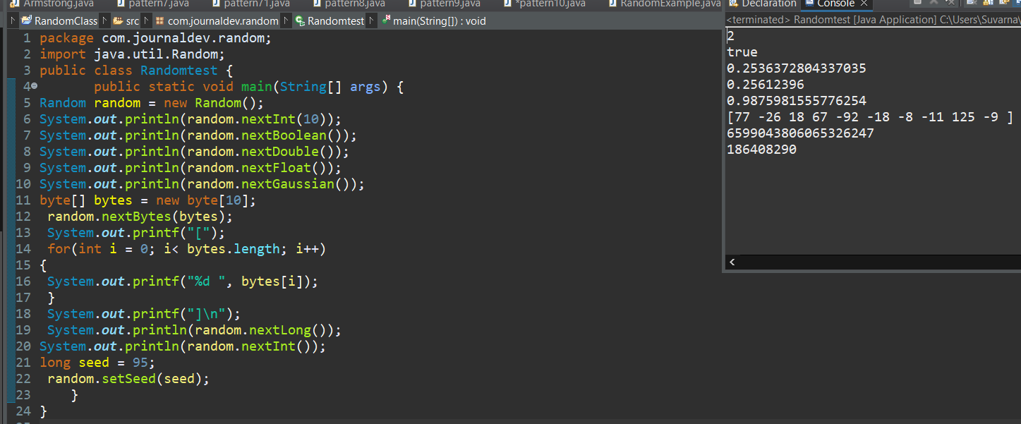

Running any of the code lines below

      // will keep the program running as each of the

      // methods below produce an unlimited random

      // values of the corresponding type

      /* System.out.println("Sum of all the elements in the IntStream returned = " +

        random.ints().count());

      System.out.println("Count of all the elements in the DoubleStream returned = " +

        random.doubles().count());

      System.out.println("Count of all the elements in the LongStream returned = " +

        random.longs().count());