**Date:30/08/2023**

**Name: Suvarna**

**Email: Suvarnaballid726@gmal.com**

**Assignment:11**

1) Complete description of random() ?

2)Usage of pow( ) present in Math class?

**Java Math random() Method**

**and**

# Math pow() method in Java

**Java Math random() Method**

The **java.lang.Math.random()** method returns a pseudorandom double type number greater than or equal to 0.0 and less than 1.0. When this method is first called, it creates a single new pseudorandom-number generator, exactly as if by the expression new java.util.Random.

### Declaration of Java Math random()

Below is the declaration of java.lang.Math.random() method is mentioned below:

public static double random()

### **Return Type**

This method returns a pseudorandom double greater than or equal to 0.0 and less than 1.0.

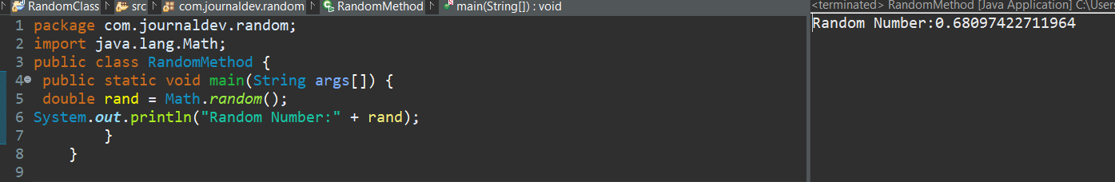

To show the working of **java.lang.Math.random()** method. Now to get random integer numbers from a given fixed range, we take a min and max variable to define the range for our random numbers, both min and max are inclusive in the range.

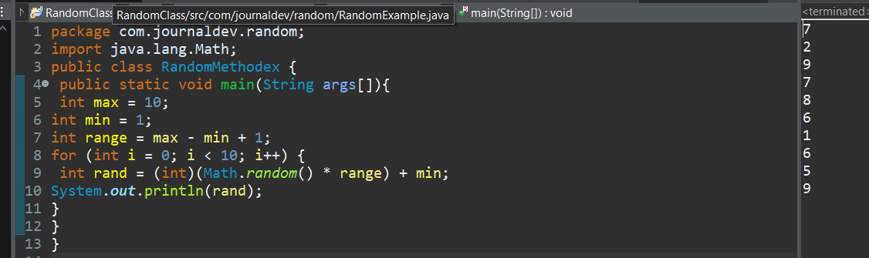

The **java.lang.Math.random()** returns a double value with a positive sign, greater than or equal to 0.0 and less than 1.0.

Returned values are chosen pseudorandomly with (approximately) uniform distribution from that range. When this method is first called, it creates a single new pseudorandom-number generator, exactly as if by the expression new java.util.Random

This new pseudorandom-number generator is used thereafter for all calls to this method and is used nowhere else. This method is properly synchronized to allow correct use by more than one thread. However, if many threads need to generate pseudorandom numbers at a great rate, it may reduce contention for each thread to have its own pseudorandom-number generator.

he **java.lang.Math.random()** method returns a double value with a positive sign, greater than or equal to 0.0 and less than 1.0.

Below is a java code demonstrates the use of random() method of Math class.

Finally, let's summarise everything we learned in the article :

1. The Math.random() method in Java provides random numerical values when it is called.
2. This, however, will produce double values in the range of 0.0 to 1.0, and not integers.
3. However, to obtain integers, you may use implicit or explicit type-casting to obtain values according to your requirements.

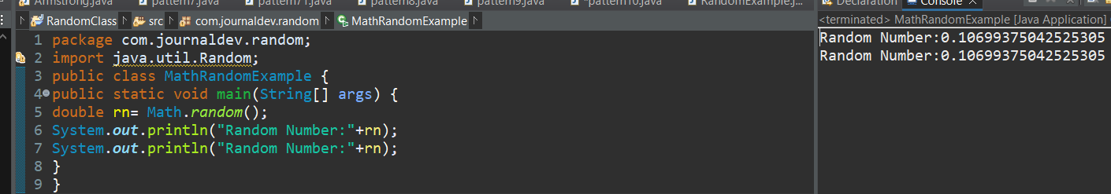

# Math pow() method in Java

# 2)Usage of pow( ) present in Math class?

# -> The Math.pow() is an built-in method in Java Math class and is used to calculate the power of a given number. The power of a number refers to how many times to multiply the number with itself

i.e. (5 * 5 * 5 * 5 = 625).

# Power of a Number in Java

# java.lang.Math.pow() is used to calculate a number raise to the power of some other number. This function accepts two parameters and returns the value of first parameter raised to the second parameter. There are some special cases as listed below:

* If the second parameter is positive or negative zero then the result will be 1.0.
* If the second parameter is 1.0 then the result will be same as that of the first parameter.
* If the second parameter is NaN then the result will also be NaN.
* The function java.lang.Math.pow() always returns a double datatype.

Syntax:

public static double pow(double a, double b)

Parameter:

a : this parameter is the base

b : this parameter is the exponent.

Return :

This method returns ab.

Example :1:MathPow

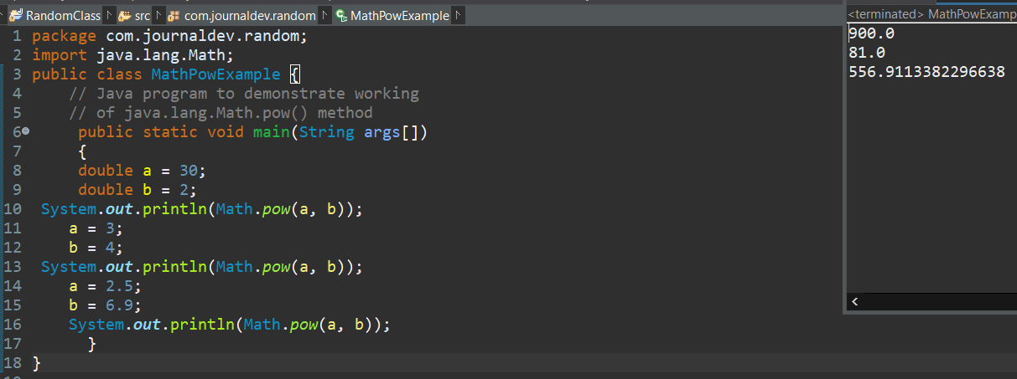

Example:2

// Java program to demonstrate working

// of java.long.math.pow method

