Date: 22nd July 2024

**22BCP116**

**Experiment 1** **Information Security - Lab**

**AIM: Study and Implement a program for Caesar Cipher**

**Introduction:**

In cryptography, Caesar cipher is one of the simplest and most widely known encryption techniques. The method is named after Julius Caesar, who used it in his private correspondence. In this technique, each letter in the plaintext is shifted a fixed number of places down or up the alphabet.

* **Program - Normal Approach:**

#include <stdio.h>

#include <string.h>

void encrypt(char text[], int shift) {

int i;

char ch;

for(i = 0; text[i] != '\0'; ++i) {

ch = text[i];

// Encrypt uppercase letters

if(ch >= 'A' && ch <= 'Z') {

ch = ch + shift;

if(ch > 'Z') {

ch = ch - 'Z' + 'A' - 1;

}

text[i] = ch;

}

// Encrypt lowercase letters

else if(ch >= 'a' && ch <= 'z') {

ch = ch + shift;

if(ch > 'z') {

ch = ch - 'z' + 'a' - 1;

}

text[i] = ch;

}

else if(ch >= '0' && ch <= '9') {

ch = (ch - '0' + shift) % 10 + '0';

text[i] = ch;

}

// Leave other characters (including whitespace) unchanged

}

}

void decrypt(char text[], int shift) {

int i;

char ch;

for(i = 0; text[i] != '\0'; ++i) {

ch = text[i];

// Decrypt uppercase letters

if(ch >= 'A' && ch <= 'Z') {

ch = ch - shift;

if(ch < 'A') {

ch = ch + 'Z' - 'A' + 1;

}

text[i] = ch;

}

// Decrypt lowercase letters

else if(ch >= 'a' && ch <= 'z') {

ch = ch - shift;

if(ch < 'a') {

ch = ch + 'z' - 'a' + 1;

}

text[i] = ch;

}

// Leave other characters (including whitespace) unchanged

}

}

int main() {

char text[100];

int shift;

int choice;

printf("Enter a message: ");

fgets(text, sizeof(text), stdin);

printf("Enter shift: ");

scanf("%d", &shift);

// Remove newline character from fgets input

int len = strlen(text);

if (len > 0 && text[len-1] == '\n') {

text[len-1] = '\0';

}

// Ask user for choice

printf("Choose an option:\n");

printf("1. Encrypt\n");

printf("2. Decrypt\n");

printf("Enter choice (1 or 2): ");

scanf("%d", &choice);

// Process based on user choice

if (choice == 1) {

encrypt(text, shift);

printf("Encrypted message: %s\n", text);

} else if (choice == 2) {

decrypt(text, shift);

printf("Decrypted message: %s\n", text);

} else {

printf("Invalid choice\n");

}

return 0;

}

Output:

1. Encryption

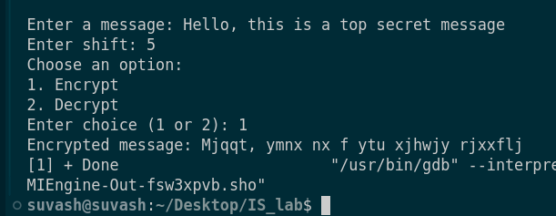

2. Decryption

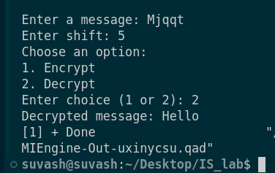

* **Modified/Revised version**

#include <stdio.h>

#include <string.h>

char shift_char(char ch, int shift) {

// Normalize shift

int range;

char base;

if (ch >= 'A' && ch <= 'Z') {

base = 'A';

range = 26;

} else if (ch >= 'a' && ch <= 'z') {

base = 'a';

range = 26;

} else if (ch >= '0' && ch <= '9') {

base = '0';

range = 10;

} else {

return ch; // Do not encrypt/decrypt non-alphanumeric characters

}

// Normalize the shift to be within 0 to range-1

shift = ((shift % range) + range) % range;

// Perform the shift

return ((ch - base + shift) % range + range) % range + base;

}

// Function to process text with given shift

void process_text(char text[], int shift) {

for (int i = 0; text[i] != '\0'; ++i) {

text[i] = shift_char(text[i], shift);

}

}

int main() {

char text[100];

int shift;

int choice;

printf("Enter a message: ");

fgets(text, sizeof(text), stdin);

printf("Enter shift: ");

scanf("%d", &shift);

// Remove newline character from fgets input

int len = strlen(text);

if (len > 0 && text[len-1] == '\n') {

text[len-1] = '\0';

}

// Ask user for choice

printf("Choose an option:\n");

printf("1. Encrypt\n");

printf("2. Decrypt\n");

printf("Enter choice (1 or 2): ");

scanf("%d", &choice);

// Process based on user choice

if (choice == 1) {

process_text(text, shift);

printf("Encrypted message: %s\n", text);

} else if (choice == 2) {

process_text(text, -shift);

printf("Decrypted message: %s\n", text);

} else {

printf("Invalid choice\n");

}

return 0;

}

**Output:**

Encryption:

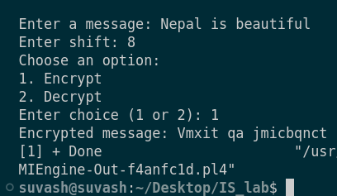

Decryption:

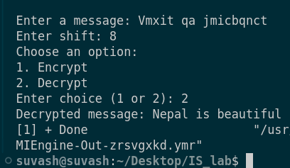

**Applications:**

* The Caesar cipher, although not suitable for strong security, can still have applications in:
* Education: It's a great tool to introduce beginners to the concepts of encryption and decryption in cryptography.
* Puzzles and Challenges: In recreational settings, it can add an element of mystery to puzzles, games, or coding challenges.
* Historical Context: It can be used in historical re-enactments to demonstrate ancient cryptographic techniques.
* Basic Obfuscation: For non-critical applications, it can offer simple data obfuscation.

***Comparative Analysis of the Original and Revised approaches:***

Maintainability: The second version is more maintainable due to its modular design. The shift_char function can be easily modified if needed, without having to change the core logic in multiple places.

Functionality: Both versions correctly implement the Caesar cipher for letters and digits. The second version's normalization of the shift value makes it more robust against larger shift values, ensuring it always falls within the valid range.

Efficiency: The second version is slightly more efficient in terms of code size and potential reuse. However, the first version might be marginally faster due to fewer function calls, though this difference is negligible for most use cases.

**Conclusion:**

To sum up, Caeser Cipher encryption is one of the most basic encryption technique that works by shifting each character of a string data by a certain amount. Though this technique is not practically used in many applications, it can be a great way to start learning about cryptography techniques.

**References:**

1.w3schools : https://www.w3resource.com/python-exercises/string/python-data-type-string-exercise-25.php

2.GeeksForGeeks: <https://www.geeksforgeeks.org/caesar-cipher-in-cryptography/>