TruthLens AI
Technical Documentation

1. Project Title
TruthLens AI – AI-Powered Misinformation & Credibility Verification Platform

2. Team Information
Team Name: TruthLens AI
Developed By: Suvasini G
Institution: CMR University, Bengaluru

3. Problem Statement
The rapid growth of digital media has resulted in the widespread distribution of misinformation, fake news, and manipulated content across social media and online platforms.
Users often struggle to determine whether information is trustworthy before sharing it. Existing solutions are either complex, slow, or lack transparency in how credibility scores are generated.
TruthLens AI addresses this challenge by providing an explainable and user-friendly credibility verification system.

4. Proposed Solution
TruthLens AI is a web-based platform that analyzes textual content and source information to generate a credibility assessment report.
The system:
- Analyzes user-provided content
- Evaluates source credibility
- Calculates a trust score
- Determines risk level
- Provides transparent explanations
- Generates downloadable PDF verification reports
The platform follows the ASEEV Framework:
ASEEV Framework
A – Analyze Content
Identifies suspicious patterns and keywords.
S – Score Credibility
Computes overall trust score.
E – Evaluate Risk
Classifies content into risk categories.
E – Explain Findings
Provides transparent explanations.
V – Verify Information
Generates verification report for users.

5. Objectives
The main objectives of TruthLens AI are:
- Detect potentially misleading content
- Improve media literacy
- Encourage responsible content sharing
- Provide explainable AI-driven verification
- Generate downloadable credibility reports
- Increase trust in digital information

6. System Architecture
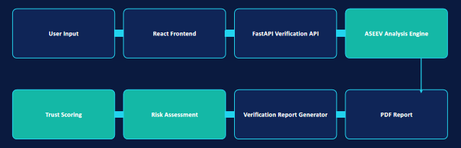
7. Technology Stack
Frontend
- React.js
- Vite
- Axios
Purpose
Provides an interactive user interface for content analysis and report generation.

Backend
- FastAPI
- Python
Purpose
Processes requests and executes the ASEEV framework logic.

Libraries Used
Axios
Used for communication between frontend and backend.

jsPDF
Used for generating downloadable PDF verification reports.
Pydantic
Used for request validation in FastAPI.

8. Functional Modules
Module 1: Content Analysis
Analyzes text entered by users.
Detects:
- Breaking News phrases
- Sensational language
- Viral propagation indicators
- Secret or unverified claims

Module 2: Source Credibility Assessment
Evaluates source URLs.
Examples:

High Credibility
- BBC
- Reuters
- The Hindu
Low Credibility
- Fake domains
- Unknown xyz domains

Module 3: Credibility Scoring Engine
Initial trust score starts at:
95
Score is reduced based on:
Indicator | Penalty
Breaking News Phrase | -25
Shocking Language | -25
Viral Content Indicator | -20
Unverified Secret Claim | -20
Low Credibility Source | -20

Module 4: Risk Assessment
Low Risk
Trust Score ≥ 80
Medium Risk
Trust Score 60–79
High Risk
Trust Score < 60

Module 5: Explainable AI Output
Provides transparent explanations such as:
- Breaking News Phrase Detected
- Sensational Language Detected
- Viral Propagation Pattern Detected
- Unverified Secret Claim Detected

Module 6: PDF Report Generation
Users can download a verification report containing:
- Trust Score
- Risk Level
- AI Confidence
- Source Credibility
- Source URL
- Analysis Reasons
- Timestamp

9. Workflow
User Enters Content
│
▼
Analyze Content
│
▼
Score Credibility
│
▼
Evaluate Risk
│
▼
Explain Findings
│
▼
Verify Information
│
▼
Generate PDF Report

10. Key Features
- Real-time content verification
- Trust score generation
- Risk assessment
- Source credibility analysis
- Explainable AI outputs
- PDF report generation
- User-friendly interface
- ASEEV framework implementation

11. Future Enhancements
Future versions of TruthLens AI may include:
- Transformer-based NLP models
- Deepfake image detection
- Fact-checking APIs
- Multilingual verification
- Source reputation database
- Browser extension integration
- Social media verification plugin

12. Sample Output Screenshots
The following screenshots demonstrate the functionality of TruthLens AI:

- Homepage Screenshot
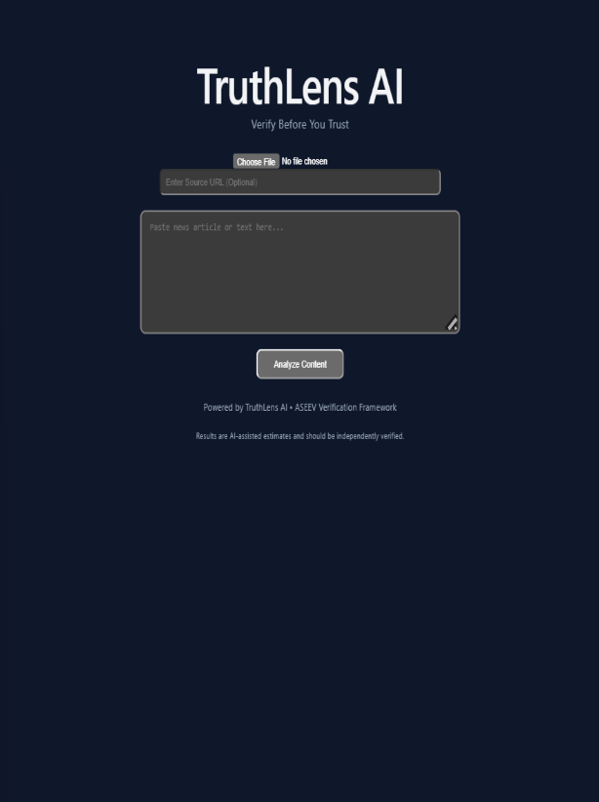
- High Credibility Analysis (BBC)
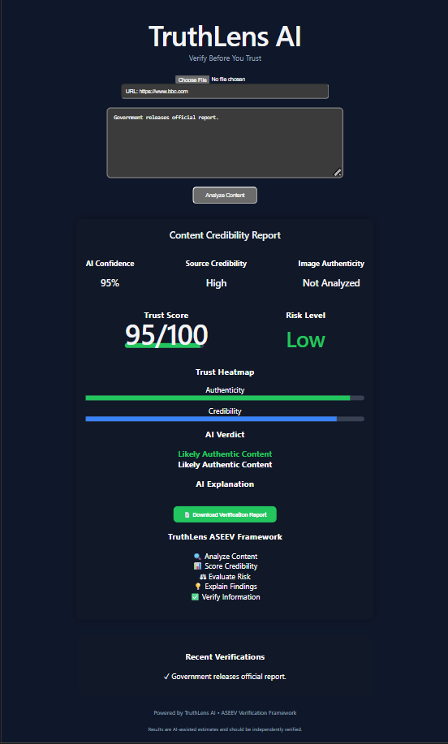
- Low Credibility Analysis (Fake URL)
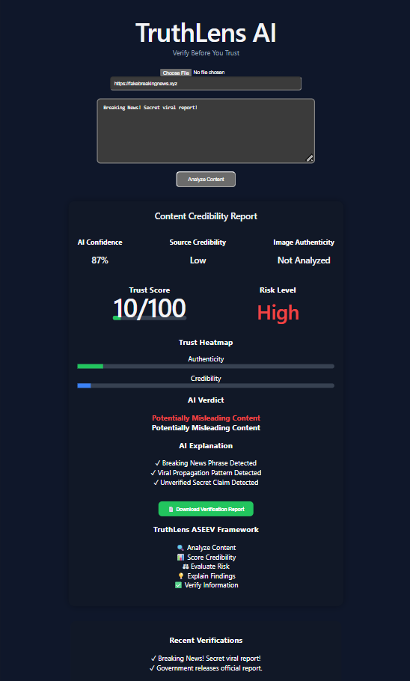

- PDF Verification Report

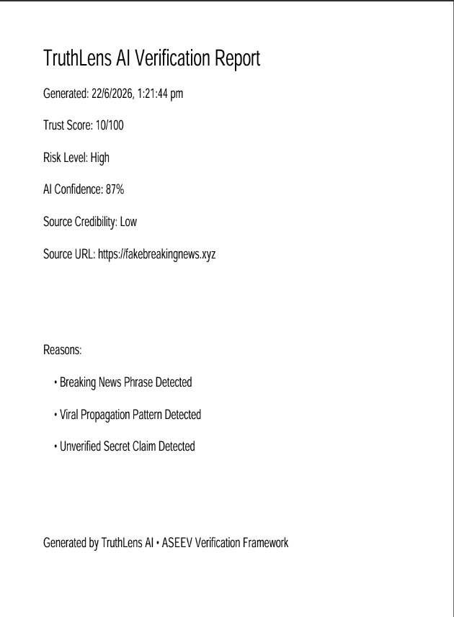

13. Business Impact
TruthLens AI helps:
- Reduce misinformation spread
- Promote responsible content sharing
- Improve media literacy
- Support educational institutions
- Assist journalists and researchers
- Increase transparency in AI-driven verification

14. Conclusion
TruthLens AI provides a practical, explainable, and scalable approach to misinformation detection through its ASEEV framework. By combining content analysis, source credibility assessment, risk evaluation, and downloadable verification reports, the platform empowers users to make informed decisions before trusting or sharing information.

Document Version: 1.0
Project: TruthLens AI
Framework: ASEEV (Analyze, Score, Evaluate, Explain, Verify)
Prepared By:
Suvasini G
CMR University, Bengaluru
Date:
June 2026

