**Experiment Name: Inter-VLAN Routing**

**Question:  
Thames College uses 2 different VLANs for Account department and Computer LAB. After VLAN configuration, PC in Account department couldn’t access the PC at Computer LAB. Explain how you as a Network Administrator can facilitate the reachability using Inter-VLAN routing.**

**Assign the following networks:**

* **Account Department: 192.168.X.0/29**
* **Computer LAB: 192.168.X.8/29  
  (*Replace ‘X’ with your Roll number*)**

**Apparatus Required:**

* **Personal Computer/Laptop (to run simulation)**
* **Cisco Packet Tracer software**
* **Switch (1 unit – e.g., 2960)**
* **Router (1 unit – for Inter-VLAN routing)**
* **6 PCs (3 in each VLAN/network)**
* **Ethernet cables (straight-through)**

**Tools Used:**

* **Cisco Packet Tracer (for network simulation and configuration)**

**Theory**

A **VLAN (Virtual Local Area Network)** is used to divide a switch into multiple logical networks. Each VLAN forms a separate broadcast domain, which improves security and reduces unnecessary traffic. However, because of this isolation, devices in different VLANs cannot communicate directly.

To allow communication between VLANs, **Inter-VLAN Routing** is required. This is achieved using a Layer 3 device that can process packets based on IP addresses and forward them across VLAN boundaries. The routing device provides a default gateway for each VLAN and handles traffic between them.

Inter-VLAN routing is important in modern networks because organizations often need both **segmentation** (for security and efficiency) and **controlled communication** (for sharing resources between departments). By enabling routing between VLANs, networks can achieve both goals effectively.

**Lab Diagram:**

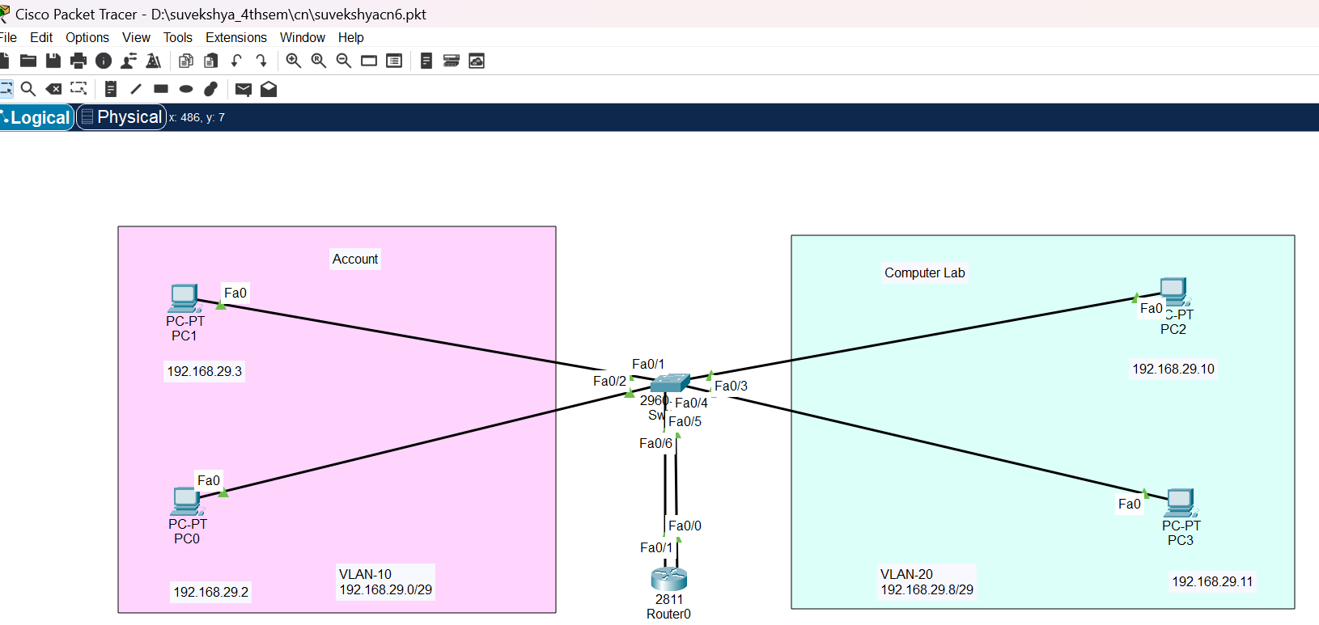

**Procedure:**

**1.Network Setup:**  
● Open Cisco Packet Tracer and create a topology consisting of one switch, one router, and six PCs.  
● Divide the PCs into two groups (representing two VLANs).  
● Connect all PCs to the switch using straight-through Ethernet cables.  
● Connect the switch to the router using Ethernet cables

2.**IP Address Assignment:**

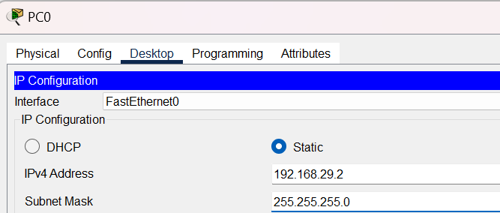

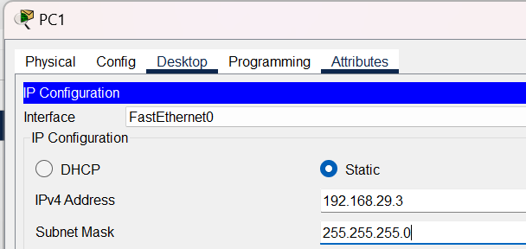

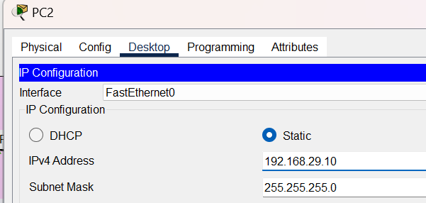

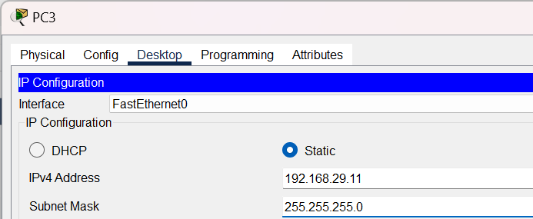

**3.VLAN Configuration on Switch:**

* Open the switch CLI ,enable witch,configure terminal and change the hostname for identification ie.suvekshya-SW1.

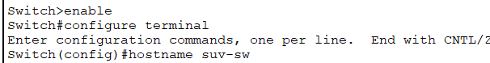

* Configure for vlan 10:

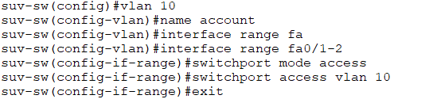

* Configure for vlan 20:

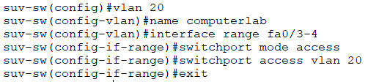

* Vlan brief:

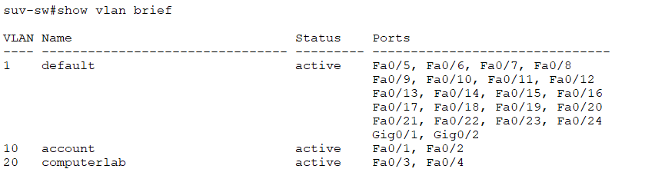

**4.now, ping to check connectivity between pc in same vlan and in different vlan :**

In same vlan :

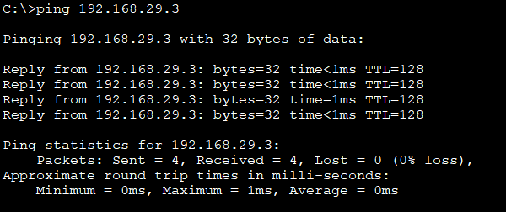

In different vlan:

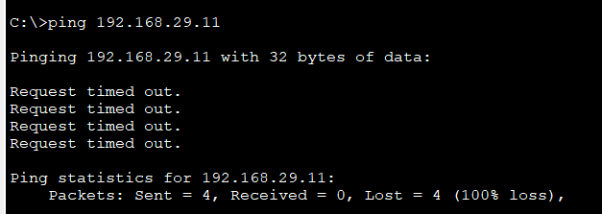

Pcs in different vlan cant communicate .to enable that we have to configure router

**5.router configuration:**

For Vlan 10

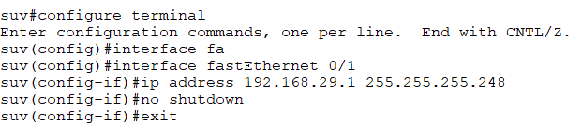

For Vlan 20

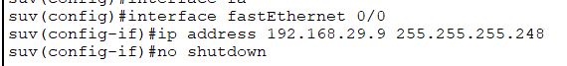

Check ip address:

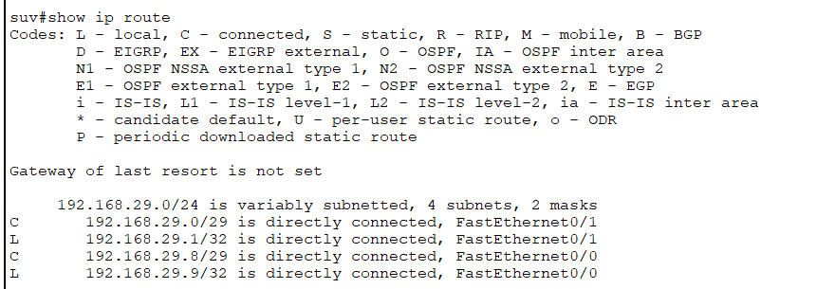

**6. Configure switch ports for VLAN access**

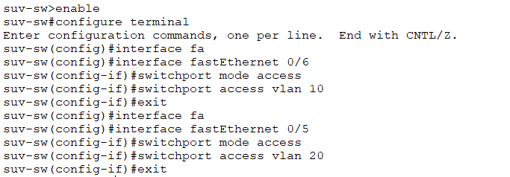

**7.Enable Spanning-Tree PortFast on Access Ports**

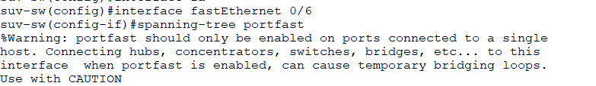

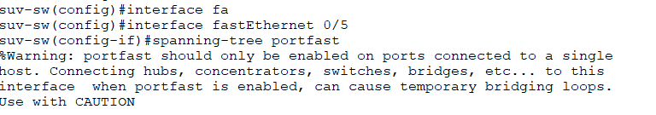

**Testing Inter-VLAN Connectivity:**

* **Ping from a PC in Account Department (VLAN 10) to a PC in Computer Lab (VLAN 20):**

PC0 IP: 192.168.29.2 (Account VLAN)

PC2 IP: 192.168.29.10 (Computer Lab VLAN)

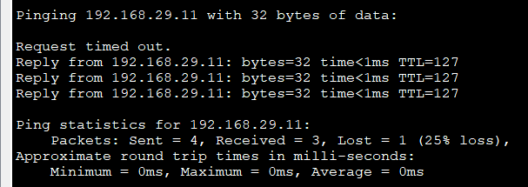

**Conclusion**

In this experiment, we successfully implemented **Inter-VLAN Routing** to enable communication between two separate VLANs — one for the Account Department and one for the Computer Lab. Initially, devices in different VLANs could not communicate because each VLAN functions as a separate broadcast domain. By assigning each VLAN a unique subnet and configuring the router interfaces with appropriate IP addresses as default gateways, we enabled the router to route traffic between VLANs. On the switch, ports connecting PCs were configured as **access ports** using switchport mode access to make them non-trunking and assigned to the correct VLANs, ensuring proper VLAN membership. **Spanning-Tree PortFast** was enabled on these access ports to allow immediate forwarding of traffic, preventing the usual STP delay for end devices and ensuring faster network connectivity. Testing through ping commands confirmed that PCs in different VLANs could communicate successfully, demonstrating the effectiveness of inter-VLAN routing. Overall, the experiment reinforced key networking concepts such as VLAN segregation, subnetting, default gateway configuration, switch port configuration, Spanning-Tree optimization, and the role of the router in connecting separate broadcast domains.