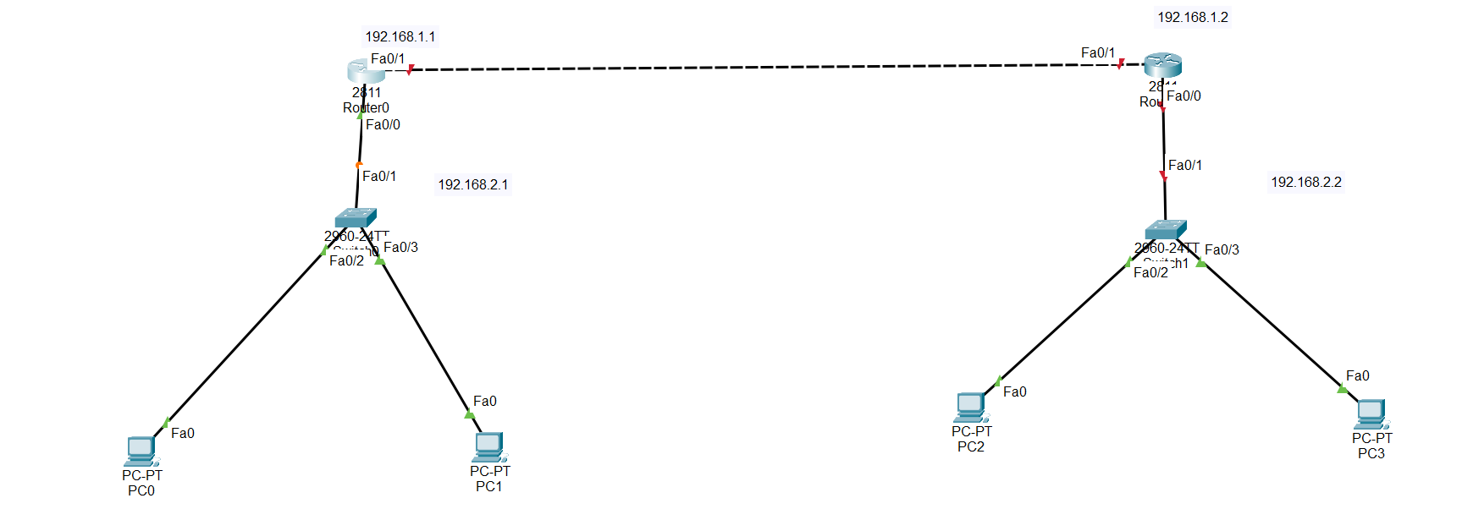

In router cli:

Set hostname,and then ip address

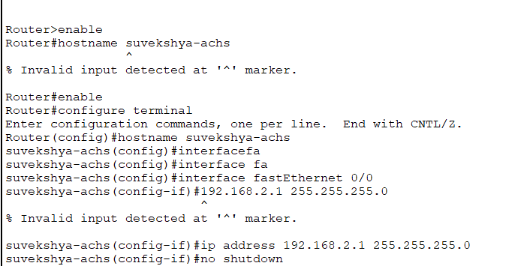

Again ,

suvekshya-achs#enable

suvekshya-achs#configure terminal

Enter configuration commands, one per line. End with CNTL/Z.

suvekshya-achs(config)#internet fa

suvekshya-achs(config)#interface fa

suvekshya-achs(config)#interface fastEthernet 0/1

suvekshya-achs(config-if)#ip address 192.168.1.1

% Incomplete command.

suvekshya-achs(config-if)#ip address 192.168.1.1 255.255.255.0

suvekshya-achs(config-if)#no shutdown

in router 2 as well do same thing in following ways:

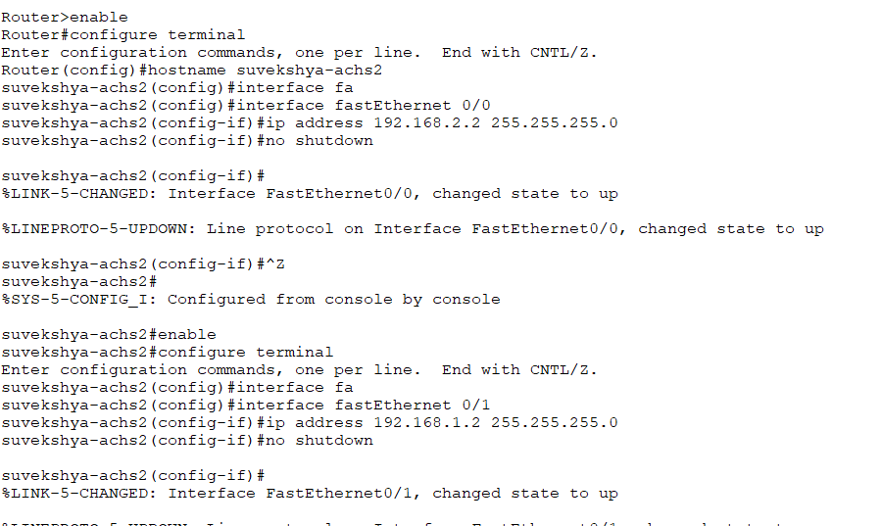

Check if ip is correct by:

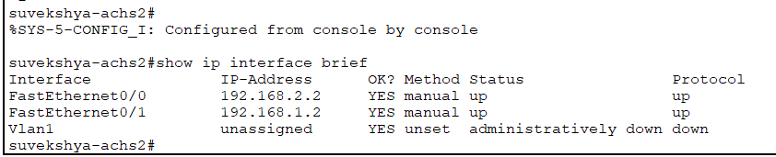

Note:

For pc in router 1 its gateway is end port 192.168.2.1

Now define routing for router 1:

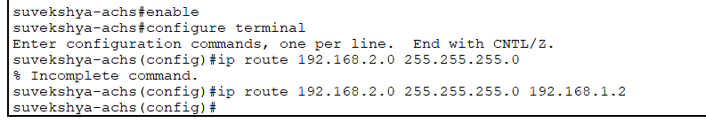

For router 2:

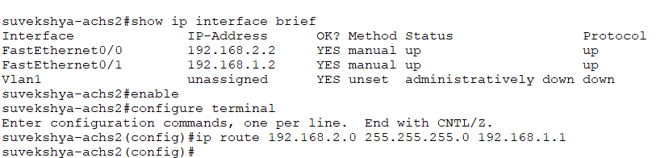note while assigning ip address for lower port in router 2 assing ip address 192.168.3.0 network

Also whle assigning ip addres for routers use dhcp protocol cmd taught in lab 7

Now assign ip address to all pc as givne in note I lab diagram

