NEURAL NETWORK AND DEEP LEARNING

ASSIGNMENT - 1

NAME – MANDA SUVIDHA REDDY

EMAIL – [SXM95990@UCMO.EDU](mailto:SXM95990@UCMO.EDU)

700 – 700729599

1. Write a python program for the following: – Input the string “Python” as a list of characters from console, delete at least 2 characters, reverse the resultant string and print it.

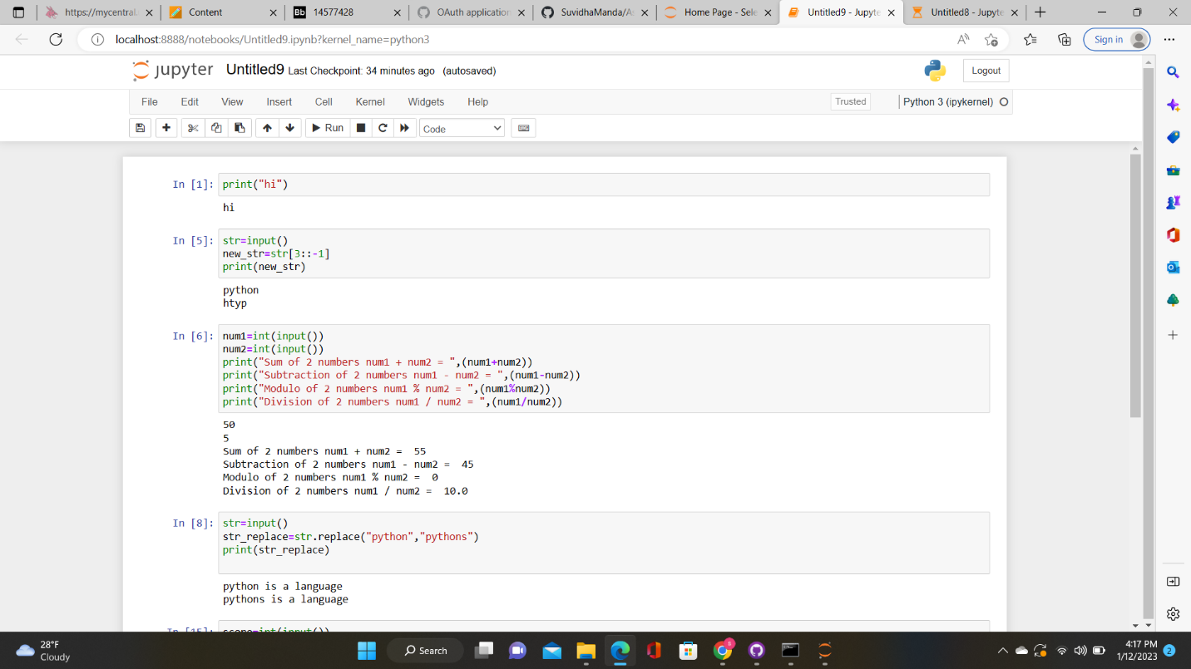

2. Write a program that accepts a sentence and replace each occurrence of ‘python’ with ‘pythons’.



1. Use the if statement conditions to write a program to print the letter grade based on an input class score. Use the grading scheme we are using in this class.

