Tower Defense Project (JavaFX)

Game Overview & Manual (How to Play)

Objective
Defend your castle for 3 minutes while enemies continuously spawn and move along the generated path. You win if the timer reaches 0 and no enemies remain alive; you lose if castle HP reaches 0.
Initial resources:

  - Base Health: 100
  - Money: 500
  - Timer: 03:00

Win/Loss Conditions
- Loss: in GameManager.handleEnemyReachedBase, enemy reaching end reduces base HP;
when HP <= 0, isGameOver = true.
- Win: in GameManager.checkAndHandleVictory, when timer expired, no active enemies remain,
and base still alive, isVictory = true.

Core Gameplay Flow
- Start from the main menu (MainMenu) and enter gameplay (Main.startGameFromMenu()).

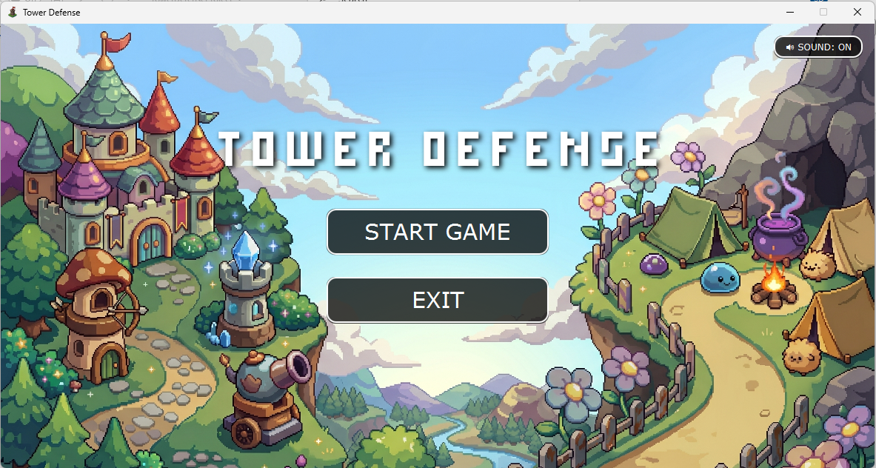

- Select a tower from the Tower Shop (right-side panel) or by keyboard shortcut (1-6).

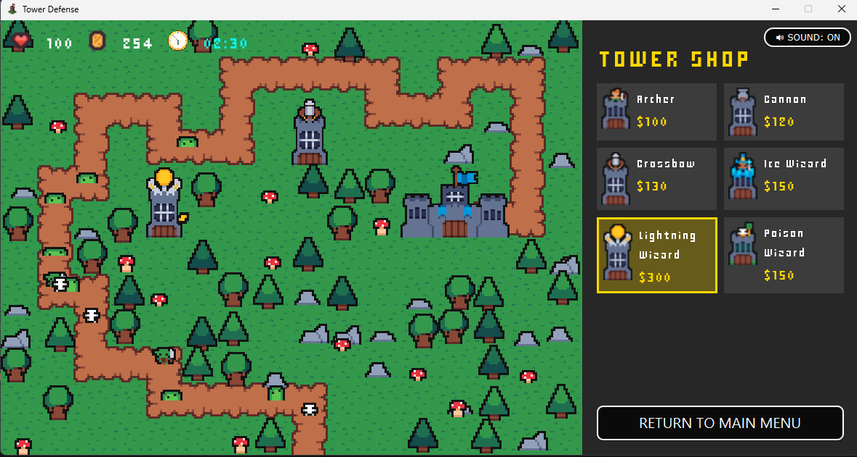
6
5
4
2
3
1

- Place towers on valid grass tiles    (not path , not castle zone , not occupied by other towers , not blocked by decoration ).

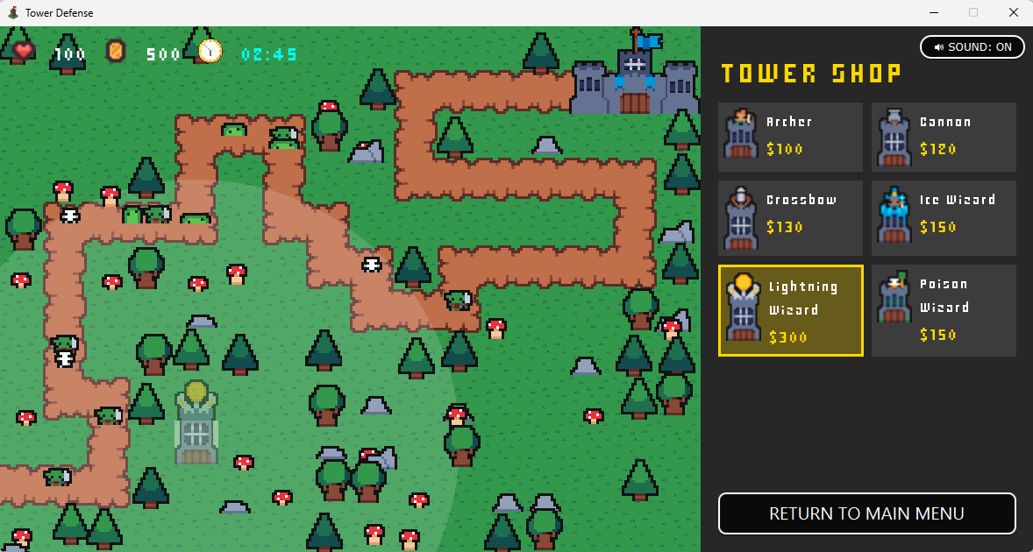

- Towers auto-attack enemies in range.

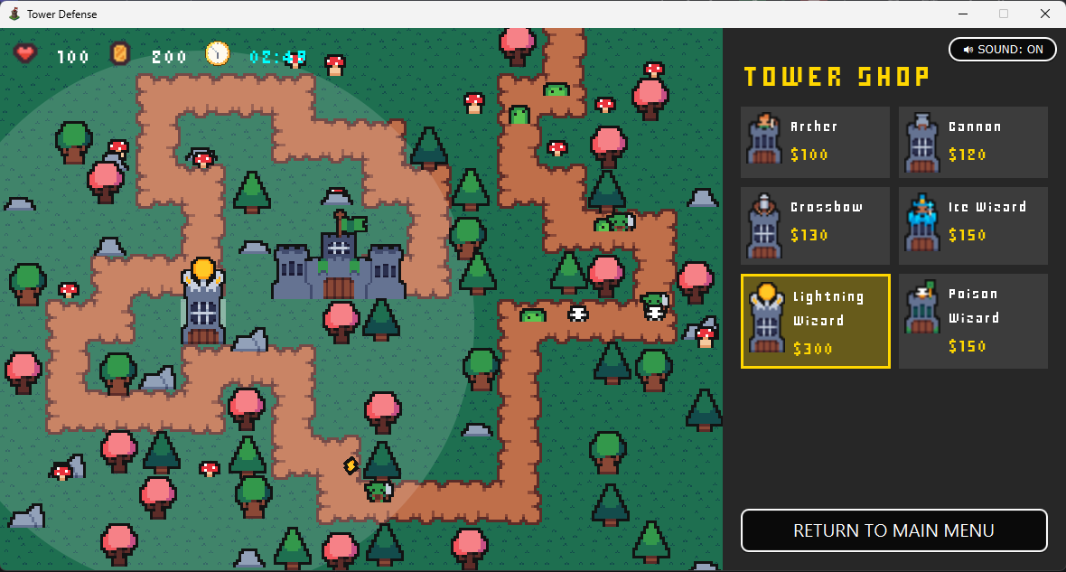

- Earn money from enemy kills.
- Click a placed tower to open Tower Status, then upgrade if affordable.

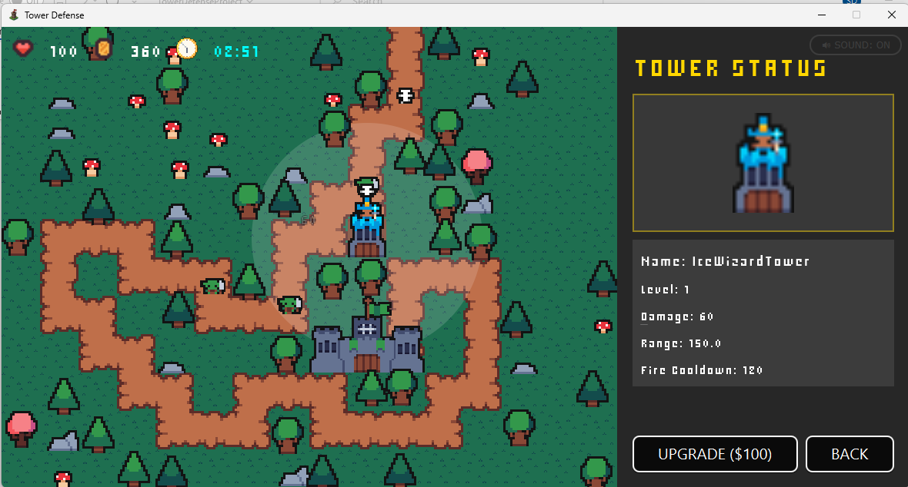

- Survive until time ends.

UI Components
- Main Menu (MainMenu)


Sound toggle Button
Exit Button
Start Button

- HUD (top-left in Main)
Coin icon + money text
Timer icon + countdown text
Heart icon + HP text



- Side Panel
Sound toggle button

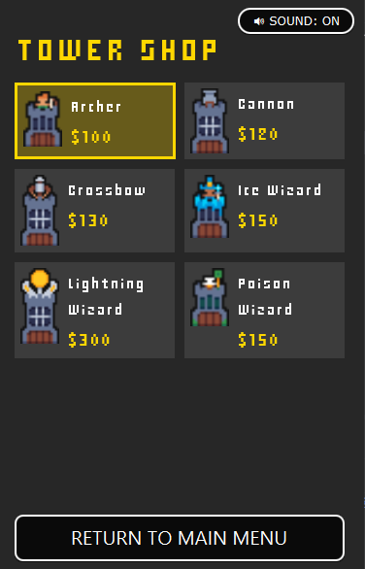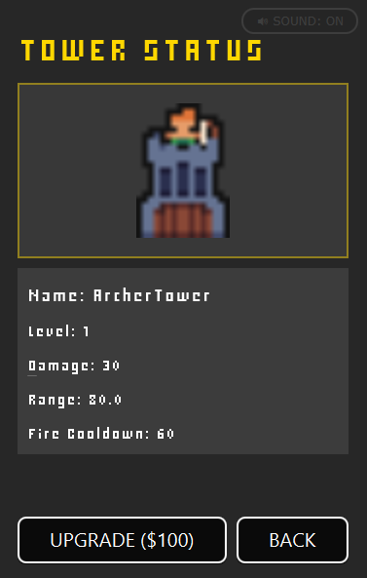
Tower Stats
Tower Price
Tower Selection Grid
Back to Tower Shop Button
Upgrade Button
Tower Preview
Return to Main Menu Button
Selected Tower Indicator

- In-game Visual Feedback
  - Hover validity tile highlight & Tower range circles & Ghost tower preview

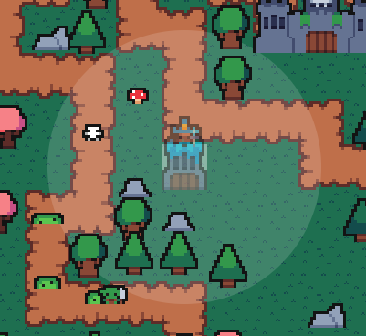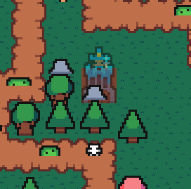
  - Projectile rotation toward targets

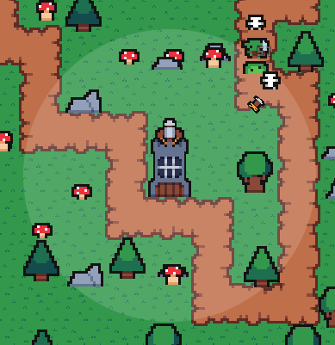

  - Enemy hit flash & Floating damage numbers (DamageText)

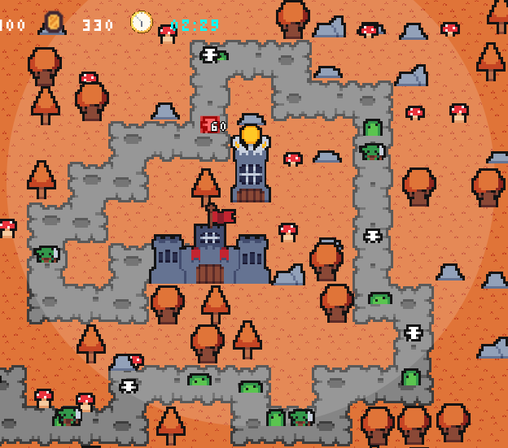

  - Castle hit shake effect

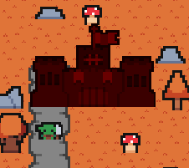

- Terminal Overlays
  - Victory overlay & Game Over overlay

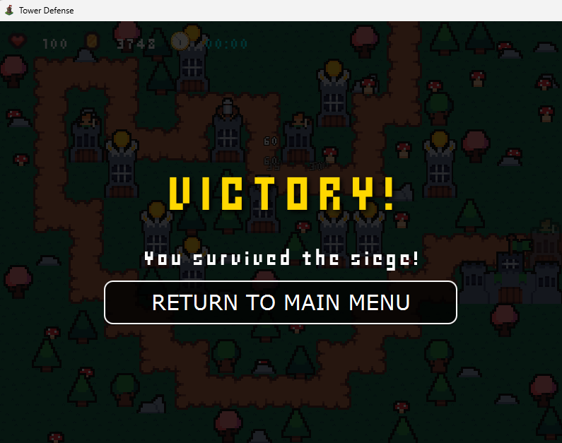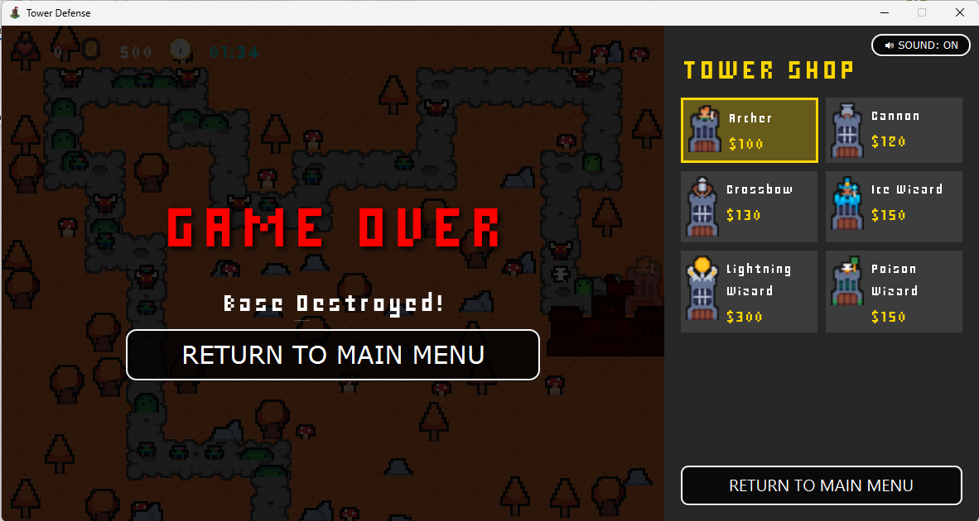

Controls
- Left Click (Map)
  - If clicking an existing tower: select/deselect tower and show range.
  - Otherwise: place currently selected tower.
- Right Click (Map/Shop)

  - clear selection/cancel placement mode.
1
2
3
4
5
6
- Keyboard shortcuts (GameView.handleKeyPress)
  - 1: Archer
  - 2: Cannon
  - 3: Crossbow
  - 4: Ice Wizard
  - 5: Lightning Wizard
  - 6: Poison Wizard

Placement Rules (from GameManager.canPlaceTower + GameMap.isBuildable)
A tower can be placed only when all conditions are true
- A tower type is selected.
- Game is not over.
- Tile is inside grid.
- Tile value is buildable grass (0), not path (1) or castle (2).
- Tile is not inside castle clearance zone.
- Tile has no decoration ( ).
- Tile is not already occupied by another tower.
- Player has enough money for selected tower.


Tower Status & Upgrade System
Selecting a placed tower opens the Tower Status Panel (Main.createTowerStatusPanel) showing

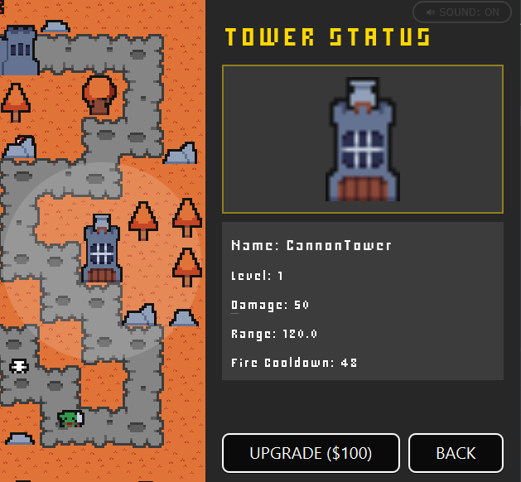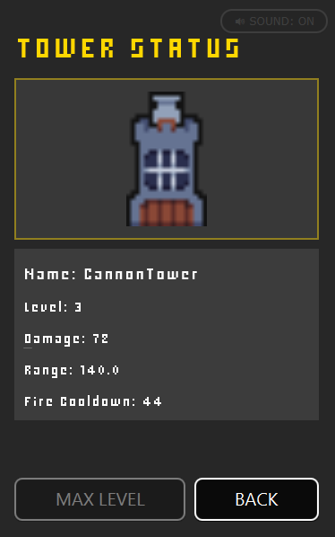
Upgrade to Max Level

Upgrade behavior (Tower.upgrade())
- level +1 (up to max level 3) | - Damage increases (scaled) |  | - Range +10
- Fire cooldown decreases (minimum-limited) |  | - Next upgrade cost increases

Tower Types (Actual Class Stats)

Tower Class | Cost | Damage | Range | Fire Cooldown
ArcherTower | 100 | 30 | 80.0 | 60
CannonTower | 120 | 50 | 120.0 | 48
CrossbowTower | 130 | 35 | 150.0 | 40
IceWizardTower | 150 | 60 | 150.0 | 120
PoisonWizardTower | 150 | 60 | 150.0 | 120
LightningWizardTower | 300 | 60 | 300.0 | 60

Enemy Types (Actual Class Stats)

Enemy Class | HP | Speed | Reward | Base Damage to Castle
SlimeEnemy | 100 | 1.0 | 10 | 1
BatEnemy | 50 | 2.5 | 15 | 1
BigSlimeEnemy | 180 | 0.8 | 20 | 2
GoblinEnemy | 90 | 1.8 | 18 | 2
SkeletonEnemy | 130 | 1.2 | 16 | 3
ZombieEnemy | 170 | 0.9 | 22 | 4
DemonEnemy | 250 | 1.5 | 35 | 5
KingSlimeEnemy | 320 | 2.0 | 45 | 50

Game Features & Complexity

Custom Graphics Pipeline
- Centralized texture preloading with AssetManager (environment, towers, projectiles, enemies).
- Theme-dependent map visuals (Theme.NORMAL, Theme.AUTUMN, Theme.SPRING).
- Depth-sorted rendering of decorations/enemies/towers for proper visual layering.

Audio Integration (SoundManager)
- Dedicated SFX for clicks, enemy hit, castle hit, victory, defeat.
- Separate menu and in-game looping BGM using MediaPlayer.
- Global mute toggle with UI synchronization.

Scaling Difficulty via Time-Based Waves
- GameManager changes enemy pools and spawn intervals by match phase
  - Early phase: slower spawn interval, easier enemies.
  - Mid phase: medium interval, stronger enemies.
  - Late phase: fastest interval, strongest enemies.

Fixed-Time Step Game Loop
- Main.createGameLoop() uses an accumulator with fixed logic step
  - LOGIC_TICKS_PER_SECOND = 60
  - LOGIC_STEP_SECONDS = 1.0 / 60
  - bounded MAX_LOGIC_STEPS_PER_FRAME
- important for stable simulation, deterministic update rhythm, reduced frame-rate dependency.

Procedural Path Generation + Pathfinding
- PathGenerator.generateRandomPath() creates randomized valid maps.
- GameMap.generatePath() reconstructs route to castle via BFS.
- Combined with tower-placement constraints, this increases replayability and algorithmic depth.

Overall Architecture & Design

application package (View/Presentation Layer)
- JavaFX bootstrapping and scene management (Main, Launcher, MainMenu)
- Rendering and player input (GameView)
- UI helpers and assets/audio (UIUtils, AssetManager, SoundManager)

logic package (Core Game Domain)
- Match state orchestration (GameManager)
- Combat entities (logic.tower.*, logic.enemy.*)
- Map/path systems (logic.map.*)
- Interfaces/contracts (logic.interfaces.*)

Why this separation matters?
- Easier maintenance and debugging (UI issues vs gameplay issues are isolated).
- Better testability (core mechanics are unit-tested without full JavaFX rendering).
- Cleaner scaling for future features (new UI widgets or new enemy/tower classes can evolve independently).

OOP Principles Applied

Inheritance
- Tower is an abstract base class concrete towers extend it
  - ArcherTower, CannonTower, CrossbowTower, etc.
- Enemy is an abstract base class enemy variants extend it
  - SlimeEnemy, BatEnemy, DemonEnemy, etc.
Code example

public abstract class Tower implements Upgradable { ... }
public final class ArcherTower extends Tower { ... }

public abstract class Enemy implements Damageable { ... }
public final class DemonEnemy extends Enemy { ... }

- Why it is important?
  - Shared fields and logic (position, stats, cooldowns, movement, health, etc.) are implemented once in base classes.
  - Reduces duplication and keeps balancing changes centralized.
  - New tower/enemy variants can be added quickly with minimal code.

Interface
- Upgradable interface implemented by Tower
- Damageable interface implemented by Enemy
Code example

public interface Upgradable {
void upgrade();
}

public interface Damageable {
void takeDamage(int amount);
}

- Why it is important?
  - Defines behavior contracts independent of concrete class.
  - Encourages consistent APIs for upgrade and damage interactions.
  - Supports future extensibility (other entities can become upgradeable/damageable without changing consumers).

Polymorphism
- Runtime dispatch through base-class references
  - GameManager stores List<Tower> and List<Enemy>
  - Calls tower.update(...) and enemy.update(...) without needing subtype-specific branching
- Tower subclasses override update(...) to use their own projectile sprite/behavior.
Code example

for (Tower tower : activeTowers) {
tower.update(activeEnemies, activeProjectiles);
}

@Override
public void update(List<Enemy> enemies, List<Projectile> activeProjectiles) {
updateProjectileAttack(enemies, activeProjectiles, CANNON_PROJECTILE_SPRITE);
}

- Why it is important?
  - Same method call, different runtime behavior by tower type.
  - Keeps the combat loop clean and open for extension.
  - Avoids large if/else or switch blocks for every subtype behavior.

Access Modifiers
- private (encapsulation, internal invariants)
  - e.g., GameManager state fields (playerMoney, baseHealth, timeRemaining, etc.)
  - helper methods hidden from external misuse (isPlacementRequestValid, isTileOccupiedByTower)
- protected (shared subclass access)
  - e.g., Tower and Enemy combat/state fields used by subclasses for specialization
- public (external API)
  - game-facing operations like update, getters/setters, placeTower, tryUpgradeTower
Code example

// GameManager
private int playerMoney;
public boolean placeTower(int row, int col) { ... }

// Tower
protected int damage;

- Why it is important?
  - Protects critical game state from unsafe direct manipulation.
  - Gives controlled extension points to child classes.
  - Exposes only what other modules (UI/tests) must use.

UML Diagram (It’s an SVG, so it can zoom infinitely without losing quality.)

src/main/java/application
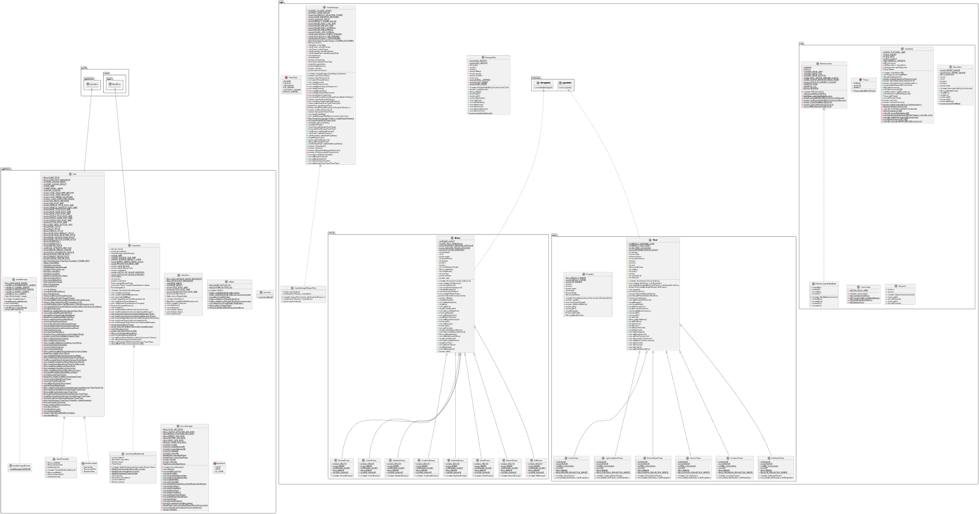



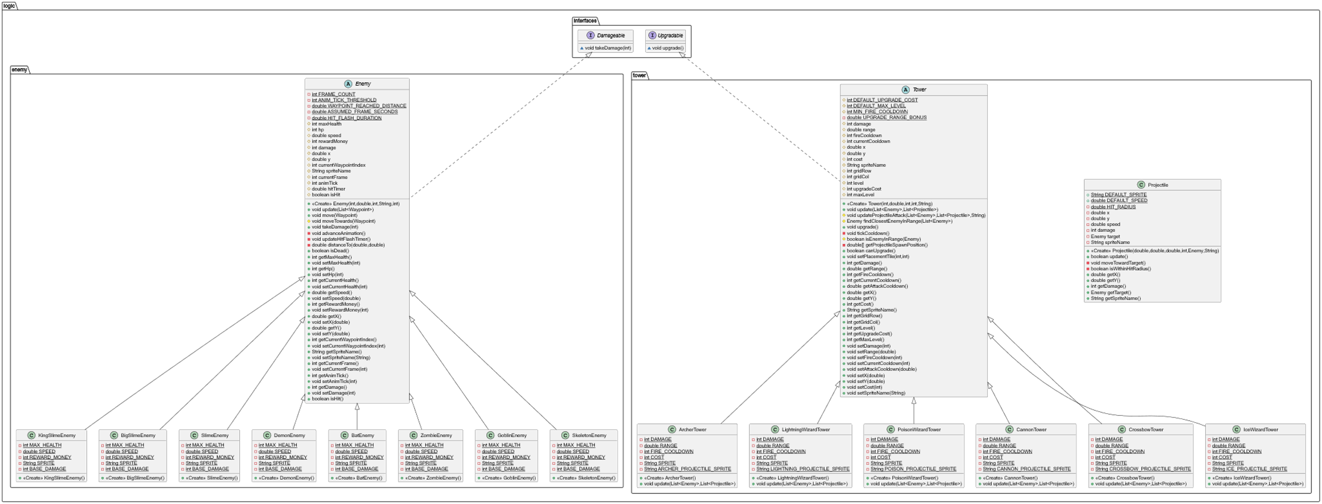
src/main/java/logic/enemy, src/main/java/logic/tower, and src/main/java/logic/

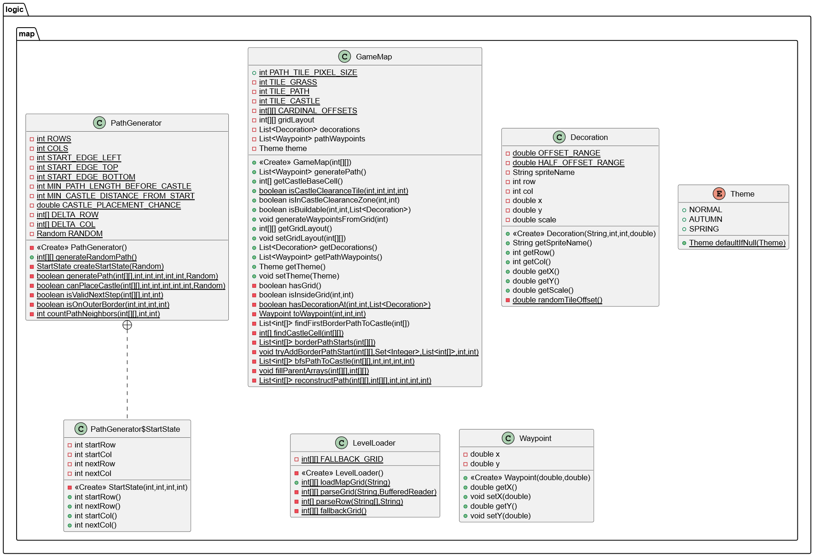
src/main/java/logic/map

src/main/java/logic/GameManager.java and src/main/java/logic/DamageText.java
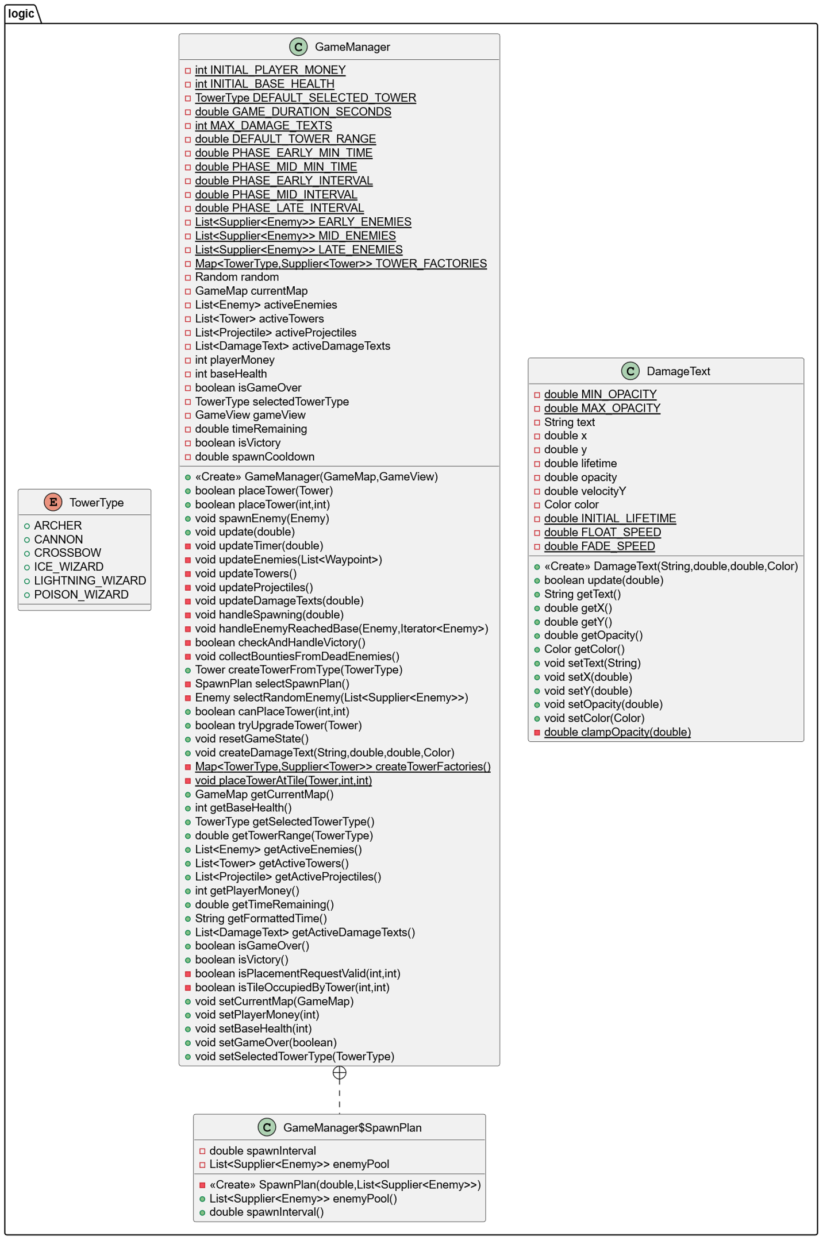


Projects Links
- JavaDoc: Click here to view JavaDoc
- UML Diagram: Click here to view full UML Diagram

