Python Programming Lab Task Sets

Submitted By: Suvikhyath Thirunahari
Roll No: 2503B05202
Set 1
- Q1. Write a Python function to calculate the factorial of a number. Use a coding assistant and document how you refine your prompt to ensure the function handles negative input and zeros.
Prompt:
Create a Python program to calculate the factorial of a number with the help of a function. First, write the simple factorial function; then, at each step, refine it. First, refine this function so that it returns 1 correctly for an input of zero. Then, further refine it so that the function handles negative numbers by raising an appropriate error message. Once the function has been refined, adapt the program to take the number as input from the user. Show each step of refinement and finally give the complete Python program with comments and user input.
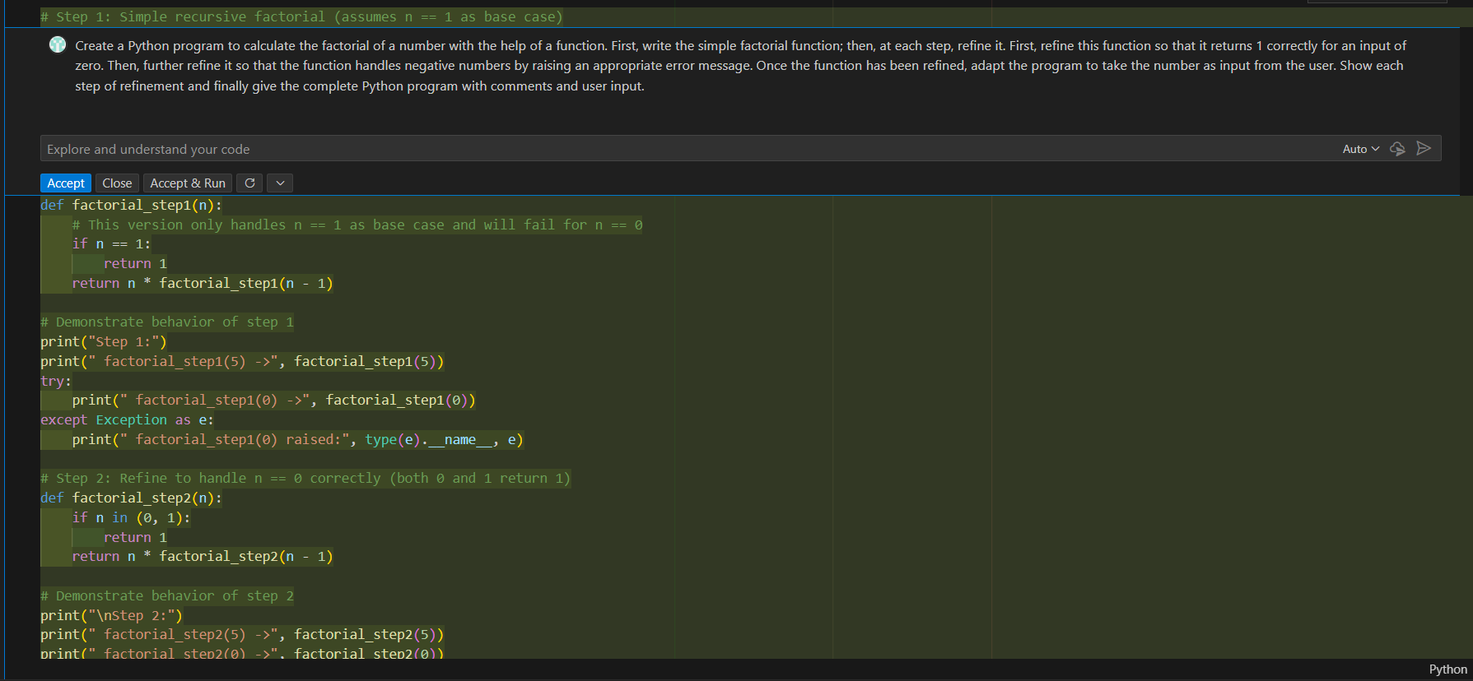
CODE :
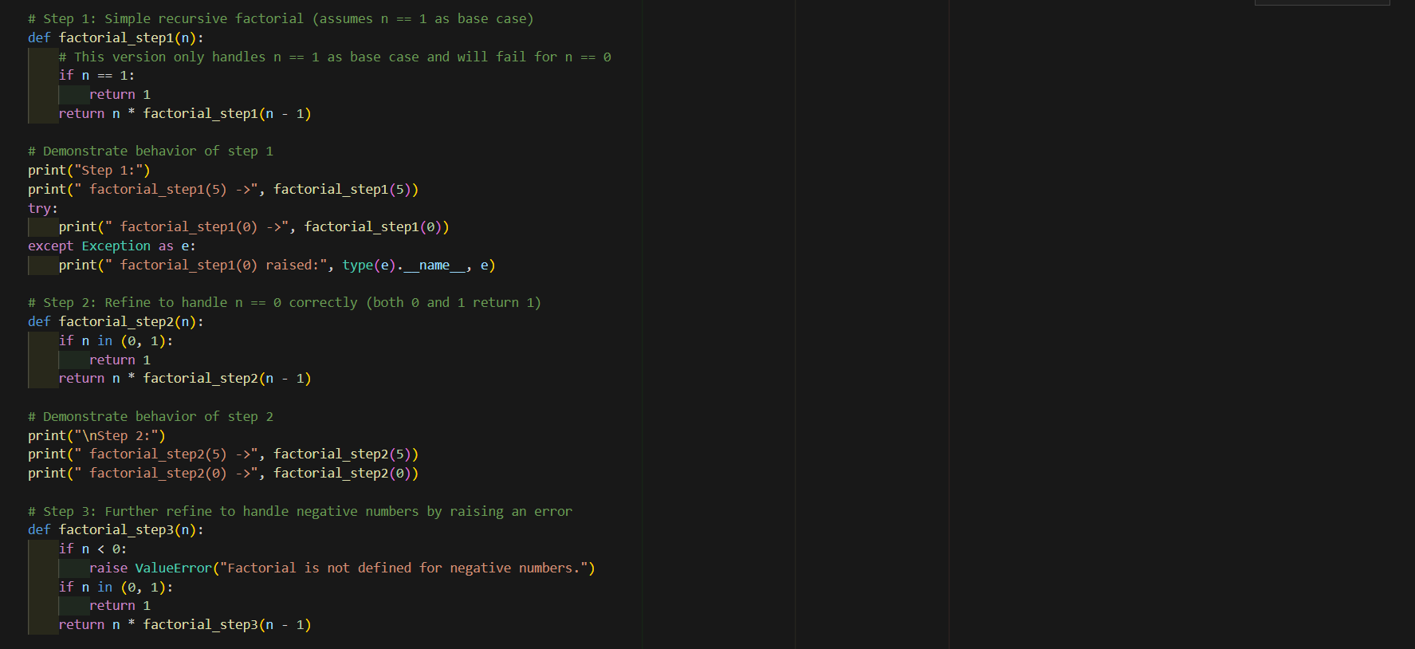
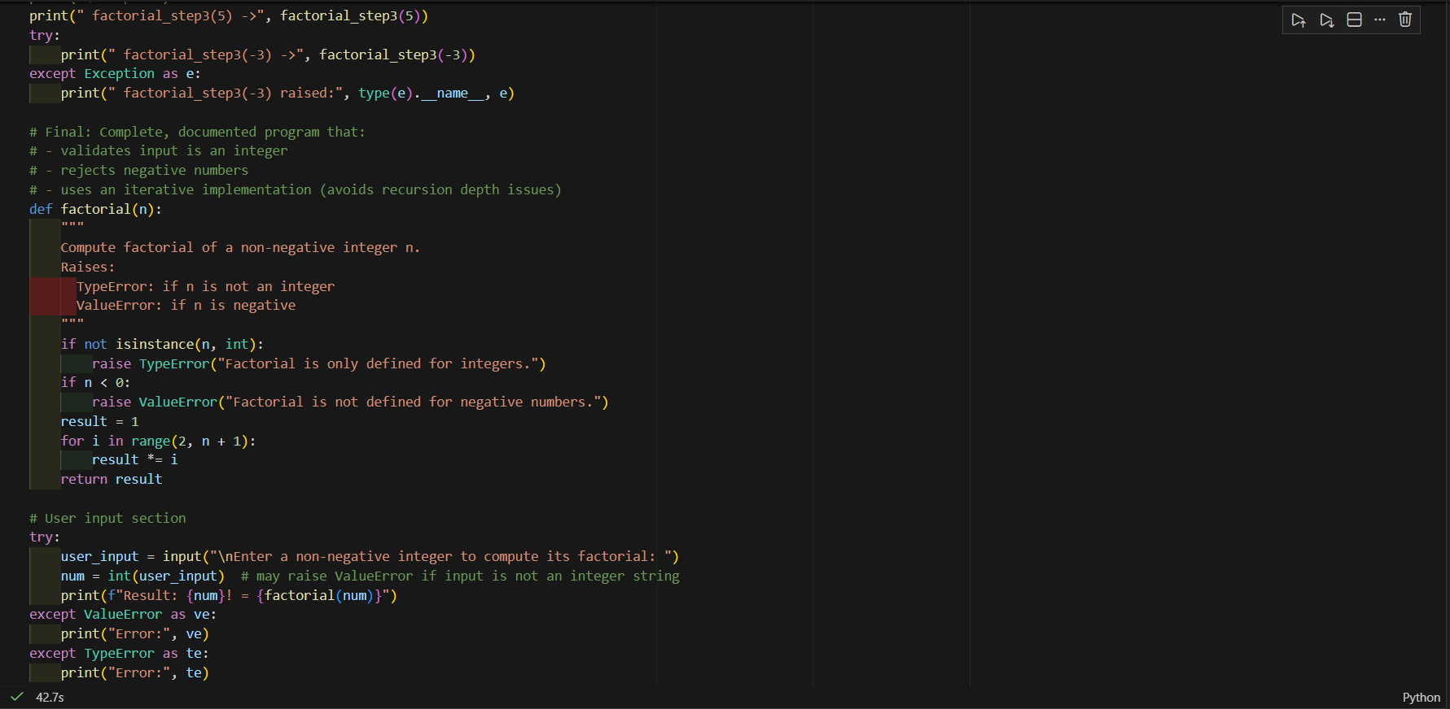
Output:
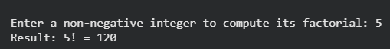
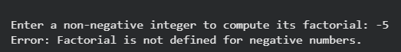
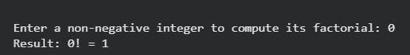
- Q2. Given a list of student marks, compute the mean and list all students above the mean. Demonstrate zero-shot, one-shot, and few-shot prompts to guide an AI tool to solve this. Summarize the differences in approach.
(Each question carries 5 marks)
Prompt:
Zero Shot:
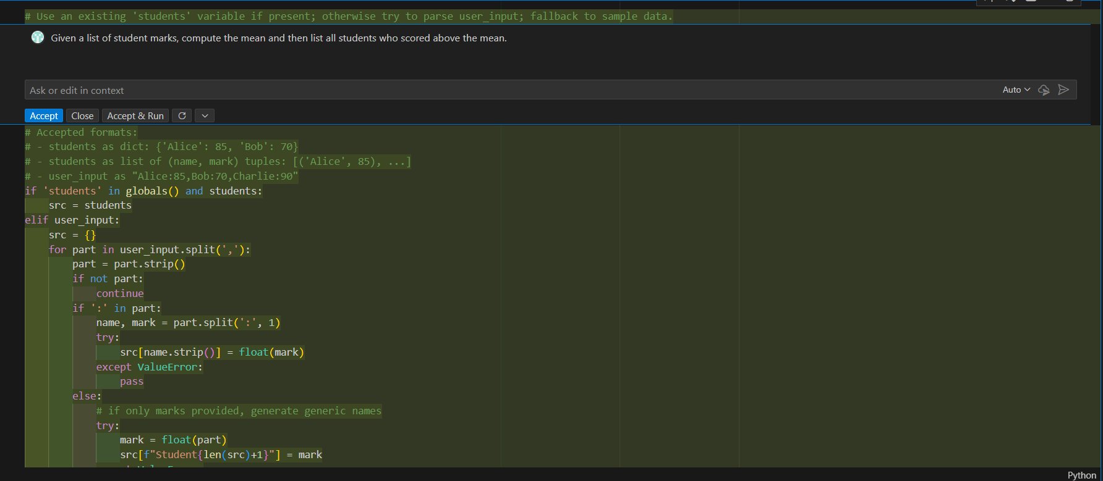
One Shot:
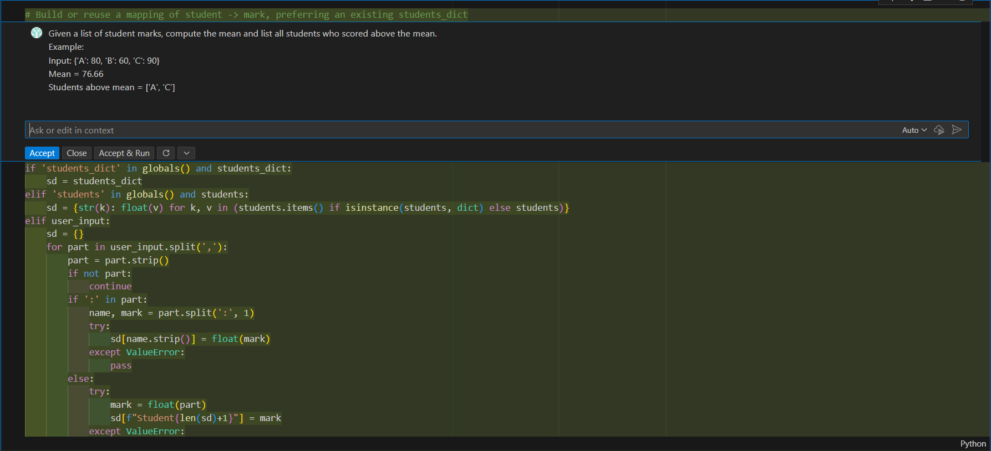
Few Shot:
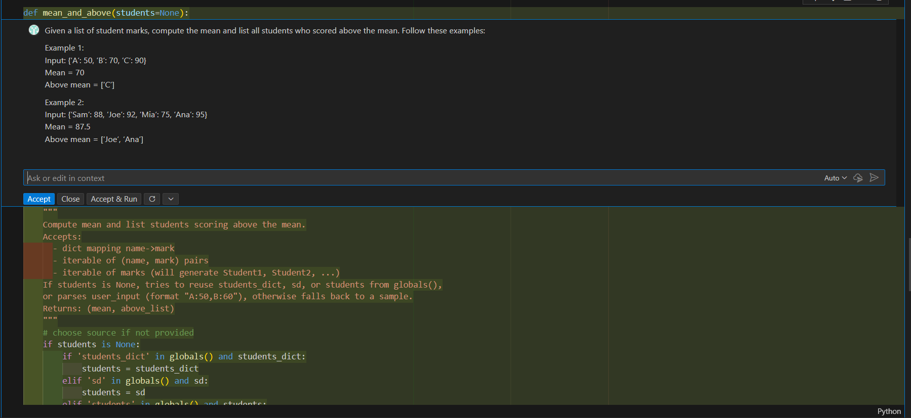
CODE:
Zero Shot:
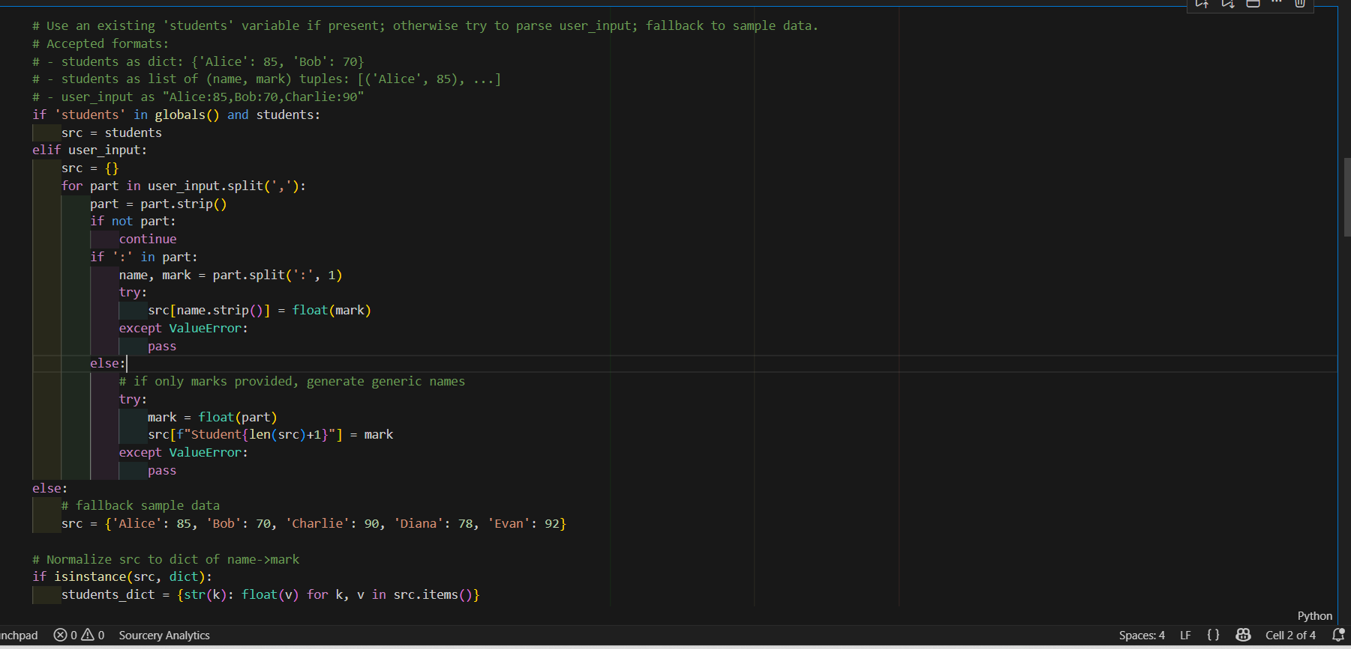
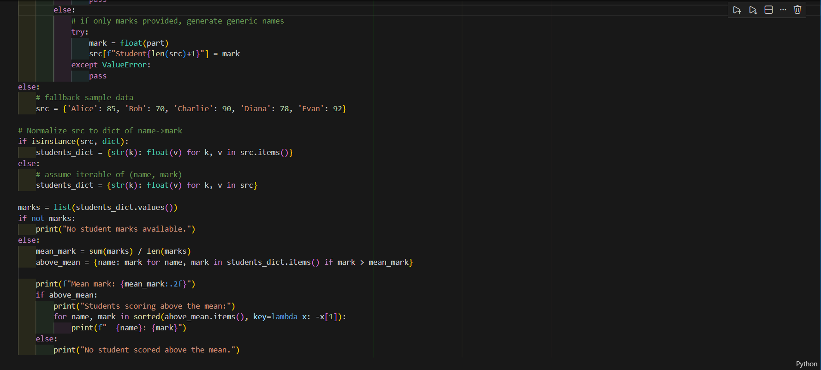
Output:
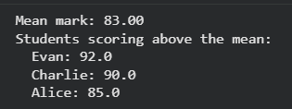
One Shot:
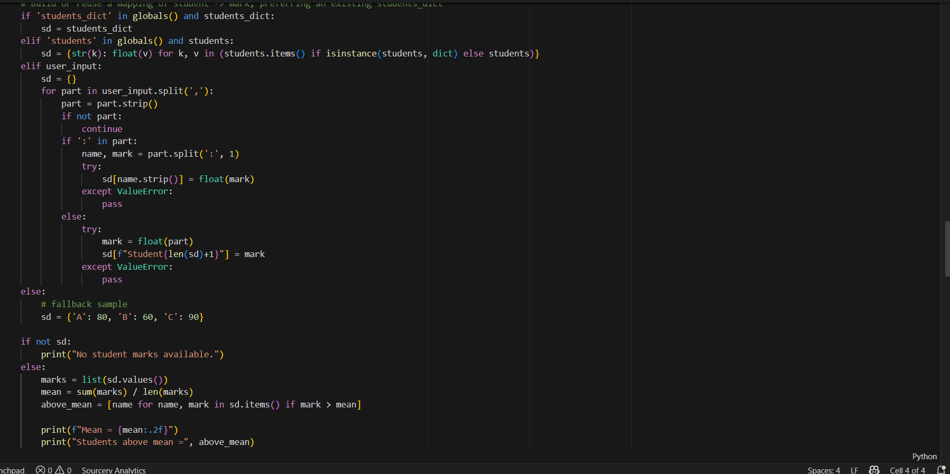
Output:
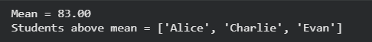
Few Shot:
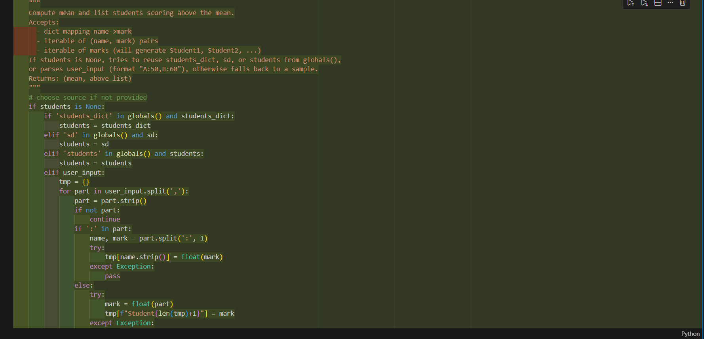
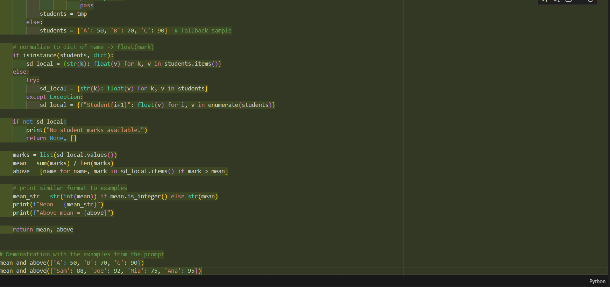
Output:
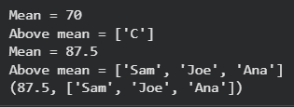
Differences:
Zero-Shot:
The AI is given no examples. It relies entirely on its general knowledge. Results may vary depending on how well the task is described.
One-Shot:
The AI is given one example to understand the format, reasoning style, and expected output. Accuracy and consistency improve.
Few-Shot:
The AI is given multiple examples, helping it clearly learn the pattern. This produces the most reliable and structured output, especially for tasks involving formatting or reasoning.

