Impact Fund Portfolio Monitor
Monthly Report — May 2026
Generated on: June 27, 2026

1. Portfolio Overview
Total Loans | 243
Total AUM | $8,346,313,267
Collection Rate | 92.6%
On-Time Payment Rate | 80.0%
Covenant Breaches | 63
Missed Payments | 72
Health Score | 77.0 / 100 — WATCH ⚠

2. Portfolio Analytics

Portfolio Health Metrics
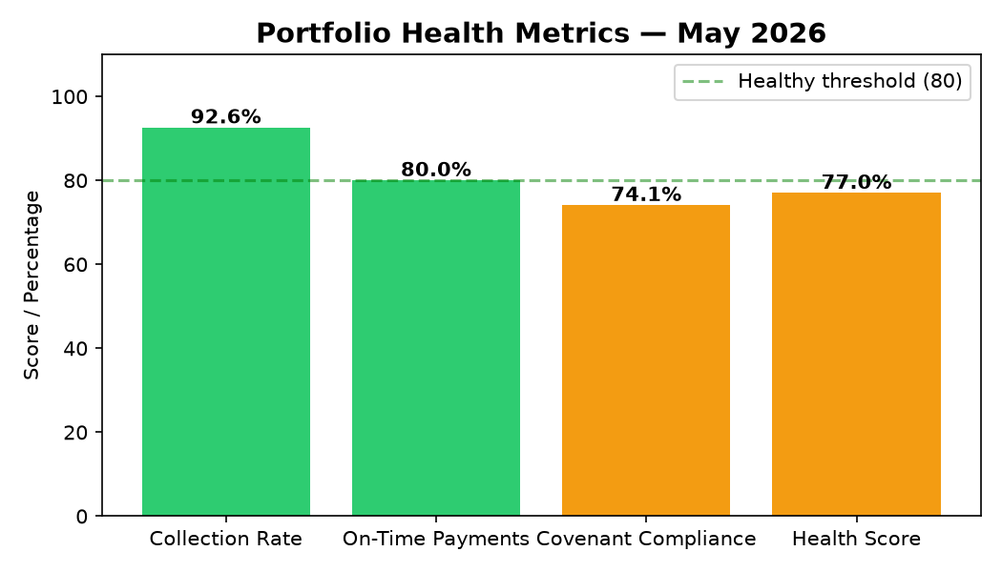

Payment Status Distribution
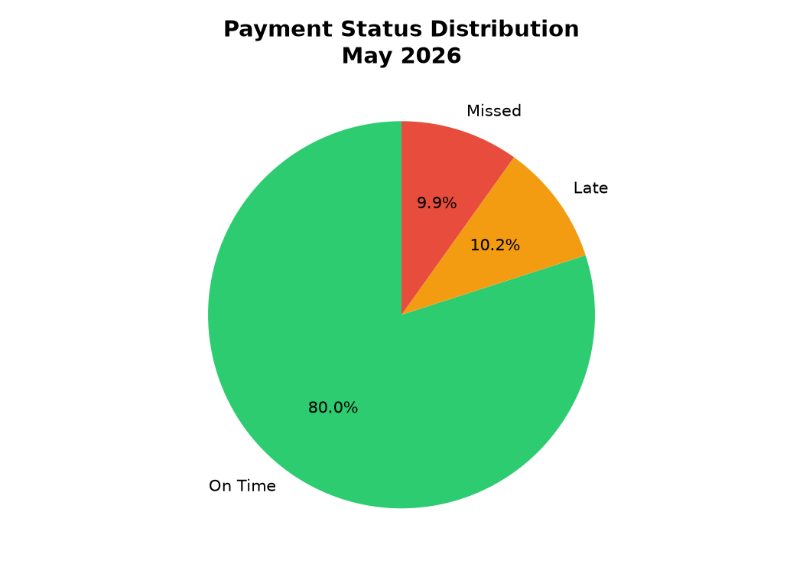

Covenant Compliance Status
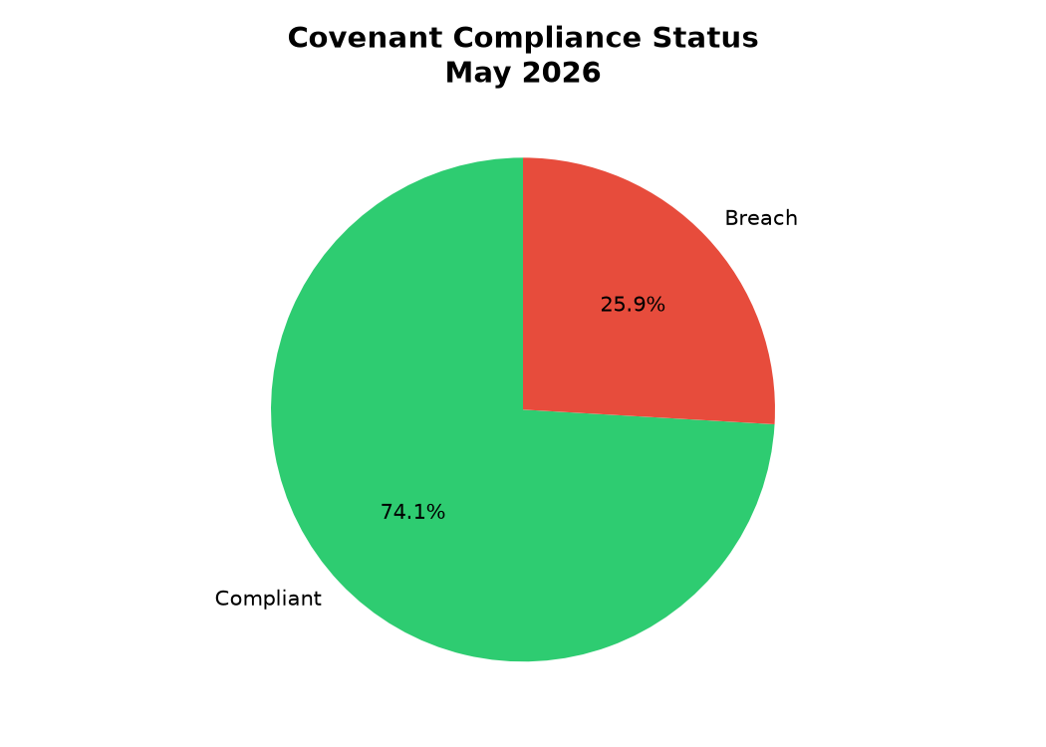

Loans by Sector
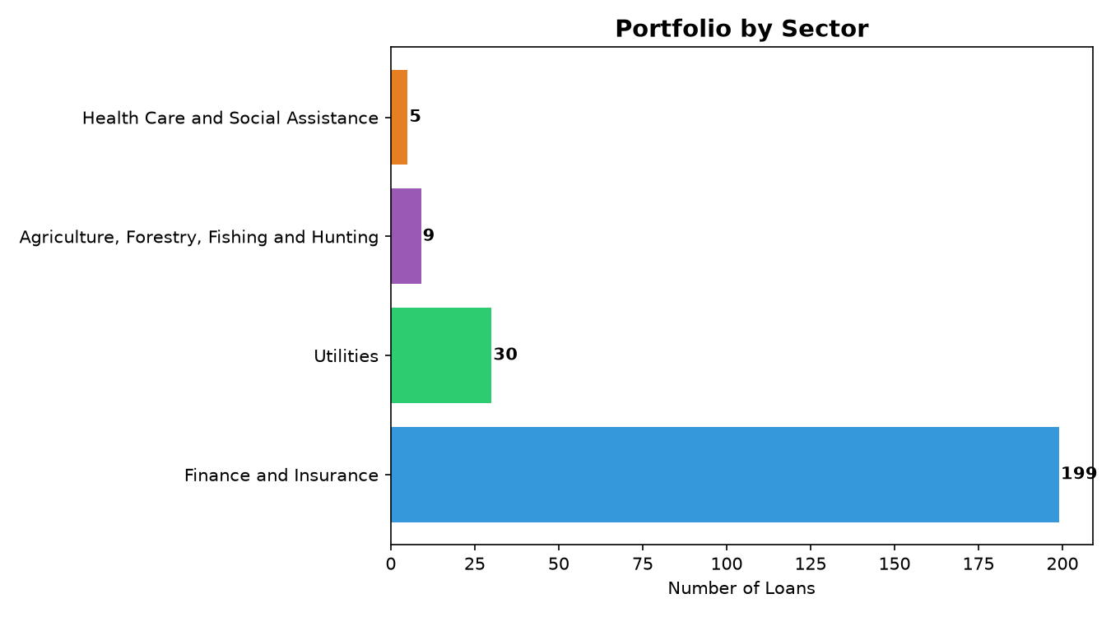

Top 10 Countries by Loan Count
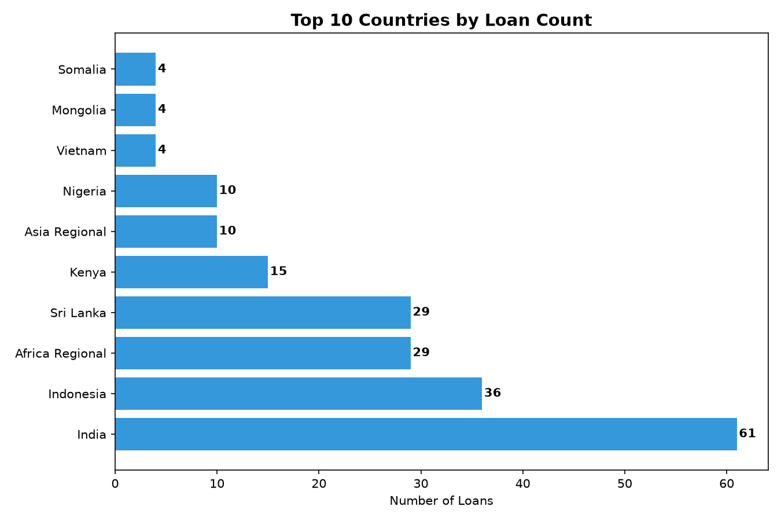

3. Investor Report
IMPACT FUND PORTFOLIO — MONTHLY INVESTOR REPORT
May 2026
============================================================
**Monthly Investor Report - May 2026**
## Executive Summary
The portfolio's health score of 77.0/100 indicates a relatively stable performance, with a collection rate of 92.6% and an on-time payment rate of 80.0%. However, we note that 63 loans are in covenant breach, and 72 instances of missed payments have occurred, highlighting areas for focused attention. Overall, the portfolio's metrics suggest a need for continued monitoring and proactive management.
## Key Risks & Action Items
* RBL Bank (India): High debt-to-equity ratio of 4.26 warrants close monitoring and potential engagement with management to address leverage concerns.
* Republic of Indonesia (Indonesia): Covenant breach due to low DSCR of 0.85 requires immediate attention, including review of repayment schedules and potential restructuring.
* Butama Hydro Electricity Company (Uganda) and International Bank (Liberia) Limited (Liberia): Large missed payments of $113,750 and $183,333, respectively, necessitate prompt follow-up and collection efforts.
* Iungo Capital B.V. (Africa Regional) and Brighter Life Kenya 2 (Kenya): Low DSCR and high debt-to-equity ratios demand enhanced scrutiny and potential mitigation strategies.
* Engagement with Republic of India (India) and Republic of Indonesia (Indonesia) to address recurring missed payments and covenant breaches.
## Outlook
In the coming month, our team will prioritize the following actions: (1) conducting in-depth reviews of borrowers with high leverage and low DSCR, (2) engaging with management teams to address covenant breaches and Payment delinquencies, and (3) exploring restructuring options for select borrowers. We will also continue to monitor the overall portfolio's health and adjust our strategy as needed to maintain a balanced risk-return profile. Our goal is to proactively manage the portfolio's risks and capitalize on opportunities to optimize returns for our investors.

4. Fund Manager Action Plan
FUND MANAGER ACTION PLAN — May 2026
============================================================
**Action Plan for Fund Manager**
### IMMEDIATE ACTIONS (this week)
1. **Republic of Indonesia (Indonesia)**: Call to discuss $26,988 and $16,244 in missed payments. Review loan terms and assess the risk of further defaults. Amount at risk: $43,232.
2. **International Bank (Liberia) Limited (Liberia)**: Contact to address $183,333 in missed payments. Verify the bank's current financial situation and potential impact on the portfolio. Amount at risk: $183,333.
3. **Republic of India (India)**: Reach out to discuss $105,417 and $69,667 in missed payments. Evaluate the borrower's ability to meet future obligations. Amount at risk: $175,084.
4. **Butama Hydro Electricity Company (Uganda)**: Call to resolve $113,750 in missed payments. Determine the cause of the default and potential solutions. Amount at risk: $113,750.
### SHORT TERM (this month)
1. **Restructuring Candidates**:
* **Iungo Capital B.V. (Africa Regional)**: DSCR of 0.81 indicates potential cash flow issues. Consider restructuring the loan to prevent further defaults.
* **Republic of Indonesia (Indonesia)**: With a DSCR of 0.85 and two instances of missed payments, restructuring may be necessary to ensure timely repayments.
2. **Covenant Waivers to Consider**:
* **DIAOUNE AGRO INDUSTRIE SARL (Guinea)**: DSCR of 0.97 is close to the threshold. Consider a temporary covenant waiver to allow the borrower to recover.
* **Brighter Life Kenya 2 (Kenya)**: DSCR of 1.01 is borderline. Monitor the borrower's performance and consider a covenant waiver if necessary.
3. **Loan Reviews**:
* **RBL Bank (India)**: Review the loan terms and assess the risk associated with a DSCR of 1.58 and D/E of 4.26.
* **Caspian Impact Investments II (India)**: Evaluate the loan's performance and consider potential adjustments to mitigate risks associated with a DSCR of 1.39 and D/E of 4.16.
### WATCH LIST
1. **Mvuvi Holdings (Mozambique)**: Monitor the borrower's performance closely, as the DSCR of 1.02 is borderline.
2. **Paryapt Solar Energy Private Limited (India)**: Keep a close eye on the borrower's cash flow, given the DSCR of 1.16 and D/E of 3.05.
3. **Government of Somalia (Somalia)**: Watch the borrower's progress, as the DSCR of 1.1 and D/E of 1.86 may indicate potential risks.
4. **LuccaHealth Medical Specialty Center Ghana Limited (Ghana)**: Monitor the borrower's ability to meet future obligations, considering the $75,000 in missed payments.
By following this action plan, the fund manager can address immediate concerns, proactively manage potential risks, and ensure the overall health of the impact fund portfolio.

5. Covenant Breaches Detail
Borrower | Country | DSCR | D/E Ratio | Status
Democratic Republic Of The Sudan | Sudan | 0.9 | 1.33 | Breach
Republic of India | India | 2.47 | 3.14 | Breach
Department of External Resources | Sri Lanka | 1.12 | 1.9 | Breach
Republic of Indonesia | Indonesia | 1.19 | 4.23 | Breach
Department of External Resources | Sri Lanka | 1.16 | 2.55 | Breach
Republic of Kenya | Kenya | 1.02 | 1.8 | Breach
Department of External Resources | Sri Lanka | 0.94 | 2.22 | Breach
Republic of India | India | 0.87 | 1.53 | Breach
Republic of India | India | 1.21 | 1.87 | Breach
Department of External Resources | Sri Lanka | 0.74 | 4.47 | Breach
Republic of India | India | 1.06 | 2.64 | Breach
Department of External Resources | Sri Lanka | 1.19 | 3.76 | Breach
Republic of Indonesia | Indonesia | 0.85 | 1.13 | Breach
Republic of Indonesia | Indonesia | 1.23 | 2.82 | Breach
Republic of Indonesia | Indonesia | 1.18 | 2.45 | Breach

6. Missed Payments Detail
Borrower | Country | Due Date | Amount Due
Republic of Zimbabwe | Zimbabwe | 2026-03-03 | $38,032.24
Republic of Indonesia | Indonesia | 2026-03-03 | $13,547.17
Republic of India | India | 2026-05-02 | $91,666.67
Republic of Indonesia | Indonesia | 2026-03-03 | $35,646.90
Republic of Indonesia | Indonesia | 2026-05-02 | $26,988.00
Department of External Resources | Sri Lanka | 2026-04-02 | $17,835.48
Republic of Indonesia | Indonesia | 2026-05-02 | $130,276.55
Republic of India | India | 2026-03-03 | $69,666.66
Republic of India | India | 2026-05-02 | $69,666.66
Republic of India | India | 2026-04-02 | $39,824.47
Republic of Indonesia | Indonesia | 2026-03-03 | $36,081.04
Department of External Resources | Sri Lanka | 2026-04-02 | $17,024.21
Republic of Indonesia | Indonesia | 2026-04-02 | $11,000.00
Republic of Indonesia | Indonesia | 2026-03-03 | $38,238.67
Republic of Indonesia | Indonesia | 2026-04-02 | $21,709.98

