**МИНИСТЕРСТВО НАУКИ И ВЫСШЕГО ОБРАЗОВАНИЯ РОССИИ**

**ФГБОУ ВО "Пензенский государственный университет"**

Кафедра "Математическое обеспечение и применение ЭВМ"

Отчет

по лабораторной работе №1

Выполнили:

Хамзин Х.

Суворов М.

Хусаинов И.

ст. гр. 17ВИ1

Проверила:

Попова Н. А.

2020

**Цель работы.** Ознакомление с процессом нормализации схем реляционных баз данных, приобретение практических навыков анализа и построения эффективных схем оперативных баз данных для информационных систем класса OLTP.

**Схема Бд**

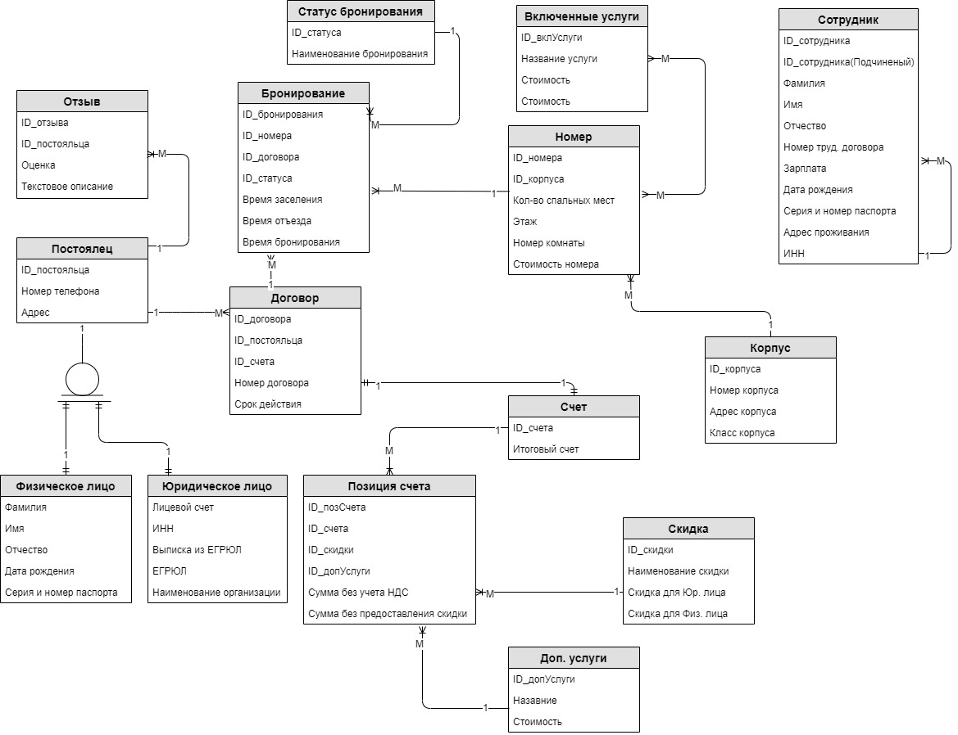

**Код Базы данных**

drop table if exists feedback cascade;

drop table if exists fiz_person cascade;

drop table if exists ur_person cascade;

drop table if exists client_booking cascade;

drop table if exists booking cascade;

drop table if exists status_booking cascade;

drop table if exists type_booking cascade;

drop table if exists contract cascade;

drop table if exists client cascade;

drop table if exists worker cascade;

drop table if exists bilt_position_service cascade;

drop table if exists bilt_position cascade;

drop table if exists bill cascade;

drop table if exists disscount cascade;

drop table if exists service_for_room cascade;

drop table if exists service cascade;

drop table if exists room cascade;

drop table if exists build cascade;

drop table if exists category_room cascade;

drop table if exists status_contract cascade;

drop table if exists occupied_client cascade;

CREATE TABLE Worker

(

id_worker serial primary key,

surname varchar(20) NOT NULL ,

name varchar(20) NOT NULL ,

lastname varchar(20) NULL ,

id_parent integer references worker(id_worker),

employment_number integer NOT NULL ,

birth_date timestamp NOT NULL ,

passport varchar(10) NOT NULL ,

address varchar(128) NOT NULL ,

itn varchar(64) NOT NULL

);

CREATE TABLE Build

(

id_build serial primary key,

build_adress varchar(45) NOT NULL ,

prestige integer NOT NULL

);

CREATE TABLE Category_room

(

id_category_room serial primary key,

name varchar(64) not null,

beds_count integer not null

);

CREATE TABLE Room

(

id_room serial primary key,

id_category_room integer references Category_room(id_category_room),

floor_lvl integer NOT NULL ,

room_number integer NOT NULL ,

room_cost float NOT NULL ,

id_Build integer references build(id_build)

);

CREATE TABLE Type_booking

(

id_type_booking serial primary key,

name_type varchar(64) NOT NULL

);

CREATE TABLE Status_booking

(

id_status serial primary key,

id_type_booking integer references type_booking(id_type_booking),

time_operation timestamp

);

CREATE TABLE UR_Person

(

id_ur_person serial primary key,

itn varchar(20) NOT NULL ,

name_organization varchar(64) NOT NULL

);

CREATE TABLE Client

(

id_client serial primary key,

adress varchar(256) NOT NULL ,

phone_number varchar(11) NOT NULL,

surname varchar(20) NOT NULL ,

name varchar(20) NOT NULL ,

lastName varchar(20) ,

birth_date timestamp NOT NULL ,

passport varchar(10) NOT null,

itn varchar(20) NOT NULL ,

id_ur_person integer references Ur_person(id_ur_person)

);

CREATE TABLE FeedBack

(

id_feed_back serial primary key,

id_client integer references client(id_client),

mark integer NULL ,

descroption varchar(512) NULL

);

CREATE TABLE Status_contract

(

id_status_contract serial primary key,

name varchar(64) not null

);

CREATE TABLE Contract

(

Id_contract serial primary key,

contract_number integer NOT NULL ,

start_date timestamp NOT NULL ,

end_date timestamp NOT NULL ,

amount float default(0),

id_status_contract integer references Status_contract(id_status_contract),

id_client integer references client(id_client) ,

id_worker integer references worker(id_worker)

);

CREATE TABLE Booking

(

id_booking serial primary key,

id_contract integer references contract(id_contract) ,

id_status integer references status_booking(id_status),

settlement_time timestamp NOT NULL ,

departure_time timestamp NOT NULL ,

booking_time timestamp NOT NULL ,

id_room integer references room(id_room)

);

CREATE TABLE Occupied_client

(

id_client integer references Client(id_client),

id_booking integer references Booking(id_booking)

);

CREATE TABLE Disscount

(

id_disscount serial primary key,

disscount_name varchar(64) NOT NULL ,

diss_person decimal NULL ,

diss_legal decimal NULL

);

CREATE TABLE Service

(

id_service serial primary key,

service_name varchar(64) NOT NULL ,

service_cost float NOT NULL

);

create table Service_for_room(

id_room integer references room(id_room),

id_service integer references service(id_service)

);

CREATE TABLE Bilt_position

(

id_bilt_position serial primary key,

id_contract integer references Contract(Id_contract),

id_disscount integer references disscount(id_disscount) ,

id_room integer references room(id_room),

id_service integer references service(id_service),

with_discount float not null

);

**Вывод:** Ознакомились с процессом нормализации схем реляционных баз данных, приобрели практических навыков анализа и построения эффективных схем оперативных баз данных для информационных систем класса OLTP.