Suvraneel Bhuin  
T91/CSE/194032

Class Roll – 19

Seven Segment Decoder - Structural Model

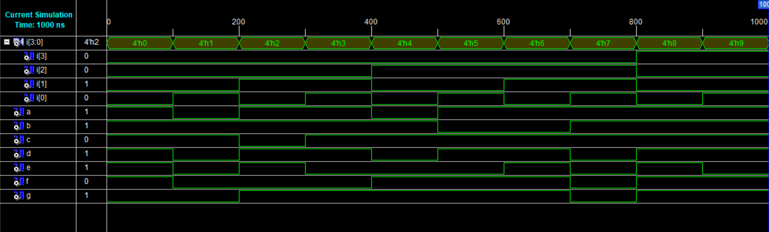

**Waveform**

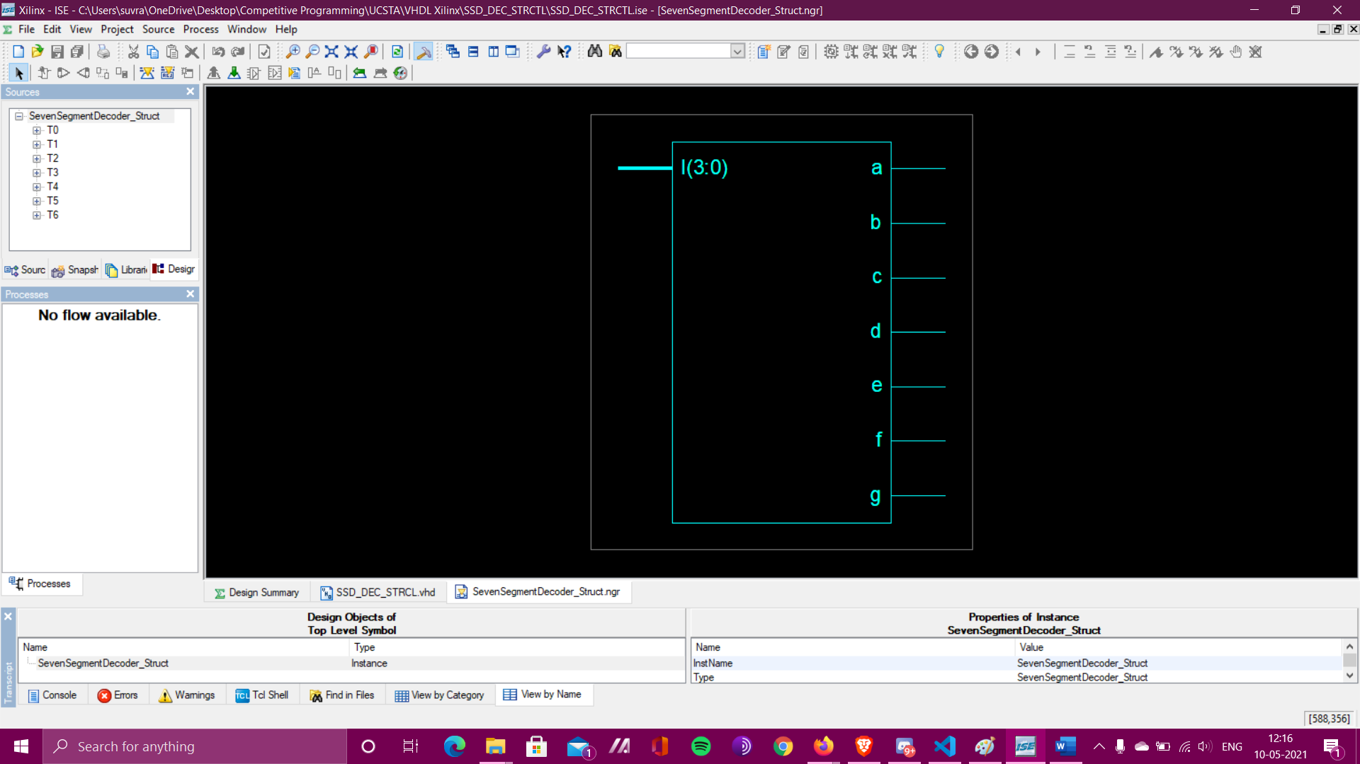

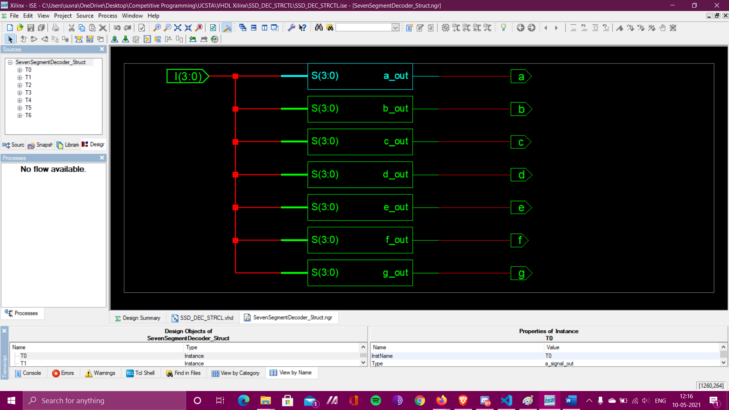

**RTL Schematic of Seven Segment Decoder**

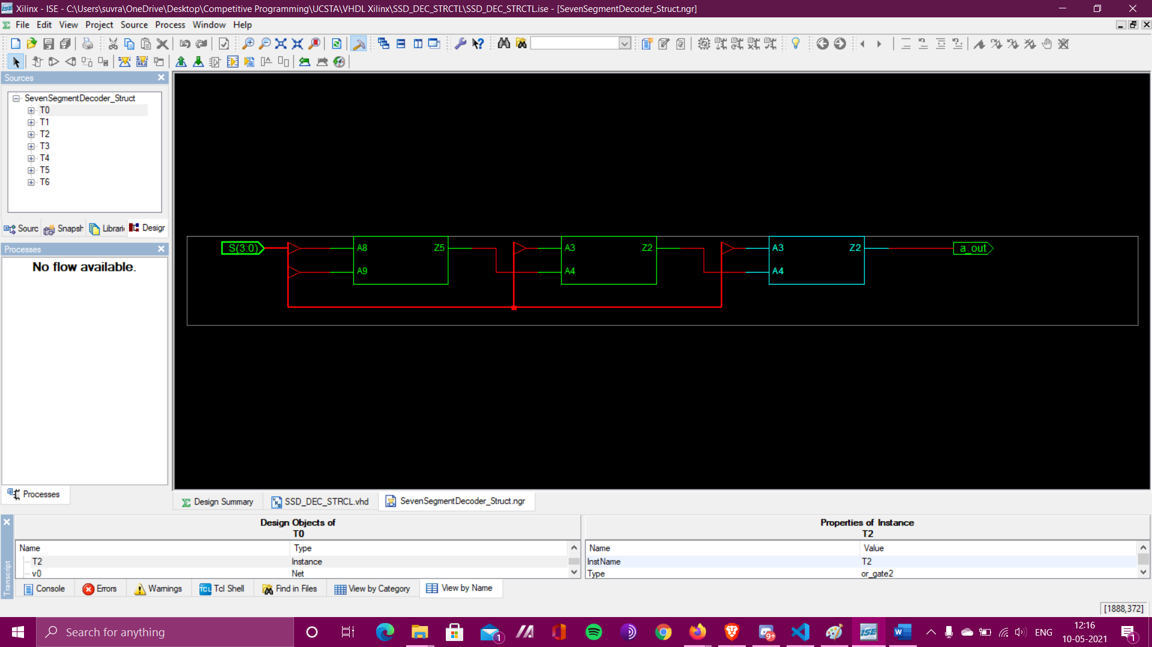

**Detailed RTL Schematic of Component a_signal_out**

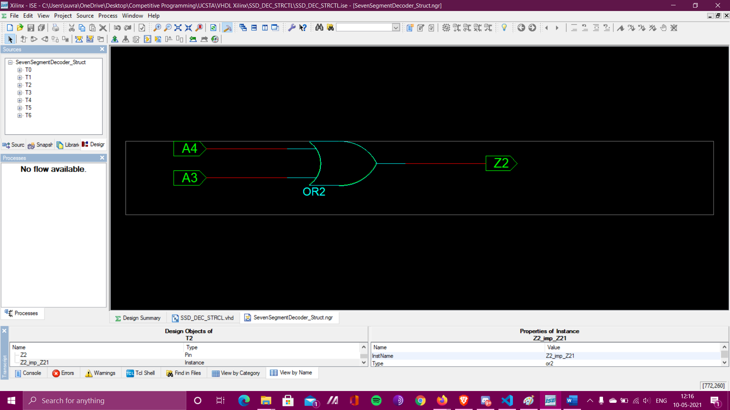

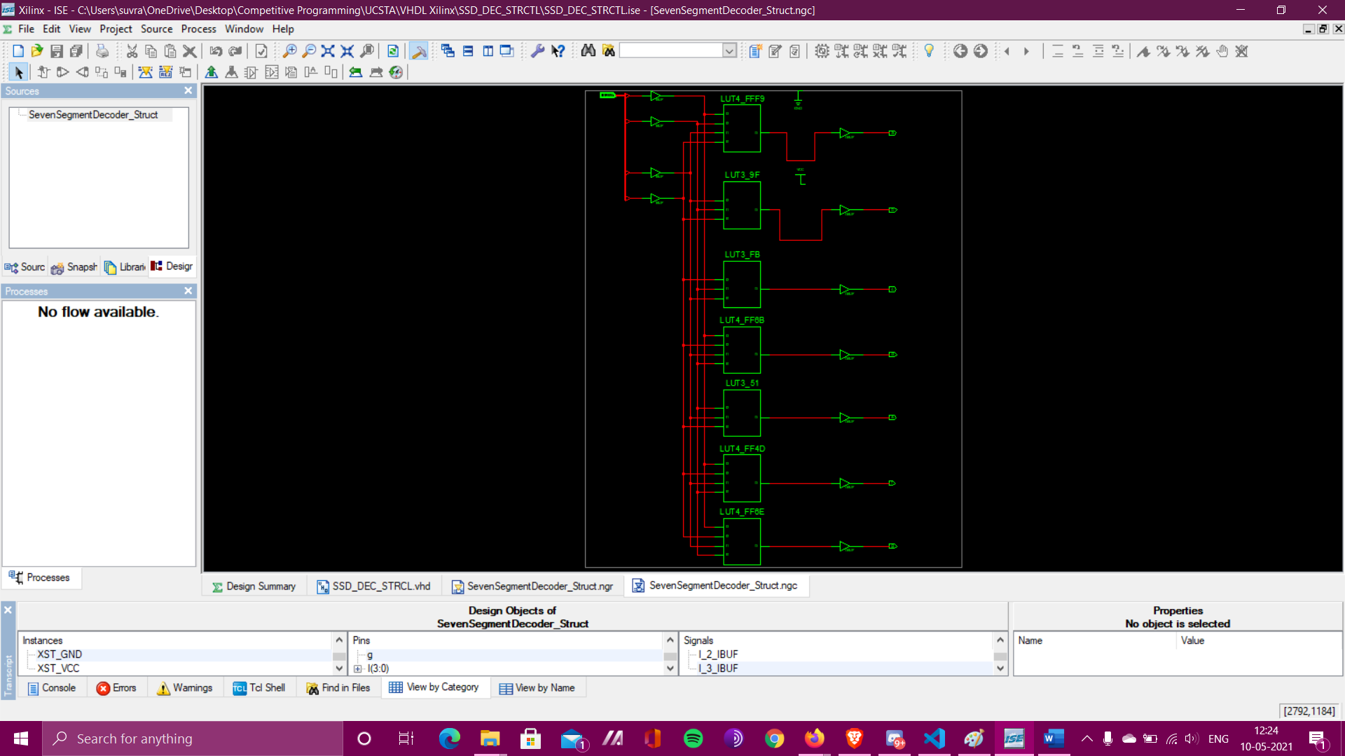

**Technology Schematic**