Suvraneel Bhuin  
T91/CSE/194032

Class Roll – 19

4 X 1 Multiplexer – Dataflow Model

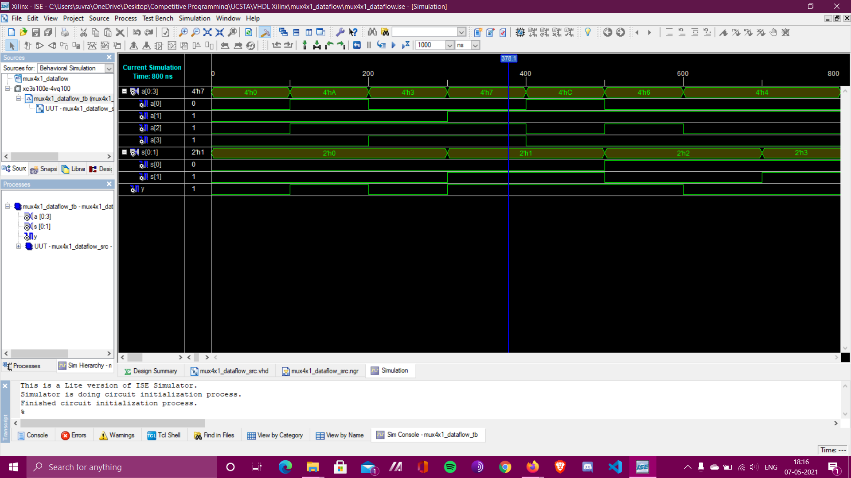

**Waveform**

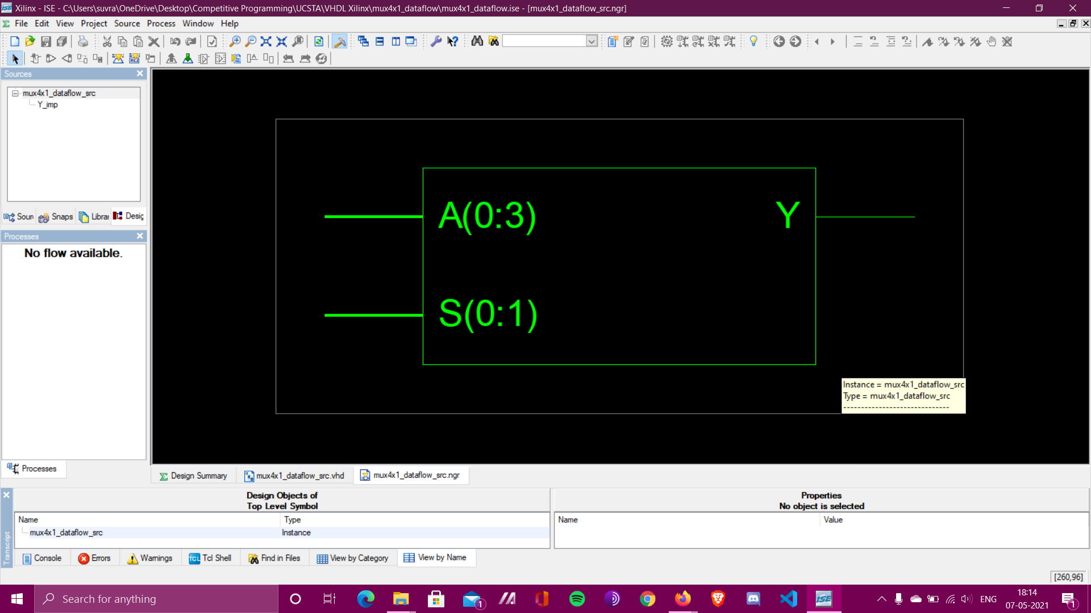

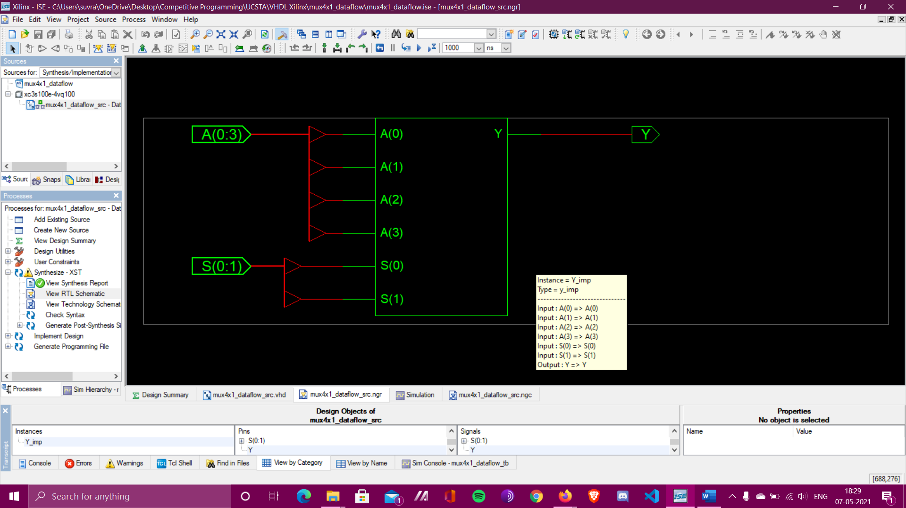

**RTL Schematic**

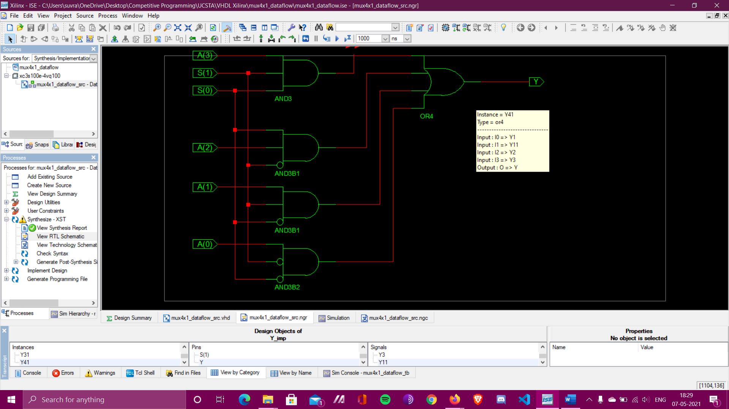

**Detailed RTL Schematic**

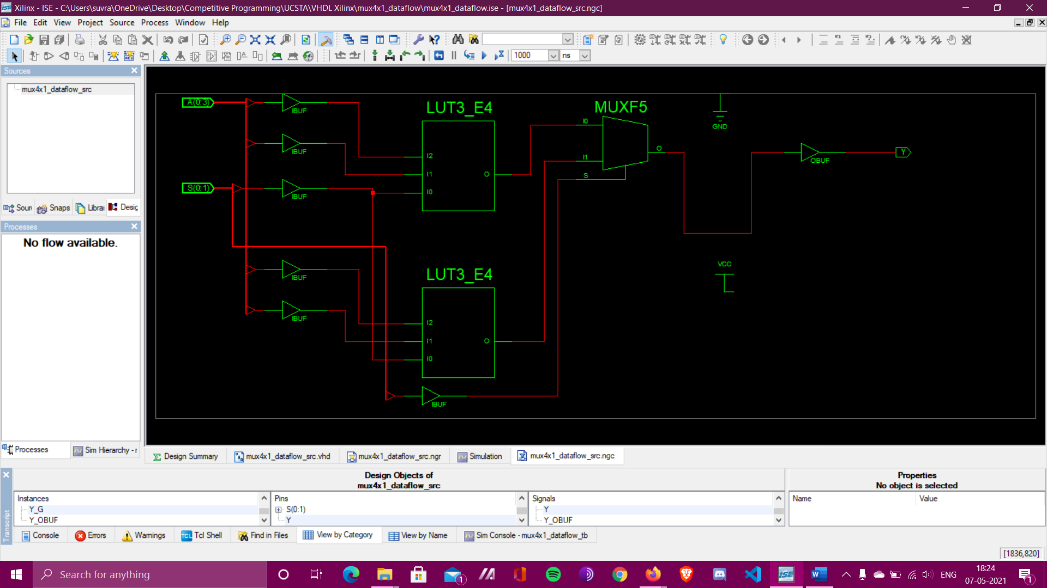

**Technology Schematic**