Suvraneel Bhuin  
T91/CSE/194032

Class Roll – 19

4 X 1 Multiplexer – Structural Model

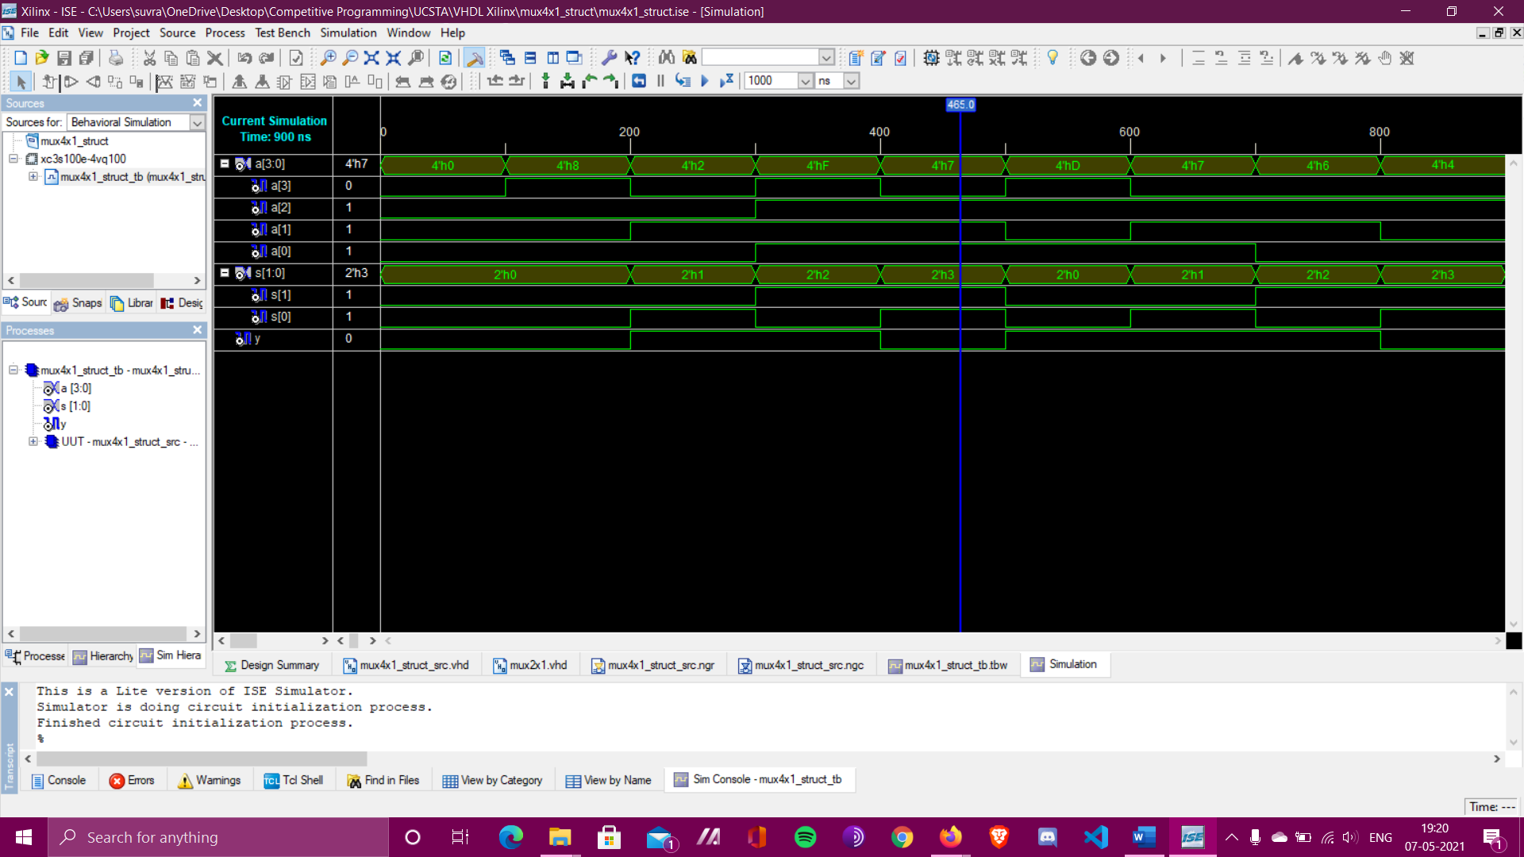

**Waveform**

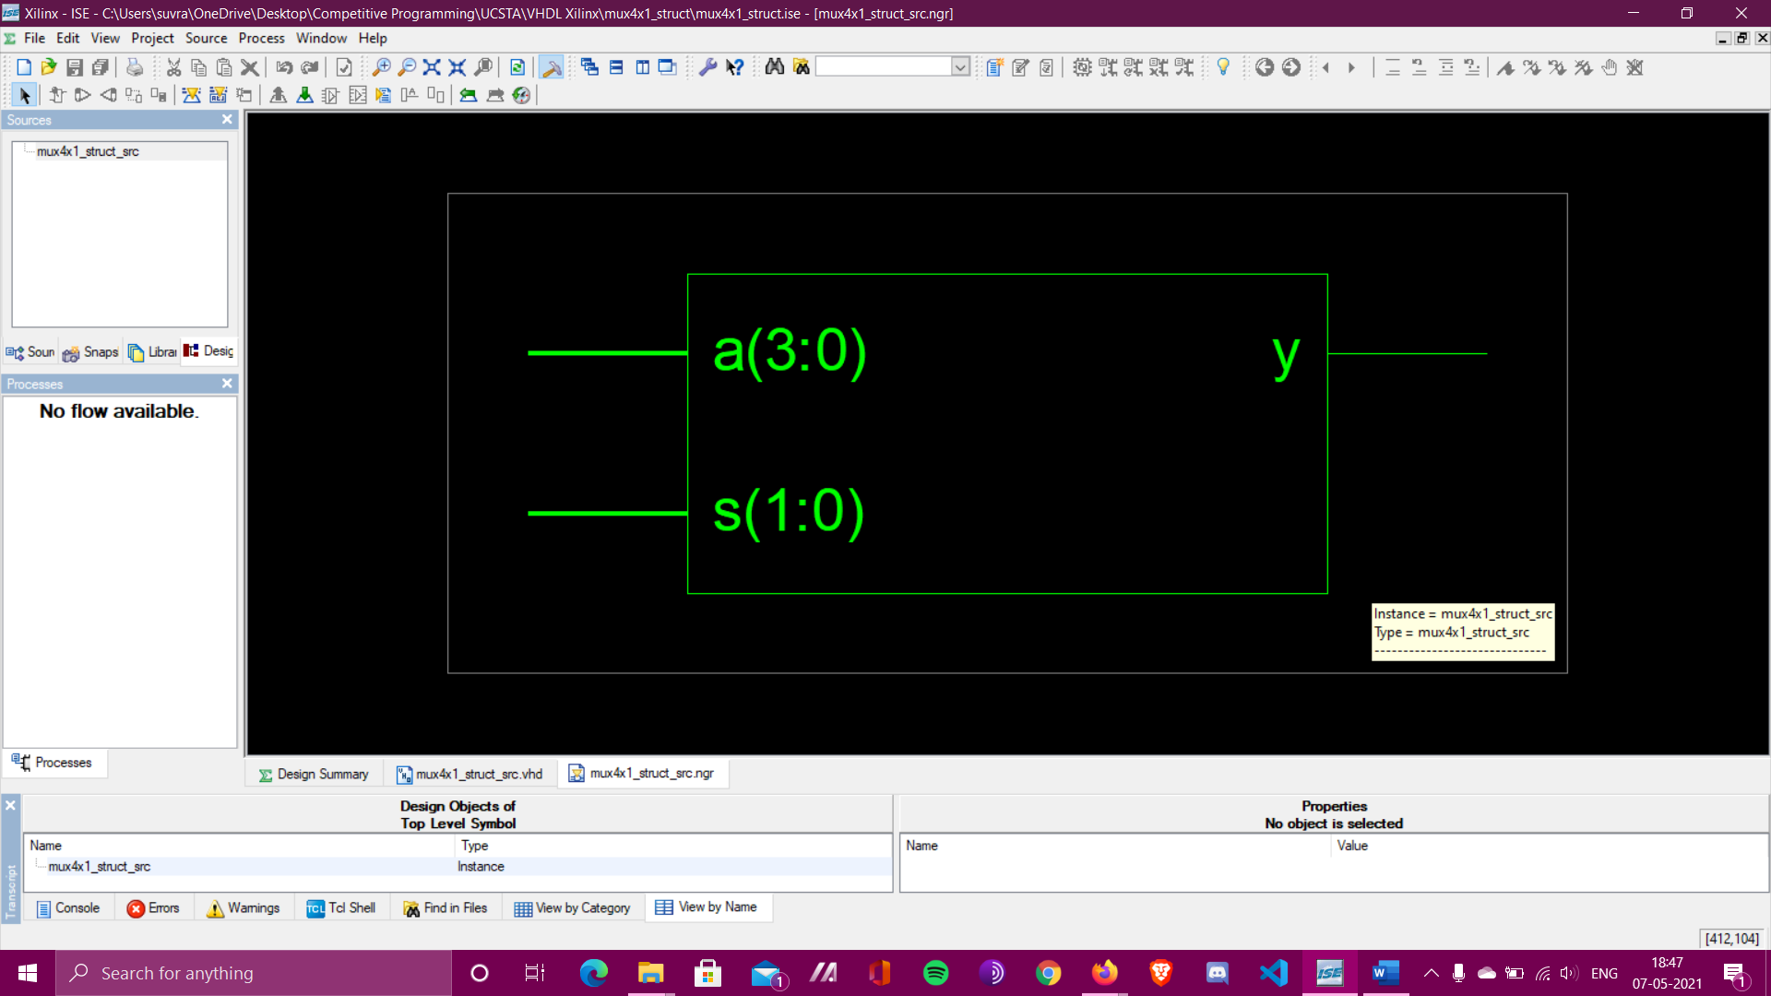

**RTL Schematic**

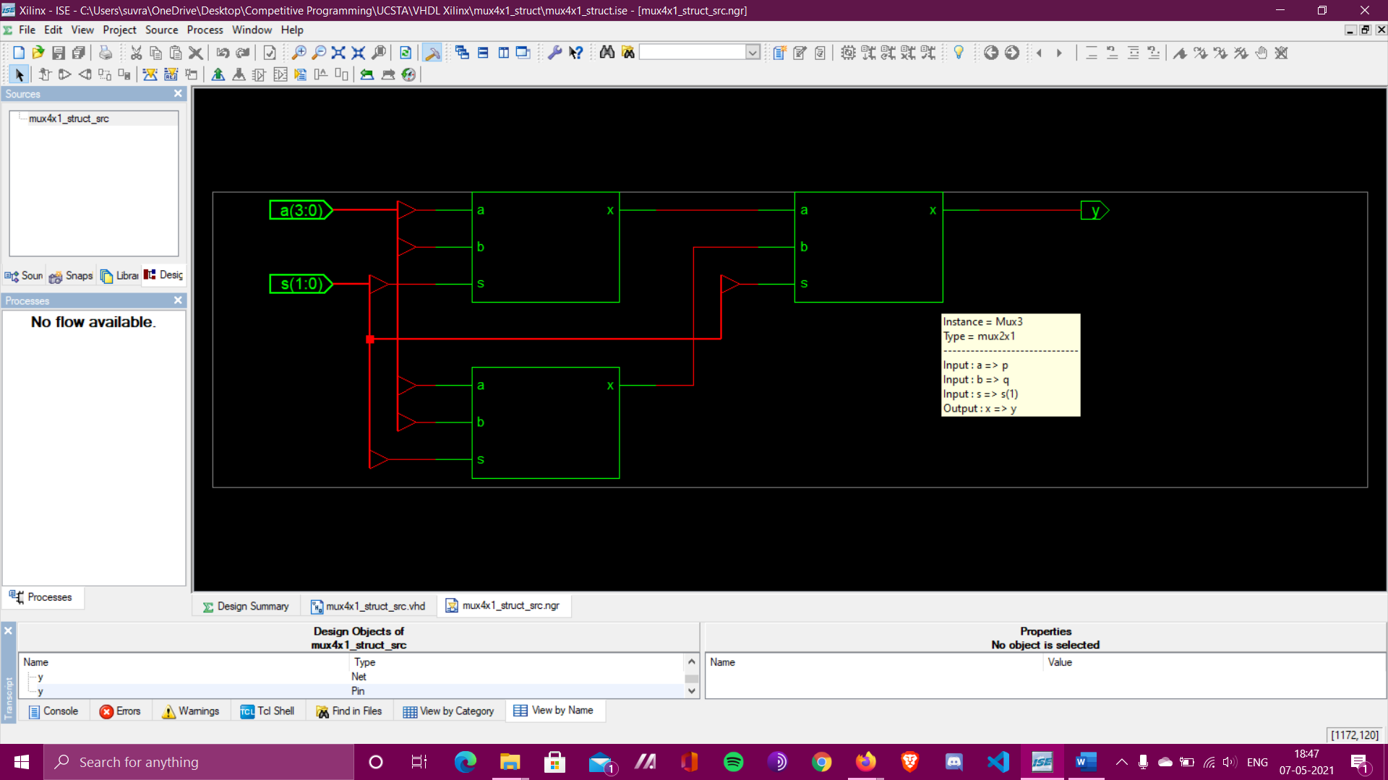

**Detailed RTL Schematic Circuit**

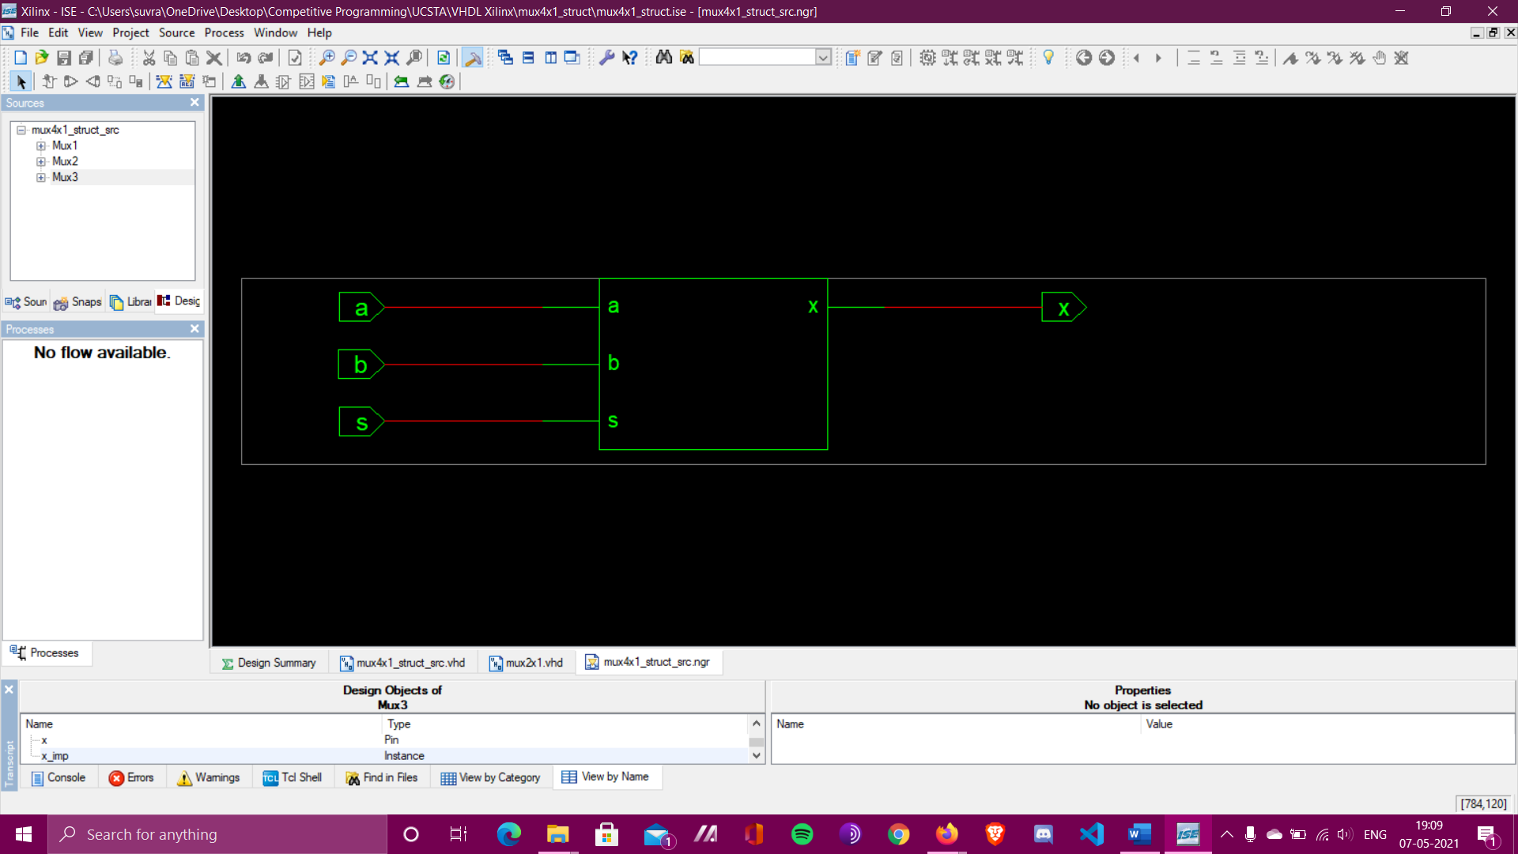

**RTL Schematic of Component 2 X 1 MUX**

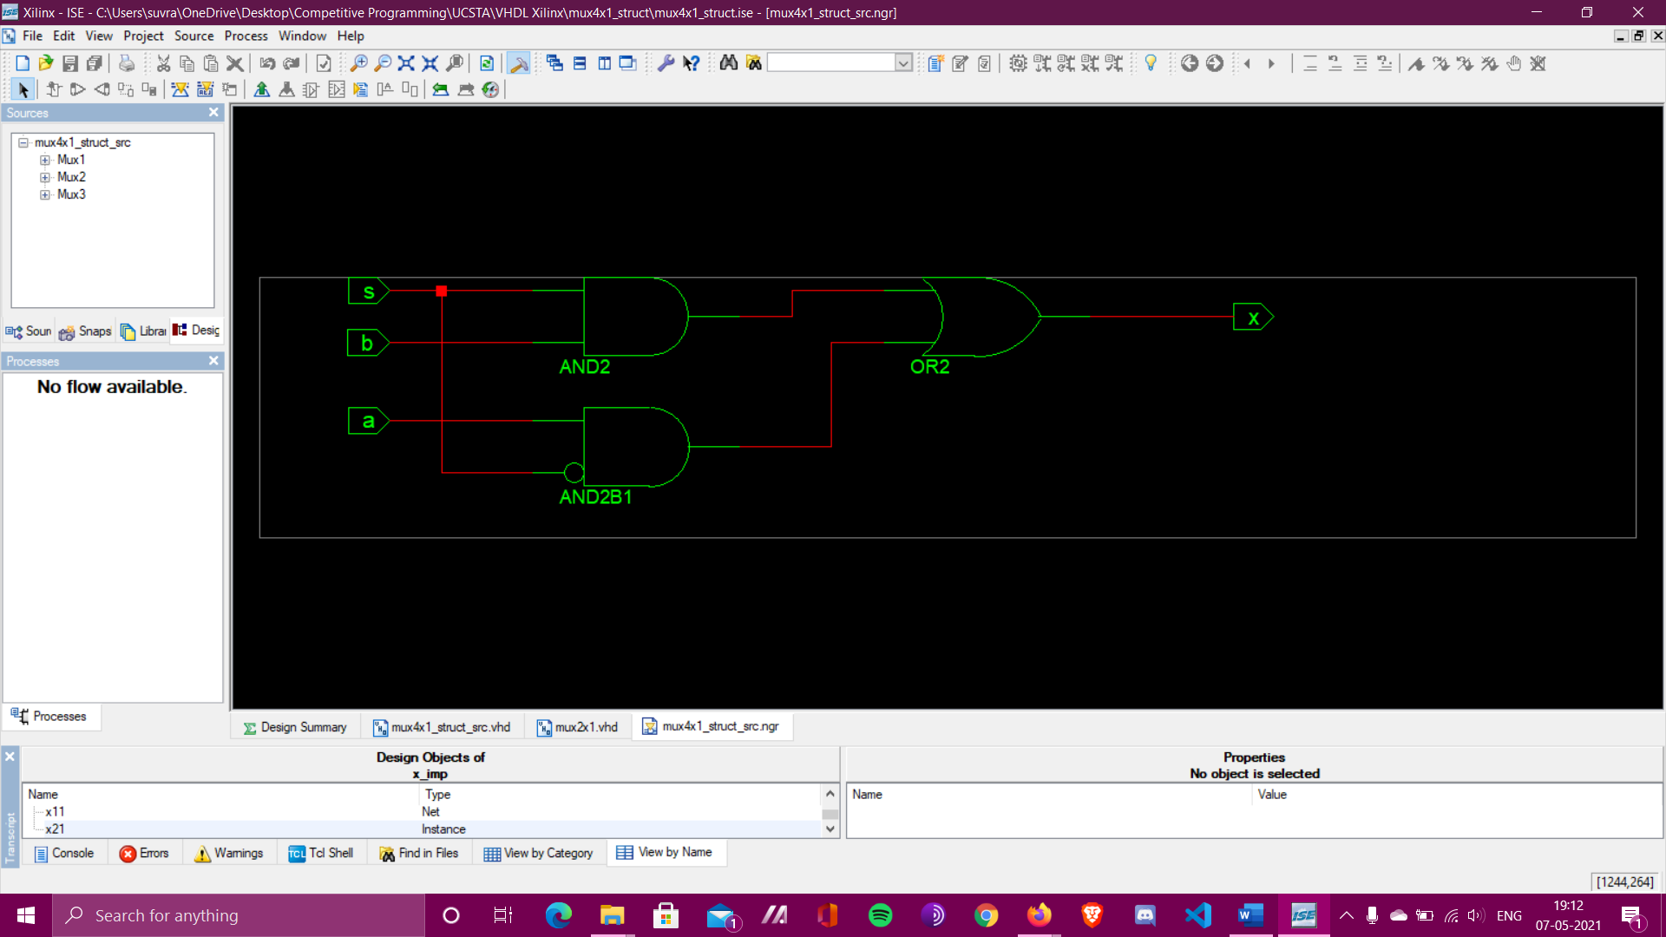

**Detailed RTL Schematic of Component 2 X 1 MUX**

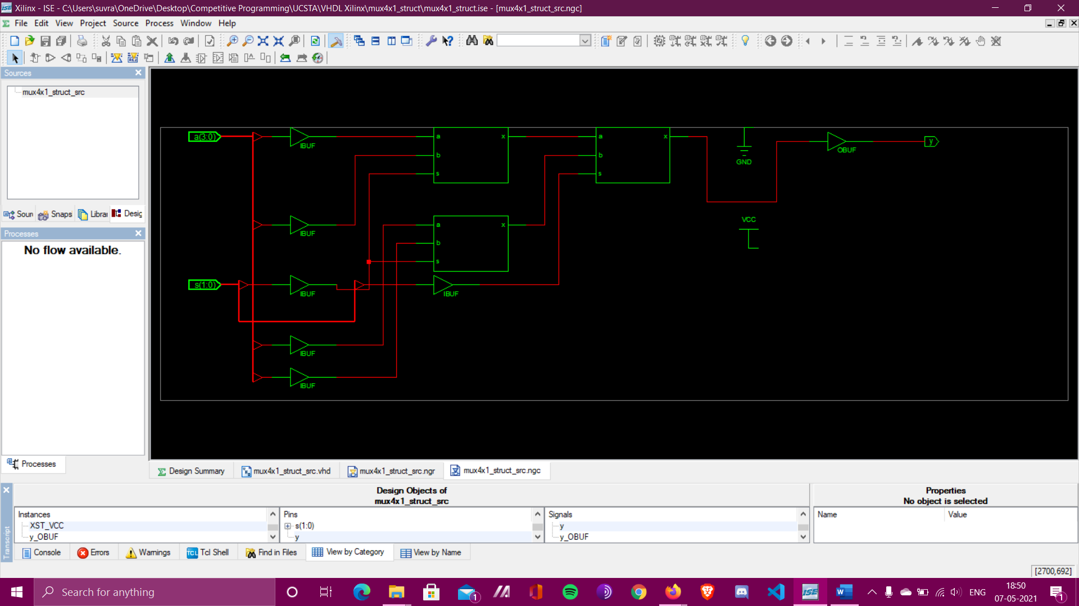

**Technology Schematic**